Shri Shivaji Education Society Amravati’s
SCIENCE COLLEGE, Congress Nagar, Nagpur
A Report on National Webinar on
Plant Tissue Culture: Techniques & Applications
15th May, 2021

Organizing secretary: Dr. Punita S Tiwari

A National Webinar on Plant Tissue Culture: Techniques & Applications was organized by Department of Botany, SSES Amravati’s Science College, Congress Nagar, Nagpur in an association with Department of Botany, St. Aloysius College, (Autonomous) Jabalpur on 15th May, 2021. A total 235 delegates (students and faculty members) from different colleges and universities across the country participated in the conference.
Session I: Inauguration:
National Webinar was inaugurated by Prof. M. P. Dhore Principal, SSES Amravati’s Science College, Congress Nagar, Nagpur, Rev. Dr. G. Vazhan Arasu Principal, St. Aloysius College, (Autonomous) Jabalpur,and chief guest Prof. Y. K. Bansal Former Head, PGTD, Dept. of Biosciences, Rani Durgavati Vishwavidyalay, Jabalpur, MP.

After Inauguration Dr. Roshni chaubey from offered verbal welcome of the guests. Dr. Shikha Bansal Head, Dept. of Botany and Microbiology, St. Aloysius’ College (Autonomous) Jabalpur, briefed about the perspectives of program along with its advantages to the participants.
Dr. Punita Tiwari, organising organizing secretary, Dept. of Botany, SSES Amravati’s Science College, Congress Nagar, Nagpur, introduced the chief guest and invited him for his speech.

Dr. Bansal appreciated and congratulated the Faculty members of Botany department for organizing the National webinar. In his speech talked about the ‘Recent Trends and Advancements in Plant Tissue Culture Technique’. He said that this technique is the need of hour for all areas of life sciences be it plant science, biotechnology, genetic engineering, pharmacy, Plant breeding, biodiversity conservation etc. He also explained that Plant tissue culture technique has proved to be blessing for horticulture, floriculture and agriculture. He explained about synthetic seeds, organ culture, secondary metabolites and advantages of the technique in detail.
Dr. Roshni chaubey introduced Dr. Prof. M. P. Dhore Principal, SSES Amravati’s Science College, Congress Nagar, Nagpur invited him to address the participants.
Prof. M. P. Dhore congratulated and acknowledged the effort taken by the Faculty members of Botany department to bring the webinar to this platform. In his speech, he also explained about the achievements and merits of the college.
He further discussed that due to the impact of Covid-19 and prolonged lockdown period, students and faculty members are facing tremendous difficulties in dissemination of teaching and conducting exams etc. It has also affected societal, mental and emotional status of mankind in general and students in particular. In such difficult situation online webinars have proved to be blessing for the students and all education fraternity where they can exchange and upgrade their knowledge.
He appealed the Researchers from Plant Tissue culture that their work should not be limited to the four walls of research laboratories; it should reach to the farmers and plant breeders for the benefit of the society. He ended his speech by greeting all members and principal of collaborating college St. Aloysius College Jabalpur and by congratulating organizing committee members and participants.
Rev. Dr. G. Vazhan Arasu Principal, St. Aloysius College, (Autonomous) Jabalpur,briefed the gathering about the his instituition and activities also congratulated the organizing committee members. He also appealed to the eminent scientists, faculty members of plant tissue Culture to apply lab to land concept for the betterment of farmers and agriculturists and plant breeders.

Dr. Shikha Bansal ,Convener, Head, Dept. of Botany and Microbiology, St. Aloysius’ College (Autonomous) Jabalpur, briefed about the perspectives of program along with its advantages to the participants.
Prof. R. N. Deshmukh, Convener,Head, Dept. of Botany, SSES Amravati’s Science College, Congress Nagar, Nagpur also congratulated all speakers and participants and proposed concluding remark.
Technical session I: After the Inauguration in Technical session speakers of the conference presented different aspects of plant tissue culture with the help of power point presentations.
- Speaker I: Ms Isha Deshpande, Bio-Design Innovation Centre, St. Alloysius College, Jabalpur. Session started with the Power point presentation on Plant Tissue Culture: Technique, Types & Scope .
- Speaker II: Dr. Mathew Chacko, Assistant Professor, Banglore in his presentation threw light on Somatic Embryogenesis and Plant Tissue Culture.
- Technical session II:
- Speaker I: Dr. Mamta Gokhale, associate Professor, St. Aloysius College, Jabalpur in her presentation explained in detail about Secondary Metabolites & Plant Tissue Culture,
- Speaker II: Mr. Piyush Sharma, Dept. of Botany, SSES Amravati’s Science College, Congress Nagar, Nagpur,explained Protoplast Culture & Cybrids in detail.

- Technical session III:
- Speaker I: Dr. Manisha Vyas, Assistant Professor, Govt. science college, Sagar, M.P. elucidated Conservation of Rare Medicinal Plants through Tissue Culture Technique.
- Interactive session: In this session, students asked their queries on topics delivered. All the Speakers very well answered their questions.
- Quiz Competition:
- At the end quiz was organized for the participants on topics presented by the speakers. About 112 students participated in the quiz. Six best performers and 1 topper of quiz, awarded with a certificate and cash prize.
- Muskan Bhatia (M.H. womens College, Jabalpur,MP), Rashmi Chopkar (Shivaji science , Nagpur), M. Maithri(Osmania University , Hyderabad), Annamma Alex (St. Alloysius College Jabalpur), Neha Thakral (Shivaji Science College, Nagpur), Kranti Bhushan Kappadnis,( AMS, Hyderabad)were declared as first six toppers of the quiz completion.
- Miss. Tanushree Banerjee form Dept. of Botany, SSES Amravati’s Science College, Congress Nagar, Nagpur scored highest marks and topped the competition
- Vote of thanks: At the end of the webinar Dr. R.H. Mahakhode proposed vote of thanks. Finally every one congratulated each other for the success of the webinar and then officially declared as end of the conference.

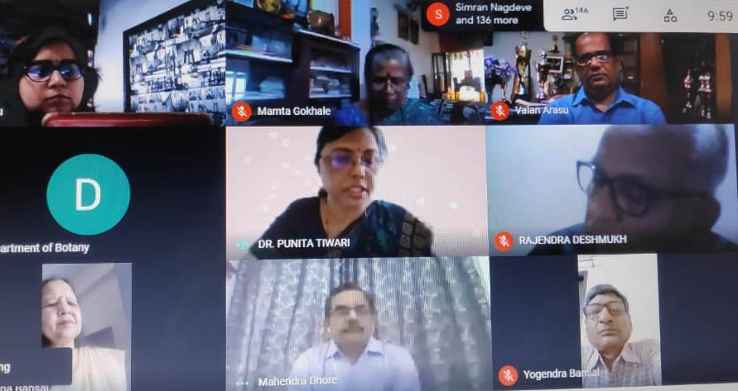
Prof. M. P. Dhore Principal, SSES Amravati’s Science College, Congress Nagar, Nagpur, Rev. Dr. G. Vazhan Arasu Principal, St. Aloysius College, (Autonomous) Jabalpur,and chief guest Prof. Y. K. Bansal Former Head, PGTD, Dept. of Biosciences, Rani Durgavati Vishwavidyalay, Jabalpur, MP. Dr. Shikha Bansal ,Convener, Head, Dept. of Botany and Microbiology, St. Aloysius’ College (Autonomous) Jabalpur, Prof. R. N. Deshmukh, Convener,Head, Dept. of Botany, SSES Amravati’s Science College, Congress Nagar, Nagpur Dr. Punita Tiwari, organising organizing secretary, Dept. of Botany, SSES Amravati’s Science College, Congress Nagar, Nagpur

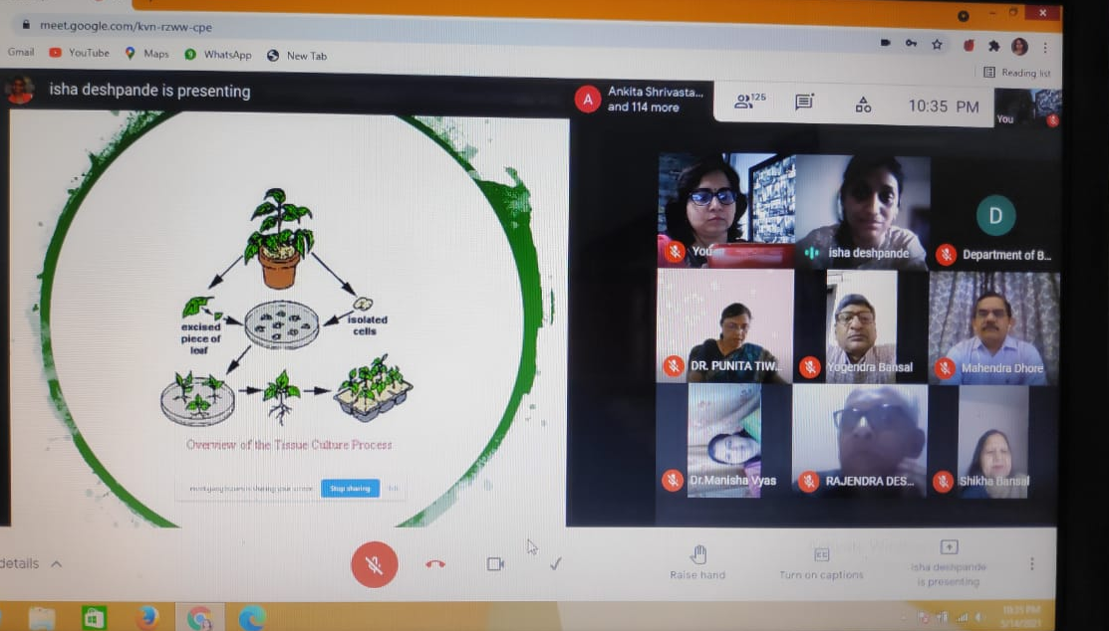

Ms Isha Deshpande, Bio-Design Innovation Centre, St. Alloysius College, Jabalpur :Power point presentation on Plant Tissue Culture: Technique, Types & Scope

