Shri Shivaji Education Society Amravati’s
Science College Congress Nagar, Nagpur
Department of Botany
BOTANY SUBJECT SOCIETY INAUGURATION PROGRAM
28 September 2017
SESSION – 2022-2023
Botany Subject Society Inaugural program under Science Association was organized on 29th March 2019 in conference hall of the college. Chief Guest of the event was Hon’ble, Dr. Jairam Khobragade, Director, Forensic Science, Institute of Science, Nagpur, President of the event Hon’ble Principal Dr. D.K.Burghate and Dr. G.R. Avchar, Vice Principal were present on the dais. Office bearers and executive members of the Botany subject society and meritorious students were felicitated at the hands of Hon’ble Chief Guest, Dr. Jairam Khobragade, President of the function Hon’ble Shri Hon’ble Principal Dr. D.K.Burghate and, Vice Principal Dr. G.R. Avchar. Meritorious students were felicitated by giving Flower, Certificates, Medals and Mementoes.
Chief Guest Dr. Jairam Khobragade,guided the students for their future goals. Presidential address was given by Hon’ble Principal Dr. D.K.Burghate.
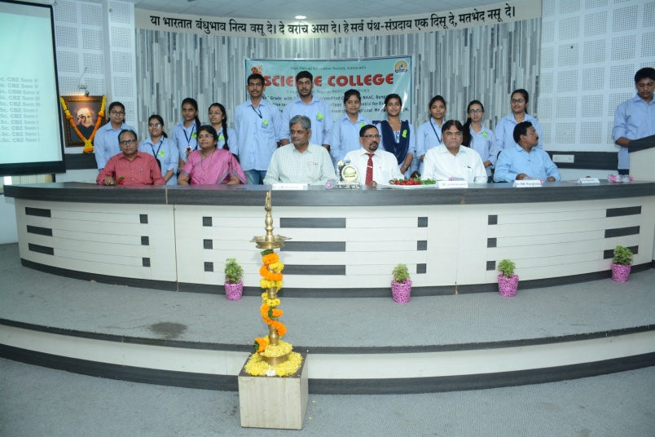

Prof. R.N.Deshmukh Dr. S.D.Puranik
Head Department of Botany Convener

