Botany Department
(2017-2018)

Botany Department organized various activities to motivate the students for their overall development.
Activities:
- This year students of B.Sc. – I, II and III visited Mahakali Dam & Dhaga Mahadev, near Nagpur on 19thAug. 2017 to study flora of the different region in their natural habitat with special emphasis on biodiversity.
- Botanical Society under Science Association was inaugurated on 28th Sep. 2017 at the hands of Dr. Jairam Khobragade, Director, Forensic Science, Institute of Science, Nagpur and also felicitated the meritorious students on this occasion.
- Students of the department actively participated in the various activities like Science Exhibition, Art exhibition, Blood donation, sports and cultural programs organized in the college during ‘Yuva Mohotsav’ 2017-18.
- World Nature Conservation Day celebrated in association with OISCA and State Forest Department on 28 July 2017. On this occasion. Hon V.K. Sinha, Principal Chief Conservator of Forest was present as a chief guest. Hon.S. Dongre, Hon. A. Giripunje and Hon. P D Deshmukh were present as guest of honor and grace the occasion.
- Department carried out Certificate Course on Floriculture & Landscaping, Plant Tissue Culture and Cultivation of Mushroom for students as regular practice of the department.
- The students of Floriculture & Landscaping visited “Golden Park” Besa, Nagpur on 26th Sep. 2017 and also guest lecture arranged on 20th Feb. 2018 on topic “Landscaping” by expert Hon. Amit Pophali as a part of curriculum of the course.
- One day workshop on “Bouquet making and Flower arrangement” was organized on 20th March 2018 by Hon. Mrs. Anju Parchure, Vice President, Nagpur Garden Club to develop entrepreneurship among the students of Floriculture & Landscaping certificate course.
- International delegates Jing Tian, Huang Baoyin & Li Hongyan, Executive Members of APQN, China visited our department on 24th March 2018 during International Conference hosted by the college,
- Green Audit regularly conducted by the Department.
Achievements:
- Ku. Sakshi Dubey & Ku. Sonali Saonerkar bagged 1st prize in Intercollegiate Poster Competition organized by Taywade College, Koradi on 5th March 2018.
- Ku. Asmiya Sadaf, Ku. Aditi Panse & Ku. Ankita Jadhav selected in Campus Interview for the post of Territory Manager (Research) in Pharmaceutical Company, Abbott, Nagpur on 16 - 17th Jan. 2018
- Ku.Asima Das & Ku. Mayuri Mishra selected for M.Sc. course at Christ College, (Deemed Univ) .Bangluru March 18, 2018.
- Students participated in Inspire Camp as trainer to explain various experiments like Mushroom Culture, Plant Tisssue Culture, Genetics, Phytorid System and Paleobotany on 26-29 March 2018.

Dr. R N Deshmukh
Associate Professor and Head

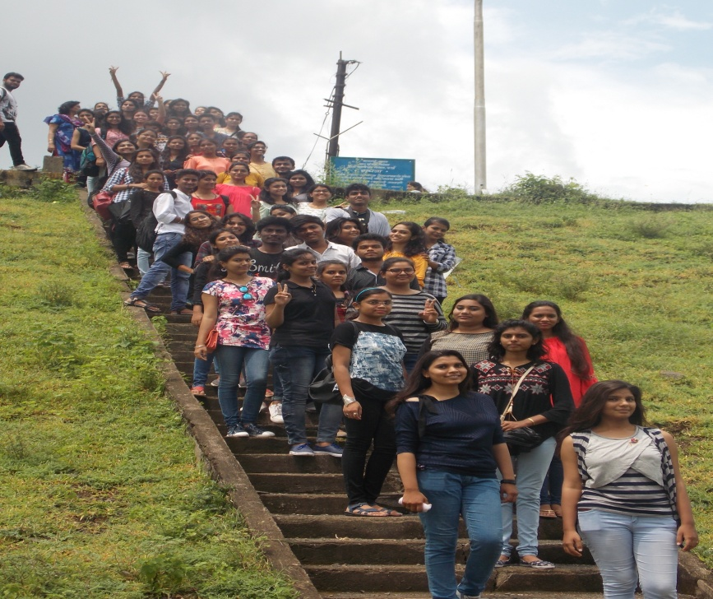
Excursion Tour at Mahakali Dam & Satnavari Forest near Nagpur
on 19thAug. 2017

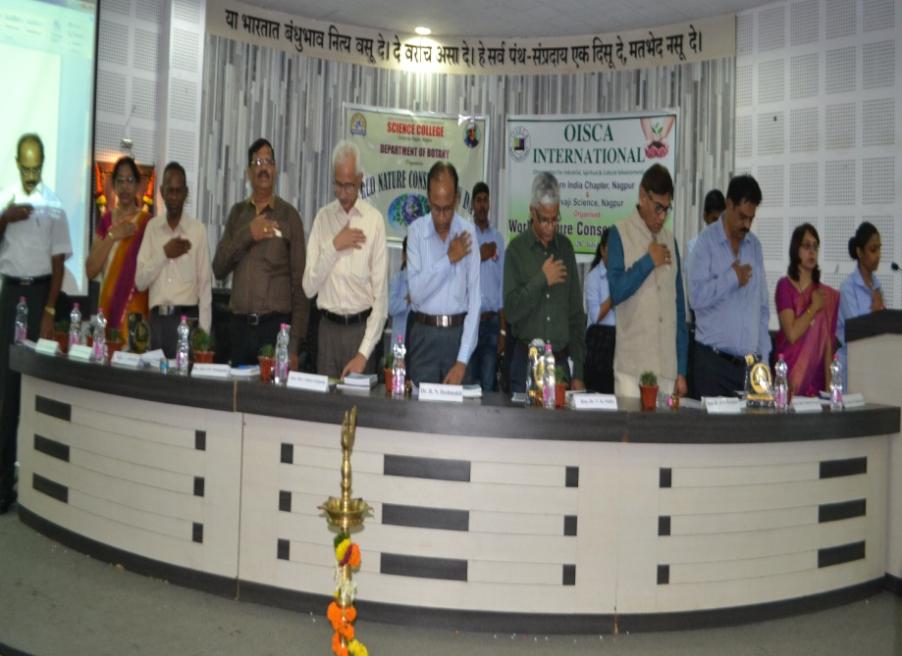
World Nature Conservation Day organized on 28th July 2017

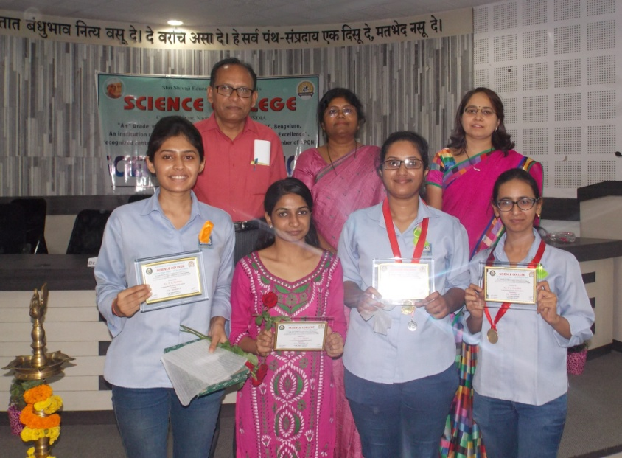
Distinction holders Felicitated in
Science Association inauguration on 28th Sep. 2017

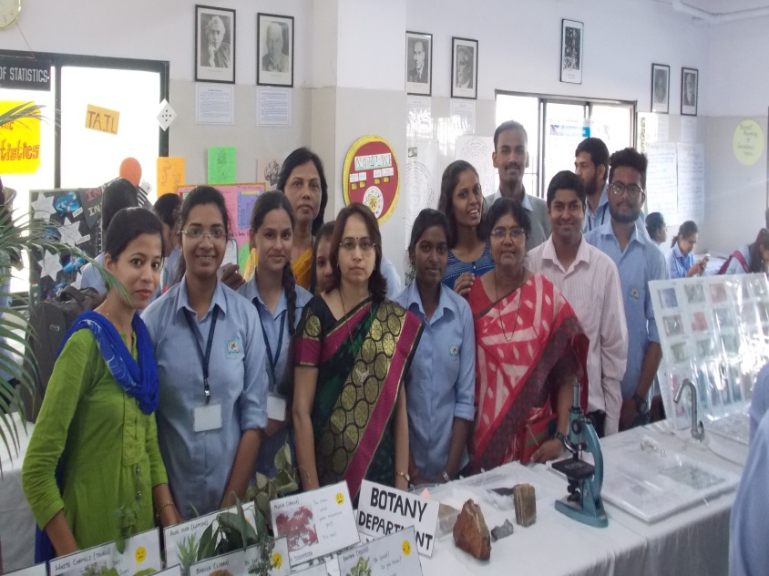
Participation of students in Science Exhibition organized during
‘Yuva Mohotsav’ 2017-18.

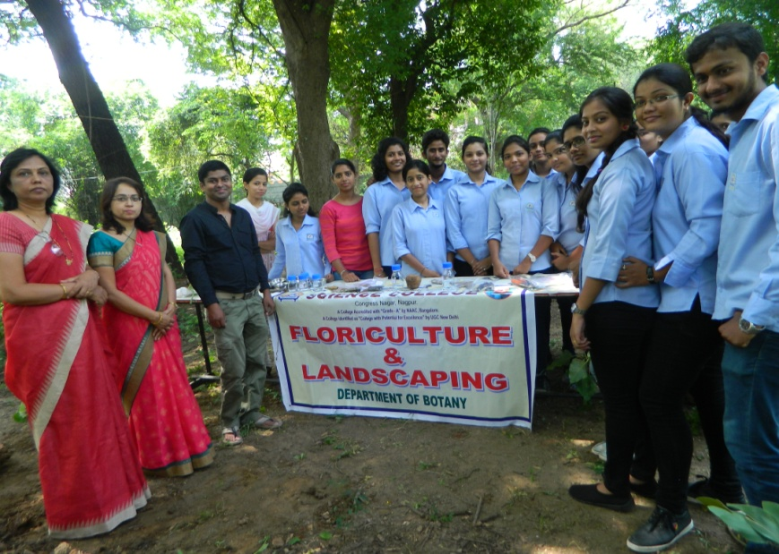
Student’s participation in self finance certificate course on Floriculture & Landscaping visited at “Golden Park” Besa, Nagpur on 26th Sep. 2017

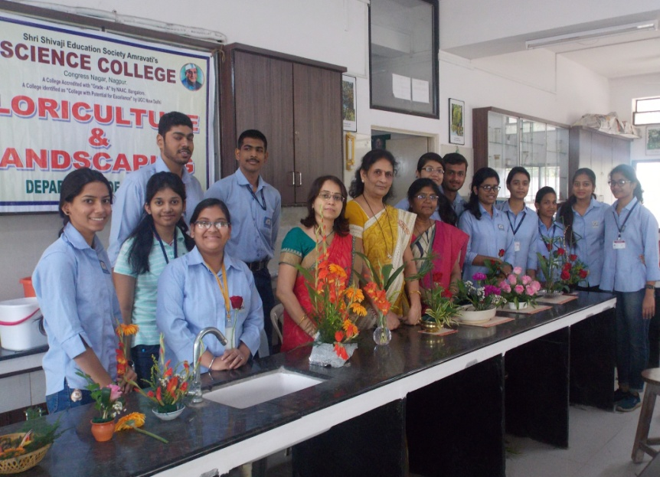
Student’s participation in one day workshop on “Bouquet making and Flower arrangement” organized on 20th March 2018

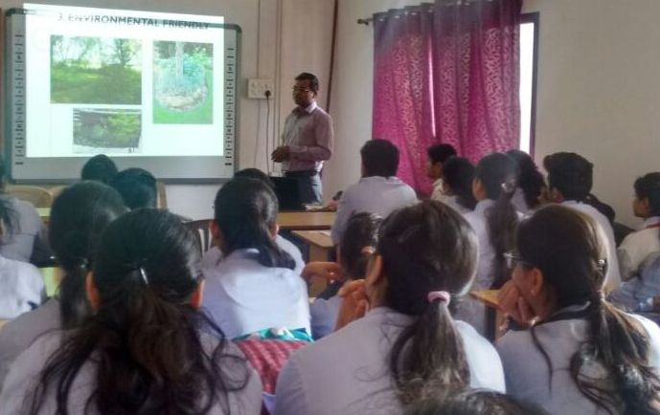
Guest lecture arranged on “Landscaping” by Hon. Amit Pophali on 20th Feb. 2018

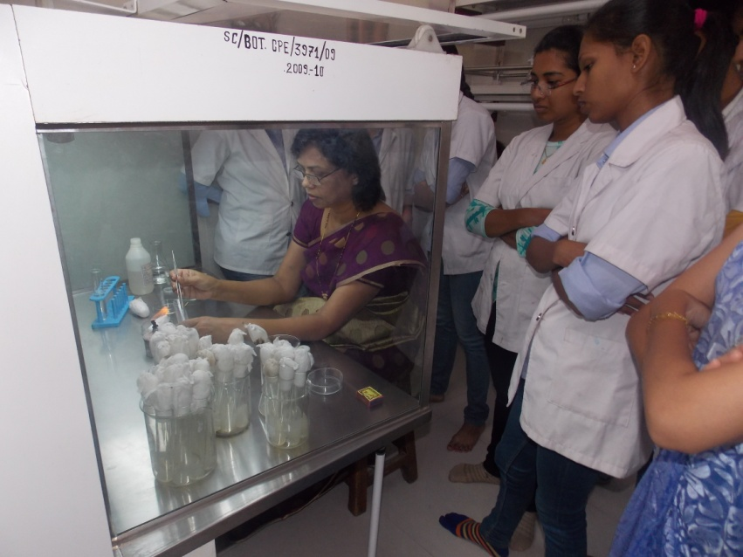
Workshop on Tissue Culture organized under Self Finance certificate course

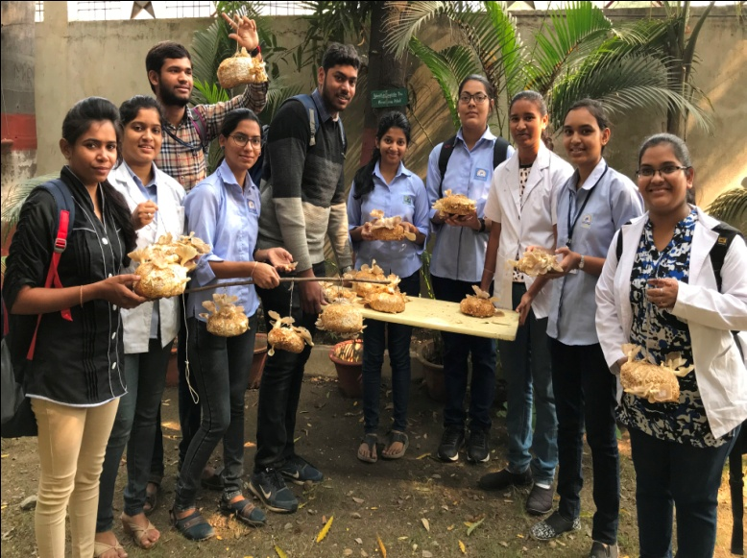
Workshop on Mushroom Cultivation organized under
Self finance certificate course

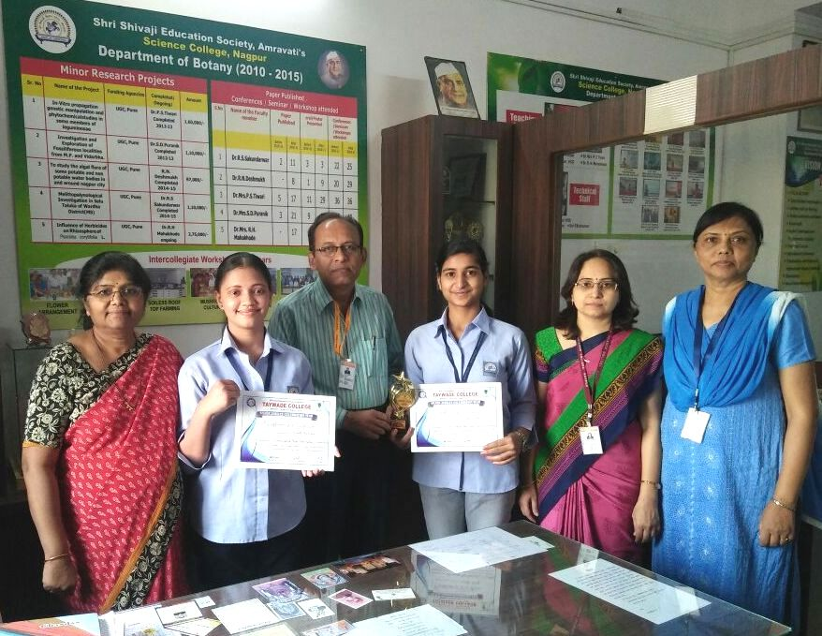
Ku. Sakshi Dubey & Ku. Sonali Saonerkar bagged 1st prize in Intercollegiate Poster Competition organized by Taywade College, Koradi on 5th March 2018
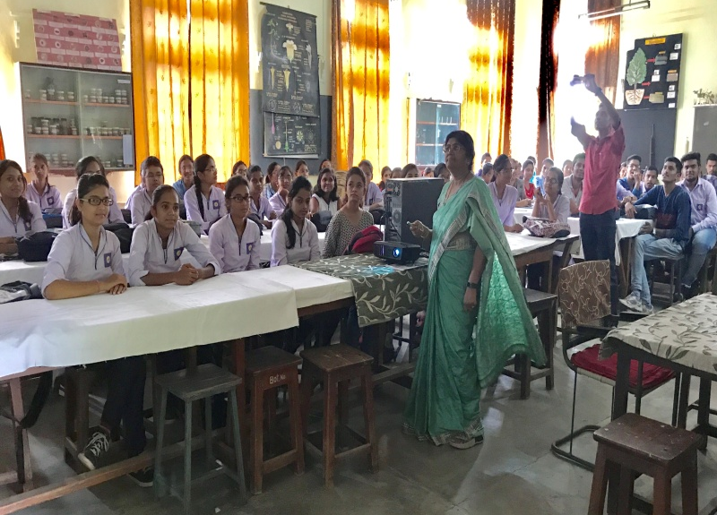
Guest lecture delivered by Dr.Mrs.S.D.Puranik on Mushroom Cultivation at M.M.College of Science, Nagpur on 21 July 2017

