Shri Shivaji Education Society Amravati’s
Science College Congress Nagar, Nagpur
Department of Botany
Organized Excursion Study Tour
Satnauri Forest and Mahakali Dam
On 19 August 2017
Session 2017-2018
==========================================================
REPORT
As a part of B.Sc. Curriculum, excursion tour was organized to Satnawari Forest and Mahakali Dam by Department of Botany, Science College Nagpur dated on 19 August 2017 for semester I botany students to study flora in their natural habitat with special emphasis on biodiversity. Total 4 teaching staff, 3 non teaching staff and 95 students were visited to Satnawari Forest and Mahakali Dam. The major objective was to familiarize the students with the wild and cultivated flora and ecology of the region.
Water population is one of the main concerns of the world today. The governments of many countries have striven to find solution to reduce this problem. Many pollutants threaten water supply, but the most widespread, especially in under develop country is the discharge of raw sewage into natural waters. The change in environmental quality can be associated with change in water quality parameters such as sediment load, nutrient concentrations, temperature, dissolved oxygen levels, and pH. The addition of excessive levels of naturally occurring or synthetic compounds, such as oil and grease, pesticides, mercury and other trace metals, and nonmetallic toxin can harm wildlife and people that depends on these aquatic resources.
The History of the Wardha district dates back to ancient times, it has a unique place in Indian Natural History, since the Ostrich egg-shell has been found at Sindi (Railway) in Wardha district. It was included in the empire of Mauryas, Shungas, Satavahanas and Vakatakas. Pravarpur, now modern-day Pavnar, was once the capital of the Vakataka dynasty. Vakatakas were contemporaries of the Imperial Guptas, the daughter of Chandragupta II. Prabhavatigupta, was married to the Vakataka ruler Rudrasena II. The Vakataka Dynasty lasted from the 2nd to 5th centuries AD, their state stretched from the Arabian Sea in the west to the Bay of Bengal in the east and from the Narmada River in the north to the Krishna-Godavari Delta in the south.
Satnavari Forest
The village Satnavari is located in Nagpur (Rural) Tahsil of Nagpur District in the State of Maharashtra in India. It comes under Nagpur (rural) Community Development Block. The nearest town is Nagpur, which is about 31 kilometers away from Satnavari.
Mahakali Dam and Temple
Mahakali Dam and Temple is a holy place for devotees who throng the temple to get a Darshan of Goddess Mahakali who is considered very auspicious the Mahakali Dam on the river Dham near the temple. The river is originated from the hills of Garamsur on the Kharangana-Kondhali route The Mahakali temple built on the bottom side of the Dam. The valuable and dense green forest surrounding the water storage attracts the tourists. Government had promoted it as a tourist place by providing the Rest Houses, gardens, Water boating etc to attract the tourists.
The Mahakali Temple is situated in the district of Wardha and is dedicated to the Goddess Mahakalı Surrounded by forests, this temple was built on the bottom side of the Mahakali Dam
Tourists can also visit the Mahakali Dam which is located on the Dham River near the temple. This river is believed to have originated from Garamsur hills situated on the Kharangana-Kondhali route

TOPOGRAPHY
Geography of Wardha district can be physiographically divided into three distinct units. These are- the uplands of the north and north east with Talegaon plateau the narrow Arvi plains to the west of the first unit, and, the Wardha - Hinganghat plains. The northern and eastern hilly part of the district is a part of the Satpura spur which projects southwards. This hilly part slopes on three sides west, south and north to merge in to the Wardha valley. This descent to the south is through a series of terraces, at least three of which are distinctly recognisable one at 500m, another at 400m and the third at 200-350m contour levels. The gradient is much steeper on the western slopes and the northern slopes.
The Arvi plains are a narrow, north to south clongated strip, about 70 kms long and 6 to 8 kms wide along the western boundary of the Arvi sub division. They are adjoining the Wardha valley, with the general elevation being 300 to 350 m and an undulating rolling topography.
The whole of the Hinganghat Subdivision and the southern two thirds of the Wardha subdivision form a fertile riverine plain draining and sloping gently southwards towards the Wardha River. The land falls from about 300m to 350m level in the north to about 220 min the south.

SOIL COMPOSITION
The soil cover in the district is classified in four main classes
- KALI(Rich black soil)
- Morand ( Black to dark brown soil)
- Kharadi (Poor and Shallow dark soil mixed with sand)
- Bardi (hilly land strewn with boulders)
The Arvi lowlands are covered by kali soil with a high clay percentage in the area adjacent to the Wardha River and by grey-black morand soils away from the river and nearer to the foothills. The soils of the Arvi lowlands are considered to be the most fertile in the entire district and perhaps in the entire Vidarbha region. The major land use category in the district is agriculture. Kharif crops are widespread in the southern part comprising the tahsils of Samudrapur Hinganghat, Wardha and Deoli. In the northern tahsils of Ashti, Arvi, Karanja. and Selu, agriculture and forest coverage occupy more or less equal areas A significantly large area under orchards is found in Hinganghat tahsil, with smaller patches in Samudrapur and Arvi tahsils. Deciduous forest is spread noticeably in Selu, Karnaja and Arvi tahsils with degraded forest around the fringes Soil resource atlas, Wardha District (Maharashtra)Catalog Record Only Includes statistical tables.

Climate:
The meteoblue climate diagrams are based on 30 years of hourly weather model simulations and available for every place on Earth. They give good indications of typical climate patients and expected conditions (temperature, precipitation sunshine and wind) The simulated weather data have a spatial resolution of approximately 30 km and may not reproduce all local weather effects, such as thunderstorms, local winds, or tornadoes
List of Local Flora:
- Withania somnifera
- Adiantum spp.
- Stevia spp.
- Victoria fern
- Riccia

Mahakali Dam
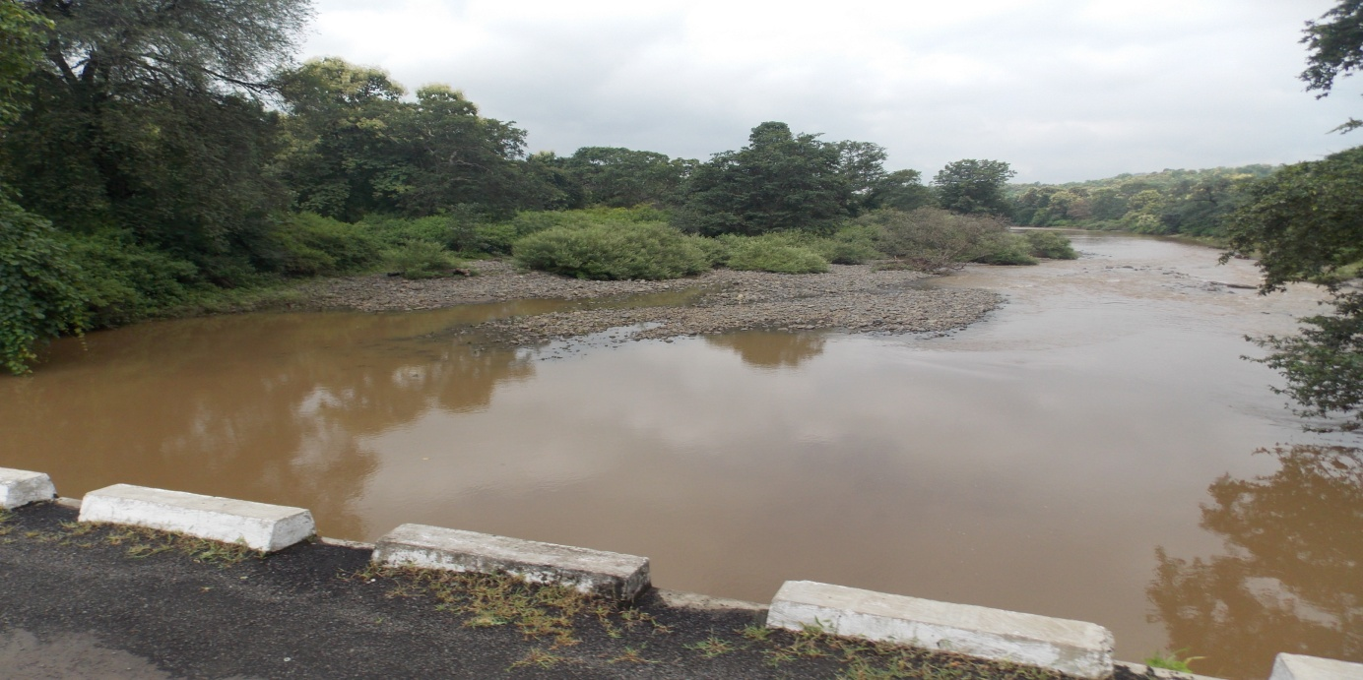

Identification of Flora
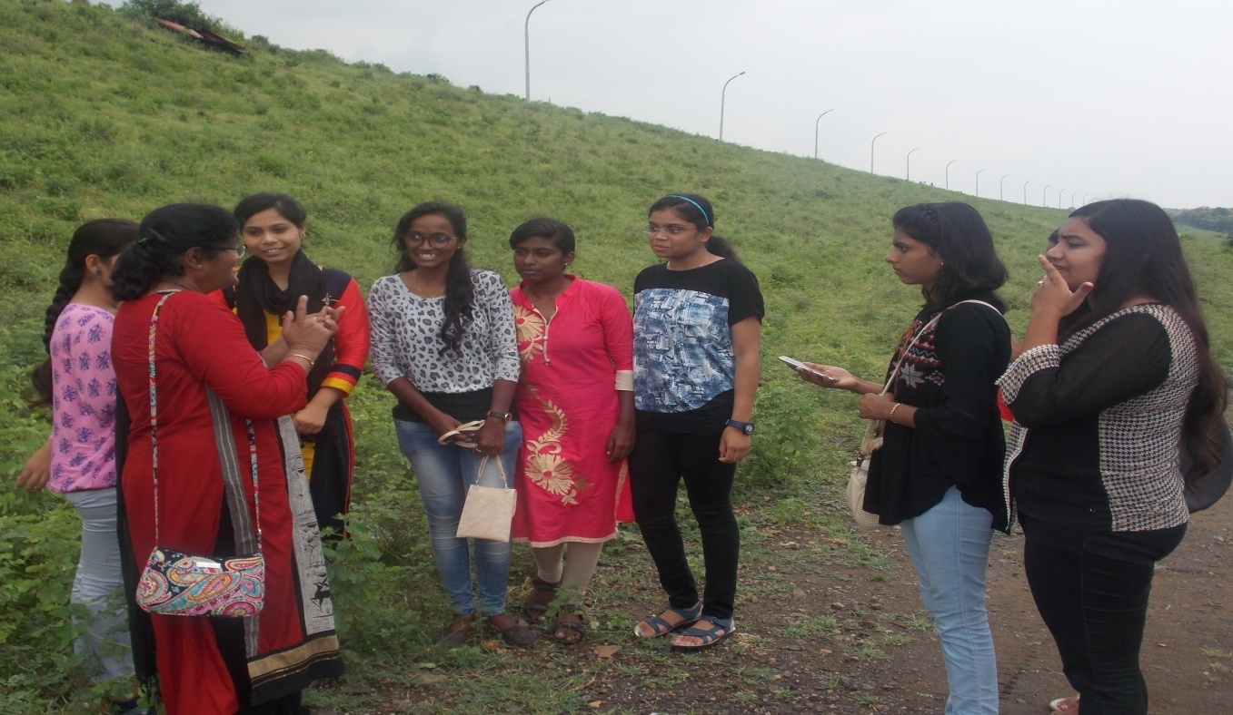

Tour In-charge
Dr. S.D.Puranik

