Shri Shivaji Education Society Amaravati’s
Science College Congress Nagar, Nagpur
Department of Botany
Organized Excursion Study Tour
Kullu, Manali Himachal Pradesh
From 6 September 2019 to 23rd September 2019
Session 2019-2020
==========================================================
REPORT

As a part of B.Sc. Curriculum, excursion tour was organized to Kullu and Manali, Himachal Pradesh by Department of Botany, Science College Nagpur from 16th September to 23rd September 2019 for semester III botany students to study flora in their natural habitat with special emphasis on biodiversity. Total 2 teaching staff, and 90 students were visited to Kullu, Manali. The major objective was to familiarize the students with the wild and cultivated flora and ecology of the region.
Manali is a resort town nestled in the mountains of the Indian state of Himachal pradesh near the northern end of the Kullu Valley in the Beas River Valley. It is located in the Kullu district, about 270 km (168 mi) north of the state capital 309 km (192 miles) north east of Chandigarh and 544 km (338 miles) northeast of Delhi, the national capital. The small town, with a population of 8,096, is the beginning of an ancient trade route to Ladakh and from there over the Karakoram Pass on to Yarkand and Khotan in the Tarim Basin. It is a popular tourist destination and serves as the gateway to Lahaul and district as well as Leh.
CLIMATE
The climate in Manali is predominantly cold during winter and moderately cool during summer. The temperatures ranges from -7 °C (19 "F) to 30 °C (86 °F) over the year with the hottest day crossing 30 °C (86 °F) and the coldest day going below -7 °C (19 °F). The average temperature during summer is between to "C (50 °F) to 30 °C (86 °F), and between -7 °C (19 °F) to 15 °C (59 °F) in the winter. Monthly precipitation varies between 31 mm (1.2 in) in November and 217 mm (8.5 in) in July. On average, some 45 mm (1.8 in) of precipitation is received during winter and spring months, increasing to some 15 mm (4.5 in) in summer as the monsoon approaches. The average total annual precipitation is 1,363 mm (53.7 in). Manali experiences snowfall predominantly between December and beginning of March. Manali is located at 32.2396 N, 77.1887 E, about 547 km (340 mi) north of new Delhi.
FLORA AND FAUNA
Kullu Manali in Himachal Pradesh is the most beautiful destination with salubrious terrain, climate and heights. This has given a growing scope to variety of vegetation, wild animals and birds at different places and levels. The variety of forests like Sal, Rhododendron, Oak, Fir, Deodar, Birch and Pines are the pride of Manali. These forests shelter for large number of wild animal and birds.
Wildlife among which some rare species like the musk deer, ibex. thar, Himalayan brown bear and snow leopard are still found here. The river Beas offers ideal fishing grounds for trout and masheer.
To protect and conserve its ecosystem, Manali has declared a reserved area - the Manali Wildlife Sanctuary.
Located about 2 km from the Manali town in the picturesque valley of Manali, the Manali Wildlife Sanctuary is reputed for its variety of flora and fauna and breathtaking scenic beauty Alpine lush green pastures and glaciers beyond gallant thatch beckons the tourists from all around Spread in an area of 31.80 sq km, the Manali Wildlife Sanctuary houses - Himalayan Black Bear, Himalayan Palm Civet, Barking Deer, Flying Fox, Gorai, Indian Hare. Stripped Hyena. Leopard, Himalayan yellow throated Marten, Serow, Kashmir flying Squirrel and Himalayan Tahr.
The sanctuary has marvelous trekking routes and also have facilities for camping in the wild. The gushing streams fascinating alpine pasture and high snow covered peaks provide a celestial pleasure to the tourists.
List of local flora:
Sr. No | Common Name | Botanical Name | Family
1 | Kashmal flower | Berberies aristata | Berberidaceae
2 | Deodar | Cedrus deodara | Pinaceae
3 | Horseweed | Erigeron canadensis | Asteraceae
4 | Allo | Girardinia diversifolia | Urticaceae
5 | Basant | Hypericum cernuum | Hypericaceae
6 | Lilyturf | Ophiopogon intermedius | Haemodoraceae
7 | Himalayan Cherry Prinsepia | Prinsepia utilis | Rosaceae
8 | Sal | Shorea robusta | Dipterocarpaceae
9 | Winged prickly ash | Zanthoxylum armatum | Rutaceae
10 | Apple | Malus domestica | Rosaceae

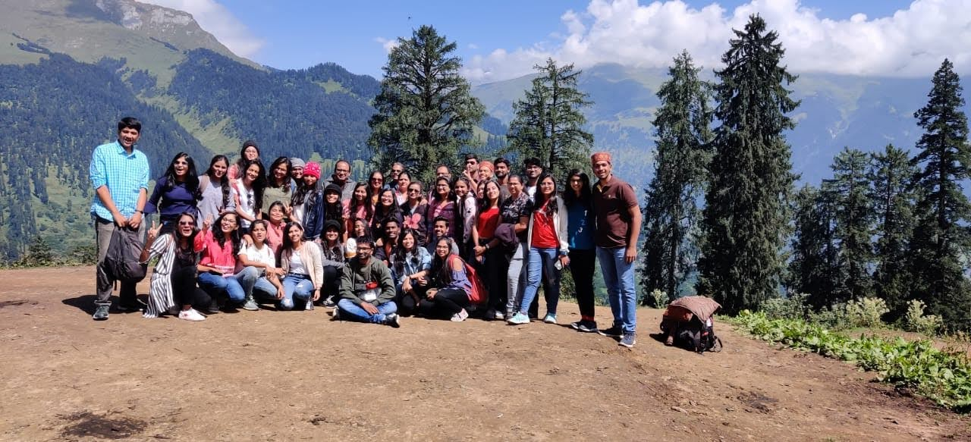
B.Sc.III students visited to Manali, Himachal Pradesh from 16th Sept. to 23rd Sept. 2019.

Tour In-charge
Prof R.N.Deshmukh
Head Department of Botany

