Shri Shivaji Education Society Amravati’s
SCIENCE COLLEGE, Congress Nagar, Nagpur
Department of Botany
Organized
WORLD NATURE CONSERVATION DAY 28th JULY 2018
Session 2018-2019
REPORT

The department of Botany of Shri Shivaji Science College, Nagpur celebrated “World Nature Conservation Day“. The programme was inaugurated at the hands of Hon. Dr. Prakash R. Itankar, Asstt. Prof. (Sr. Gr.), Pharmaceutical Sciences, RTM Nagpur University, Nagpur. Hon. Dr.G.R.Avachar, Vice- Principal was present as chairman of the function. Dr.R.N.Deshmukh, Head, Dept. of Botany, Dr.A.D.Bobdey, Head, Dept. of Zoology, Dr.R.H.Mahakhode, Convener of the programme were present on the occasion. All guest and students took an oath during the ceremony.
Dr. Prakash R. Itankar delivered a power point presentation on the topic “Translational Research in Herbals: Past to Future to Past”. He advised the students to be a part of nature. He emphasized the importance of medicinal plants in the welfare of mankind and also gave the importance of translational research as “bench to bedside” to translate the knowledge of basic science to modern medicinal techniques for economically poor patients.
Dr.R.N.Deshmukh, Head, Dept. of Botany also spokes on this occasion. In his address, he appealed the students to grow at least one plant and conserve it properly and gave importance of conservation of nature by giving simple tips and further said that the third world war does not occur for water crisis but nature will gradually deteriorate due to over exploitation of the resources.
Dr.R.H.Mahakhode, convener of the programme guide to the young ignited minds to understand the truly meaning of sustainability and also to inculcate environment-friendly habits to lead a green lifestyle. Convener also gives some simple tips that can make lifestyle green.
Dr.Mrs.P.S.Tiwari, Dr.Mrs.S.D.Puranik, Dr.Mrs.P.D.Burghate, Miss. Monali, Mr. Manish, Mrs. Pranjali and Mrs. Sharayu were present on the occasion and students were taken pain taking efforts for the success of event.
The programme was conducted by Metta Patil, Tanushree Banerjee, Azmina Khan, Kaivalya Dani, Anurag Rao, Riya Agrawal, Vaishali Mewade and Radhika Dhok. Ku. Prachi Satke proposed the vote of thanks.
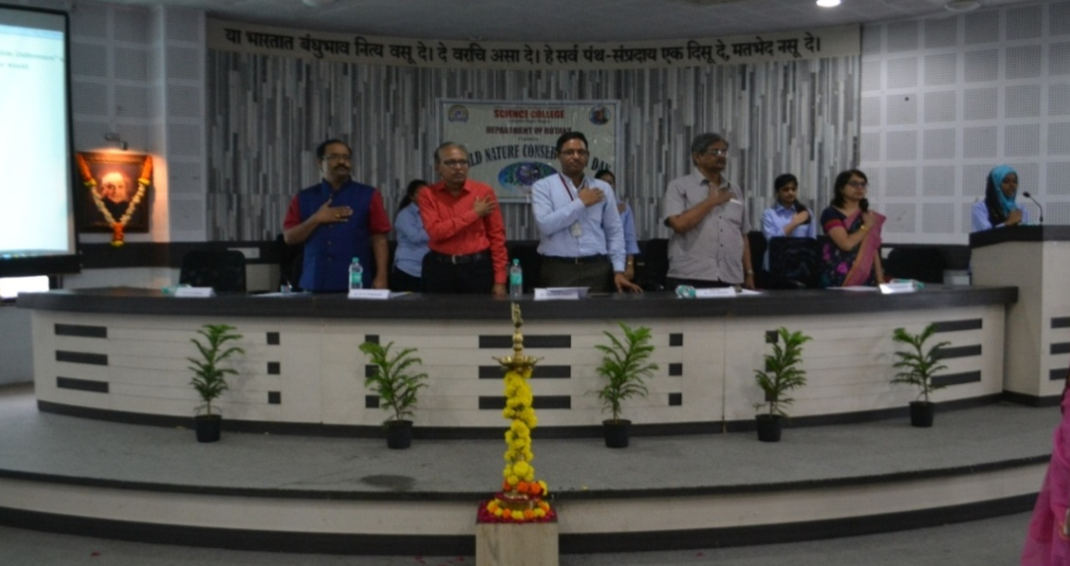
Dr. Prakash R. Itankar, Asstt. Prof. (Sr. Gr.), Pharmaceutical Sciences, RTM Nagpur University, Nagpur, Dr.G.R.Avachar, Vice- Principal, Dr.R.N.Deshmukh, Head, Dept. of Botany, Dr.A.D.Bobdey, Head, Dept. of Zoology, Dr.R.H.Mahakhode, Convener took an oath during the ceremony.

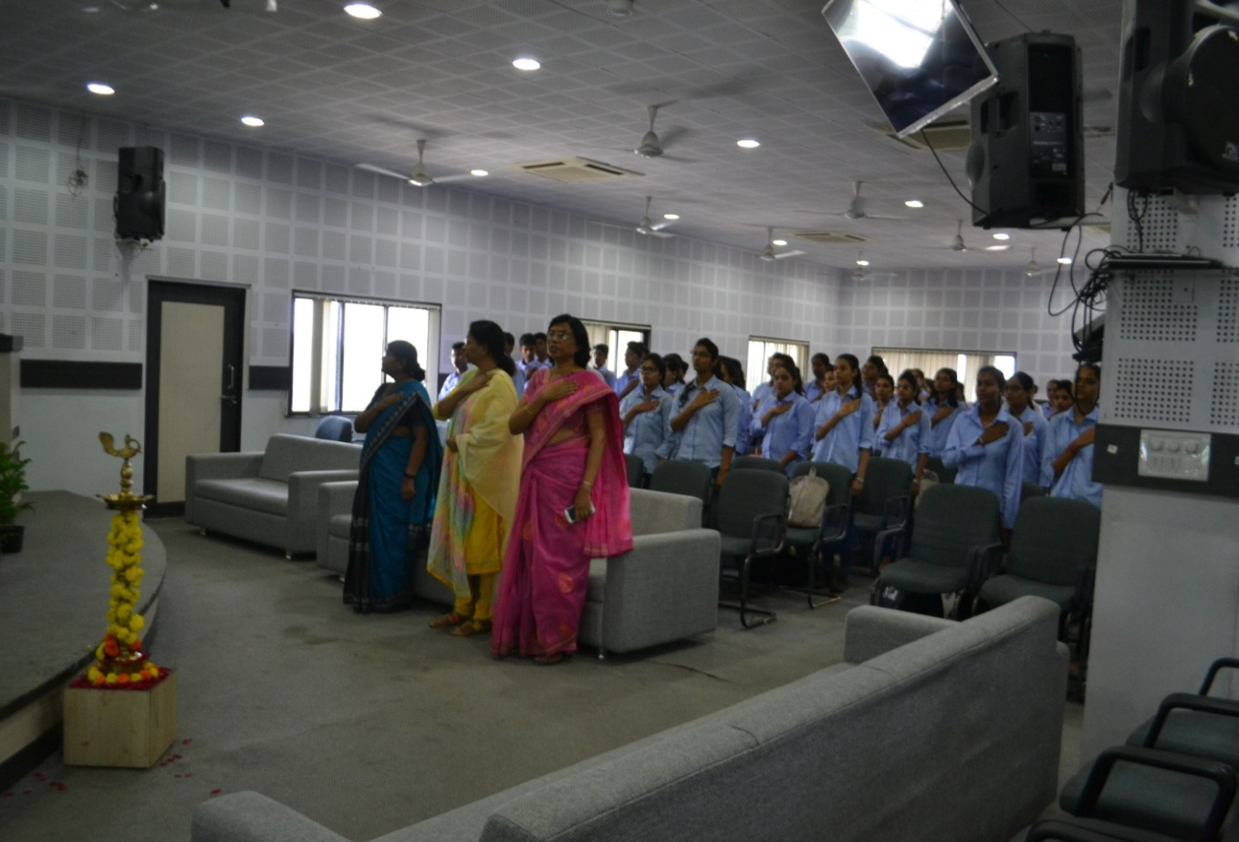
Dr.Mrs.P.S.Tiwari, Dr.Mrs.S.D.Puranik, Dr.Mrs.P.D.Burghate and students were present on the occasion of World Nature Conservation Day.

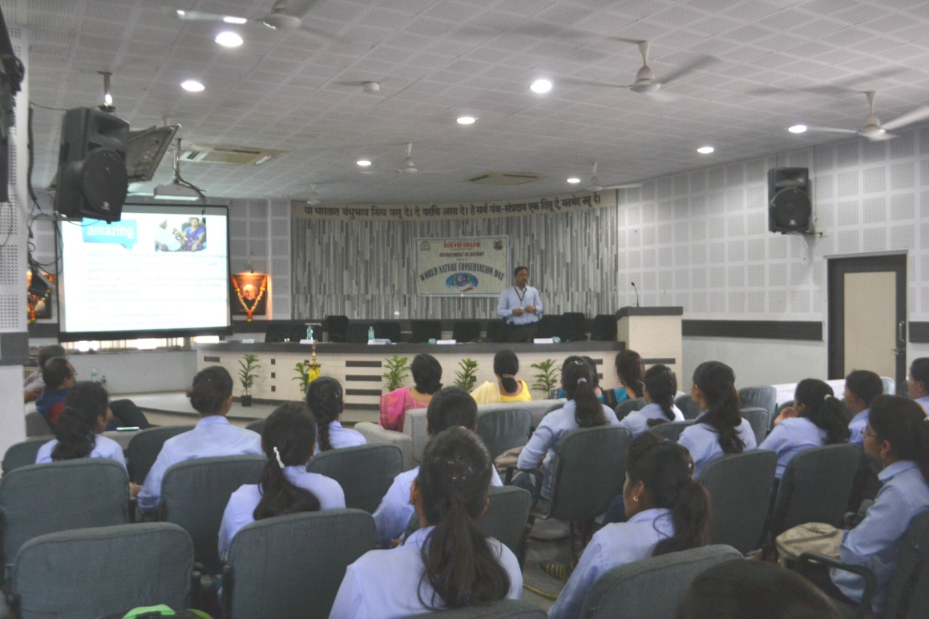
Dr. Prakash R. Itankar delivered a talk on “Translational Research in Herbals: Past to Future to Past”

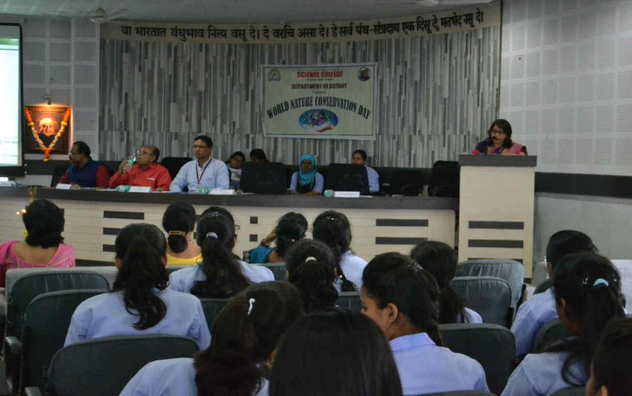
Dr.R.H.Mahakhode, convener introduced the guest and briefed about the activities.

Convener
Dr. R.H.Mahakhode

