Shri Shivaji Education Society Amravati’s
Science College Congress Nagar, Nagpur
Department of Botany
Organized Excursion Study Tour
Pachmarhi
From 30th Aug 2018 to 2nd Sept. 2018
Session 2018-2019
==========================================================
As a part of B.Sc. Curriculum, excursion tour was organized to Pachmarhi by Department of Botany, Science College Nagpur in session 2018-2019 for B.Sc second year botany students to study flora in their natural habitat with special emphasis on biodiversity. Total 4 teaching staff and 90 students were visited to Pachmarhi. The major objective was to familiarize the students with the wild, bryophytes as well as pteridophyitic plant and aquatic flora of the region.
Pachmarhi is known as Satpura Ki Rani, is a hill station in the central Indian State of Madhya Pradesh Its is a large plateau. The landscape characterized by rugged hills, forests and deep ravines. Its take 5 hours to travel from Nagpur to Pachmarhi Hill Station. Pachmarhi is a hill station and is famous for waterfalls and green vegetation like.

CLIMATE
Vegetation regions can be divided into five major types: forest, grassland, tundra, desert, and ice sheet. The dominant vegetation in this region consists mostly of moist deciduous forests along with the bamboo thickets as well as the Tectona grandis (Teak) and Shorea robusta (Sal) are the most common and unique flora species found in the forests, with the latter found nowhere else in India. Tropical moist deciduous forests, tropical dry deciduous and central Indian sub-tropical hill forests are the major ecosystem types within Pachmarhi. The most common tree in the dry deciduous forests of this area is the Sal.
FLORA AND FAUNA
Important species include Psilotum triquetra (whisk fern) and Ophioglossum nudicaule (Adder's-tongue ferns). The largest wild herbivores found in the reserve are Gaura, which together with bears, tigers and leopards, Ratufa indica (Giant Squirrel) and Spilornis cheela (Crested serpent eagle) are rare and endangered. The endemic flora of the Pachmarhi biosphere reserve includes sal and wild mango. The endemic fauna includes bison, Indian giant squirrel and flying squirrel. The endemic flora of the Pachmarhi biosphere reserve includes Sal and wild mango. The plants that grow naturally in a particular area are called flora of that area. The animals which live naturally in a particular area are called fauna of that area. There are number of water-falls in Pachmarhi but among them “BEE FALL” is considered as most popular one and must visit tourist point.
List of Local Flora
- Cyathea sps
- Funariais terrestrial moss
- Funaria hygrometrica
- Anthoceros sps
- Marchantia sps
- Pinus sps
- Plagiochasam sps
- Psilotum sps
- Lycopodium sps
- Sellaginella sps
- Ophioglossum sps
- Bixa orellana
- Azadiracta indica
- Mangifera indica
- Butea monosperma
- Tectona grandis
- Shorea robusta
- Termenelia arjuna
- Syzigium sps

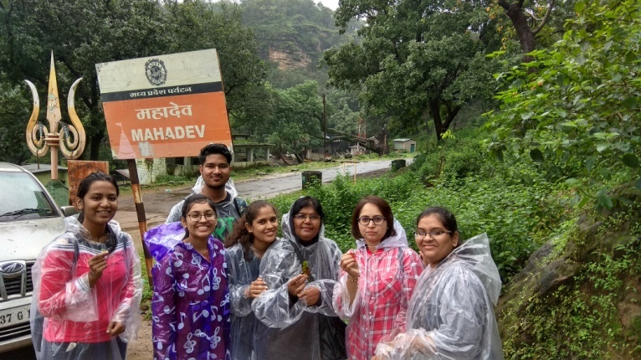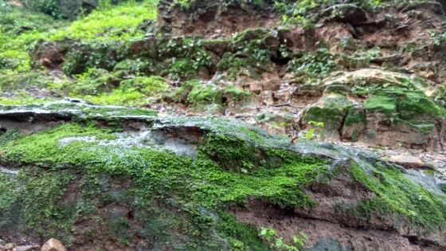

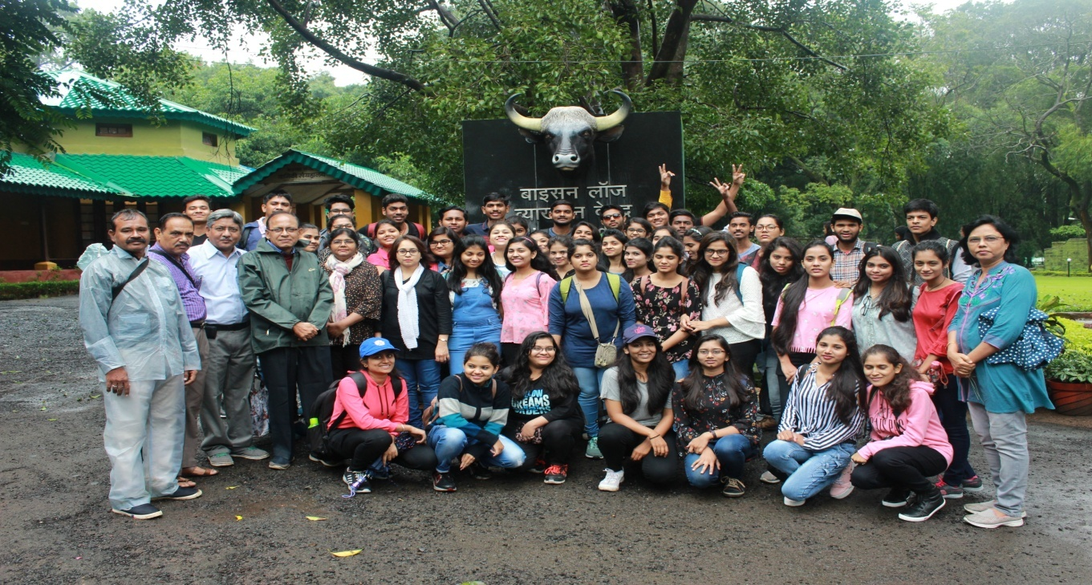

Prof. R.N.Deshmukh Dr. S.D.Puranik
Head Department of Botany Tour In-charge

