Report
Eco-friendly Dry Holi 2018-2019
Eco-friendly Dry Holi festival was celebrated on 16th March 2019 at Botany Department. The aim of the festival was to greater awareness in the society about importance of environment. Students prepared natural colours from plants. These colours were prepared in dry and wet form from the plants and from synthetic substances which are easily available at home. Various herbal colours made by the students such as orange colour from Butea (Palash) flower, Yellow from turmeric (Haldi), orange red from Heana (Mehandi) , Red from beet root, rose petals and Raktha-Chandan, Black from home made kajal, light yellow from gram flour, green from Spinach (palak) and purple colour from black berry (Jamun) , natural blue from Neel seeds.

Synthetic colours cause health problems and is also major cause of environmental problems. Students and teachers celebrated the festival of colours in an eco-friendly way. Prior to the day of holi, holifire by burning timber of foliage and unwanted old materials which has lead to environmental pollution and waste of natural resources.

The programme was conducted under the guidance of Dr. R.N. Deshmukh, HOD, Dr. (Mrs) S.D. Puranik, Dr. P.S. Tiwari, Dr. R.H. Mahakhode and staff members and non-teaching staff participated in this programme.

Eco-friendly Dry Holi 2018-2019
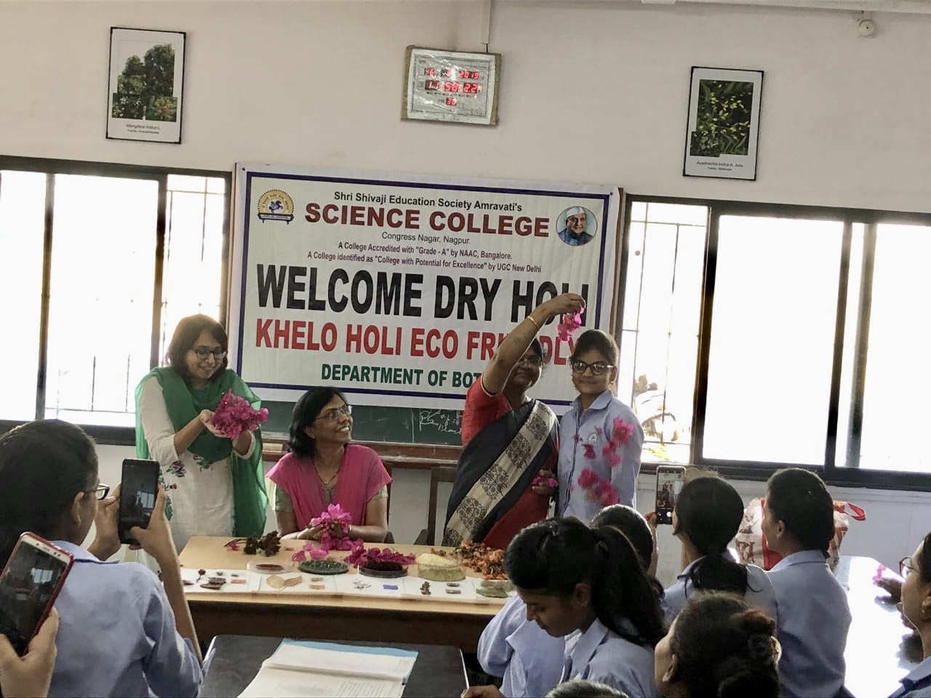

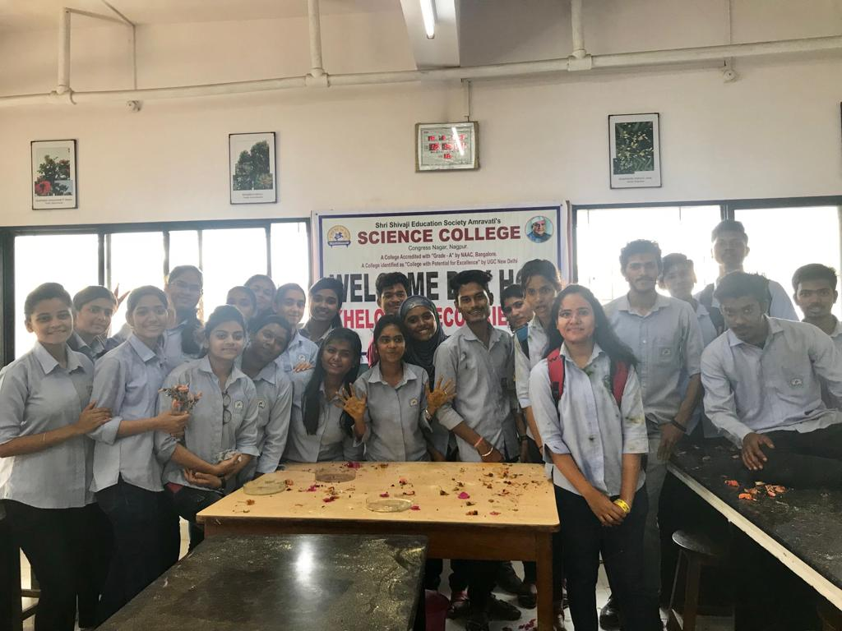
Eco-Friendly Dry Holi celebration by department on 16th March 2019.

