Shri Shivaji Education Society Amravati’s
SCIENCE COLLEGE, Congress Nagar, Nagpur
Department of Botany
Organized
WORLD NATURE CONSERVATION DAY 28th JULY 2017
Session 2017-2018
REPORT

The department of Botany of Shivaji Science College, Nagpur in association with OISCA chapter and Maharashtra State Biodiversity Board celebrated “World nature Conservation Day” on 28th July 2017.
The programme was inaugurated at the hands of Hon. Dr. Vinay Sinha, Chief Principle Conservator, Maharashtra State Biodiversity Board. Hon. Dr.D.K. Burghate, principal was present as chairman of the function. Hon. Ashok Giripunje, Forest Conservator, Nagpur, Hon. D.P. Deshmukh, Honorary Director, DFO, Hon. Subhash Dongre, Publicity officer, Maharashtra State, Nagpur and Shri. S.J.Bawankar, Dr.Mrs.P.D.Burghate and Dr.S.S.Darokar were present as guest of honor on this occasion.
On this occasion Principal Dr.D.K.Burghate highlighted the activities of OISCA and appeals the students to do the activities for the welfare of mankind and involvement in the process of nature preservation.
Dr.Vinay Sinha, Chief Principle Conservator, Maharashtra State Biodiversity Board spoke on this occasion and appeal the students to work with mission and passion according to oath taken during the ceremony. Dr. Ashok Giripunje and Shri D.P. Deshmukh also guided the students on this occasion.
Dr.Mrs.R.H.Mahakhode, Convener of the programme said, conserving nature should be the top priority in todays world. We all need to fight to save our mother earth from pollution and destruction. Through this celebration our main aim is to promote the concept of preserving nature among young students.
Dr.R.N.Deshmukh, Asso. Professor & Head, department of Botany also present on this occasion. Dr.Mrs.P.S.Tiwari, Dr.Mrs.S.D.Puranik and students were taken pain taking efforts for the success of event.
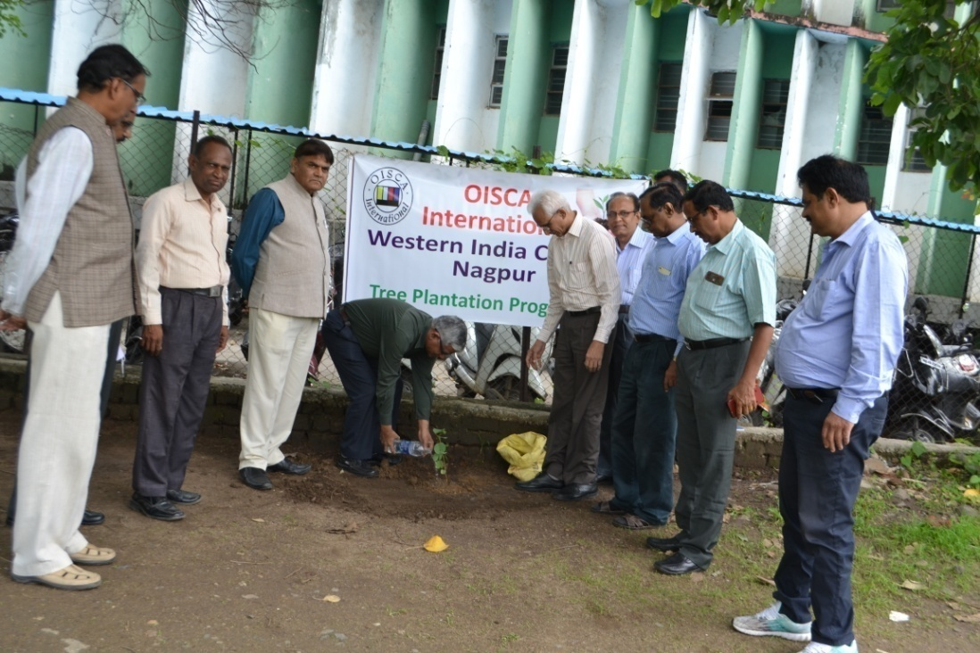
Tree Plantation at the hands of Hon. Dr. Vinay Kumar Sinha, Chief Principle Conservator, Maharashtra State Biodiversity Board
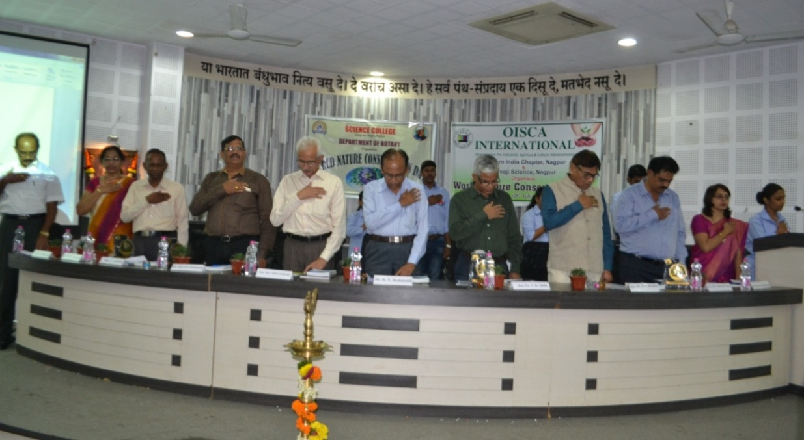
Hon. Dr. Vinay Sinha, Chief Principle Conservator, Maharashtra State Biodiversity Board, Hon. Dr.D.K. Burghate, Principal. Hon. Ashok Giripunje, Forest Conservator, Nagpur, Hon. D.P. Deshmukh, Honorary Director, DFO, Hon. Subhash Dongre, Publicity officer, Maharashtra State, Nagpur, Shri. S.J.Bawankar, Dr.Mrs.P.D.Burghate, Dr.S.S.Darokar and Dr.Mrs. R.H.Mahakhode, Convener take oath on World Nature Conservation Day. 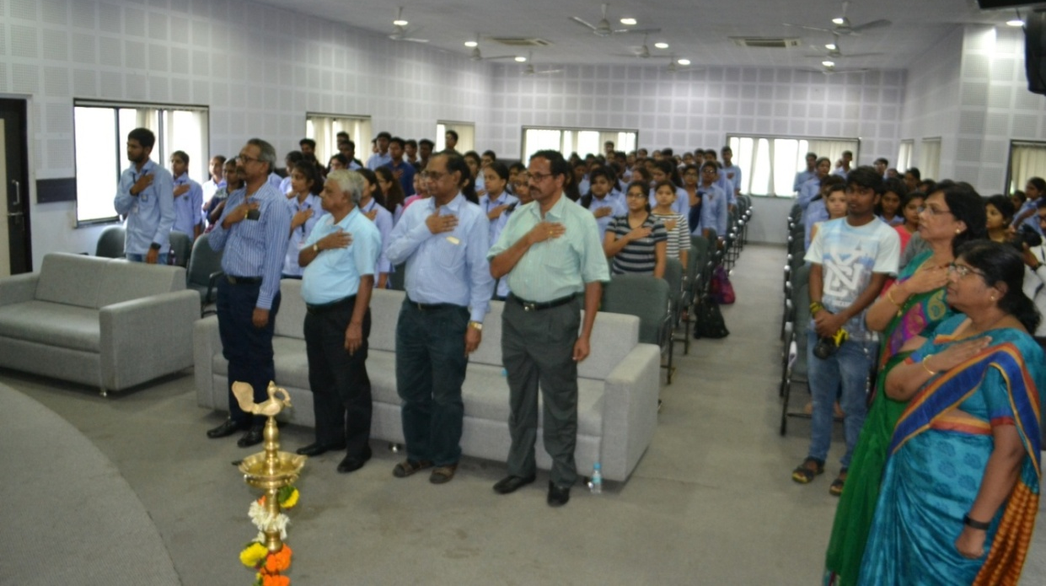
Guests, Faculty members and Students were take oath on the occasion of World Nature Conservation Day

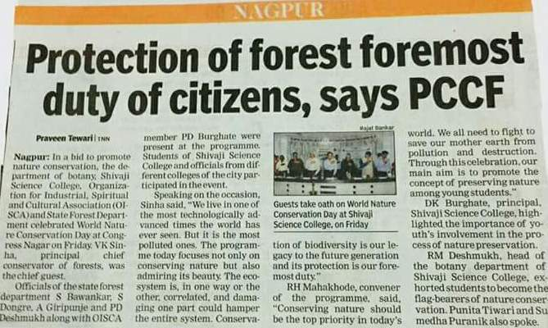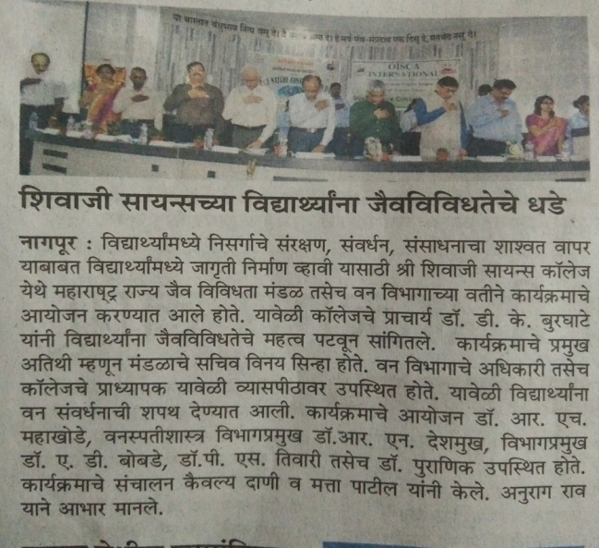
News covered in ‘The Hitavada’ and ‘Lokmat’ news papers, Nagpur.

Convener
Dr. R.H.Mahakhode

