Shri Shivaji Education Society Amravati’s
SCIENCE COLLEGE, Congress Nagar, Nagpur
Department of Botany
Organized
WORLD NATURE CONSERVATION DAY on 30th JULY 2019
Session 2019-2020
REPORT

The department of Botany of Shri Shivaji Science College, Nagpur celebrated “World Nature Conservation Day“on 30th July 2019. The programme was inaugurated at the hands of Hon. Prof. Anjali Phaley, Dept. of Biology, L.A.D. College, Nagpur. Hon. Dr.M.P.Dhore, Principal was present as chairman of the function. Dr.R.N.Deshmukh, Head, Dept. of Botany, Dr.R.H.Mahakhode, Convener of the programme were present on the occasion. All guest and students had taken a oath during the ceremony.
Prof. Anjali Phaley delivered a power point presentation on the topic “Conservation is today’s need”. She advised the students to be a part of nature. She emphasized the importance of water conservation. In her speech she stressed that forest improves the quality of water and air. They also help to keep the atmosphere cool. She pointed out that human being have negatively impacted the environment through deforestation and depletion of natural resources for industrialization. This has led to reduce supply of oxygen on the earth.
Prof. Phaley conducted the workshop on ‘Seed Balls techniques’ to conserve the forests. She developed a miniature garden to demonstrate forest conservation. The students really enjoyed the workshop and learnt about forest conservation.
Dr.M.P.Dhore, Principal focused on the water crisis situation in Nagpur. Water is life and it is precious to save water and save forests. He gave this message to the students realized the importance of conservation of water and have pledged to conserve water and use it scarcely.
Dr.R.N.Deshmukh, Head, Dept. of Botany also spokes on this occasion. In his address, he appealed the students to grow at least one plant and conserve it properly and gave importance of conservation of nature by giving simple tips and further said that the third world war does not occur for water crisis but nature will gradually deteriorate due to over exploitation of the resources.
Dr.R.H.Mahakhode, convener of the programme guide to the young ignited minds to understand the truly meaning of sustainability and also to inculcate environment-friendly habits to lead a green lifestyle.
Dr.Mrs.P.S.Tiwari, Dr.Mrs.S.D.Puranik, Mr. Manish Chinchmalatpure and Mrs. Sharayu Deshmukh were present on the occasion and students were taken pain taking efforts for the success of event.
The programme was conducted by Tanushree Banerjee and Ku. Prachi Satke, Ku. Alolika Ray proposed the vote of thanks.
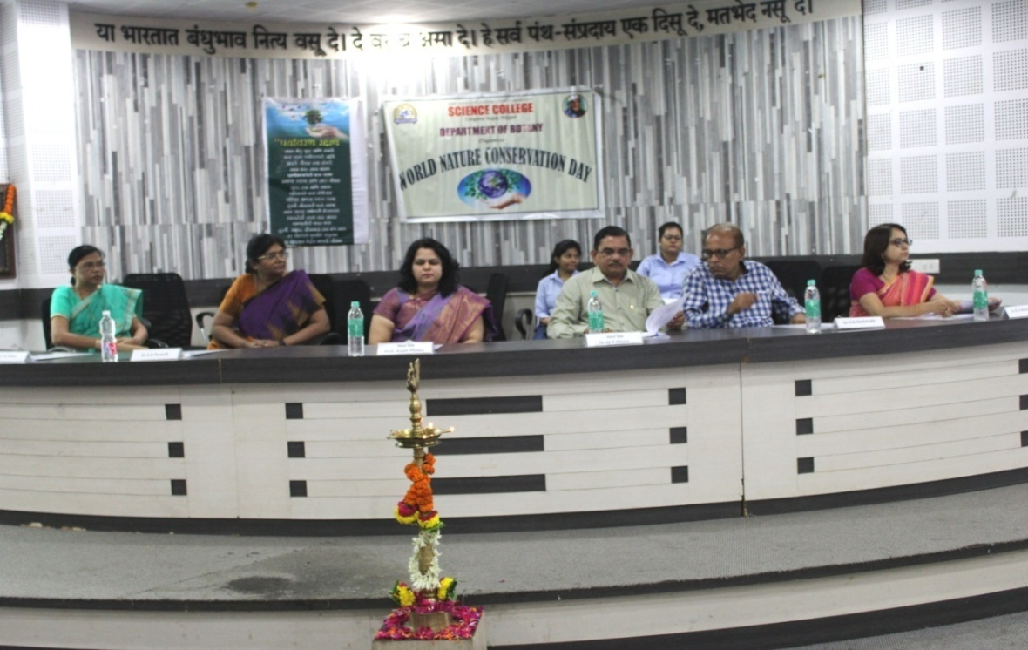
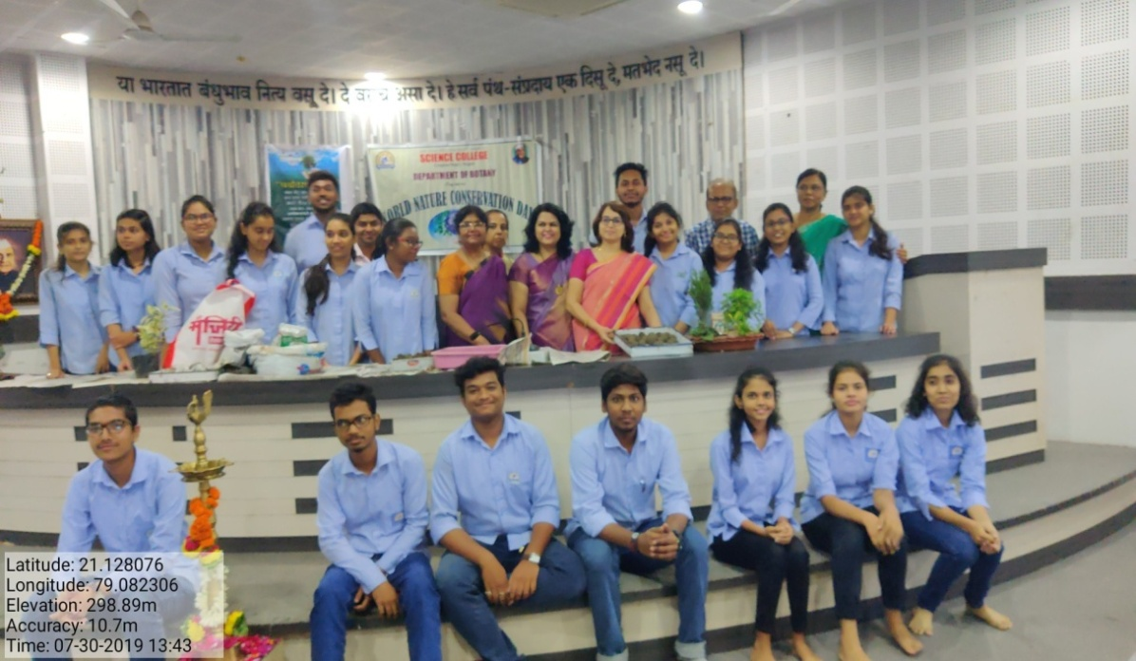

Guest lecture on “Conservation is today’s need”

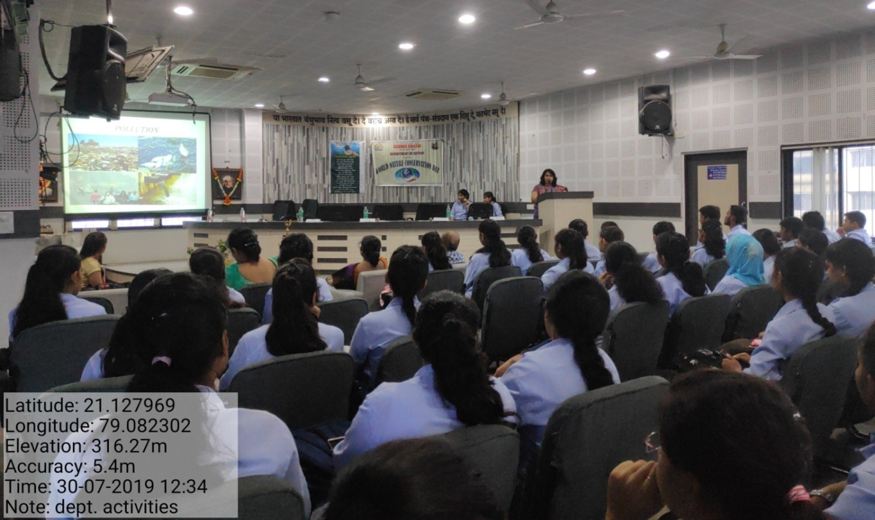
Prof. Anjali Phaley delivered a lecture on “Conservation is today’s need”

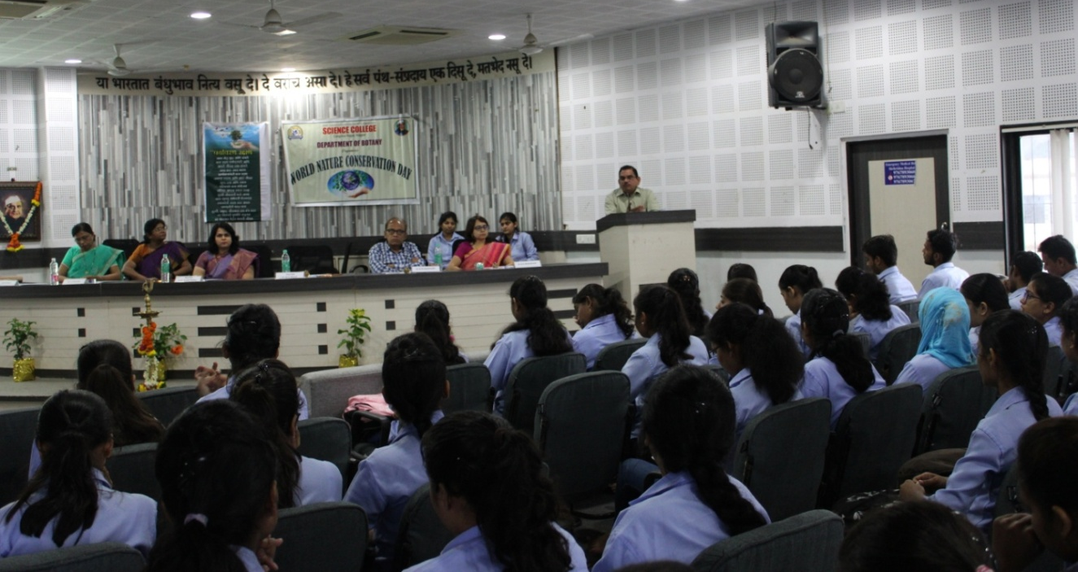
Dr. M.P.Dhore, Principal addressing the students about the importance of conservation of water
One Day Workshop on
Seed Balls Technique& Miniature Garden

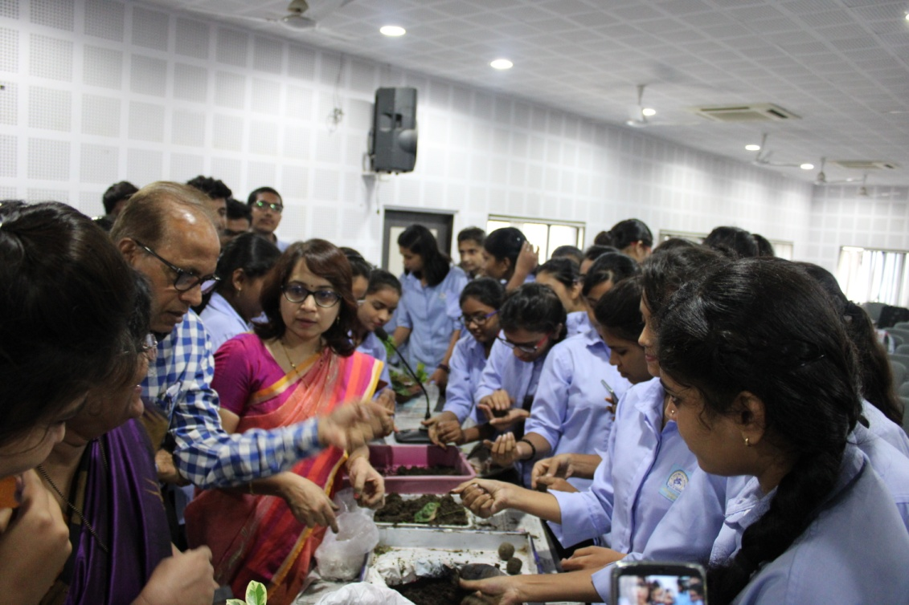

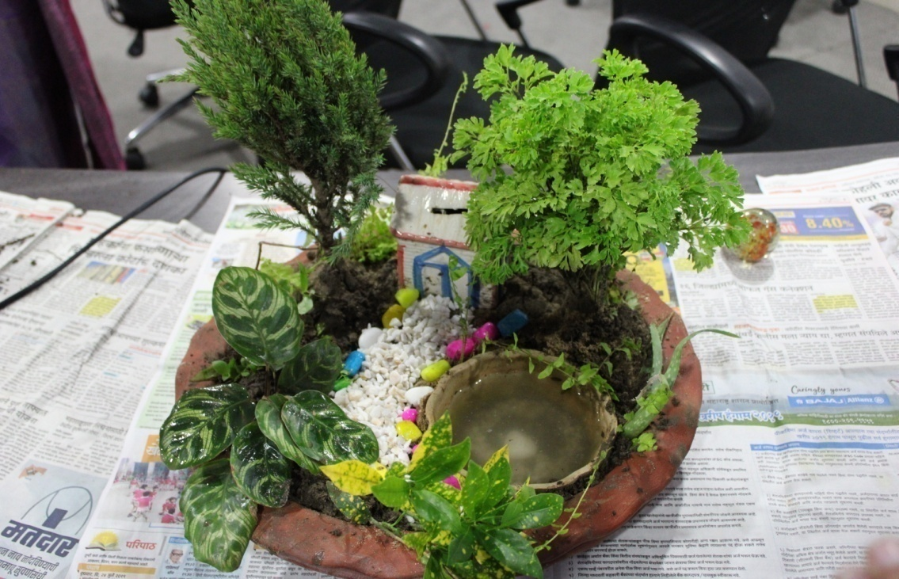

Convener
Dr. Mrs. R.H.Mahakhode

