REPORT
Skill Based Certificate Course
Mushroom Cultivation 2018-19

Botany department organized Mushroom Cultivation under the Skill Based Certificate Course on 9th Feb. 2019. The president of the program was Dr.C.J.Chandekar, principal of the college. Mr. Abhimanyu Dongarwar, founder of Sky Mushrooms was the chief guest. He emphasized on the importance of management of mushroom units and use of quality spawn and proven technologies for promoting mushroom cultivation for wealth from waste. Over 100 student were participated. Participants of training program also shared their experiences during training program. Student also interacted with the expert. Dr.R.N.Deshmukh, H.O.D. of department of Botany stressed the importance of edible mushroom cultivation and requested for organizing more such training programs for benefit of rural youths. He also urged to cultivate and to make available quality spawn for mushroom farming. Dr.C.J.Chandekar sir asked the student to develop a entrepreneur skill amongst them and gave importance of mushroom cultivation, skill based certificate course. Introductory remarks were give by Dr.S.D.Puranik convener of the mushroom cultivation. In her introductory remark, she gave details of mushroom cultivation from 2005 to till date. Ku. Grishma Ninave and Ku. Saloni Meshram anchored the program. Mr. Anurag Rao gave the vote of thanks. Dr.P.S.Tiwari and Dr.R.H.Mahakhode and other teaching and nonteaching staff were present to grace the occasion.
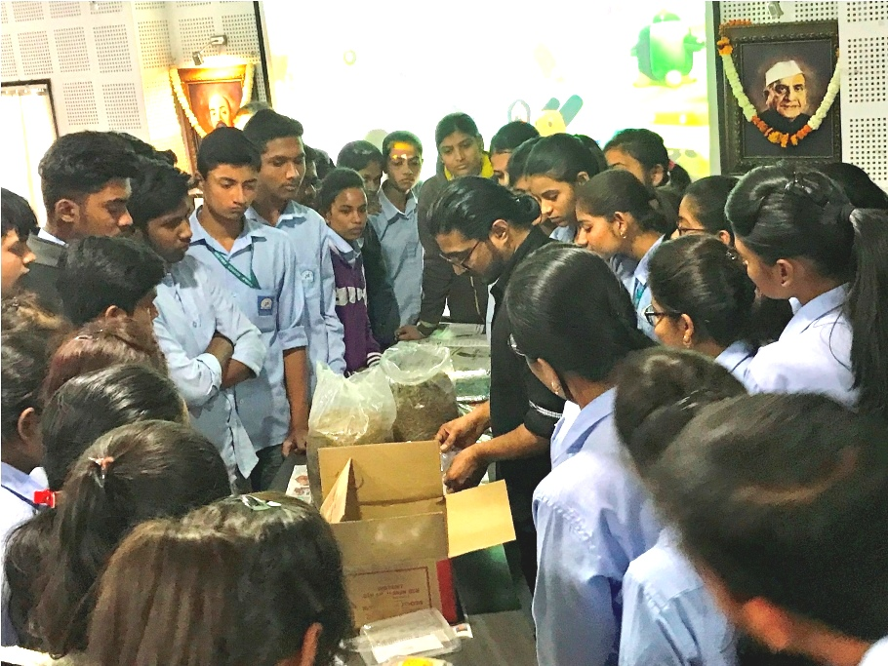
Mr. Abhimanyu Rao demonstrating techniques in workshop on Mushroom Cultivation under the Skill Based Program on 9th Feb. 2019.

