Shri Shivaji Education Society Amravati’s
SCIENCE COLLEGE, Congress Nagar, Nagpur
Workshop Organized
On
Plant Tissue Culture Techniques
2021-22
----------------------------------------------------------------------------------------------
A training program on Plant Tissue Culture Techniques was organize for the students of B.Sc. sem V and VI students by Department of Botany, SSES Amravati’s Science College, Congress Nagar. Work shop was conducted by Prof. Punita Tiwari, professor, Dept. of Botany. 3 to 15 days workshop included general introduction, Media preparation, sterilization technique, Explant preparation, Inoculation technique, incubation and observation. Observation of different stages viz: callus formation, shooting and rooting, multiple shoot formation, regenerative callus, identification.
30 students of botany dept., Shivaji science and 30 students of Sant Gadgebaba Science College, Hingna, participated in the workshop. After completion of workshop visit to Ankur seeds, Biotech lab was organized.
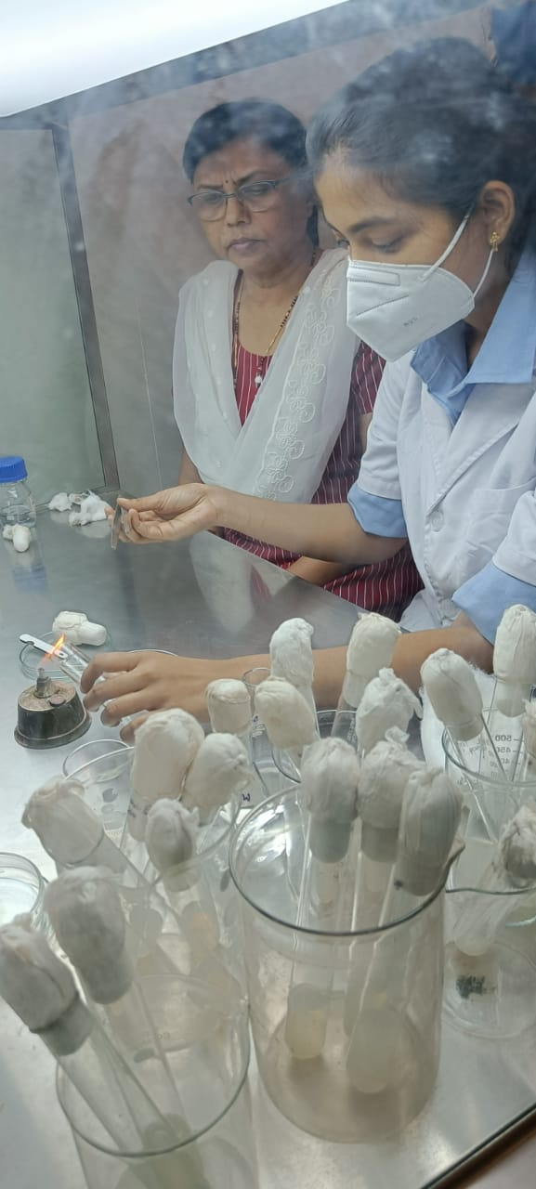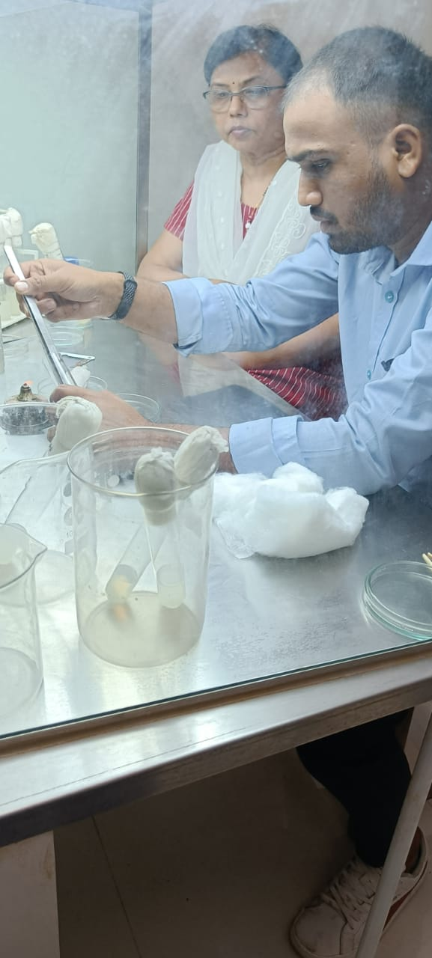
Convener & trainer Dr. P.S.Tiwari conducting the workshop. (Inouculation)
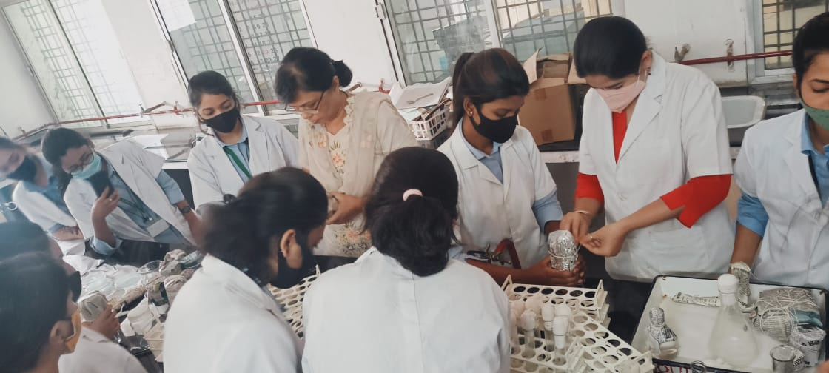
Media Preperation
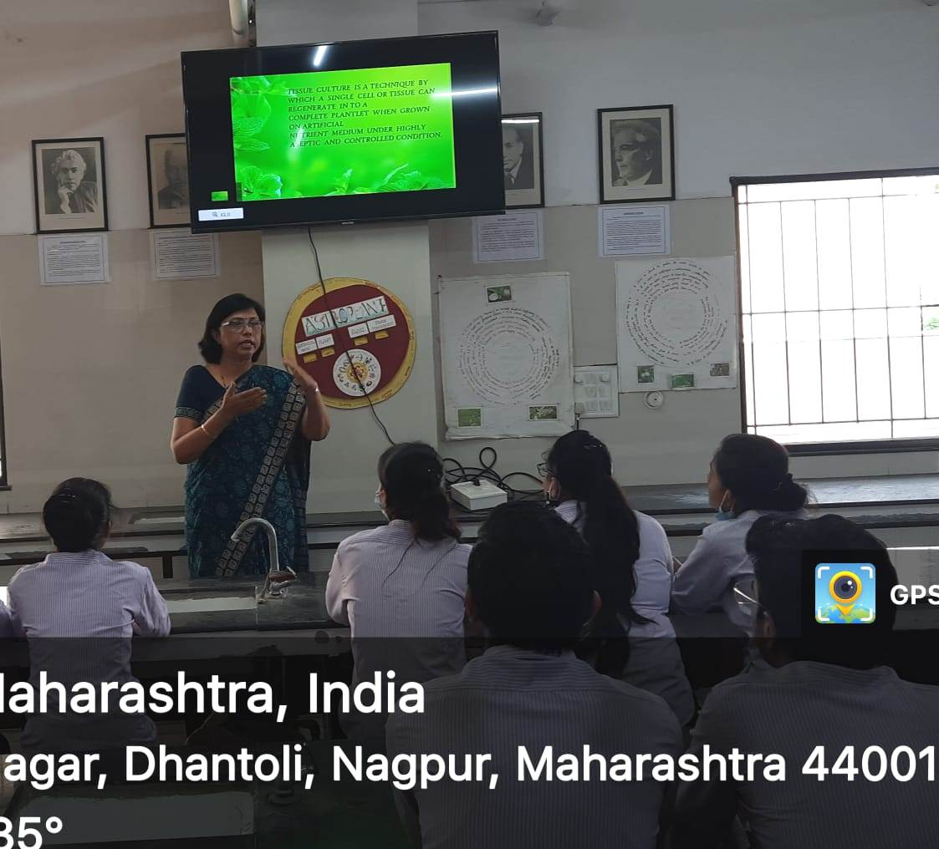
Students from Hingna College attending workshop
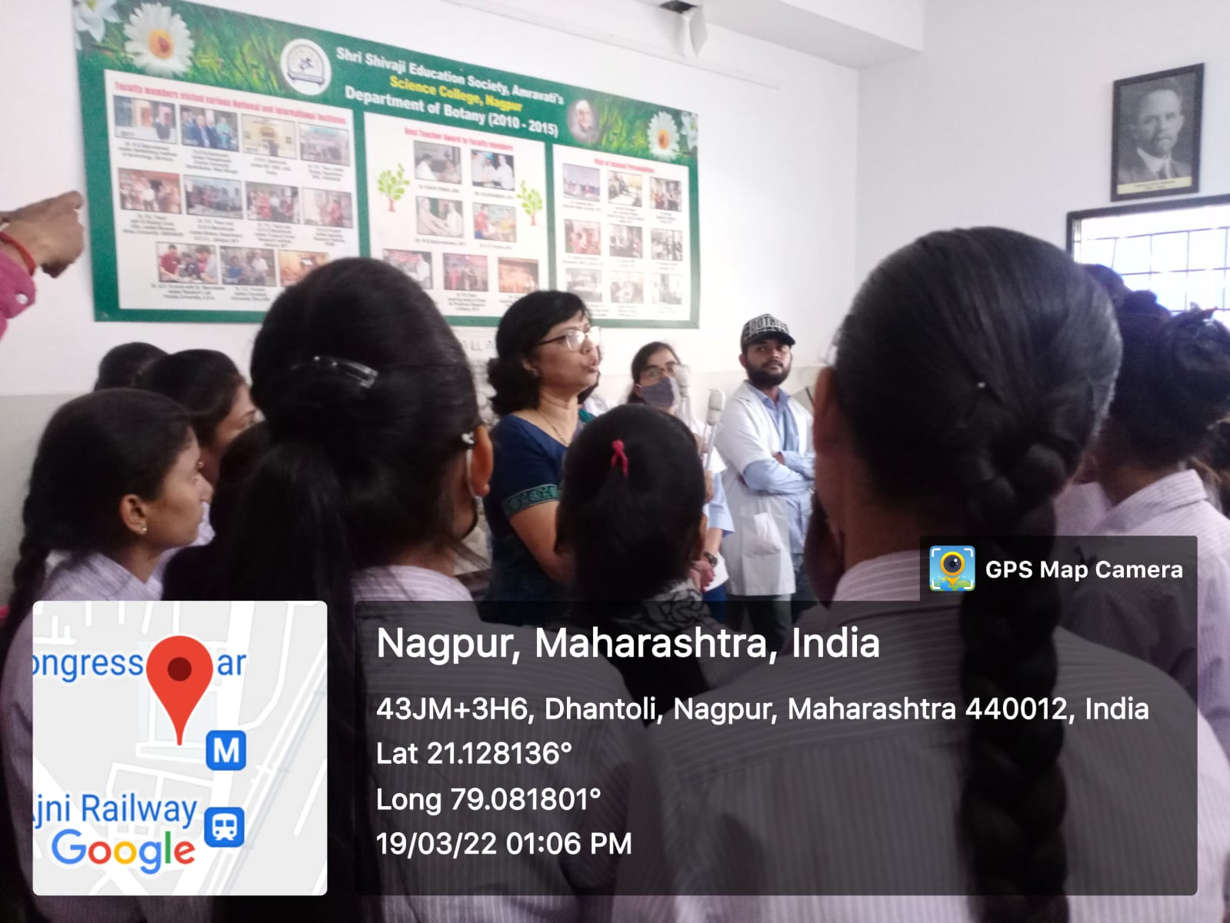

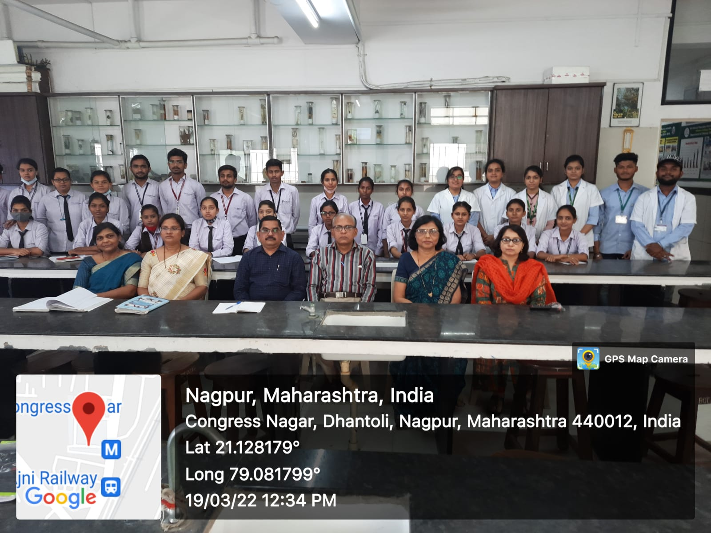
Students of Sant Gadge baba college, Hingna with faculty members and Principal

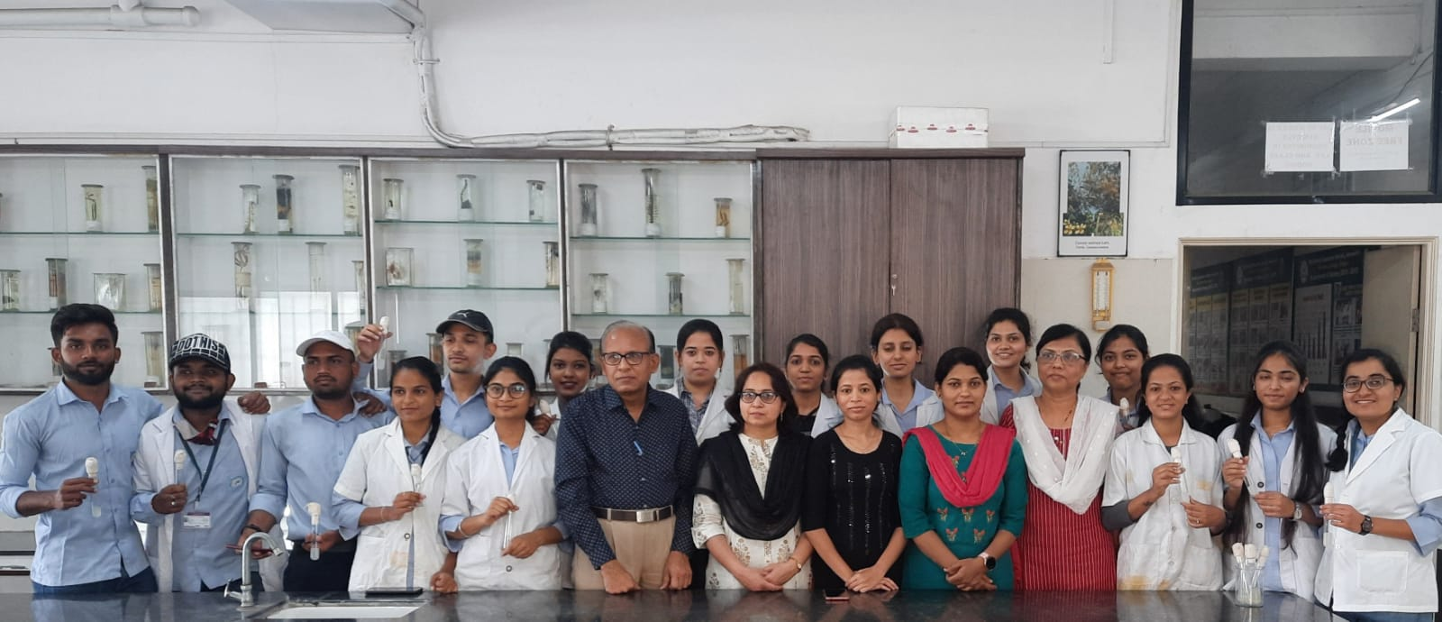
Students of Botany dept, Shivaji Science College with faculty members

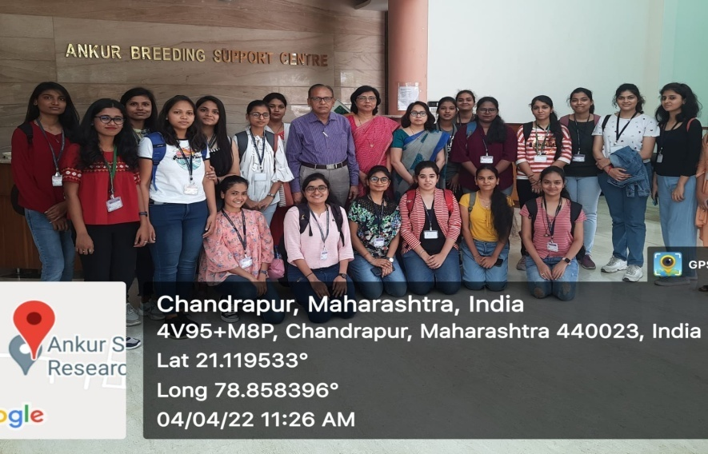
Visit to Ankur Seeds Pvt. Ltd

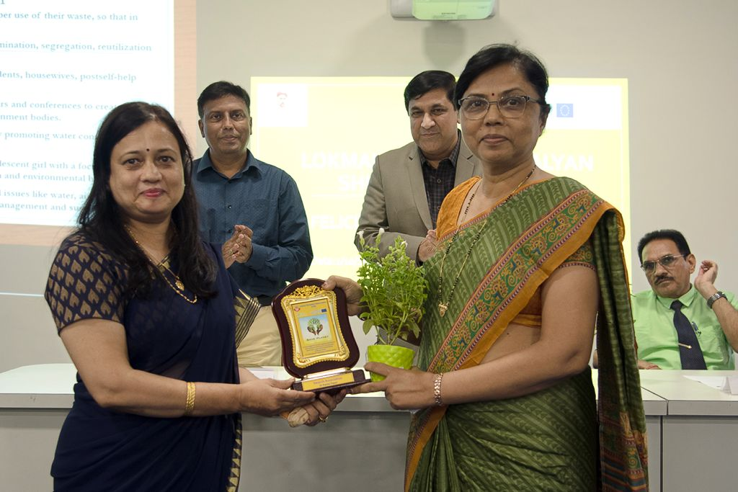

Convener
Pro.P.S.Tiwari

