A project report on
Title of Project (Font size -16)

Submitted to
Rashtrasant Tukdoji Maharaj , Nagpur University (RTMNU)
For the degree of
Master of Science (M.Sc.) in chemistry

Submitted by
Name of Student (Font Size 16)

Under the supervision of
Name of Supervisor (Font Size 16)
Designation (Font Size 14)
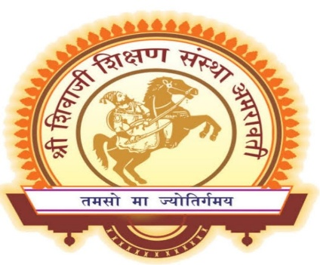
( Qualification (Font Size 14))

Department Of Chemistry
Shri. Shivaji Education Society Amravati’s
Science College,
Congress Nagar, Nagpur
2021 - 2022

CERTIFICATE

This is to certify that the thesis entitled “Title of Project Font -14” submitted by Name of Student (Font size -14), and ,in partial fulfillment of the requirements for the award of Master of science (M.Sc.) in chemistry of R.T.M. Nagpur University, at the Shri. Shivaji Education Society Amravati’s, Science College, Nagpur is an authentic work carried out by Them under my supervision and guidance in the department of chemistry, Shri Shivaji Science College, Nagpur – 440012

Name of Supervisor (Font -14)
Designation (Font -14)
Date:- Department of Chemistry
Place:- Nagpur Shri. Shivaji Education Society Amravati’s
Science College,
Congress Nagar, Nagpur

CERTIFICATE

This is to certify that the thesis entitled Title of Project Font -14” “submitted by Name of Student (Font size -14), and, in partial fulfillment of the requirements for the award of Master of Science (M.Sc.) in chemistry, at the Shri. Shivaji Education Society Amravati’s, Science College, Nagpur is an authentic work carried out by Them under the supervision of Name of Supervisor (Font size -14) and guidance in the department of chemistry, Shri. Shivaji Education Society Amravati’s, Science College, Nagpur – 440012

Date:-
Place:-. Nagpur
Head
Name of Head (Font size 14)
Head and Professor
(Qualification Font size 14.)
Department of chemistry
Shri. Shivaji Education Society Amravati’s,
Science College, Nagpur

DECLARATION

I, Name of Student (Font size -14) M.Sc. in Chemistry, Shri. Shivaji Education Society Amravati’s, Science College, Nagpur, declare that all my dissertation works are original and no part of this work has been submitted for any other degree or diploma in any other university. All the given information and works are true to my knowledge and belief.

Date:.
Place: Nagpur. Name of Student (Font Size 14)
( M.Sc. II year , sem IV)

