Shri Shivaji Education Society Amravati’s
SCIENCE COLLEGE, CONGRESS NAGAR, NAGPUR
Session 2019 – 2020
National Cadet Corp
3 MAH GIRLS BATTALION NCC NAGPUR
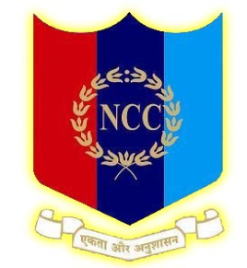
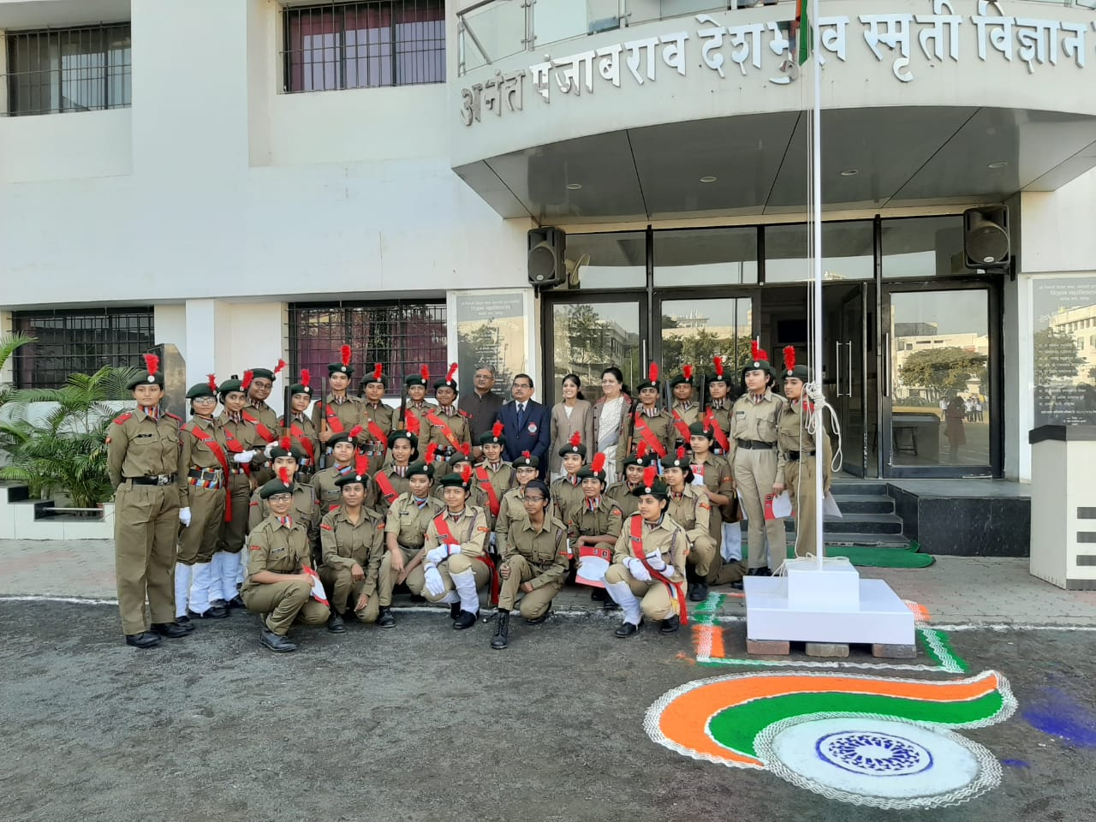
Ceremonial parades were organized in the college, on the occasion of Republic Day celebrations in presence of Hon’ble Principal Sir.

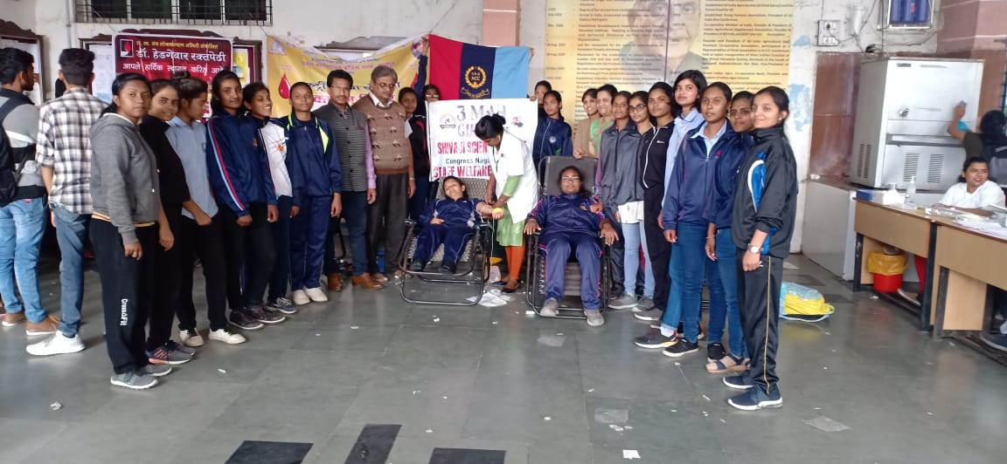
Blood Donation Camp on the occasion of the Birth anniversary of Panjabrao alias Bhausaheb Deshmukh
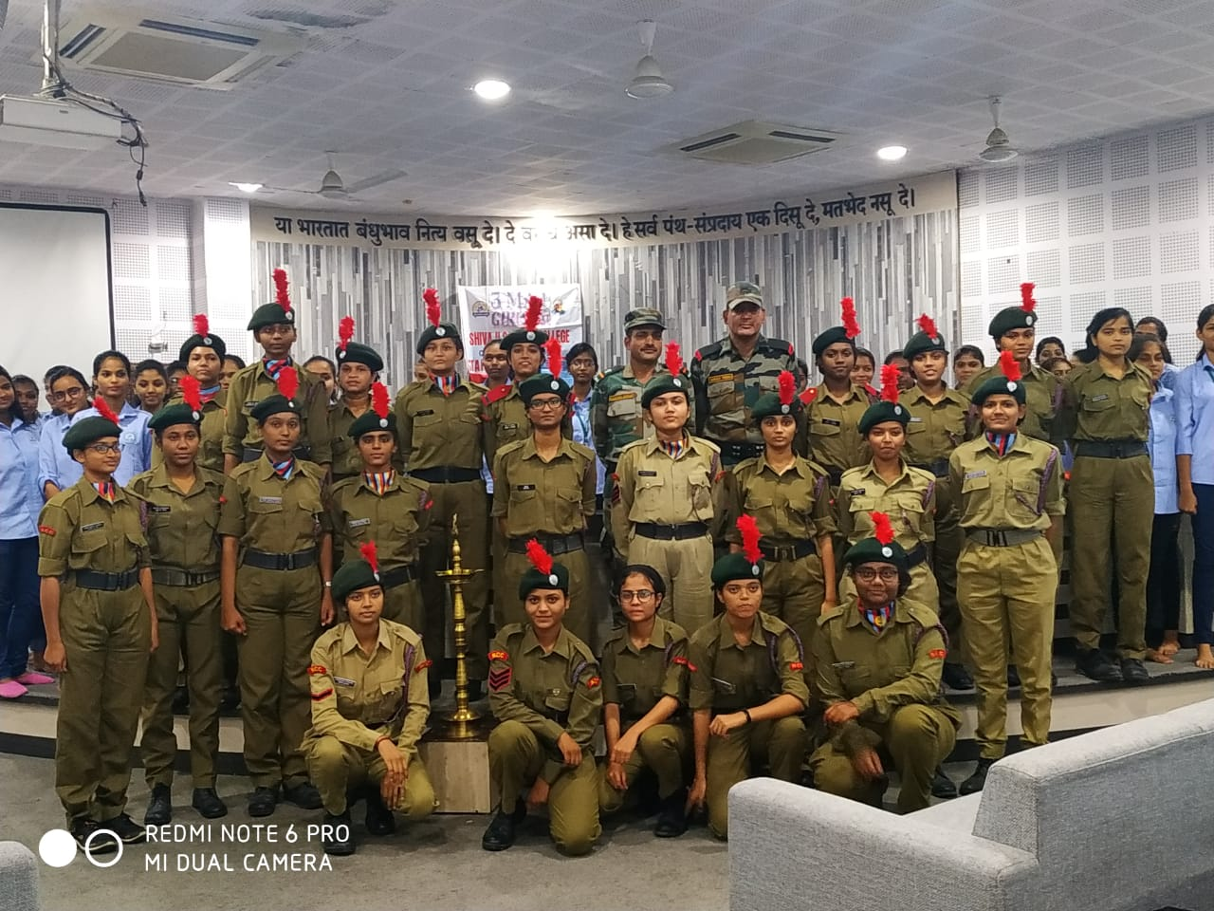
NCC awareness program 2020 organized in the college premises.
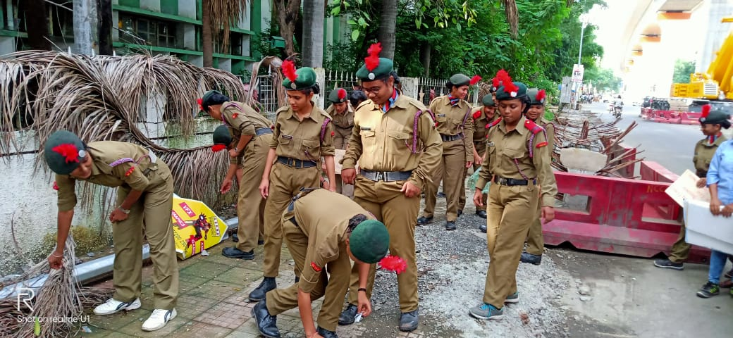Swachh Bharat Abhiyan Program organized in the college by NCC cadets.

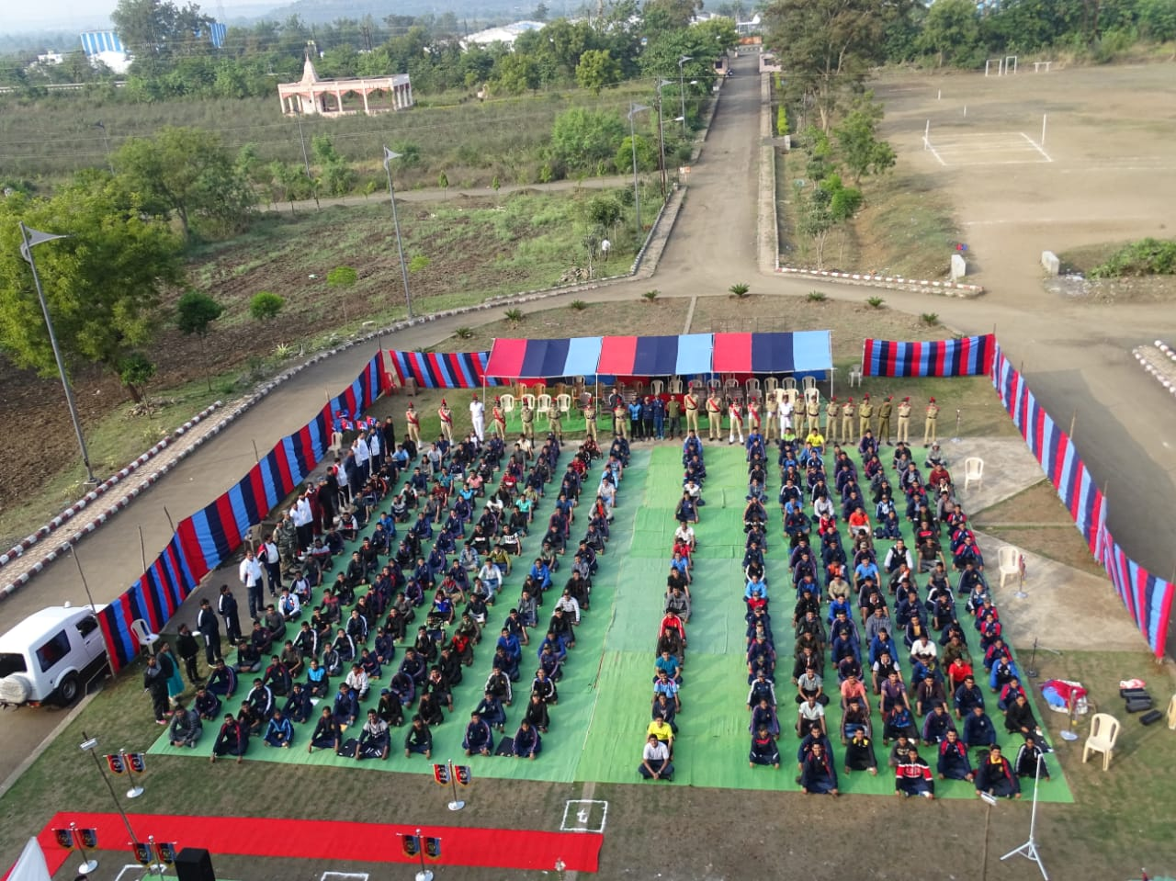
NCC camp organized by 3 MAH Girls BN, NCC, Nagpur.

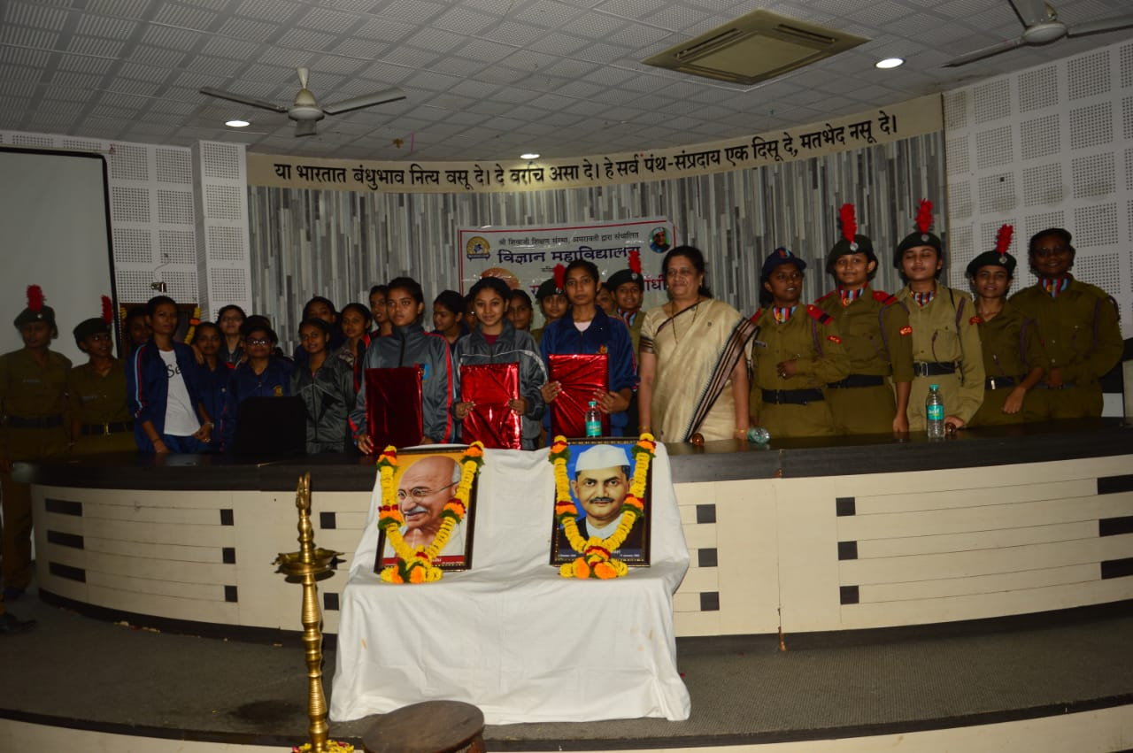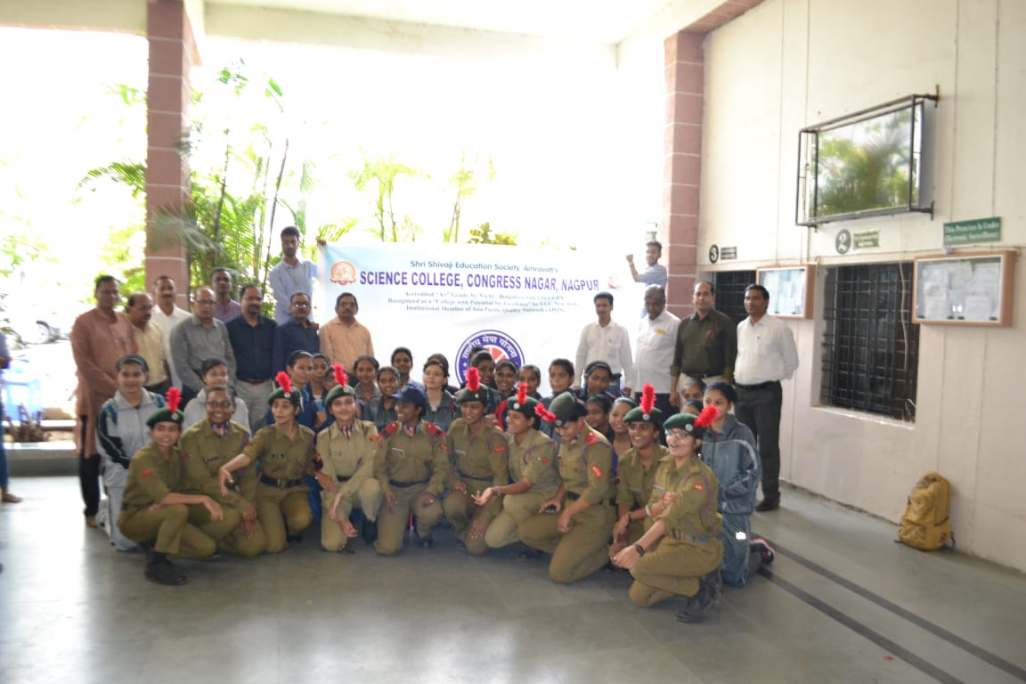
Painting Competition and Tree Plantation Program in the college premises
organized by NCC Cadets

