Shri Shivaji Education Society Amravati’s
SCIENCE COLLEGE, CONGRESS NAGAR, NAGPUR
Session 2020 – 2021
National Cadet Corp
3 MAH GIRLS BATTALION NCC NAGPUR
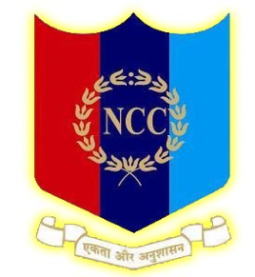

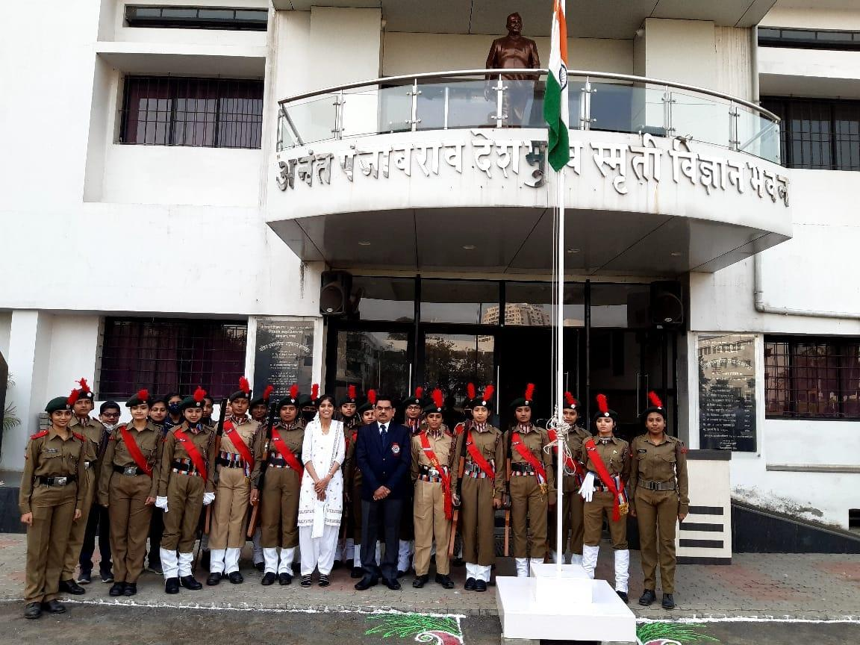
Ceremonial parades were organized in the college, on the occasion of Republic Day celebrations.

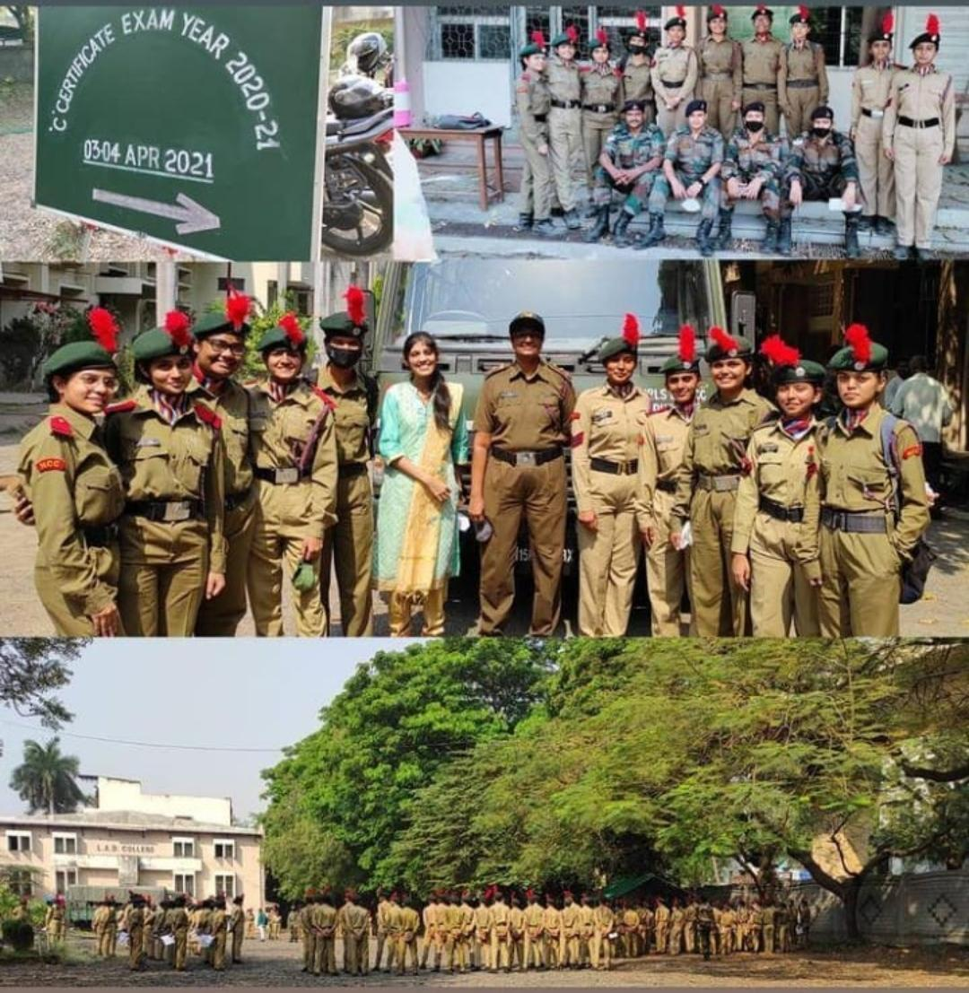
C' Certificate examination on dated 03/04/2021 and 04/04/2021
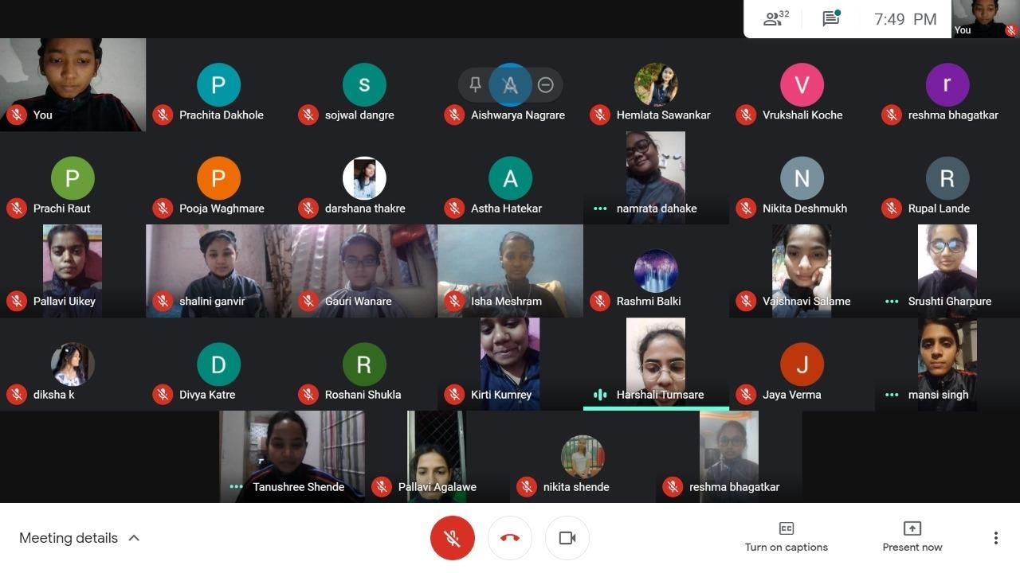
Online cadres were arranged for C' cert appearing cadets.

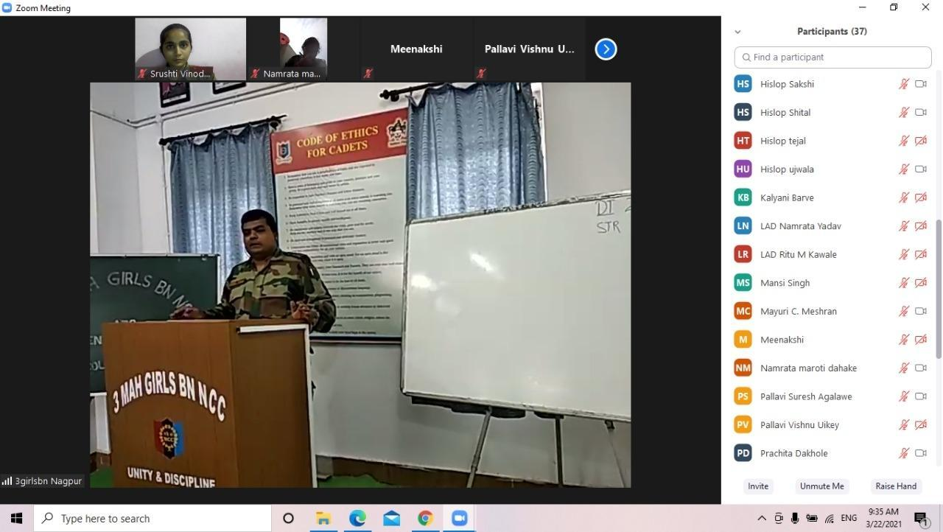
3 Mah Girls BN, NCC unit conducted online Classes for C' Cert appearing cadets.

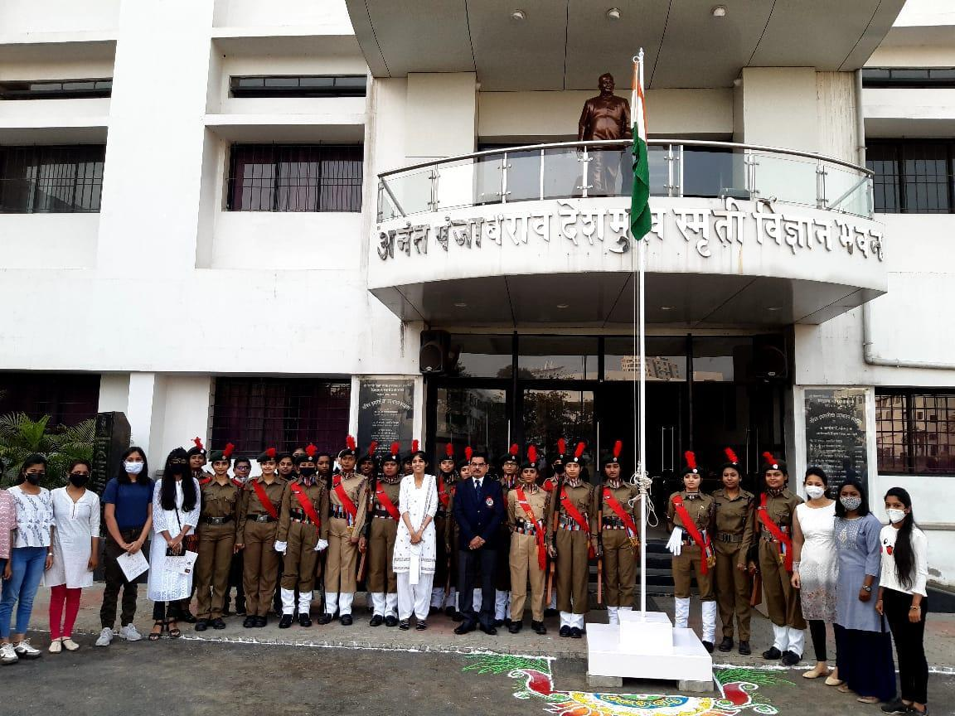
B' Certificate and C' Certificate distribution ceremony program was held on 26/01/2021 in presence of Hon’ble Principal Prof. M. P. Dhore Sir.

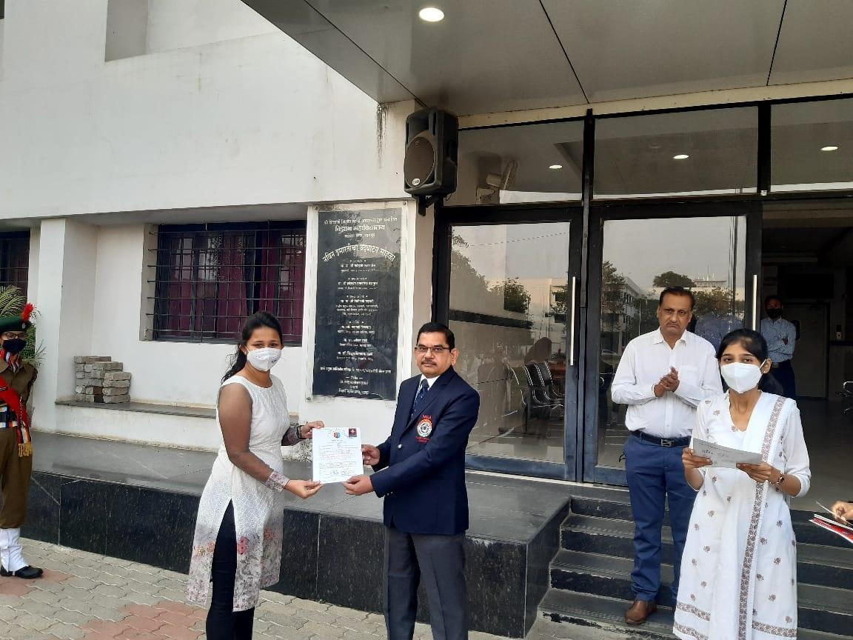
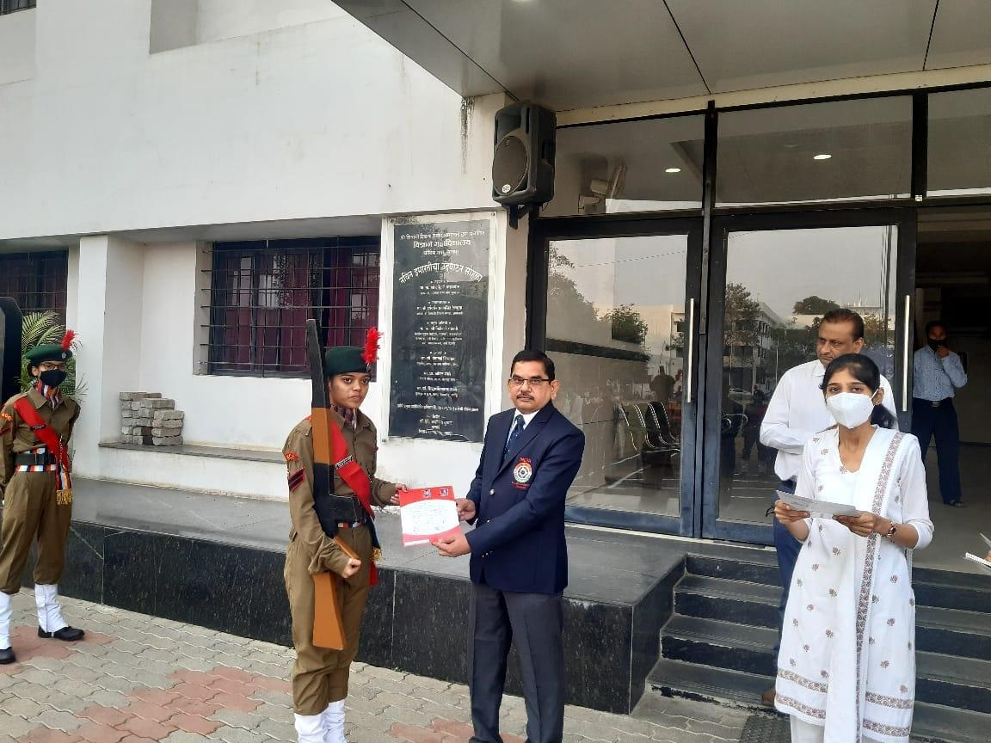
Certificate distribution ceremony program was held on 26/01/2021.

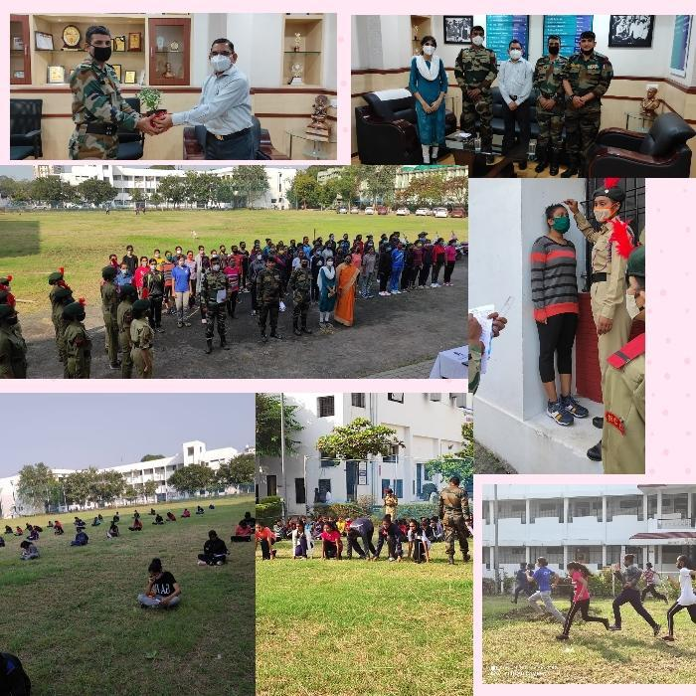
First Year Enrollment Process (Year 2020-2021)

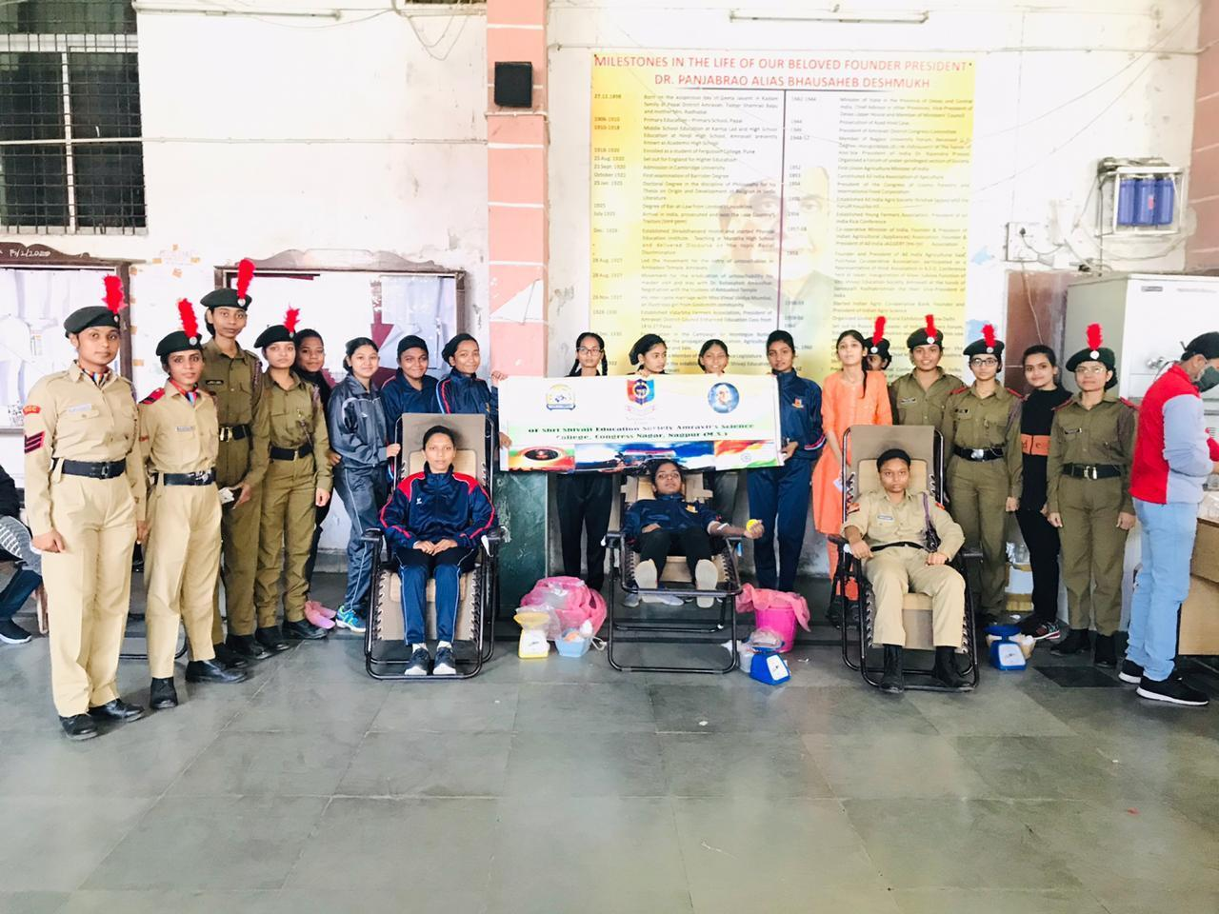
Blood Donation Camp was organized by the College.

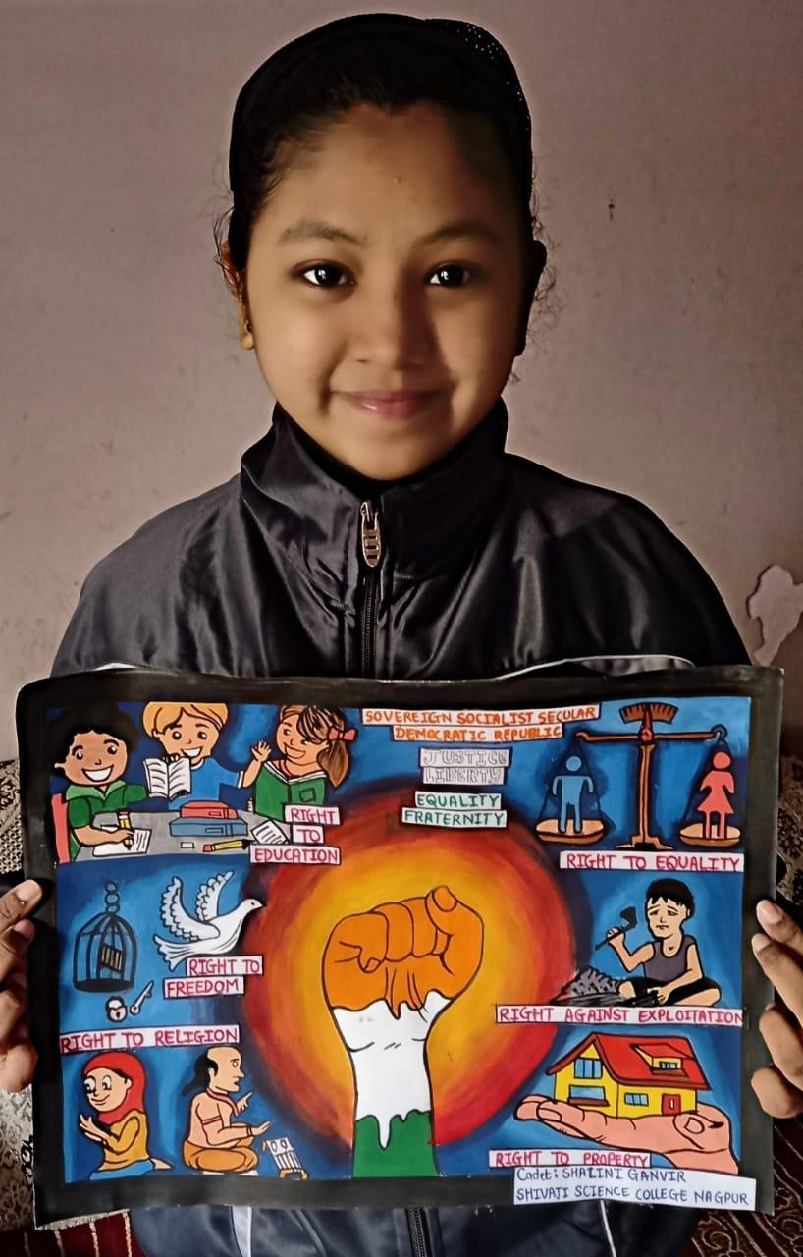
Constitution Day Youth Club Activities Campaign - Poster making by Cdt. Shalini Ganvir

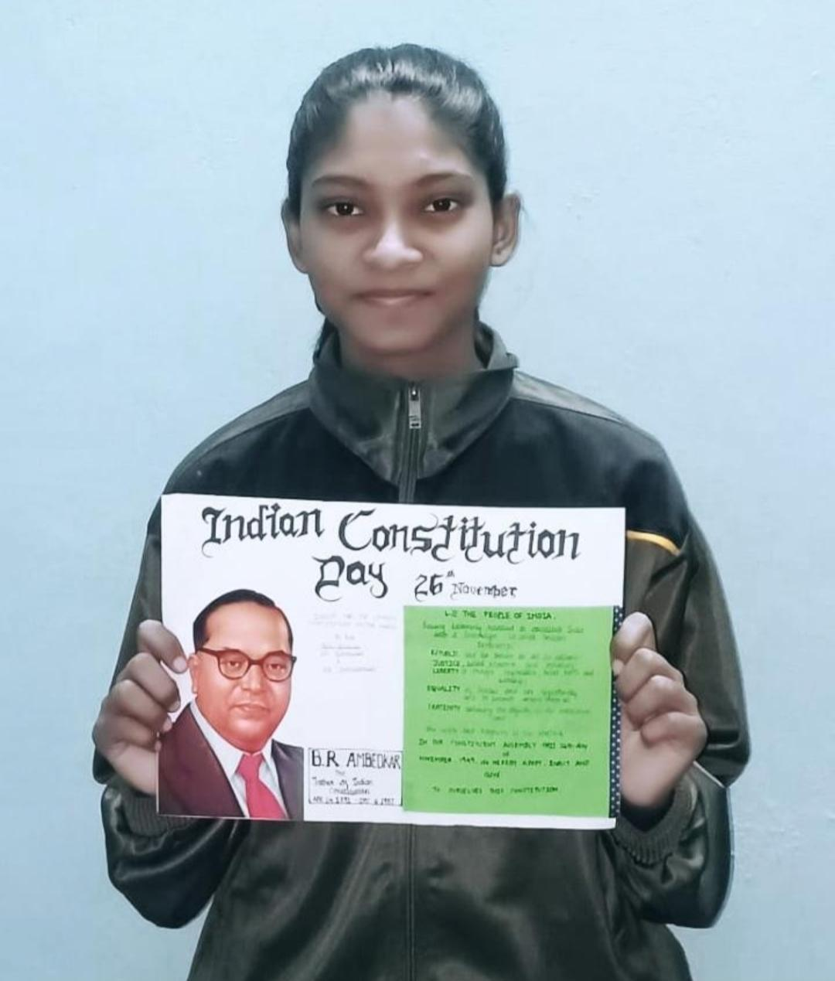
Constitution Day Youth Club Activities Campaign - Poster making by Cdt. Deepali Choudhari

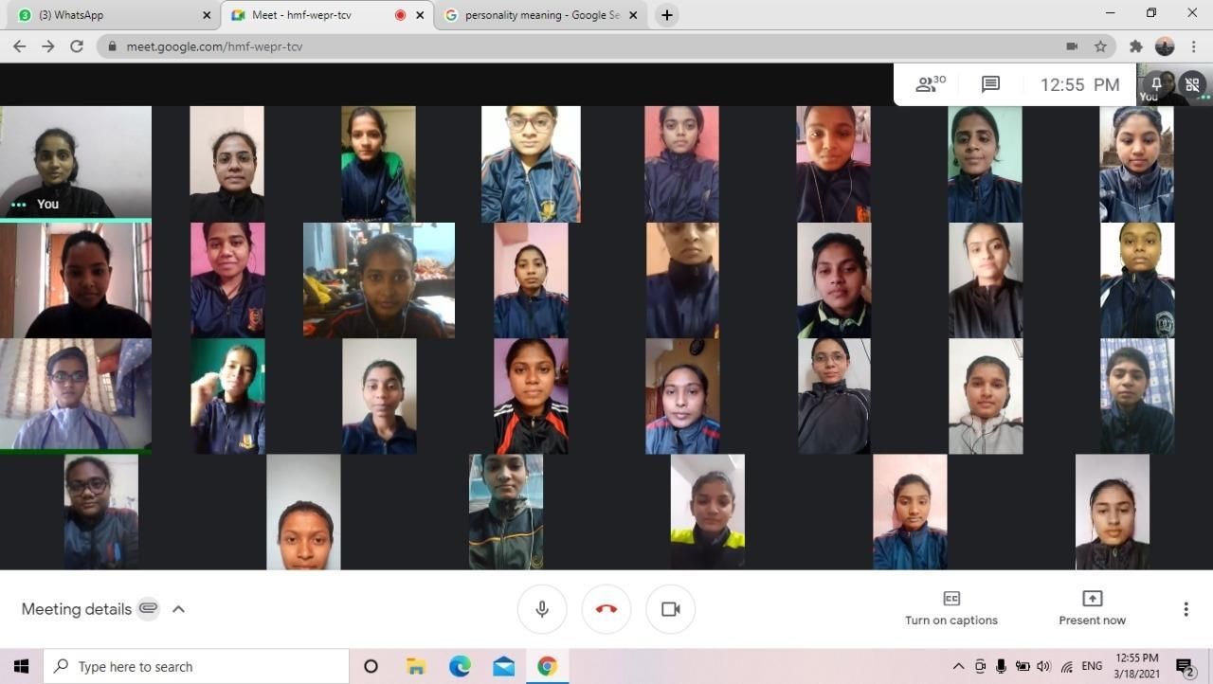
Online seminar conducted for B' and C' Cert appearing cadets

