Shri Shivaji Education Society Amravati’s
SCIENCE COLLEGE, CONGRESS NAGAR, NAGPUR
Session 2021 – 2022
National Cadet Corp
3 MAH GIRLS BATTALION NCC NAGPUR
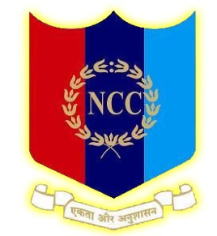
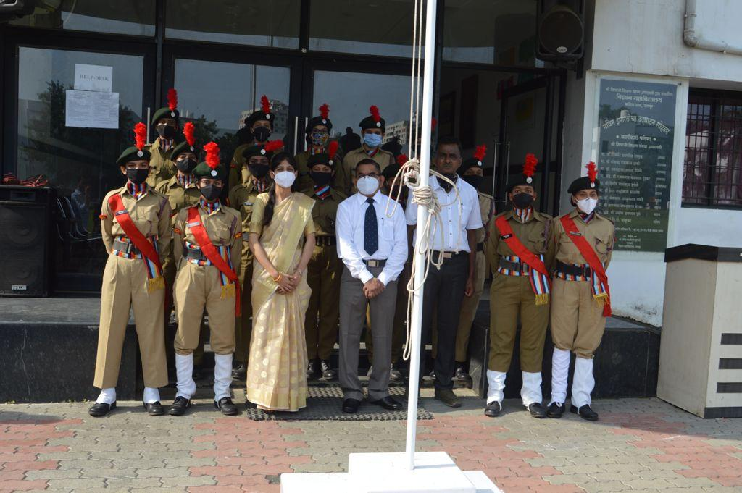
Independence day celebration in presence of Hon’ble Principal Prof. M. P. Dhore Sir on 15 August 2021

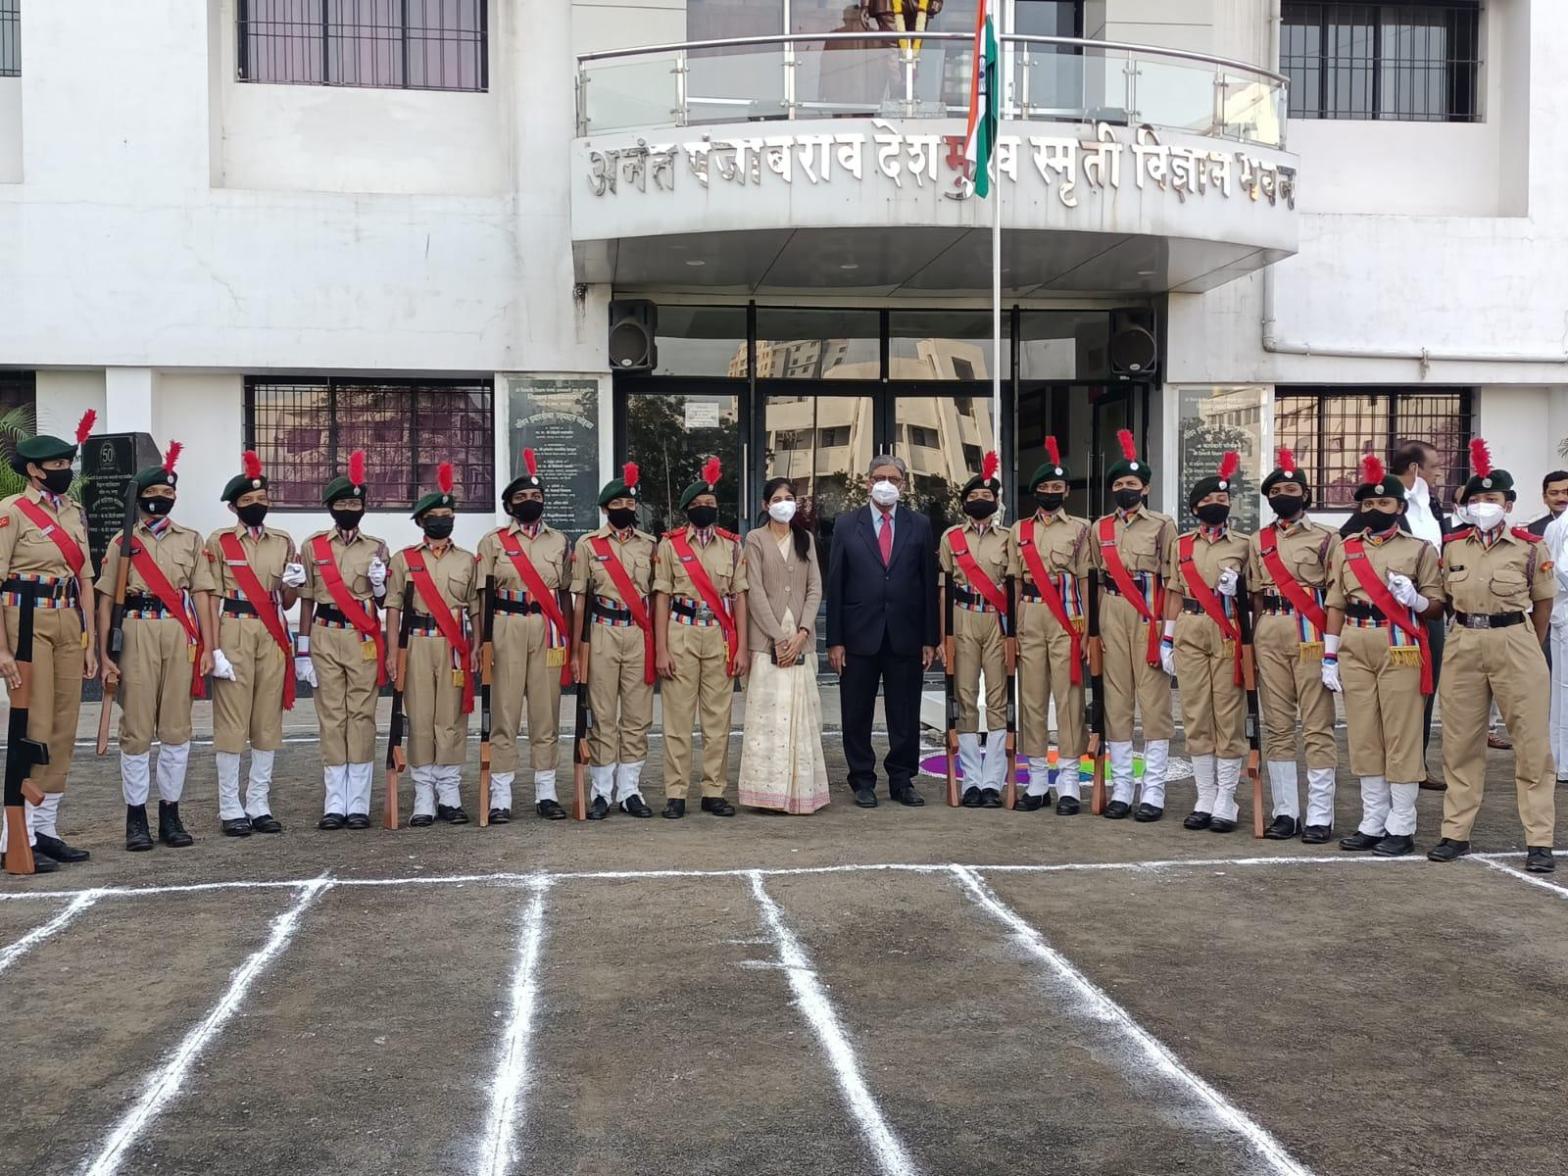
Ceremonial parades were organized in the college, on the occasion of Republic Day celebrations in presence of Hon’ble Vice Principal Sir.
.
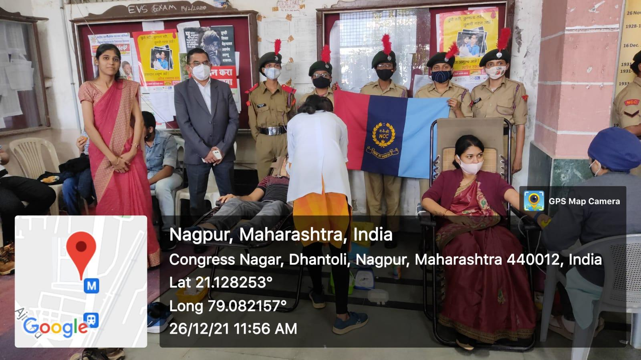
Blood Donation Camp on the occasion of the Birth anniversary of Panjabrao alias Bhausaheb Deshmukh on 27th December 2021.
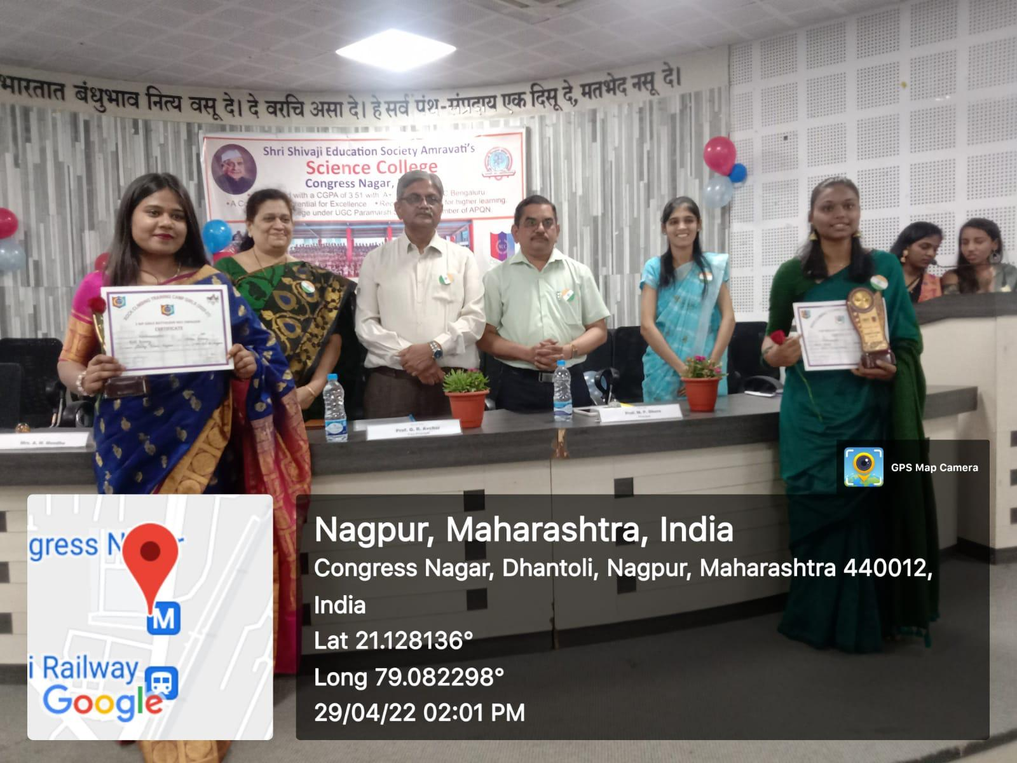
NCC certificate distribution ceremony program was held on 29 April 2022

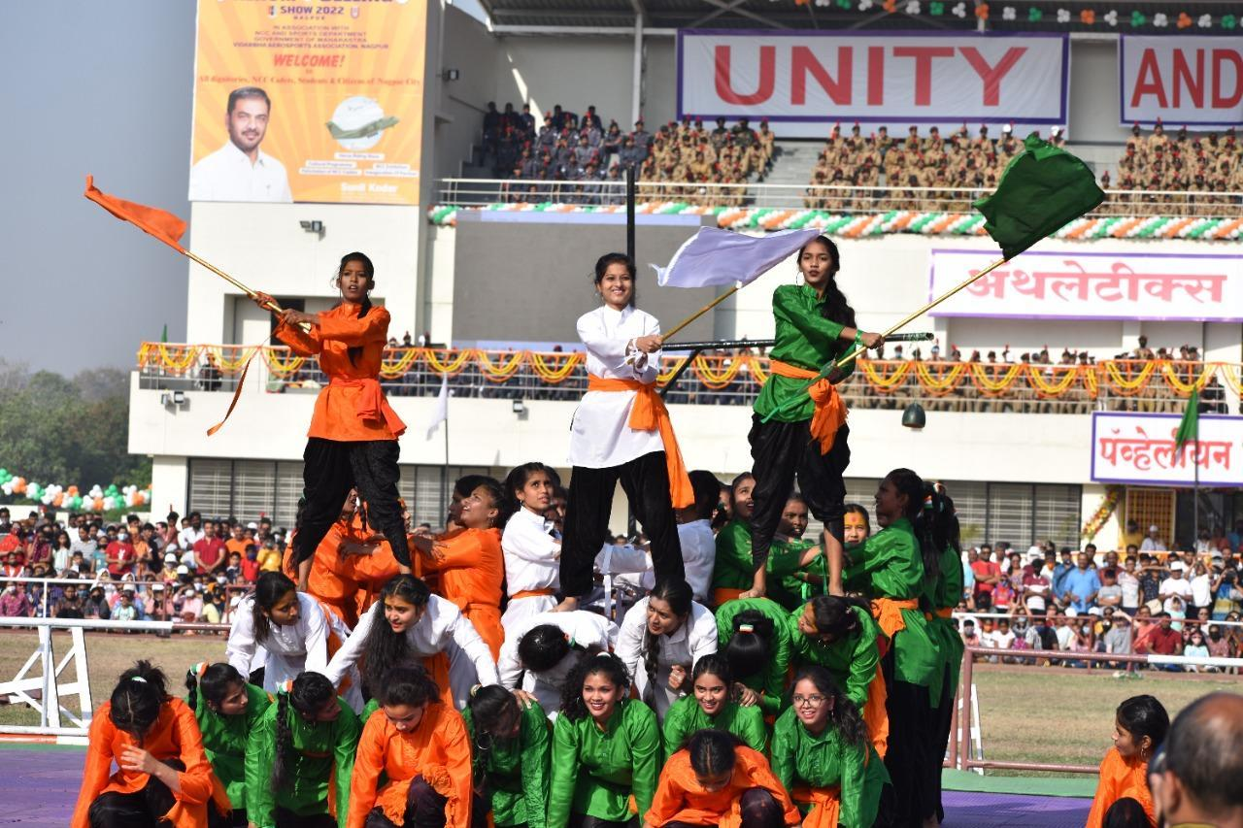

Cultural Programme on 29 March 2022 based on the 75th Anniversary of Independence for Nagpur citizens at Mankapur Stadium, Nagpur.
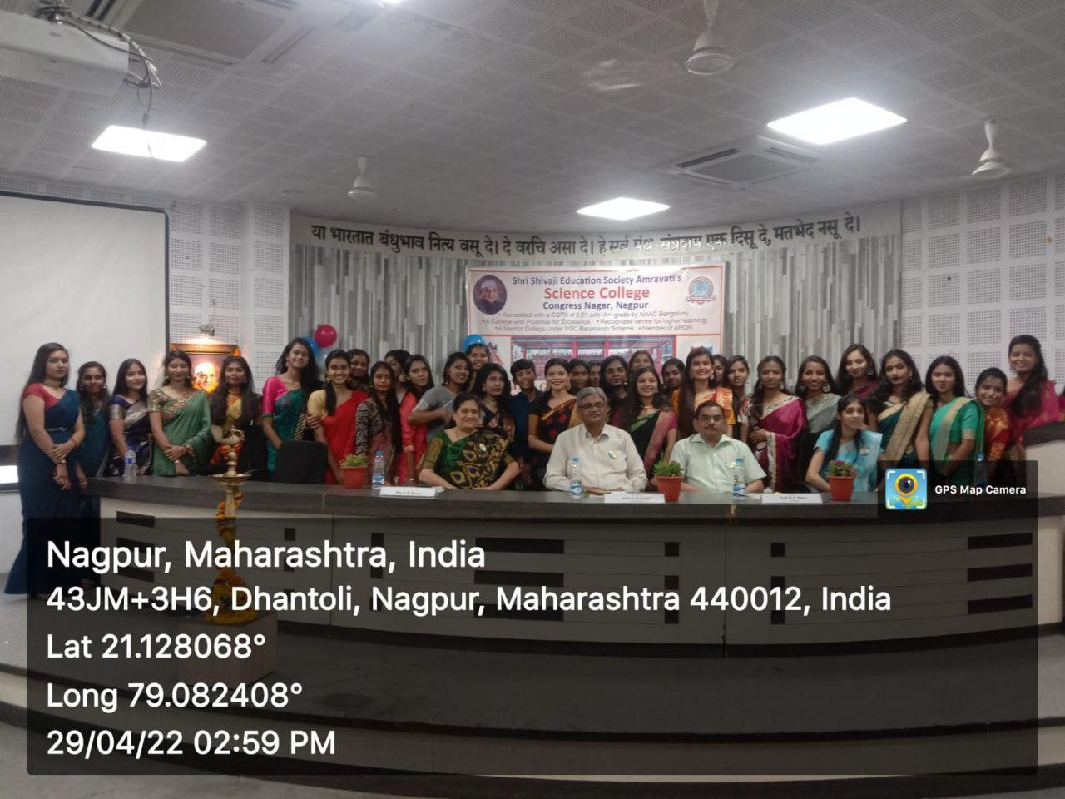
NCC Farewell Program in presence Hon’ble Principal Prof. M. P. Dhore Sir was held on
29 April 2022.

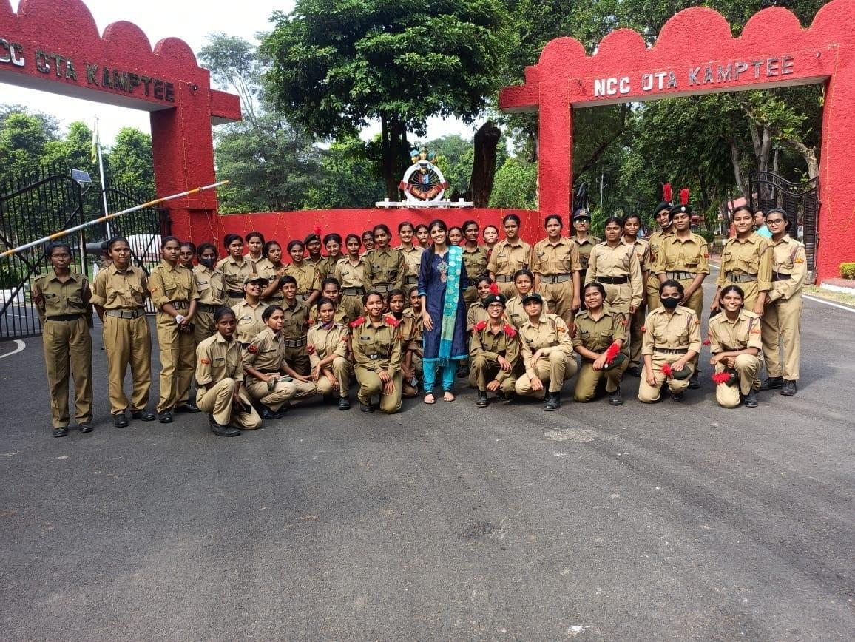
40 NCC cadets actively participated in the Firing Practice at OTA Kamptee on 12 Nov. 2021.

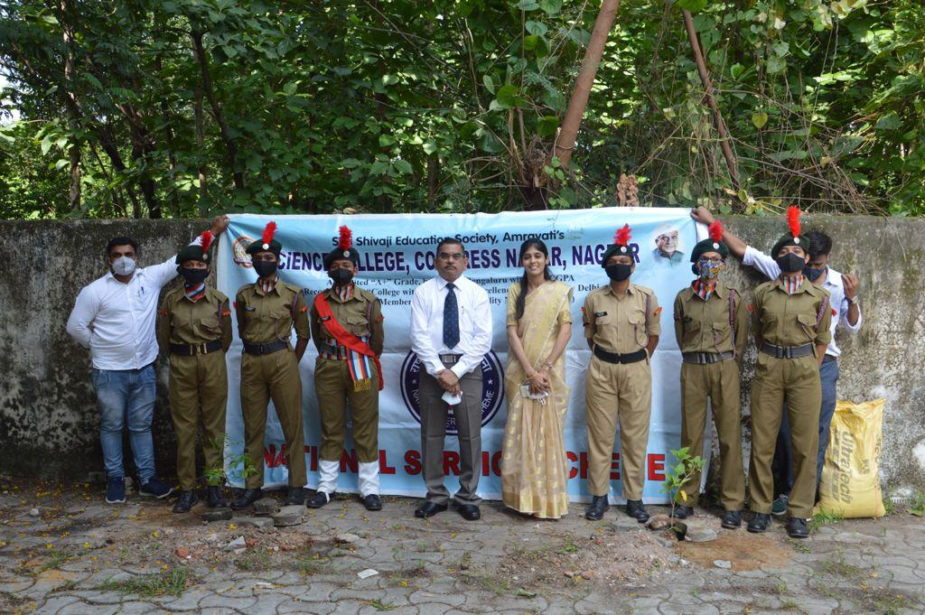
Plantation day celebrated in presence Hon’ble Principal Prof. M. P. Dhore Sir.

