Shri Shivaji Education Society Amravati’s
SCIENCE COLLEGE, CONGRESS NAGAR, NAGPUR
Session 2022 – 2023
National Cadet Corp
3 MAH GIRLS BATTALION NCC NAGPUR
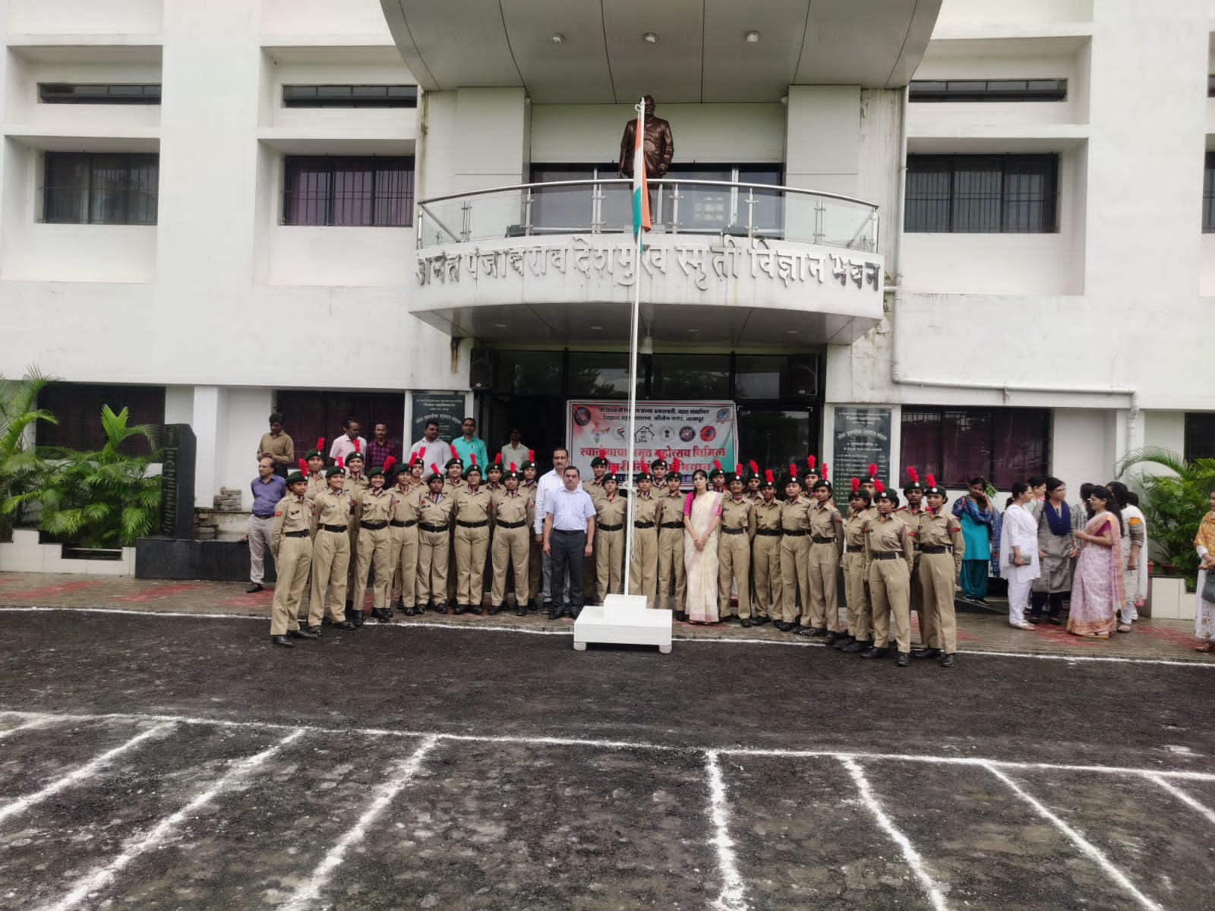 | 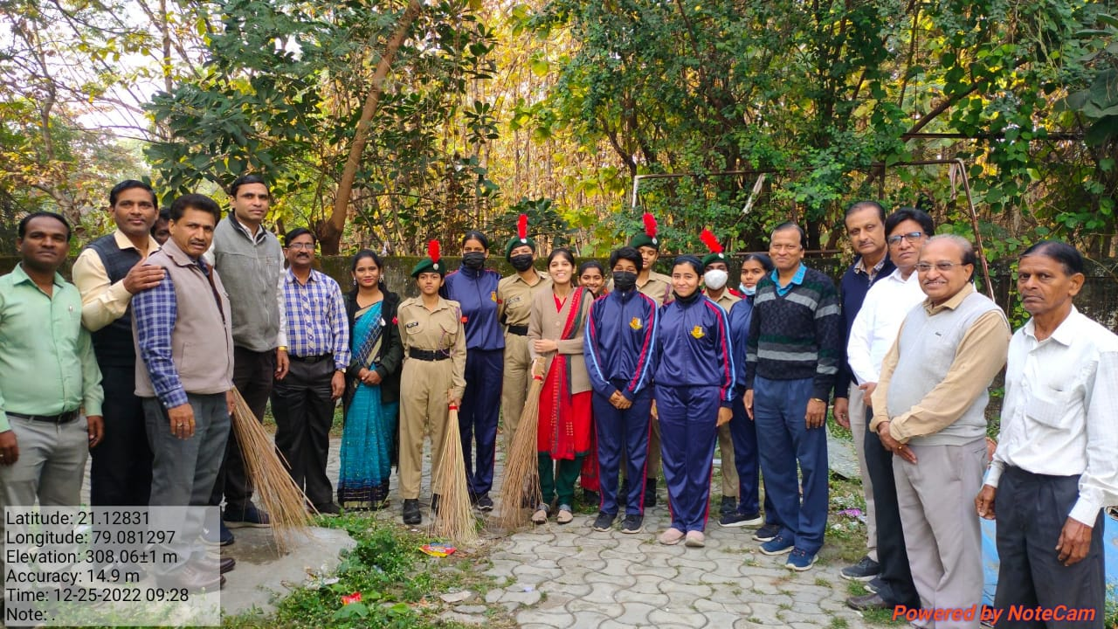  Swachata Abhiyaan
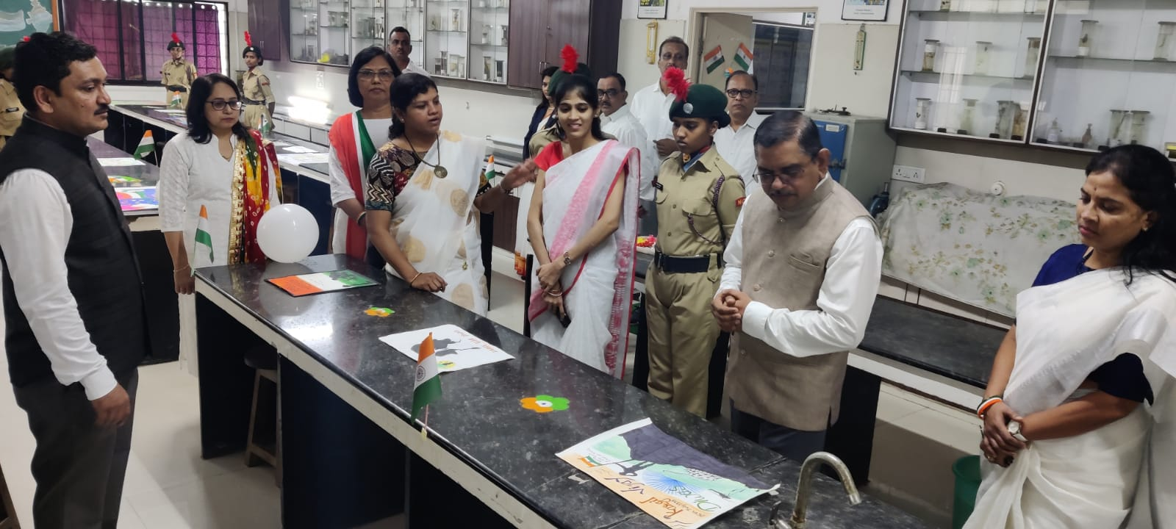  Poster Exhibition | 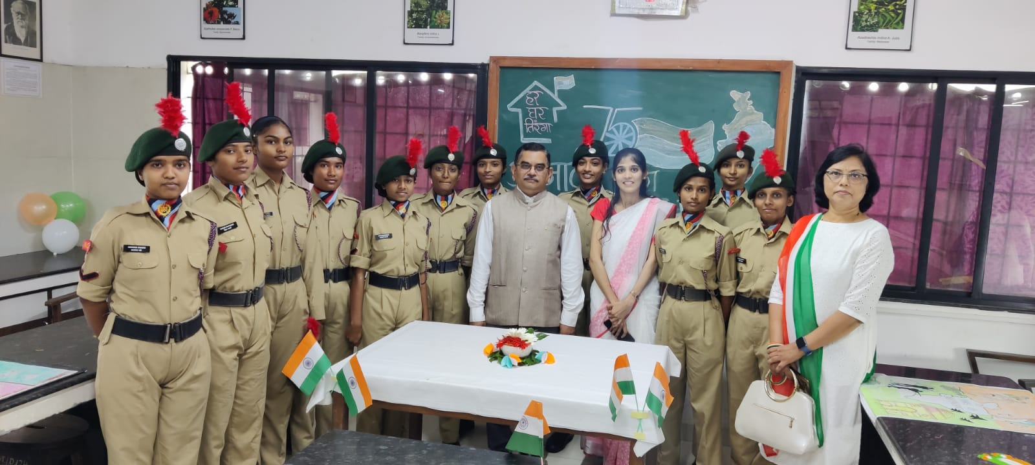
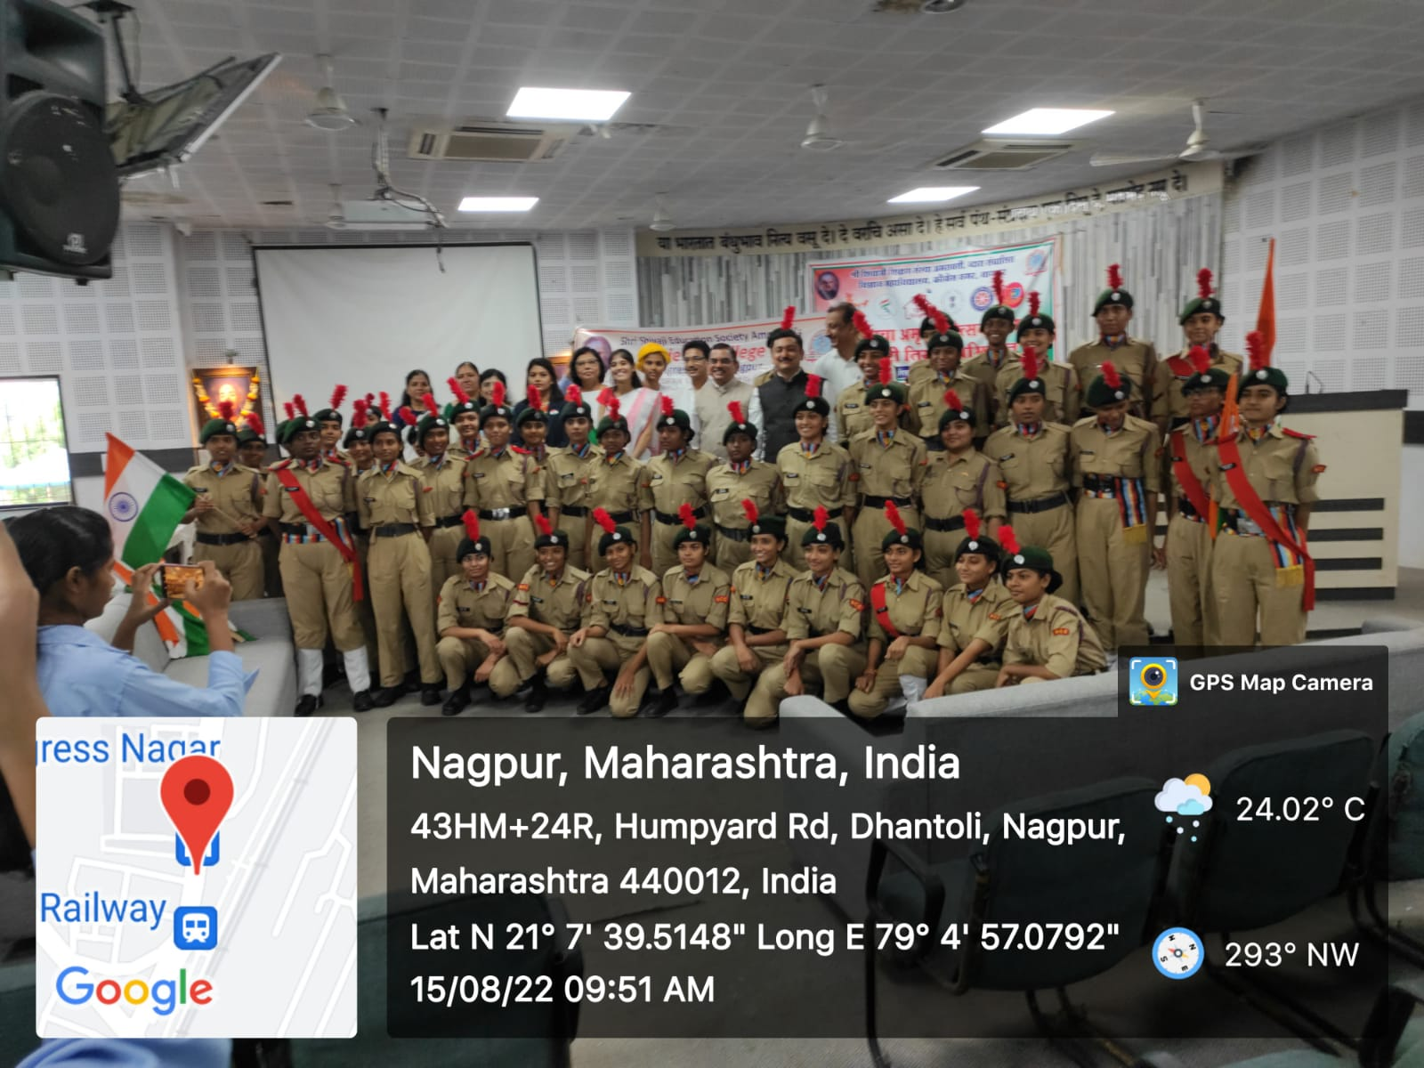 | 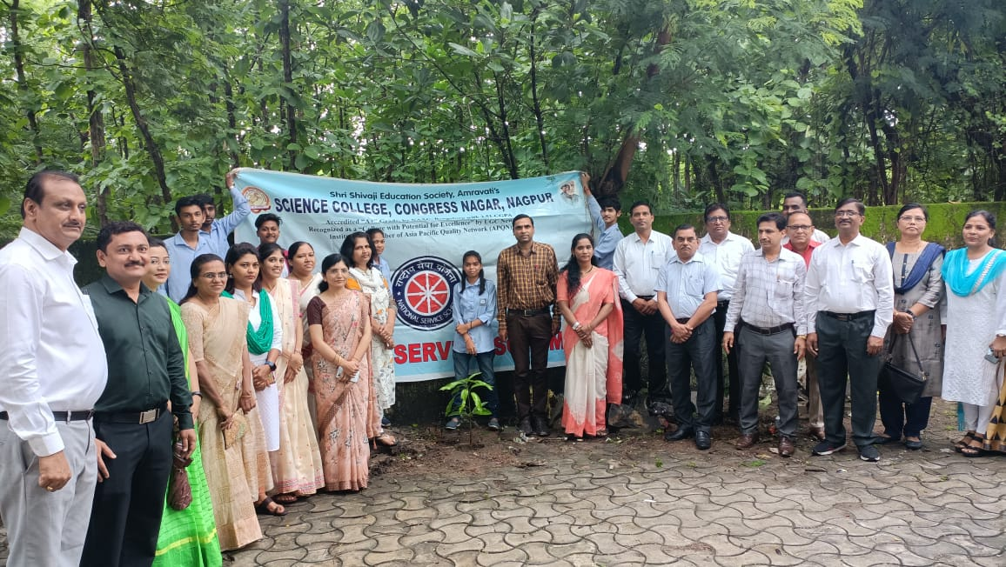  Plantation drive celebrated in College Premises
Har ghar tiranga celebration on the occasion of Azadi ka Amrut mahotsav in presence Hon’ble Principal Prof. M. P. Dhore Sir dated 13 August 2022 to 15 August 2022.
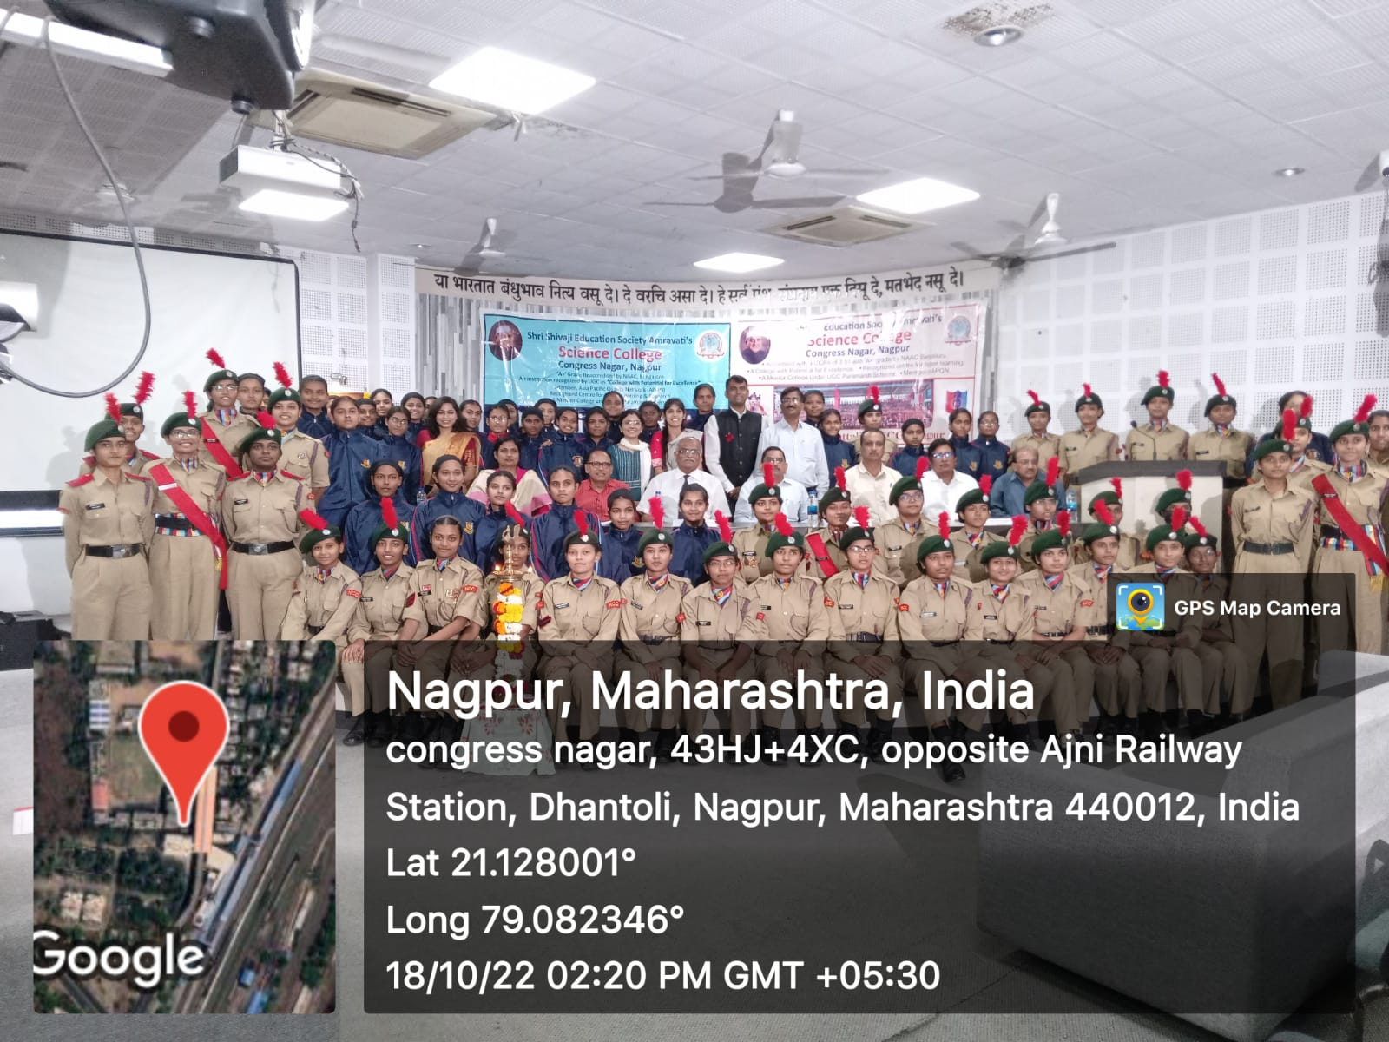 | 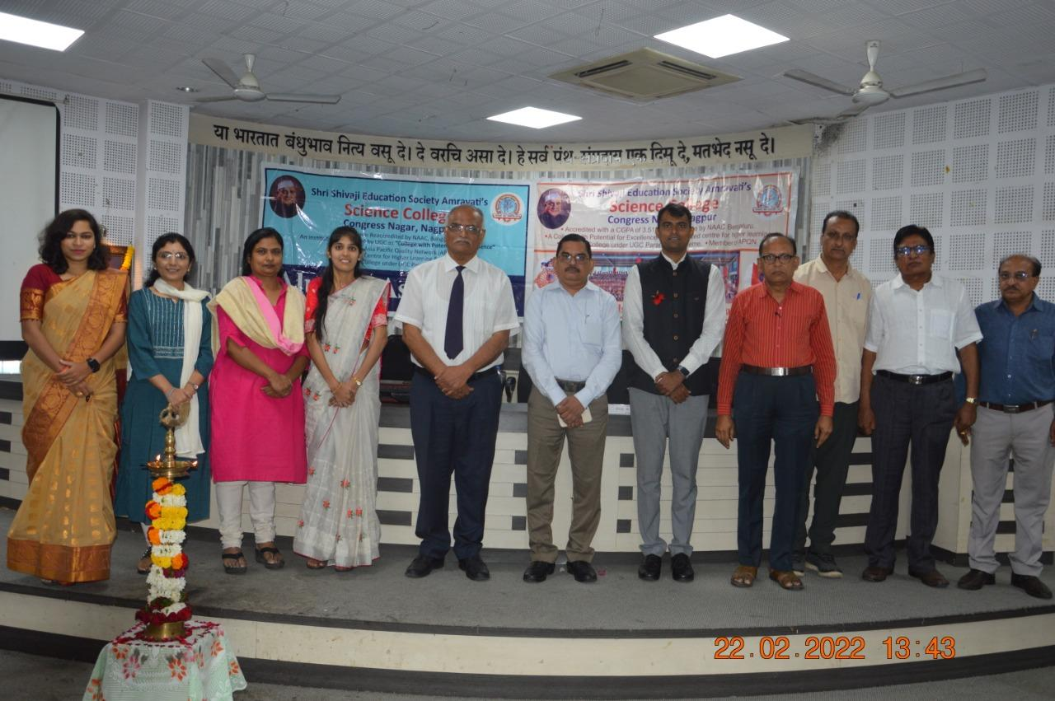
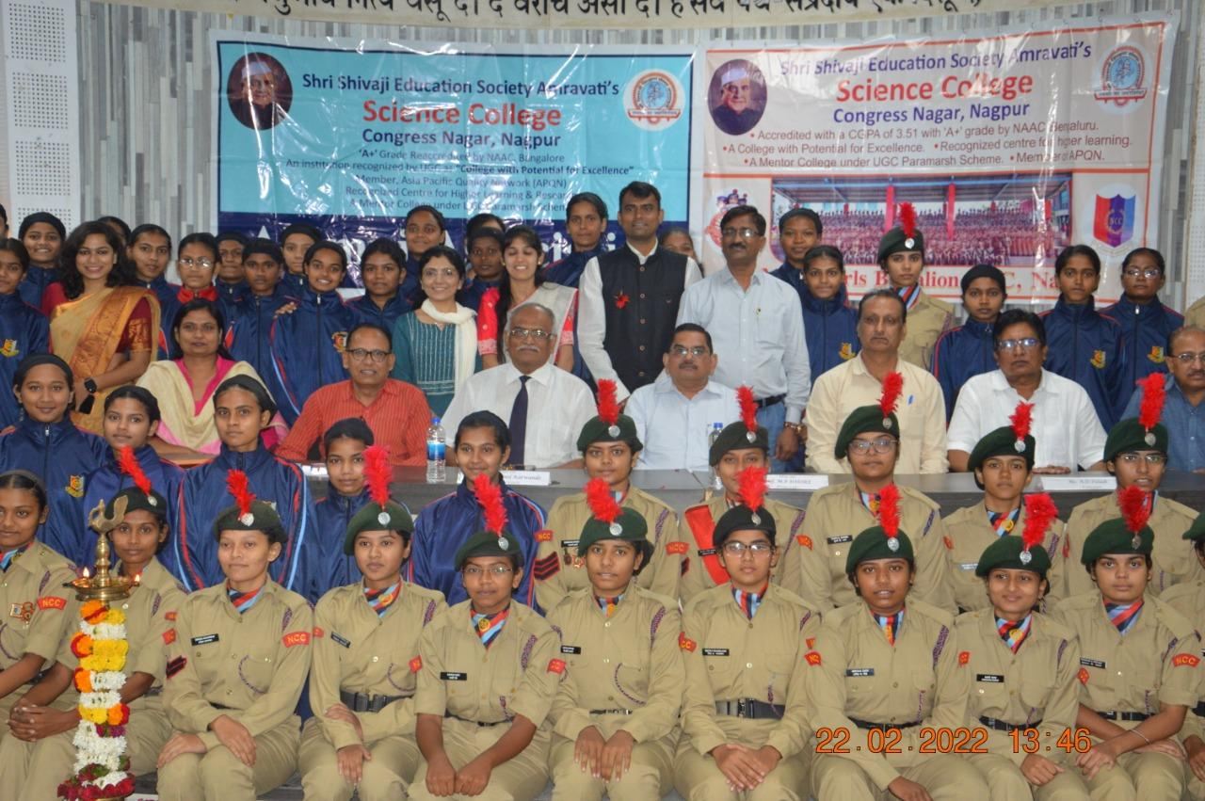 | 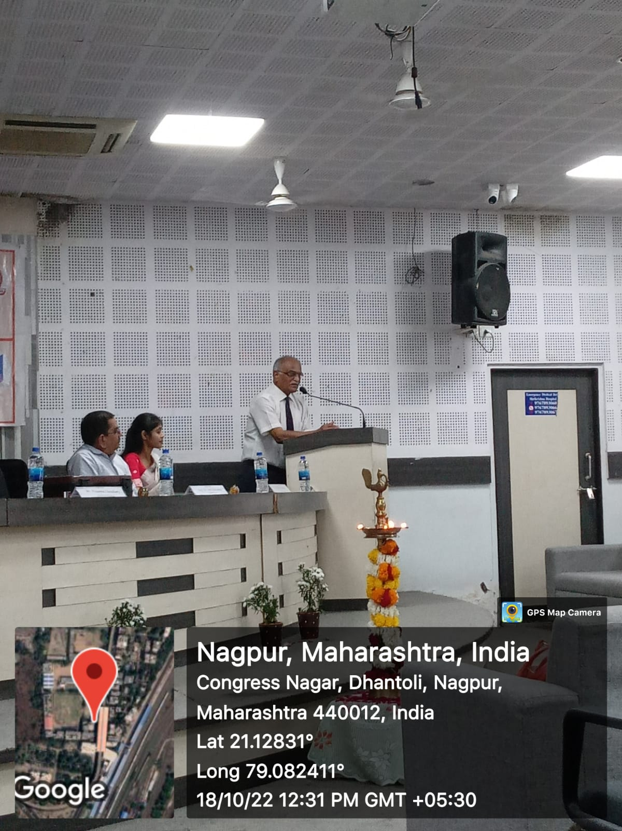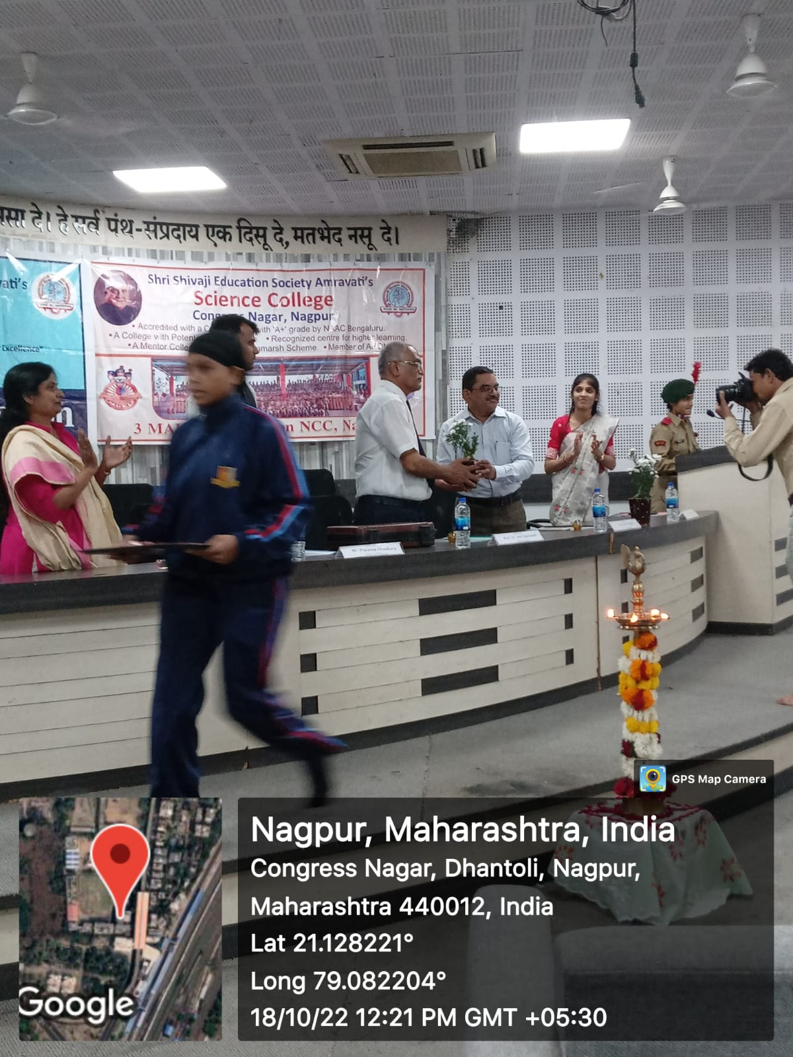
Guest lectures on the topic ‘‘Why should you take armed forces as a career option?” by Dr. Anil Karwande sir and Guest lectures on the topic “Career opportunities in armed forces and ways to join it?” by Prassana Chowdhari Sir on 18 Oct. 2022.
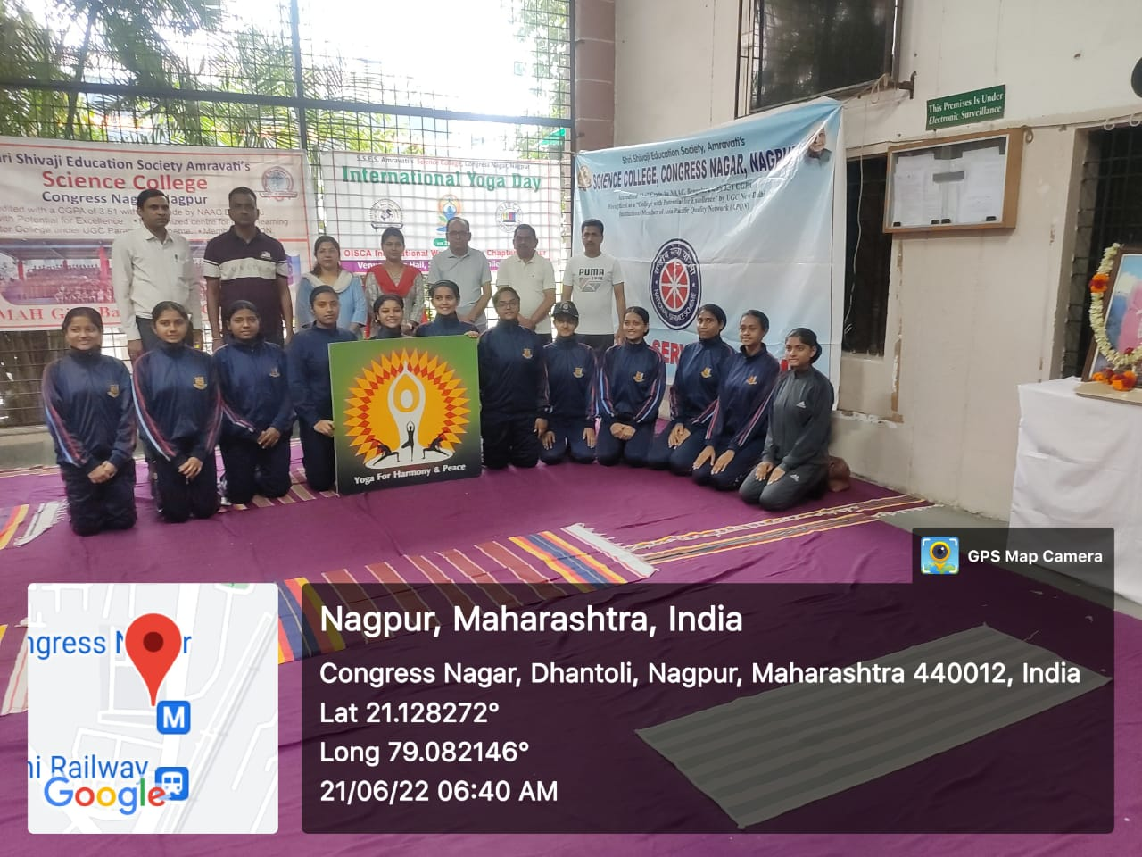
International Yoga Day Celebration on dated 21 June 2022 in presence of Hon’ble Principal Prof. M. P. Dhore Sir along with teaching faculty members and NCC cadets has actively participated.

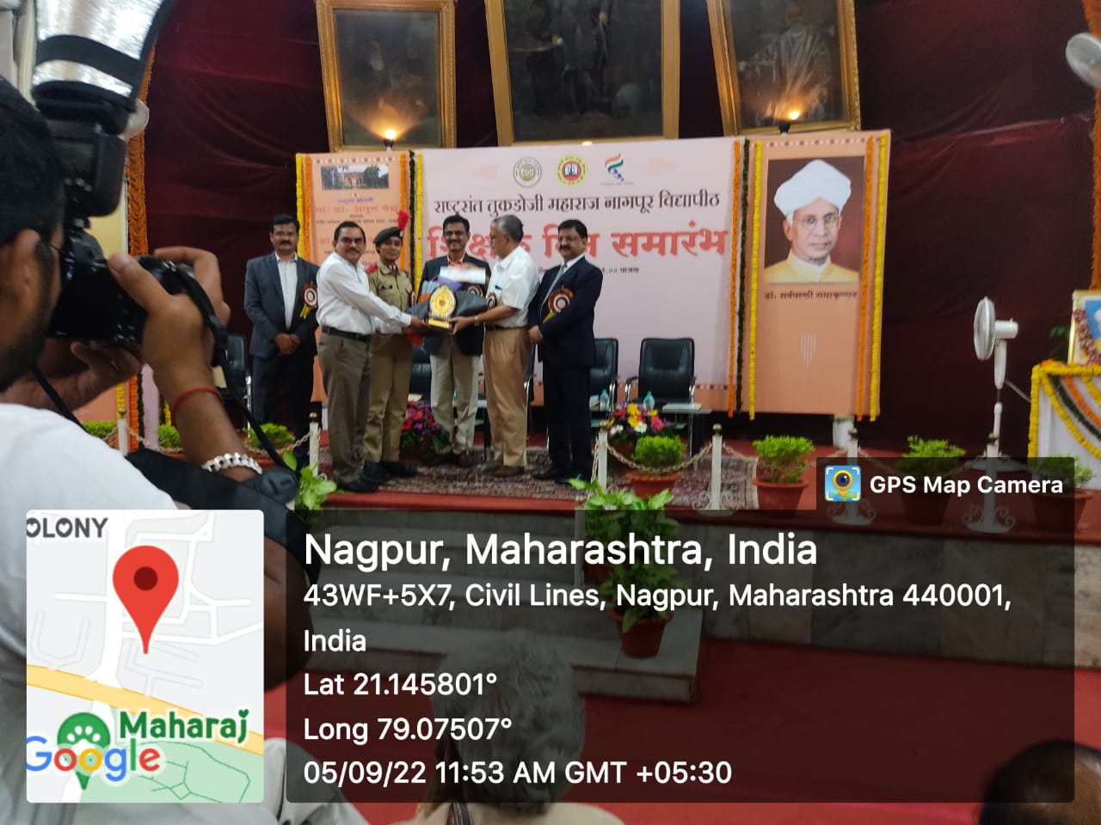
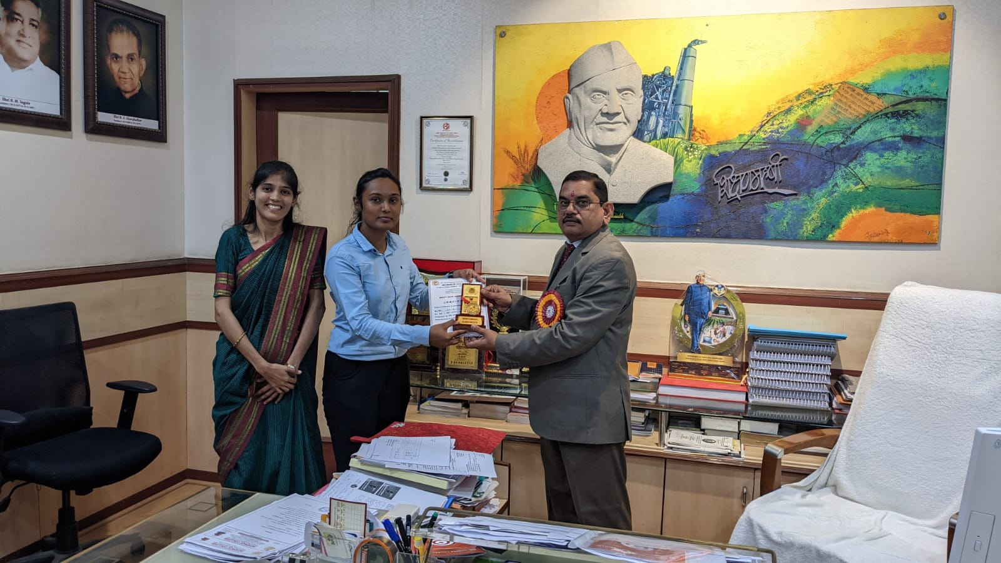
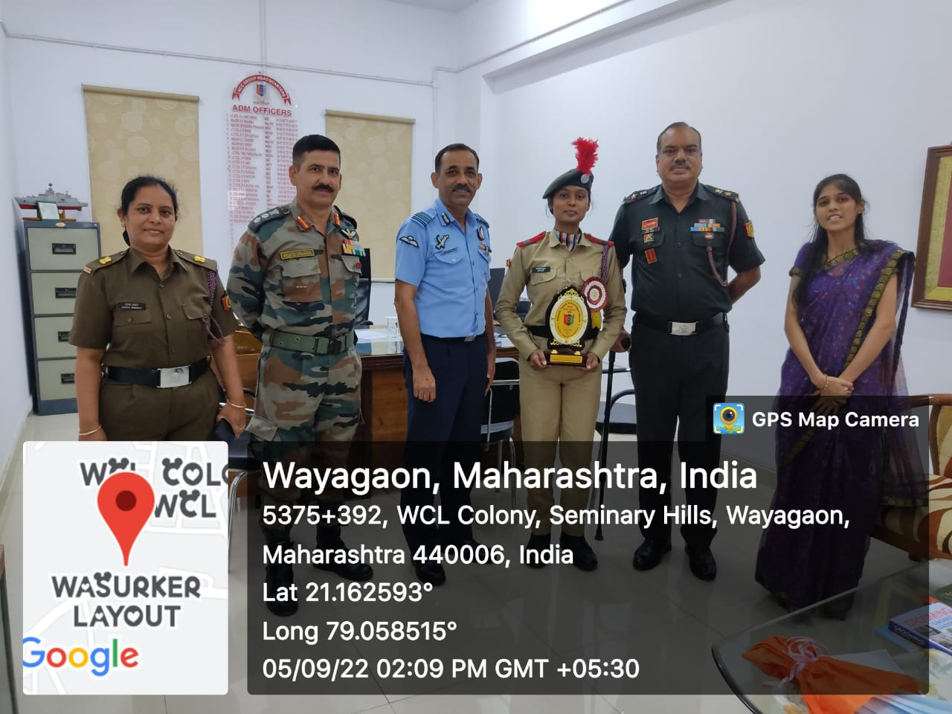

NCC Best Cadet Award (Senior Wing) given by R,T.M. Nagpur University, Nagpur to CWO Rashmi P. Balki for the training year 2020-21 on 5th September 2022.

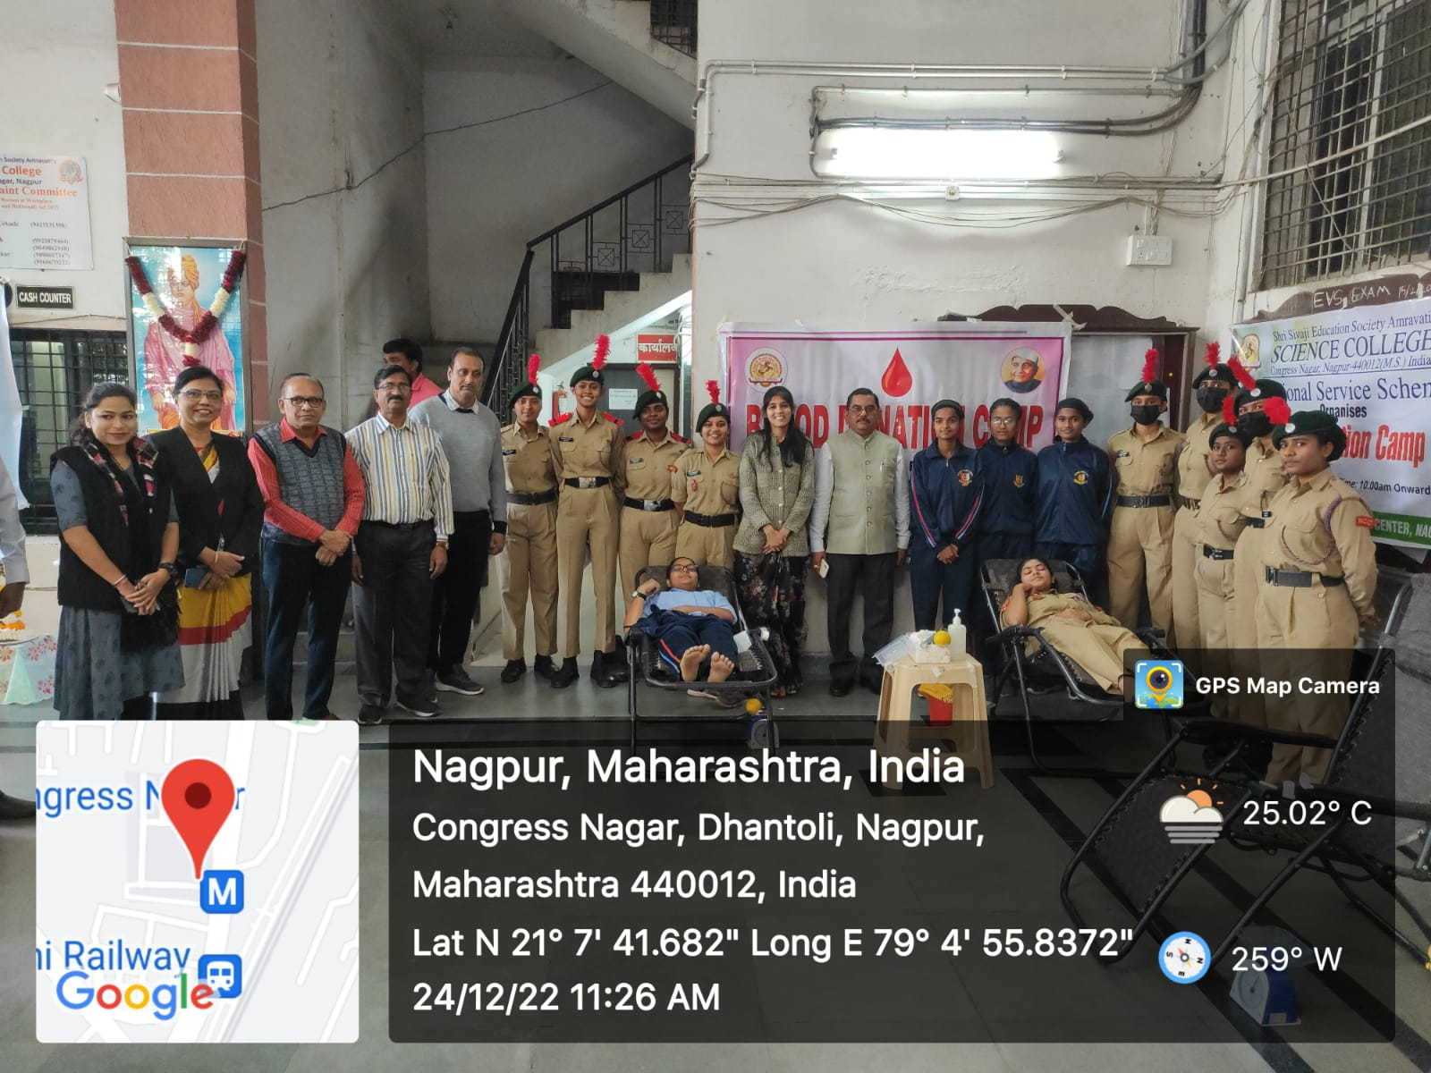
Blood Donation Camp was organized by the NCC unit on the occasion of the 124 th Birth anniversary of Dr. Panjabrao Deshmukh.

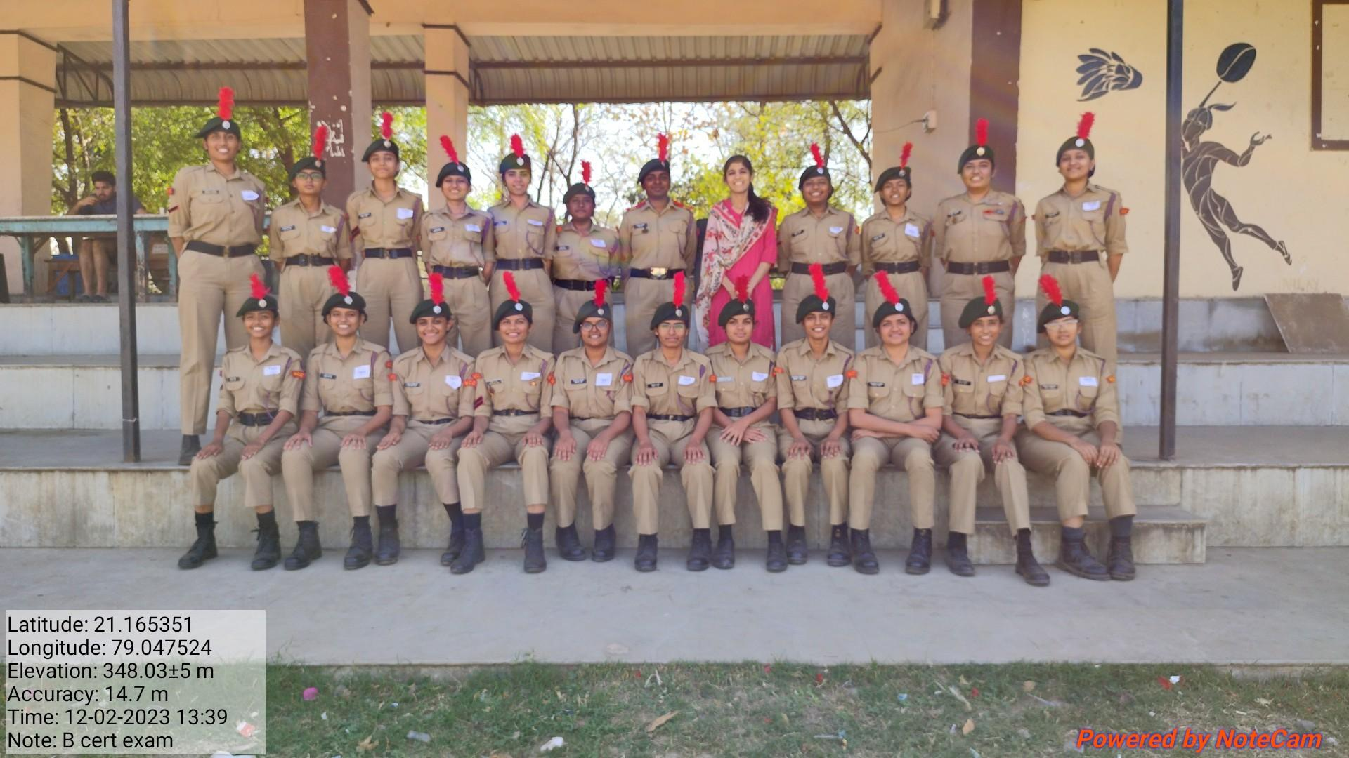 | 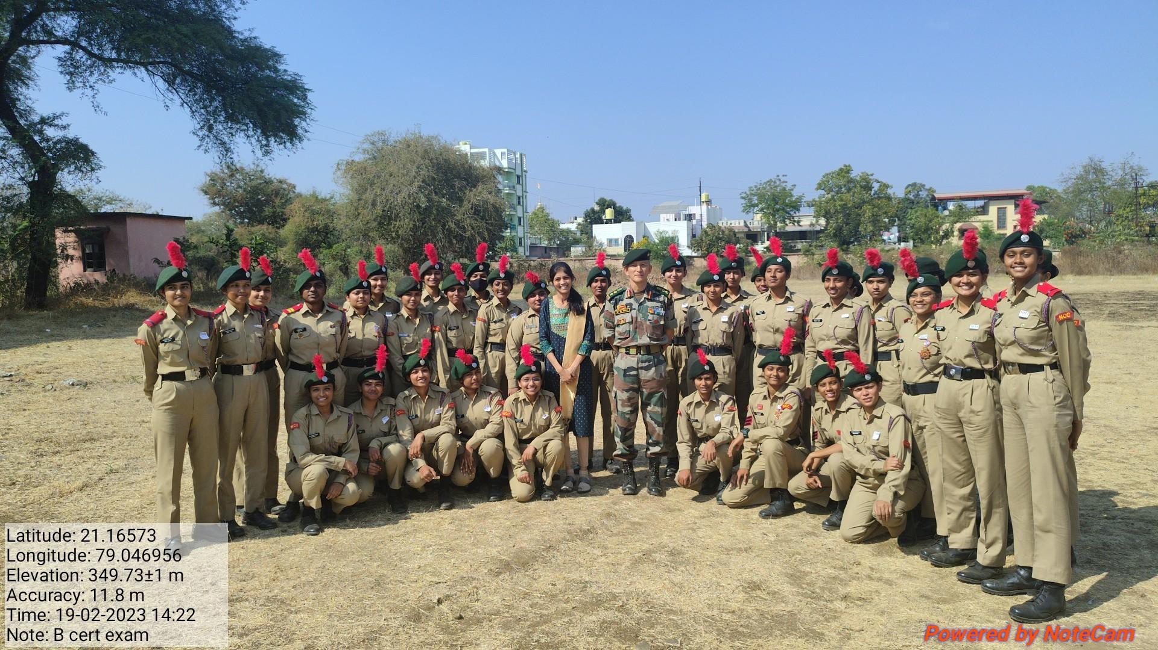

B’ cert exam. held on 11-12 Feb. 2023 and C’ cert exam. held on 18-19 Feb. 2023.
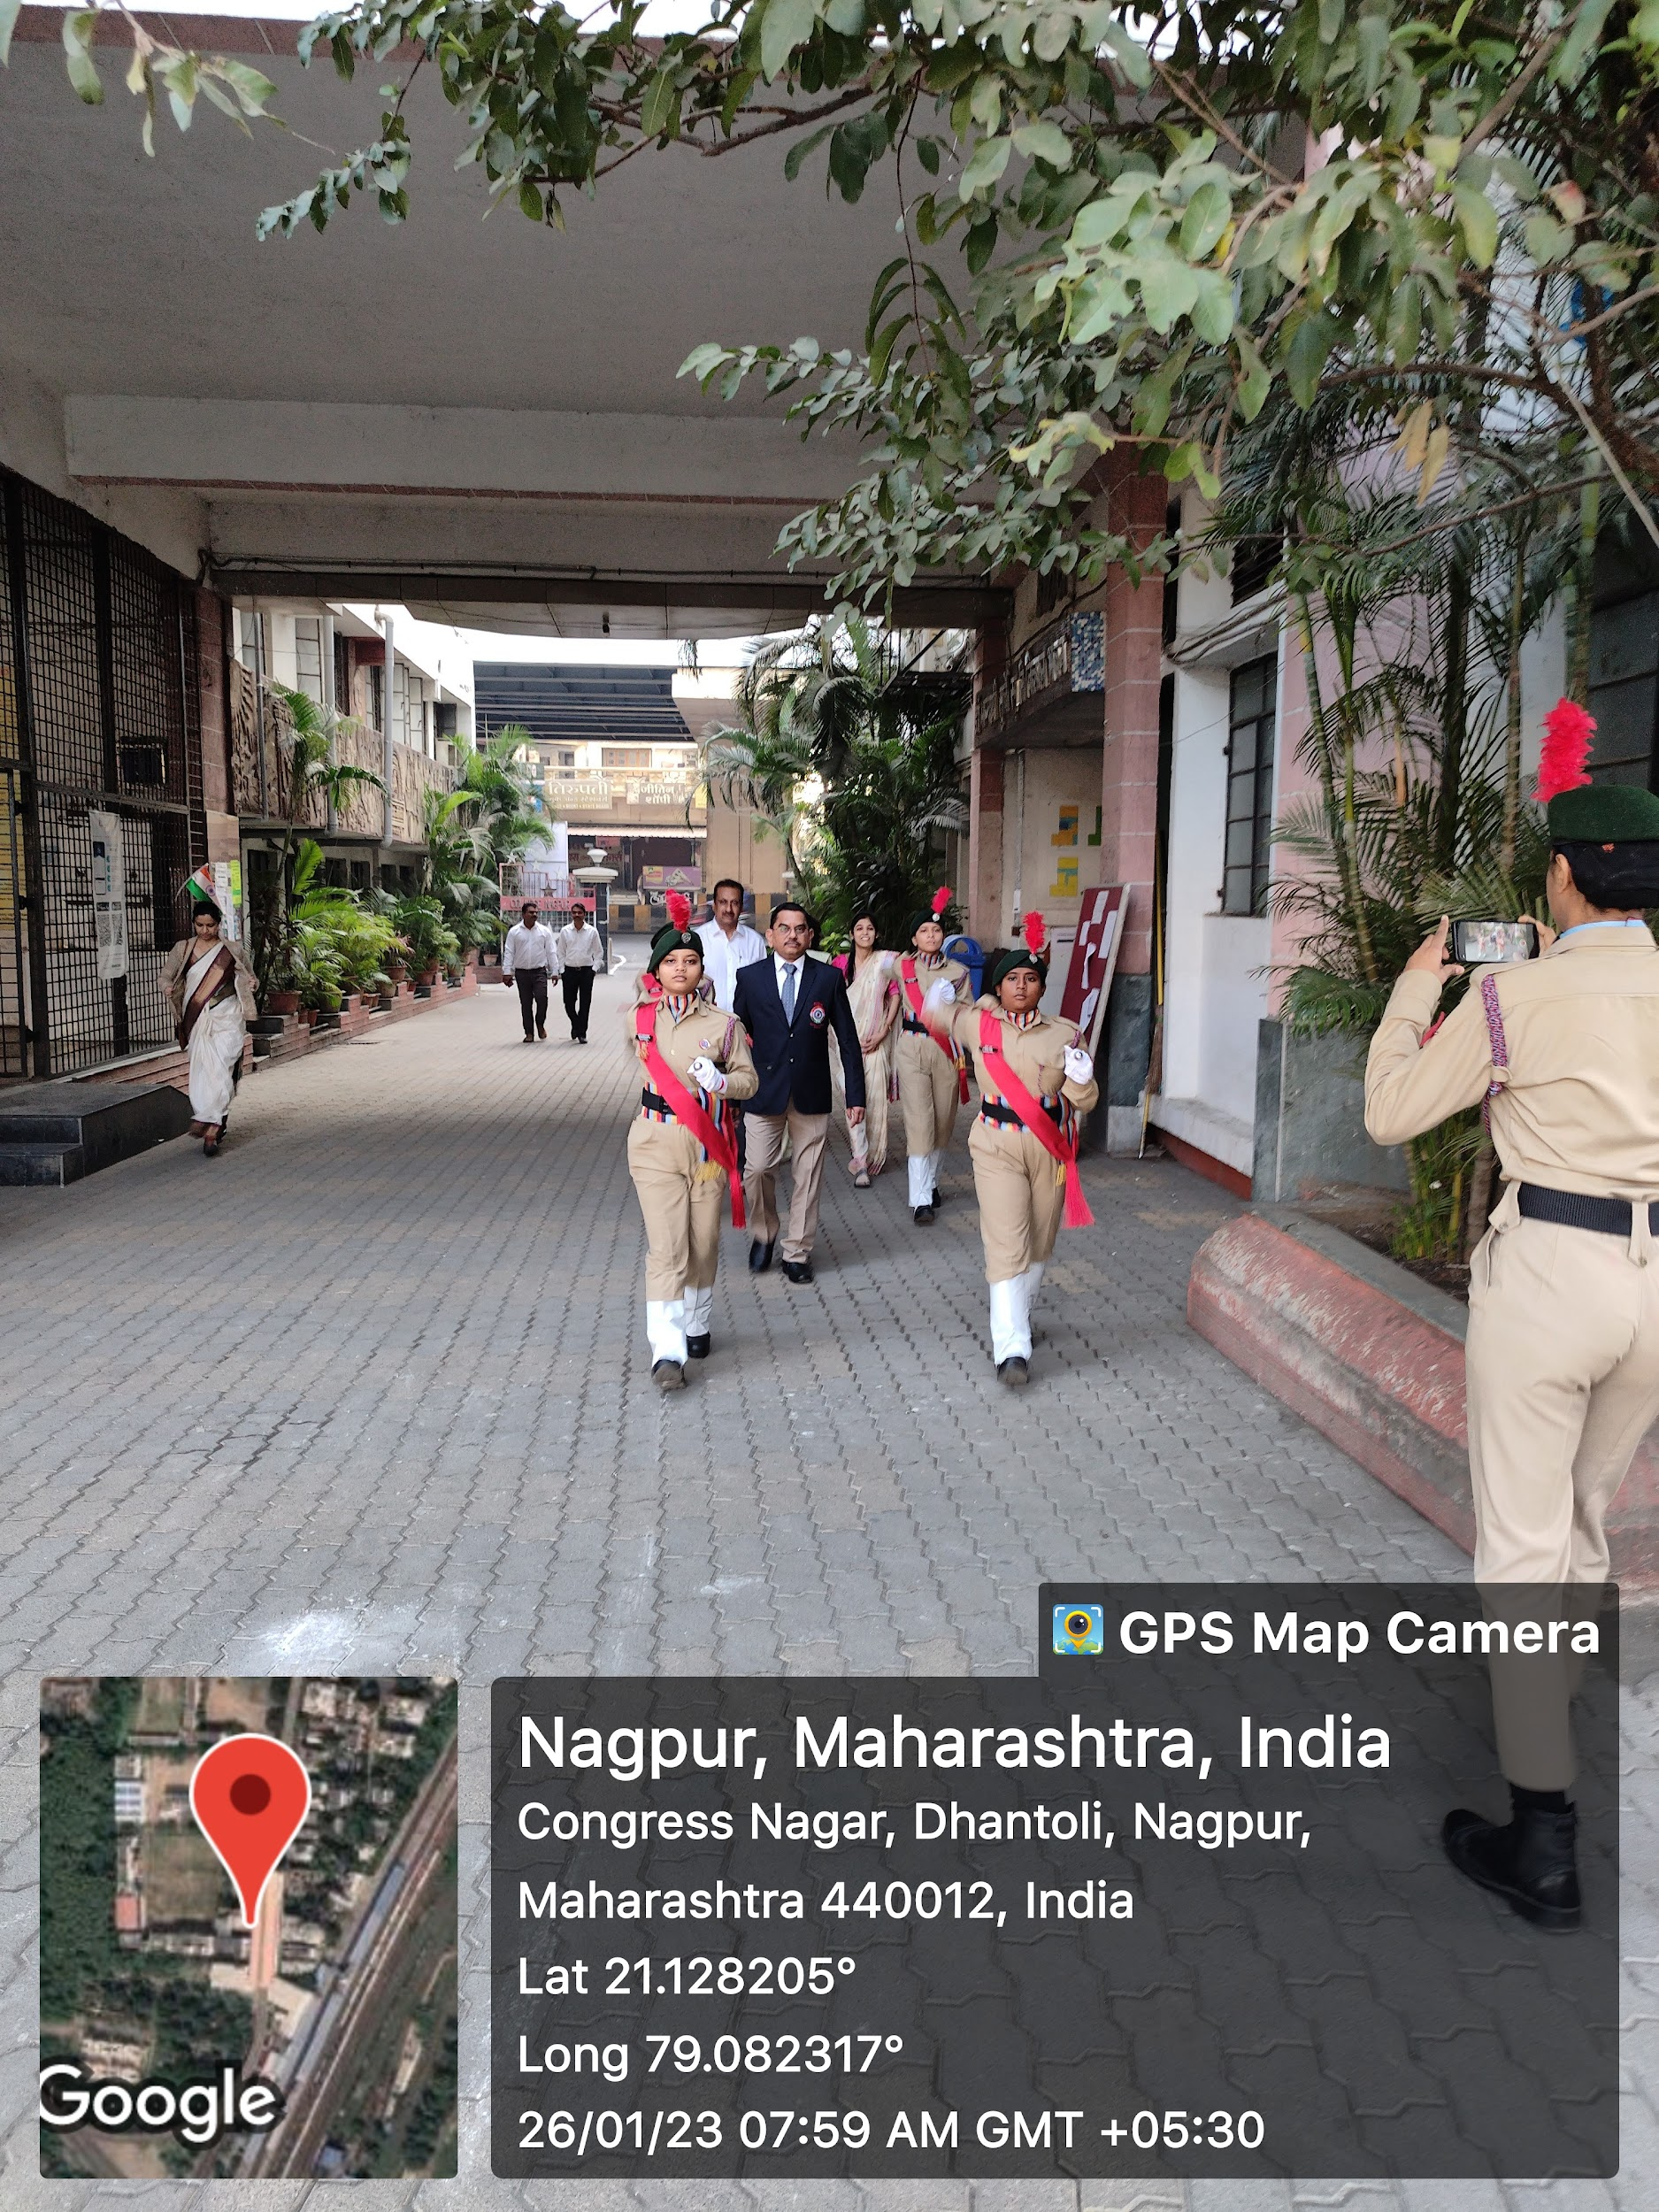 | 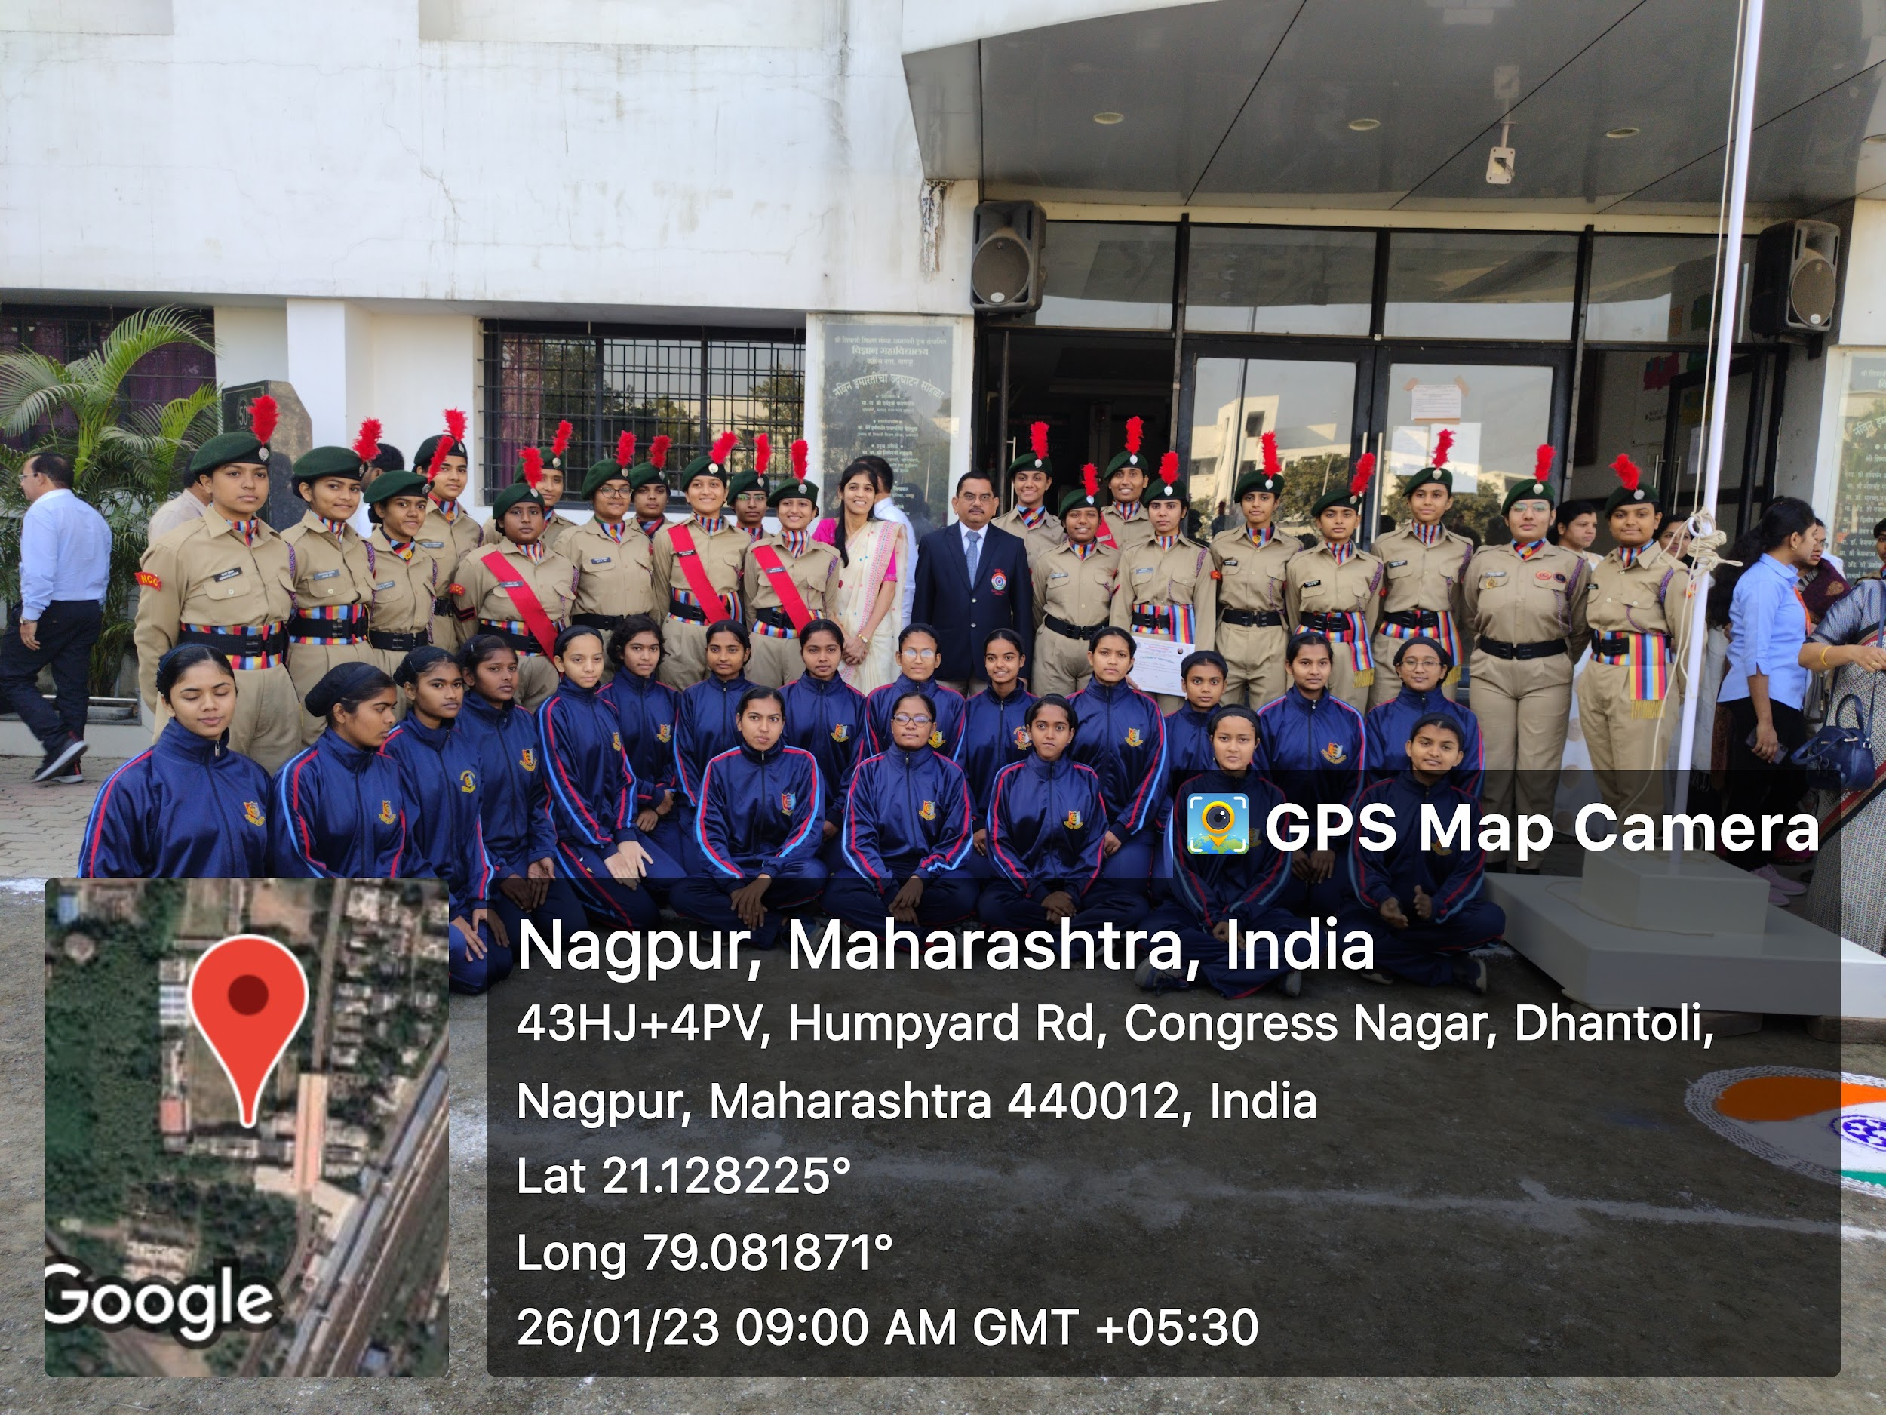
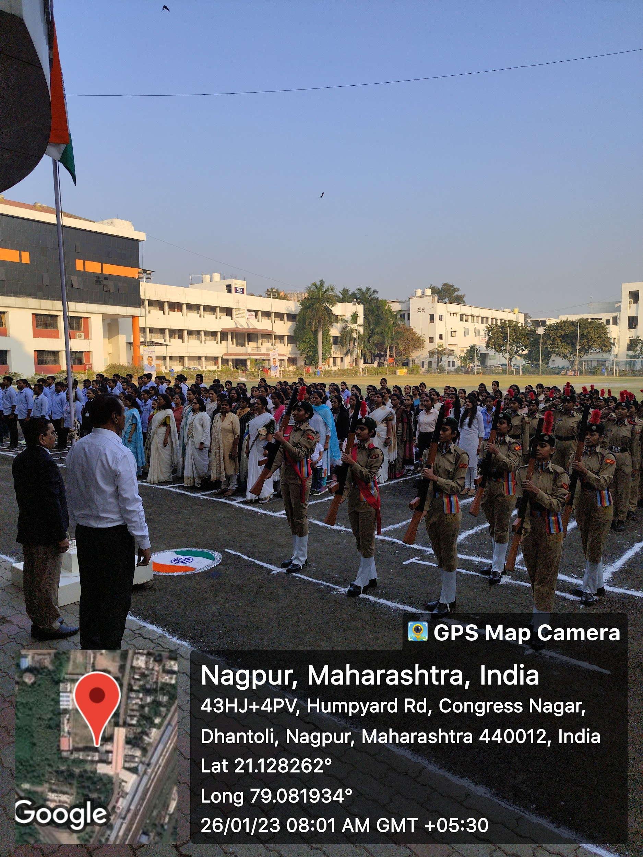 | 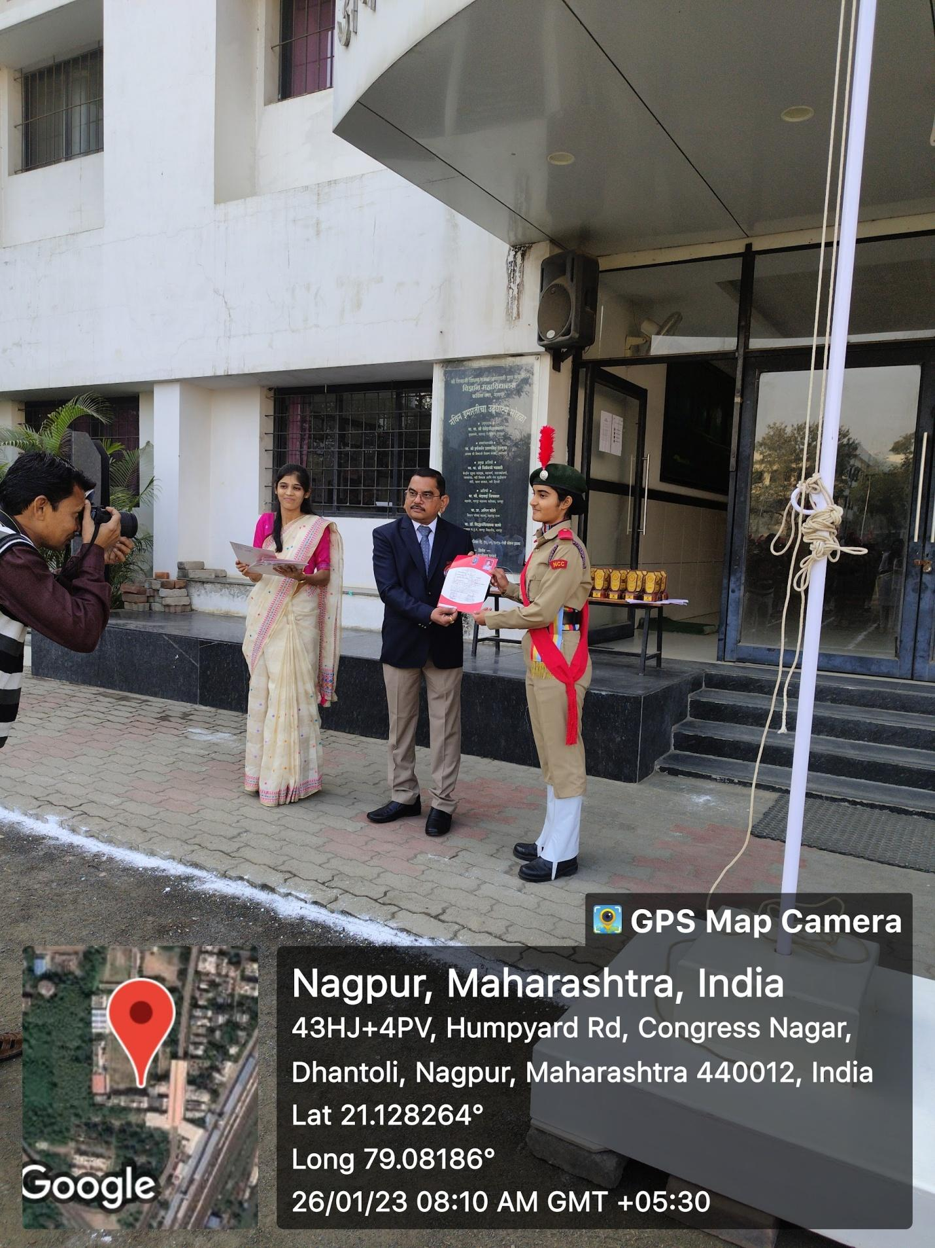

Ceremonial parades and B and C Certificate Distribution ceremony program were organized by the NCC unit on the Republic Day in presence of Hon’ble Principal Prof. M. P. Dhore Sir.

