ANUGAMI LOKRAJYA MAHAABHIYAN; ANULOM
Date: 01/08/2019
Anugami Lokrajya Mahaabhiyan was held in Shri Shivaji Science College Congress Nagar Nagpur in the presence of NSS . At this occasion Shri Hemant Bramhankar, east Vidarbha division representative anulome . Shri Abhay Deshmukh Nagpur. Shri Gadekar District Information Officer . Smt Shaileja Wagh Information Officer gives the information about this scheme. In their speech they said about the information and public relations account is with the government for the 'publicity' of the government schemes. An NGO called 'Anulom', meaning 'Subsequent Lokrajya Mahabhiyan', has been established recently.
The government has taken various development works at the village level through the social responsibility funds of corporate companies. It is understood that the responsibility for these activities lies on 'Anulom'. It is understood that the organization has been entrusted with the task of creating positive public opinion. At this occasion around 100 NSS volunteers were present.

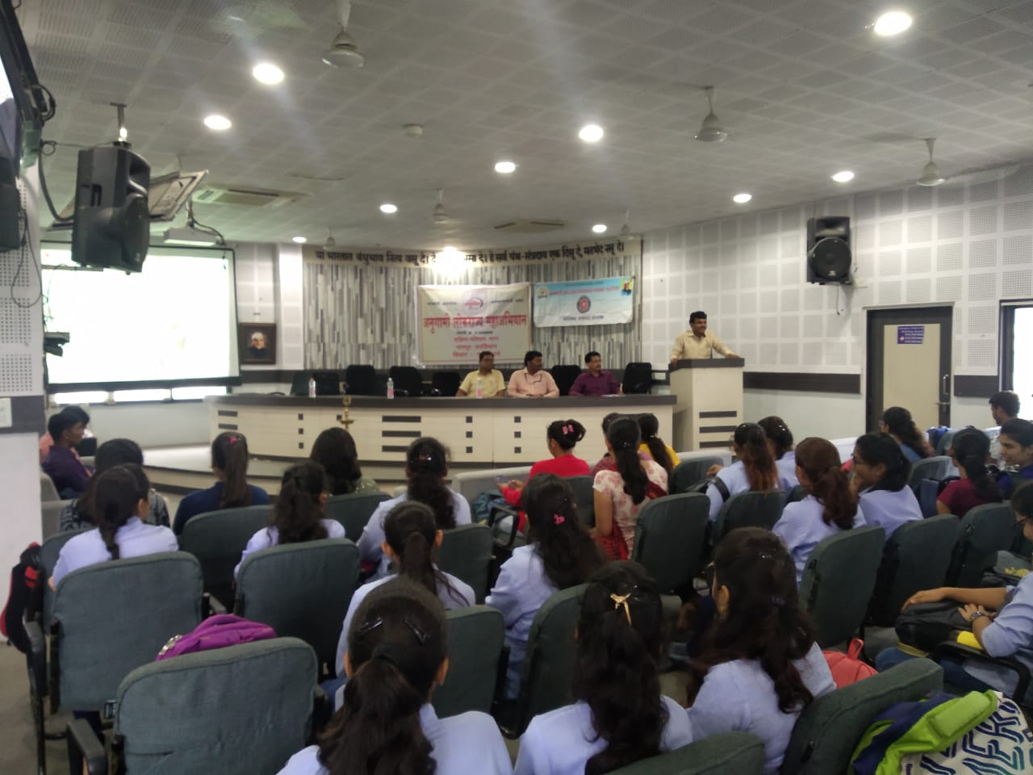
Shri Hemant Bramhankar, east Vidarbha division representative “anulome” counselling students

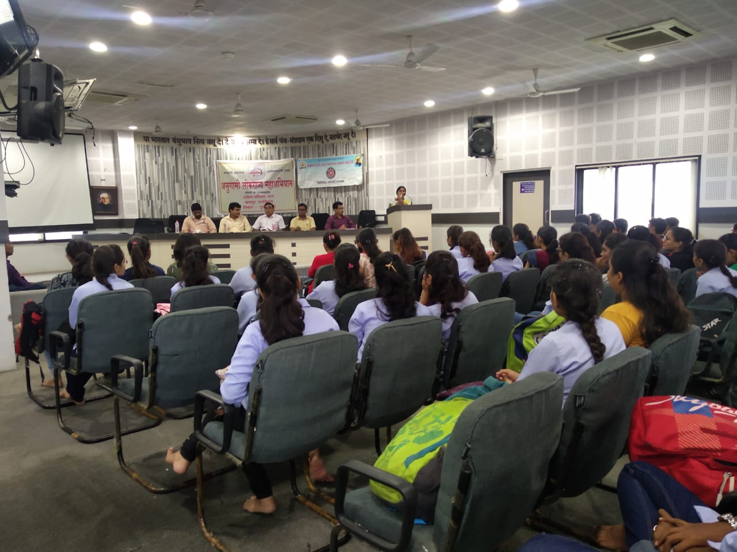
Smt Shaileja Wagh Information Officer explaining about the scheme

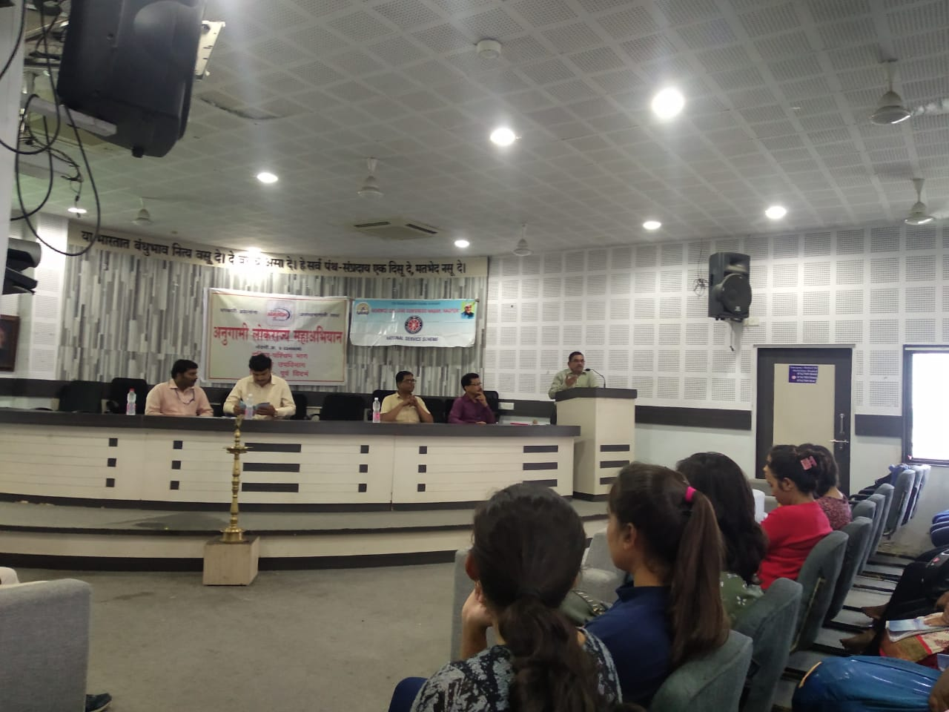
Principal M. P. Dhore addressing students

