Session 2020-2021
Blood Donation Camp
26th December 2020
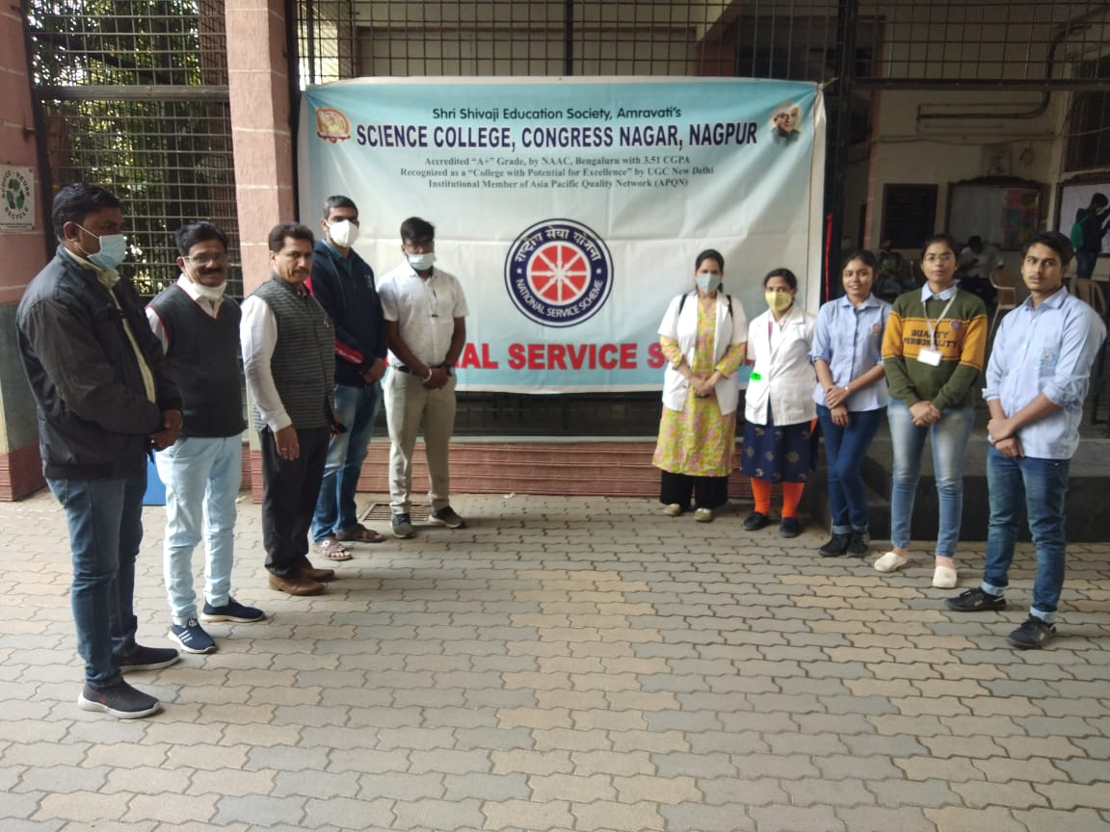
Prof. P. S. Utale, NSS Coordinator with Officials from Government Medical College, Blood Bank, Nagpur
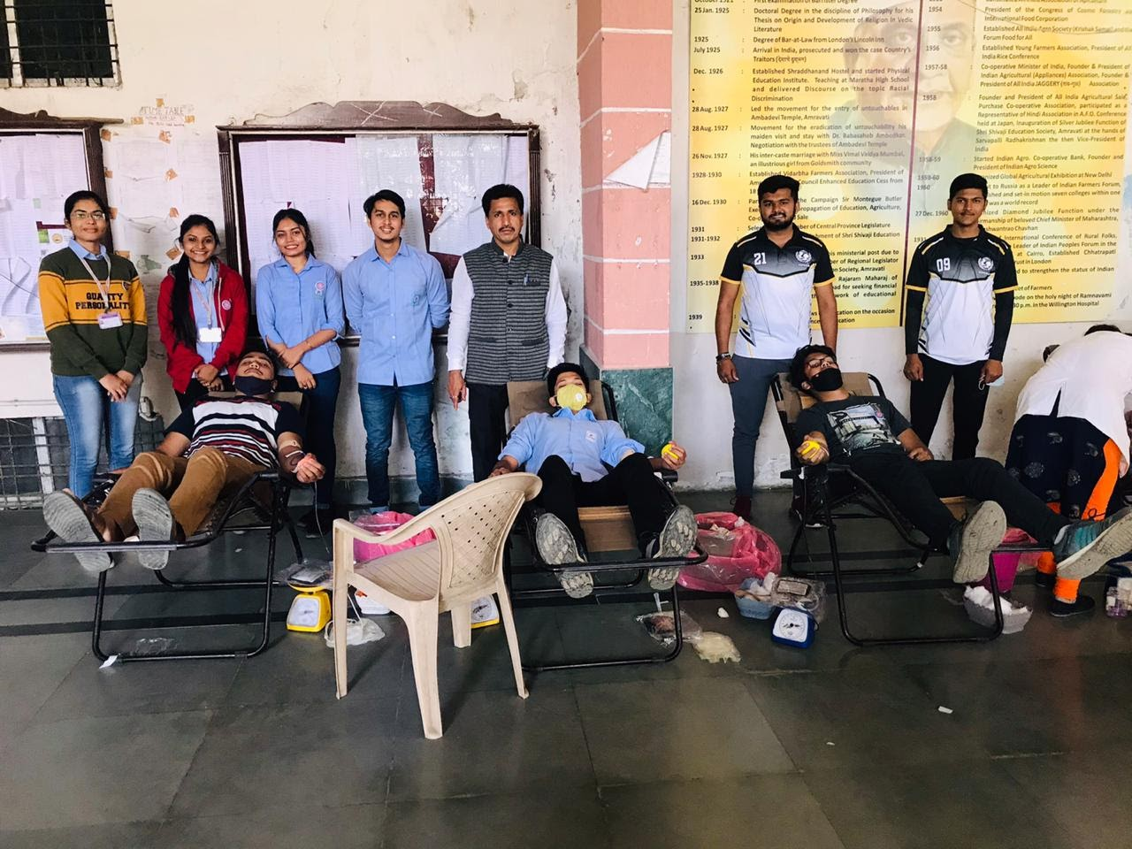
NSS Volunteers taking part in the blood donation
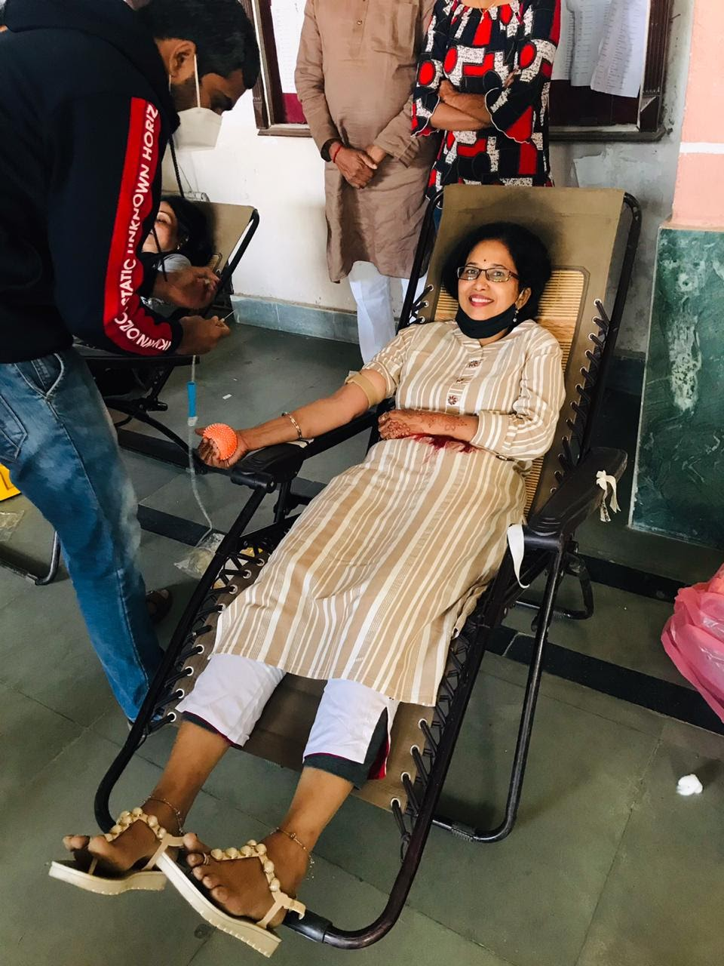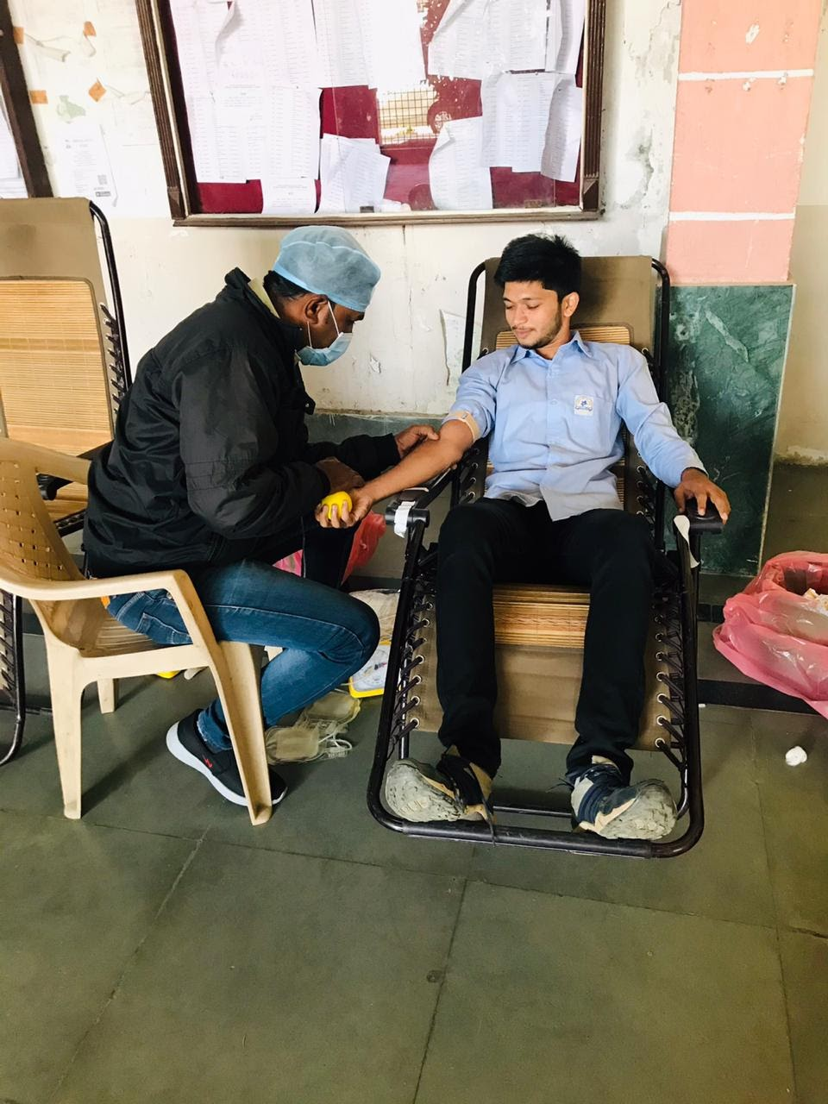
Student and family member of Faculty participating the Blood donation

