Seminar of Human Rights and Constitution of India

Activity : N.S.S Activity .
Date : 8 September 2018
Department : NSS

College : Shri Shivaji Science College, Nagpur.

Location :NAGPUR

Monitored by: Name(s) and position:

1- Dr.P. S. Utale, (convenor).

Objectives of the Seminar:

- To understand the Constitution and Human Rights.
- To prepare students for Competitive Exams.

Points of Note:

The NSS team from Pune had organized the program “Awareness on Human Rights and Constitution of India” on 8th of September 2018. They also gave a seminar on the topic mentioned above. Later they took an Exam which was based on Constitution and Human Rights. The main motive was to create awareness among students about the topic and give them the first hand experience regarding the competitive examinations.

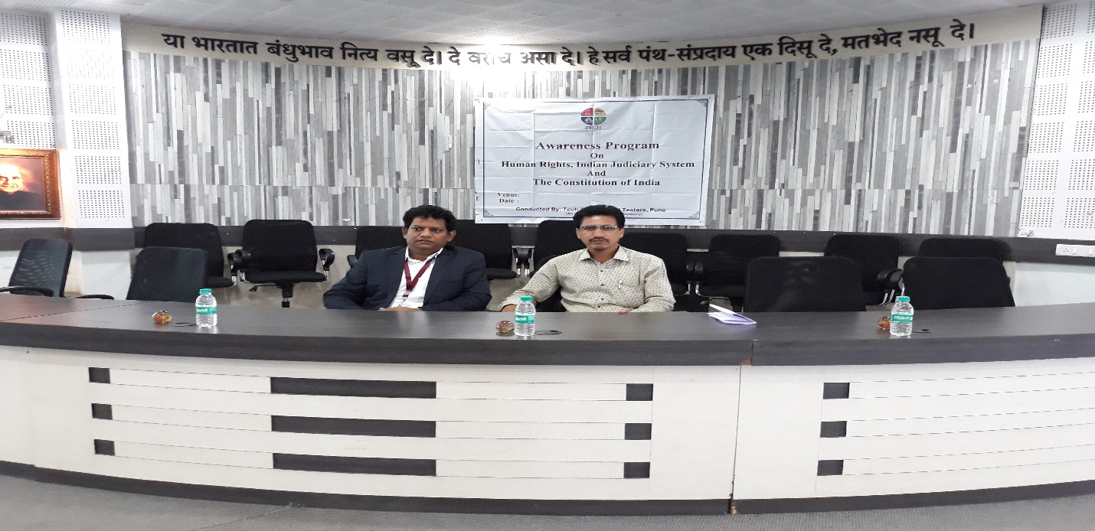
Pune Guest with NSS Programme Officer
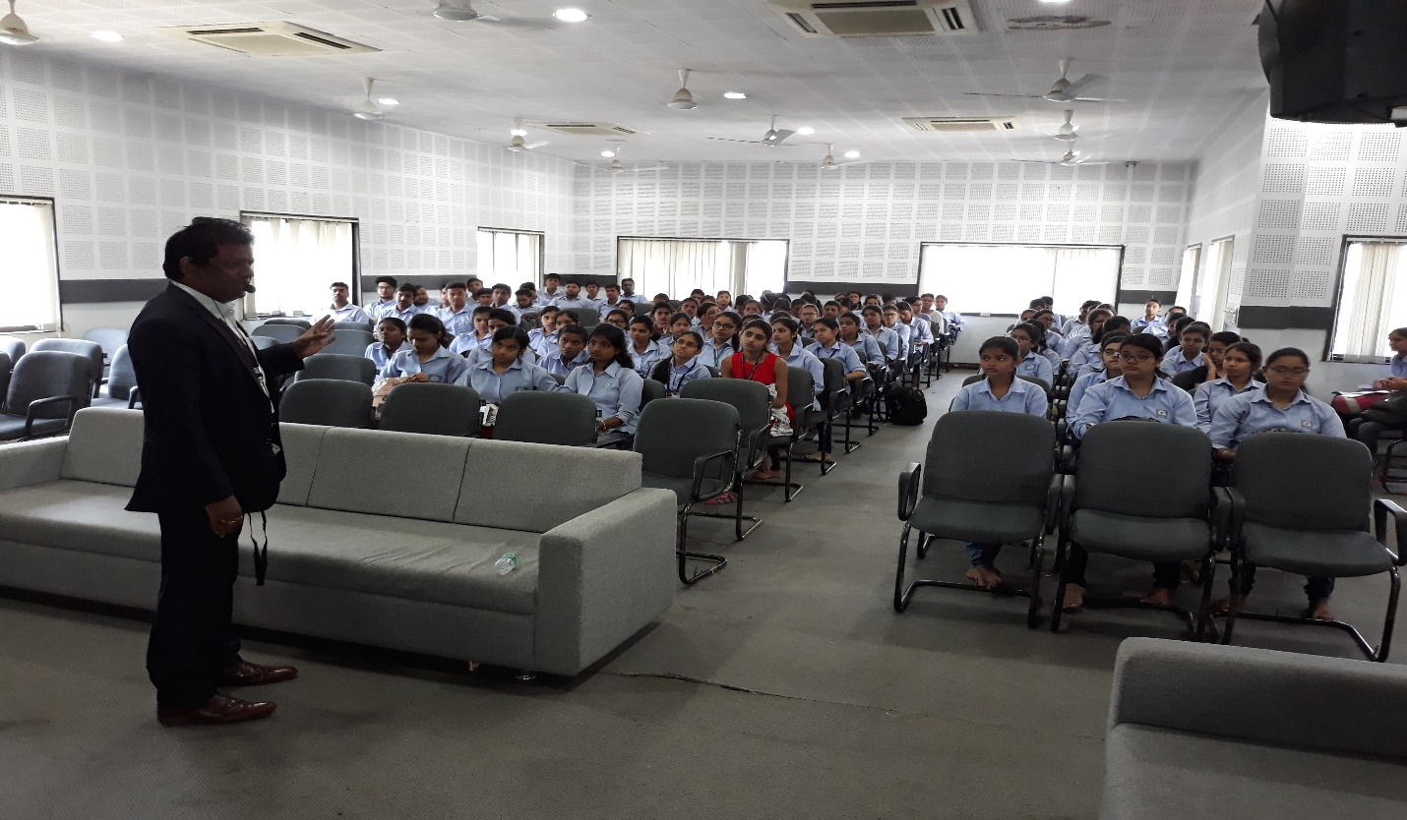
Speaker delivering a talk on Human Rights and Constitution

