N.S.S. CAMP
2019-2020

Swachha-Bharat Abhiyan

Place : Fetri Dist.Nagpur

From 5 Jan 2020 to 11 Jan 2020

N.S.S CAMP : 2019-2020
Day 1: Sunday, 5 Jan 2020
Inauguration Ceremony of NSS Camp
The National Service Scheme of Shri Shivaji Science College Nagpur organized 7 days camp from 5 Jan to 11 Jan, moto on Swachha Bharat Abhiyan.
The camp was inaugurated by the foster director of Shri Shivaji Science College Nagpur and working member of Shivaji Education Socienty Amravati Mr. Hemant Kalmegh, director of N.S.S. committee Mr. Keshavrao Gavande, chief guest of the ceremony and Working member of shri shivaji education society Mr. Keshavrao Metkar. Miss. Dhanashri Dhomane Sarpanch gram Panchayat Fetri, Mr. Ashish V.Ganorkar, Dr. G.R. Avachar vice principal of science college Nagpur, Dr. Prashantshing Utale N.S.S. coordinator science college Nagpur.
The inaugurated function was started at 12.30 pm; Director and chief guest interacted with student as well as gave information about N.S.S. at 6 pm all volunteers and coordinator pray community prayer.
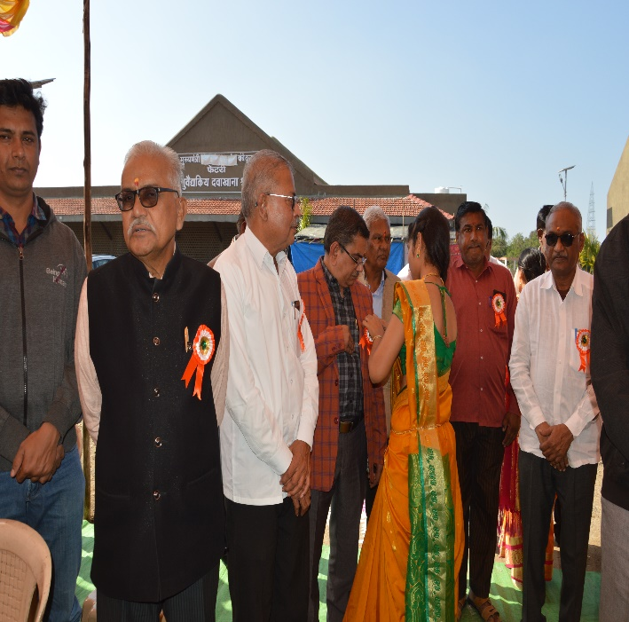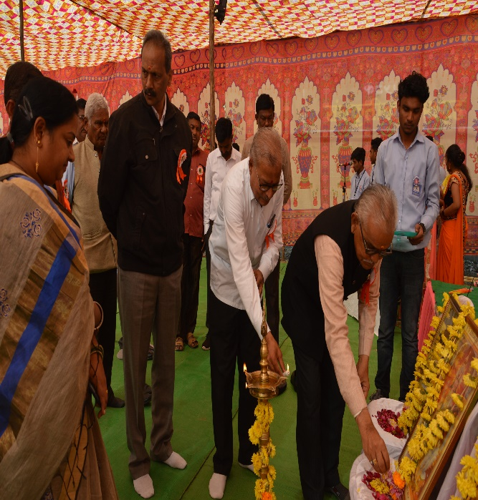
All the Guests including working member of Shivaji Education Socienty Amravati Mr. Hemant Kalmegh, director of N.S.S. committee Mr. Keshavrao Gavande, chief guest of the ceremony and Working member of shri shivaji education society Mr. Keshavrao Metkar. Miss. Dhanashri Dhomane Sarpanch gram Panchayat Fetri, Mr. Ashish V.Ganorkar, Dr. G.R. Avachar vice principal of science college at the inaugural function of NSS Camp

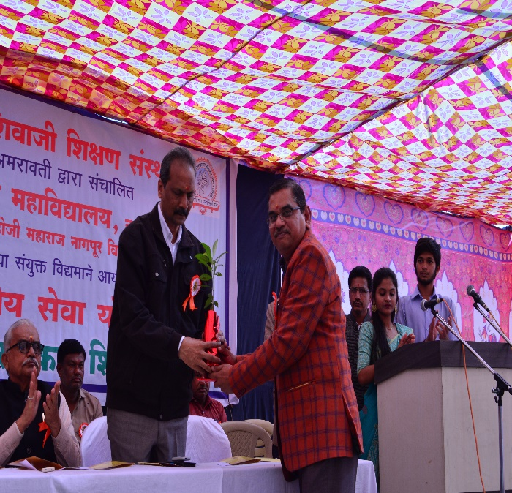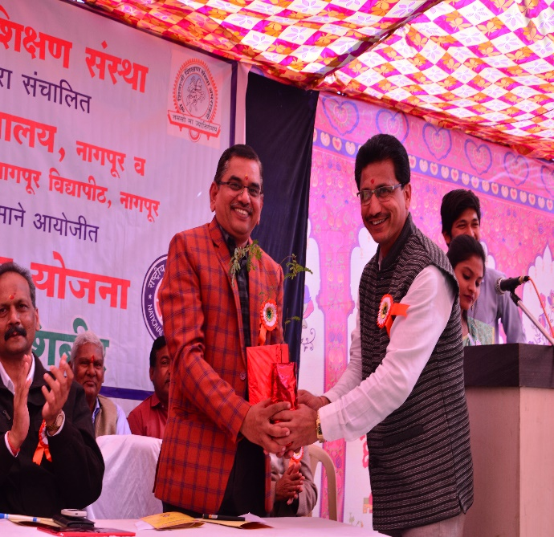
Prof M. P. Dhore welcoming working member of Shivaji Education Socienty Amravati Mr. Hemant Kalmegh, and Prof P. S. Utale, Program Officer NSS welcoming Prof M. P. Dhore ,Principal , Science College, Nagpur
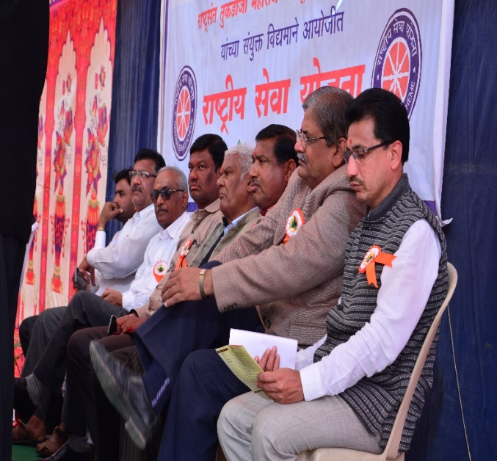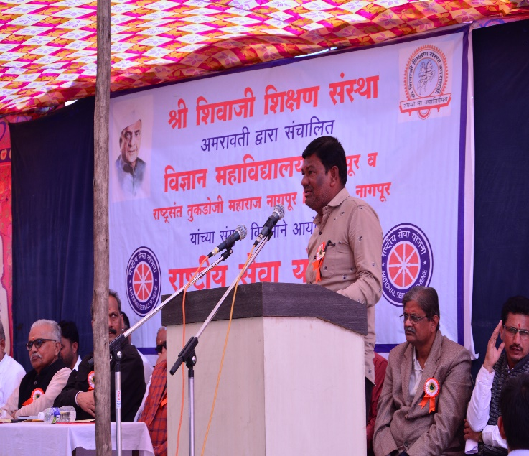
All the guests on the dais and Mr. Ashish V. Ganorkar addressing the gathering

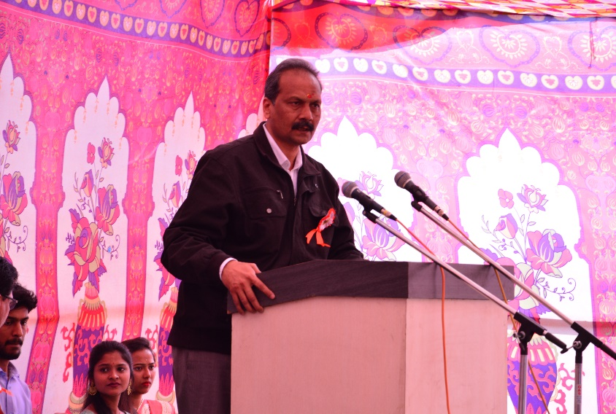
Working member of Shivaji Education Socienty Amravati Mr. Hemant Kalmegh, addressing the gathering at the Inaugural day of NSS Camp
Day 2: Wednesday, 6 Jan 2020
Activity: Swachha Bharat Abhiyan (campus cleaning)
Monitored by:
- Dr. M.P. Dhore principal of science college Nagpur
- Dr. Prashantsingh Utale N.S.S. Coordinator science college Nagpur
- Mrs. Dhanashri M. Dhomne, Sarpanch grampanchayat panchayat
- Dr. S.S Darokar member of N.S.S. of Science college

Point to be note :

The N.S.S. team of Sri Shivaji Science college had organized the 7 days camp “Swachh Bharat Abhiyan” from 5 Jan to 11 Jan 2020. Behalf of this on second day i.e on 6 Jan 2020 camp organized campus cleaning work, from this work volunteers can understand the importance of the cleanliness and maintained the discipline in our day to day life. Also student can learn how to keep cleanliness to our surrounding where they live. Regularly waking up early and doing yoga for a healthy body.
At 2 pm we had guest lecture on biodiversity by Dr. Nitin Dongarwar assistant professor of botany of RTMNU Nagpur. After guest lecture all volunteers involved in sport activity. At 8 pm we had dinner.
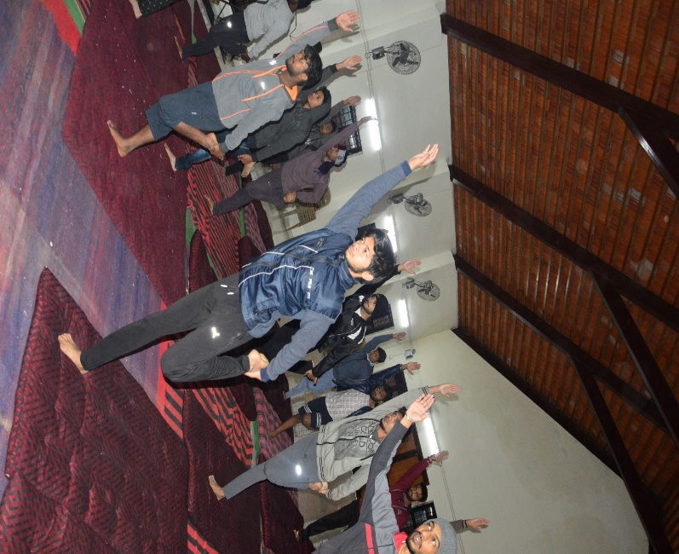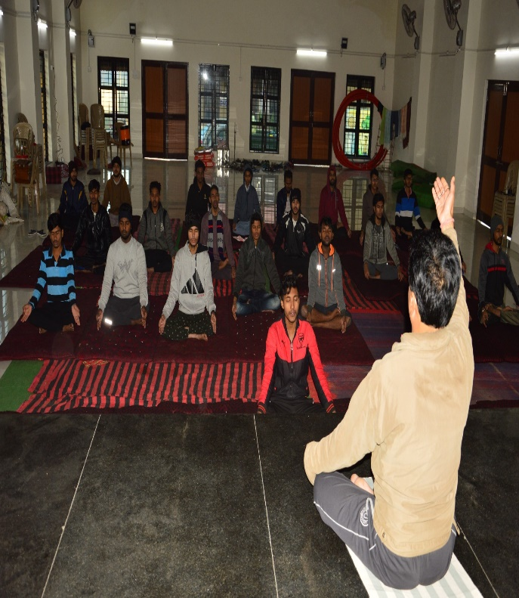
NSS volunteers performing Yoga and the Yoga Instructor instructing students
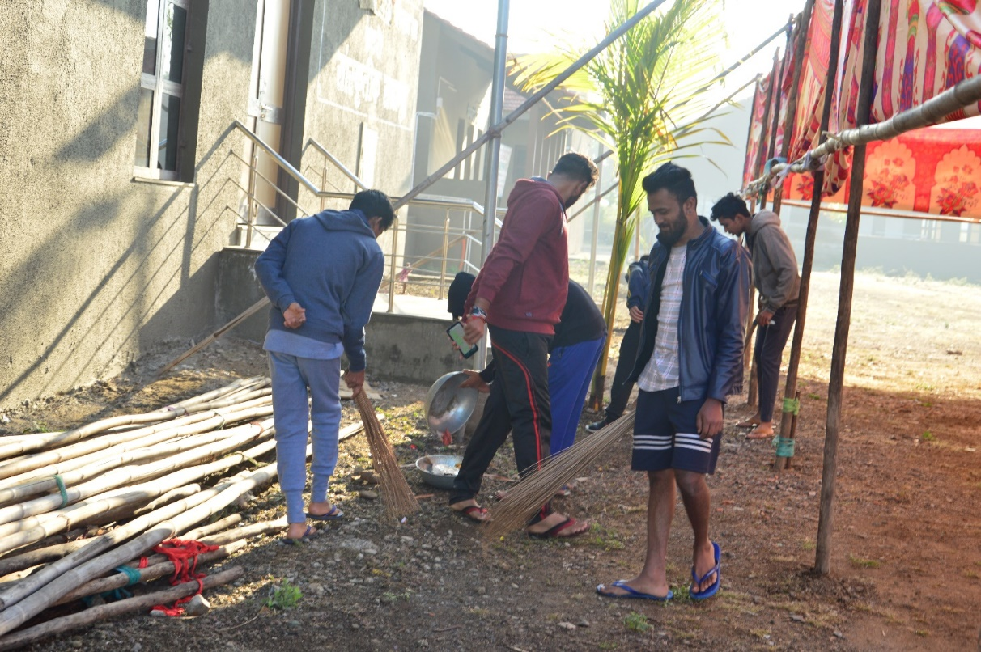
NSS volunteers cleaning the Camp campus

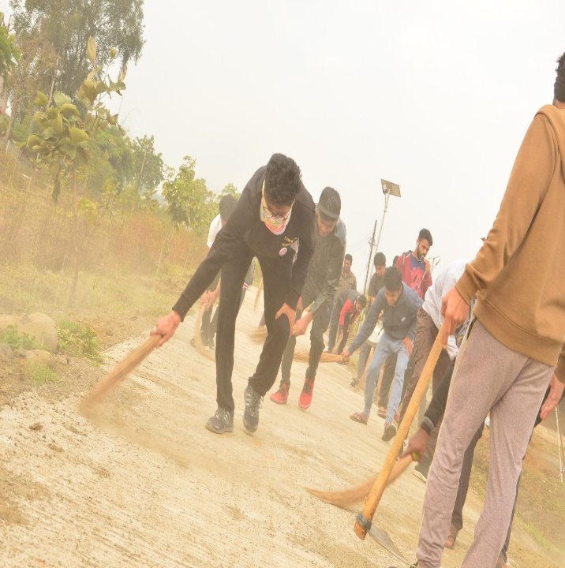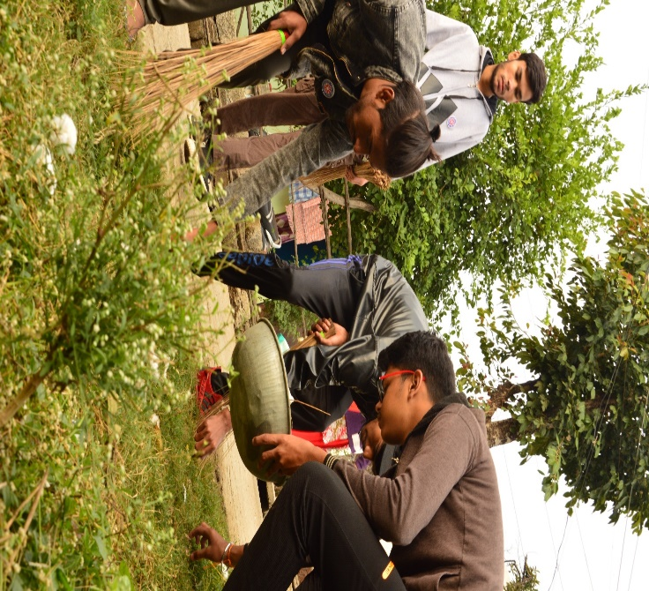
NSS volunteers cleaning the village

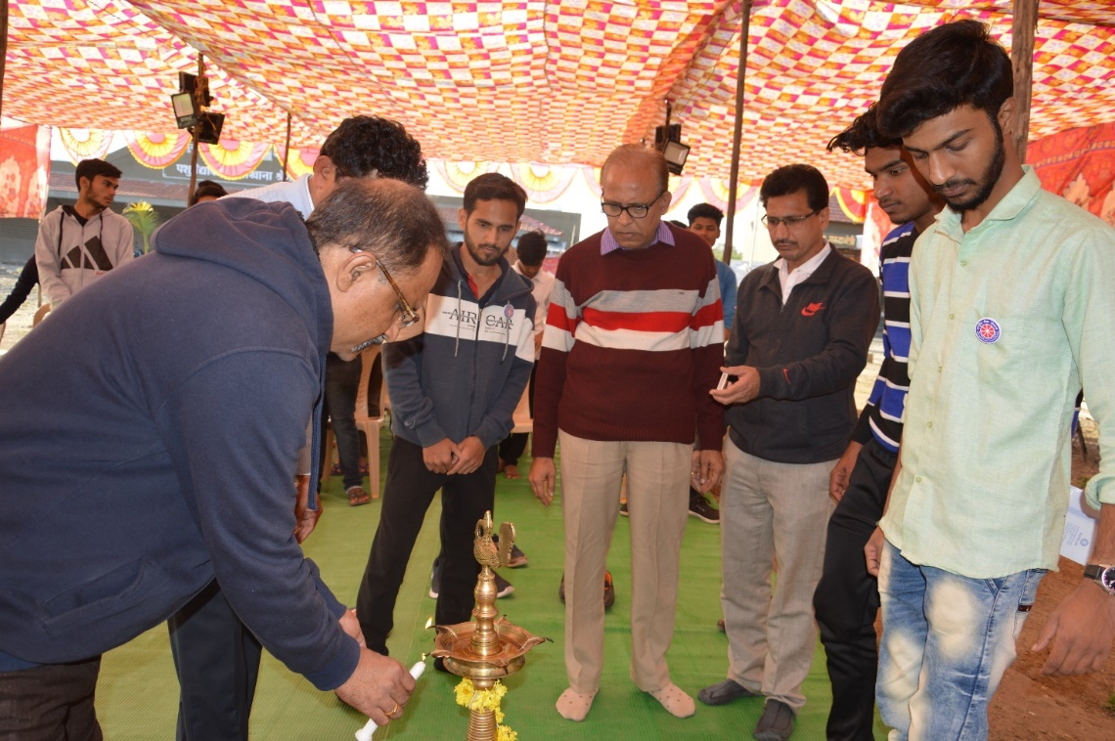
Inauguration of Day 2 Program at the hands of Dr. R. N. Deshmukh, Prof A. D. Bobade and Dr. Nitin Dongarwar Assistant professor of Botany of RTMNU Nagpur
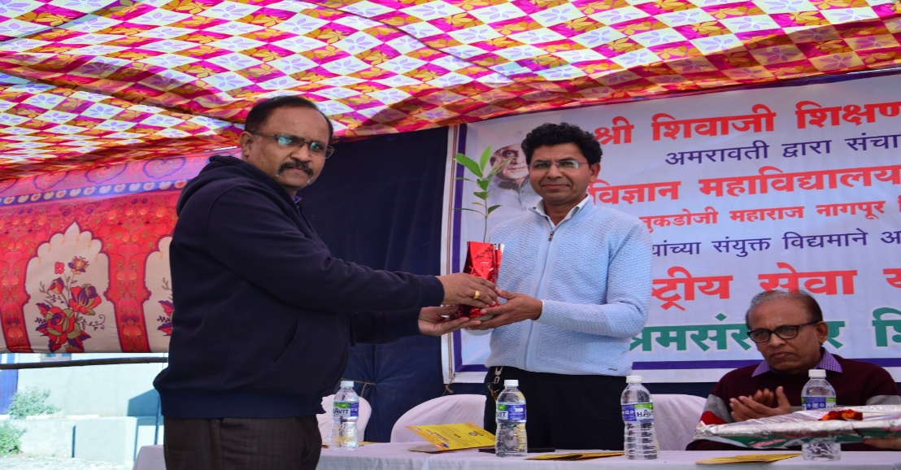
Prof A. D. Bobade welcoming Guest speaker Dr. Nitin Dongarwar, Assistant professor of Botany of RTMNU Nagpur

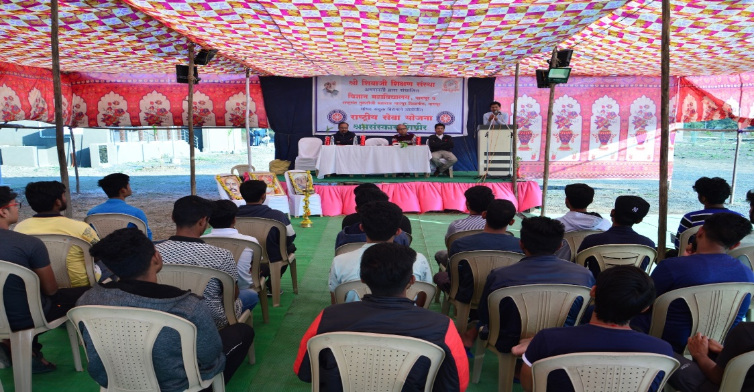
Speaker Dr. Nitin Dongarwar, Assistant Professor of Botany of RTMNU Nagpur delivering a lecture on biodiversity

Day 3: Wednesday, 7 Jan 2020
Points of Notes:
The day started at 6am when all the volunteers exercised and performed yoga as instructed by our NSS coordinator, then all the candidates had their breakfast. After that from 8am to 11am we had conducted cleanliness program in village. We cleaned the streets and unclean spots inside the village. After that all the volunteers had their lunch and some rest. At 2pm there was a guest lecture on personality development and protection of environment by Dr. A.K. Ane, Science College, Pauni.
After that all the students had a GK quiz where they all participate. Then all the volunteers and the guest with the coordinator had dinner all together.
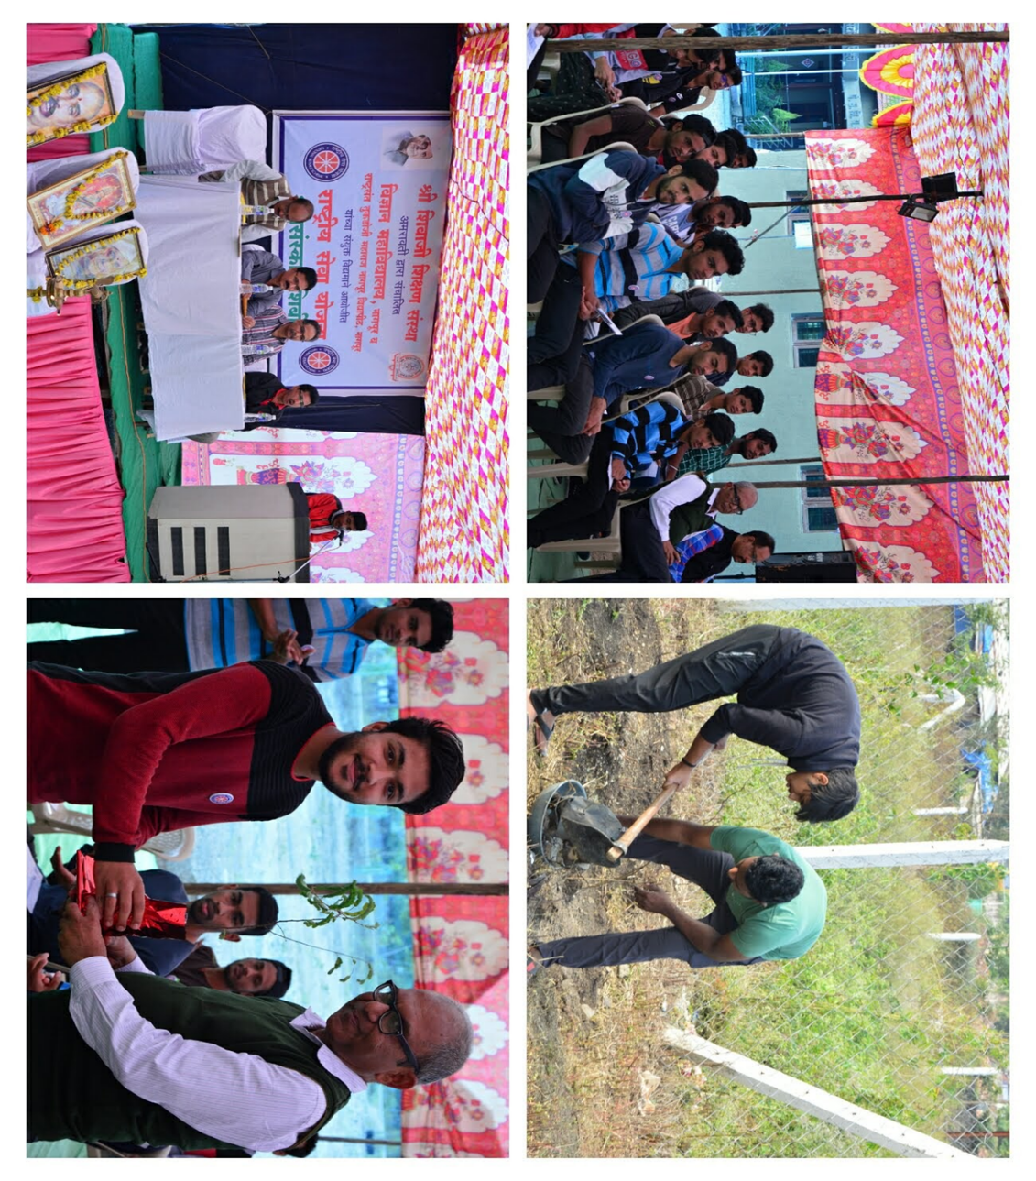
Prof Darokar, Head of physics department ,Dr.S.W.Anwane, on the third day of NSS Camp

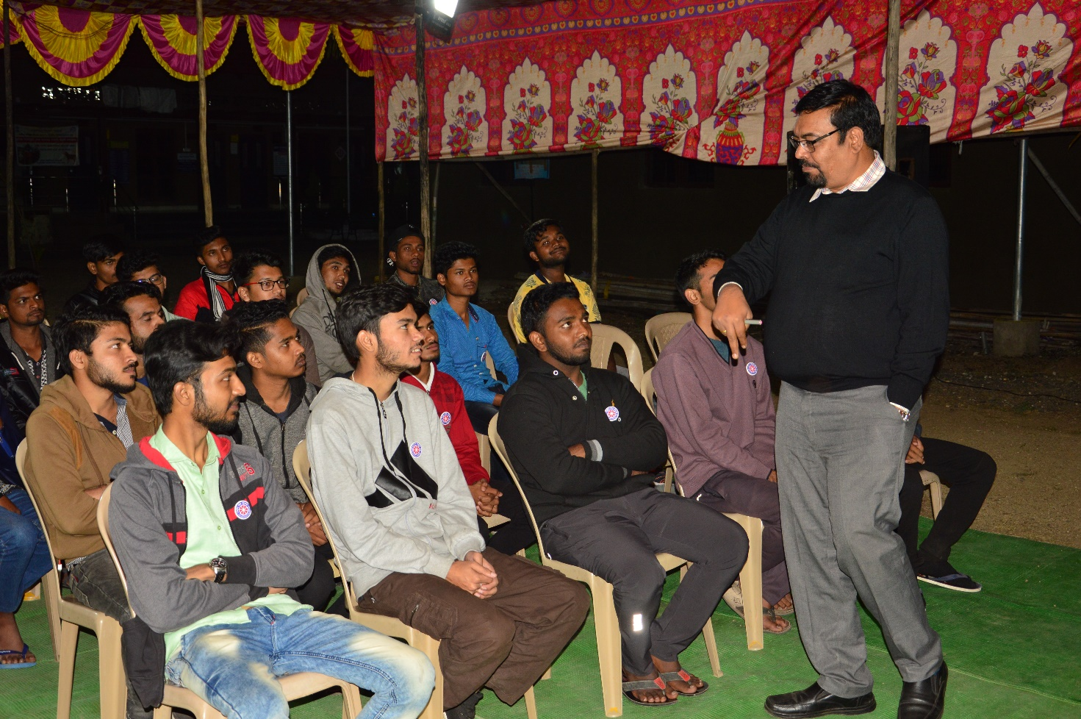
Dr. A.K. Ane, Science College, Pauni. Addressing students on personality development and protection of environment

Day 4: Thursday, 8 Jan 2020
Point of note:
All the student woke up at 6 am and did yoga and exercise under the guidance of coordinator after that all volunteer had healthy breakfast and from 8 am to 11 am all NSS volunteer conducted tree plantation on the both sides of street as well as empty places of the village. At the tree plantation program officer of the regional forest department, Sarpanch of the village were present. After planting tree all volunteers take bath and then healthy launch. After launch all volunteers play cricket, football and badminton. At 2 pm there was guest lecture on impact of internet on youth by Mr. Ashish Dhabale sir. After guest lecture all volunteer with guest take dinner at 8 pm.
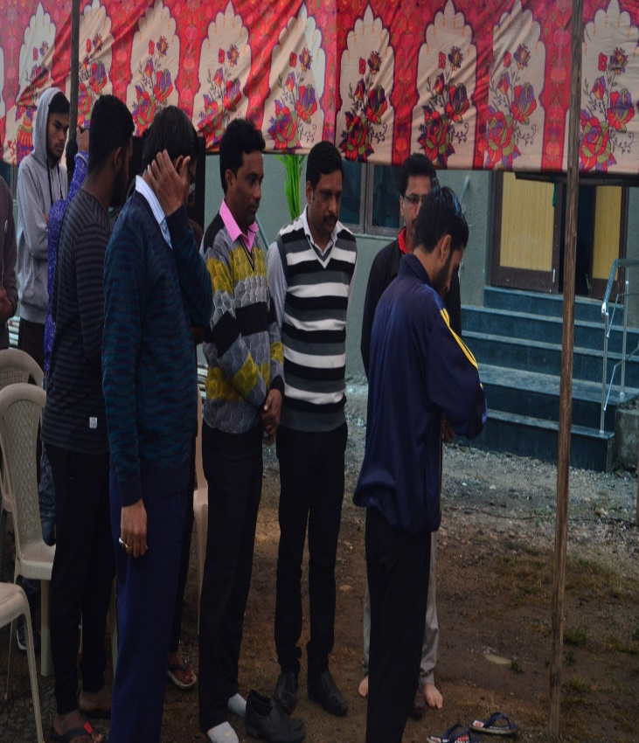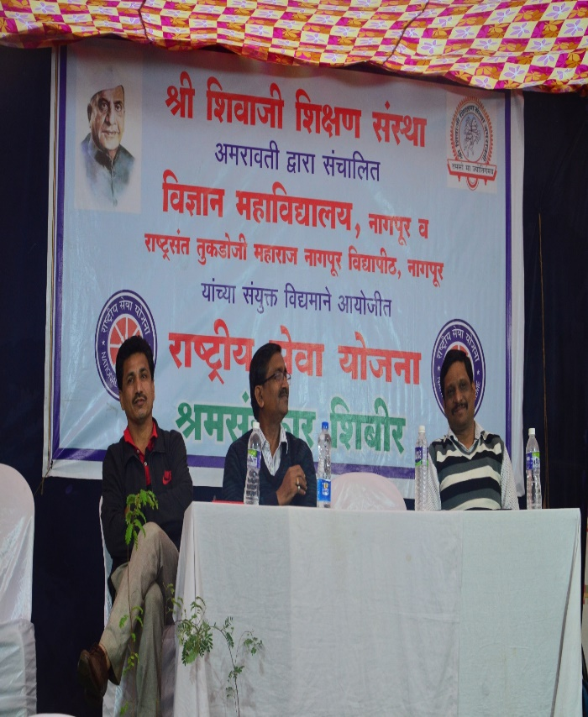
Dr. S.R. Pande, Science college Nagpur , Mr. Ashish Dhabale sir on the 4th day of NSS Camp

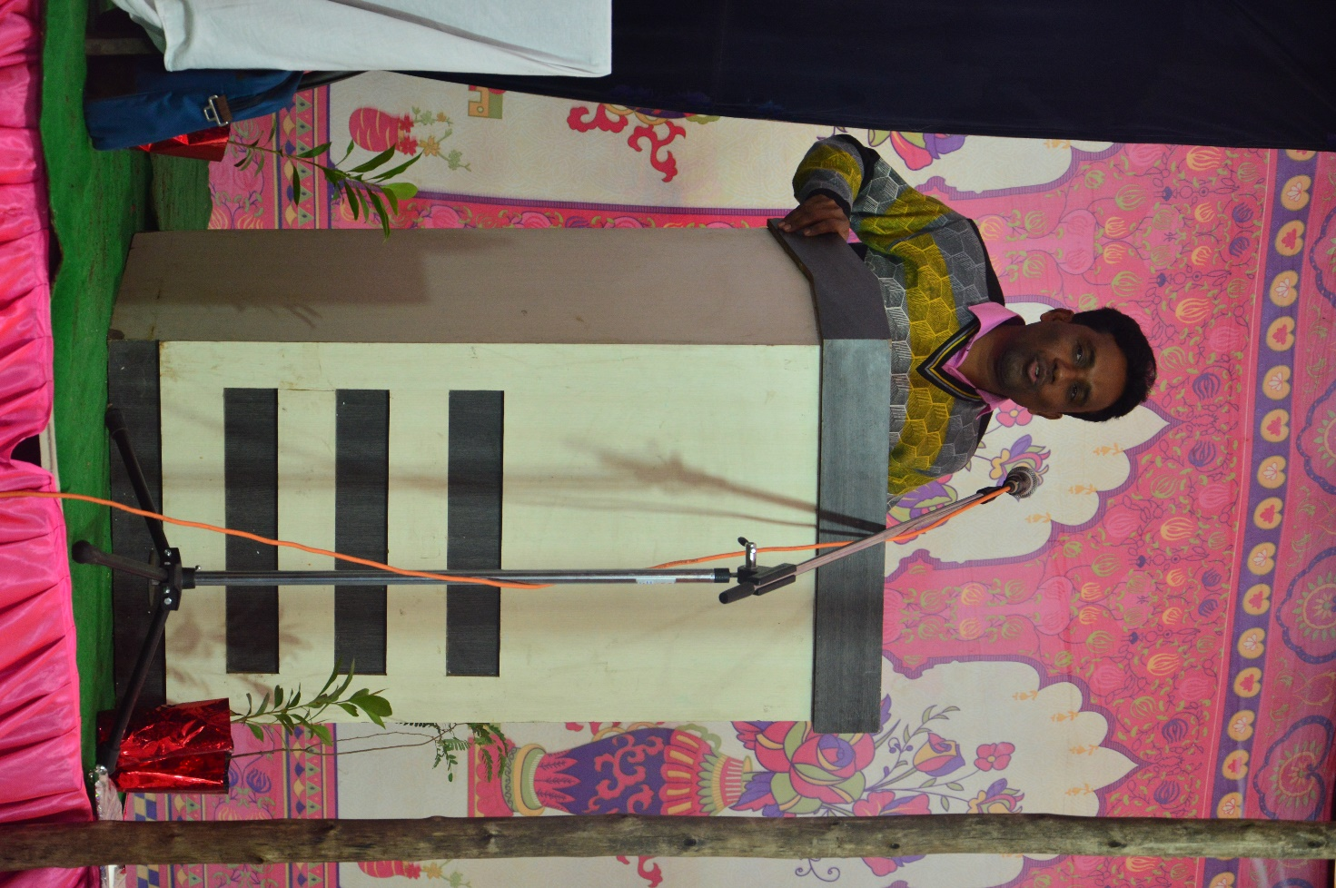
Mr. Ashish Dhabale sir delivering a lecture on impact of internet on youth

Day 5: Saturday, 9 Jan 2020
Point Of Note:
Our day start with yoga and breakfast after that we all visited the farm where we constructed a small canal wall of rock and sand. After construction all volunteers freshed and take lunch. After the lunch all gathered for sport activity. At 2 PM there was a guest lecture on student’s stress and cyber crime by Dr. Vikas Borkar sir and Dr. Ashok Khobragade . After guest lecture all volunteers with coordinator and guest lecture had dinner at 8 PM. After dinner all student were practiced for cultural event.
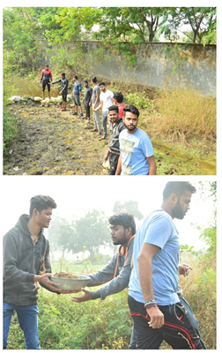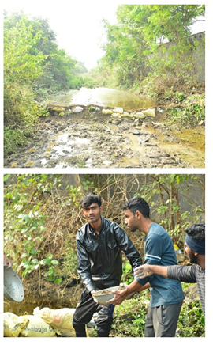
NSS volunteers constructed a small canal wall of rock and sand

6th day: Sunday, 10 Jan 2020
Cultural Program on Social Issues in Village
It was second last day of the camp. The day started with yoga and exercise, then there have delicious breakfast for students. All students for freshed at 10 AM and at 11 AM all students make arrangement for teachers staff and villagers for cultural event. At 12 AM cultural program was started, in cultural program every volunteers were gave their participations. From the cultural event volunteers as well as villagers were understand social issues around them. On cultural event, Dr.V.A. Dakole , Dr. A.D. Bobade, Dr. R. H. Mahakode, Dr. R.U. Urkude, Ku. P.B. Zamarkar, Ku. A.D. Fuladi teachers staffs Science College, Nagpur were present.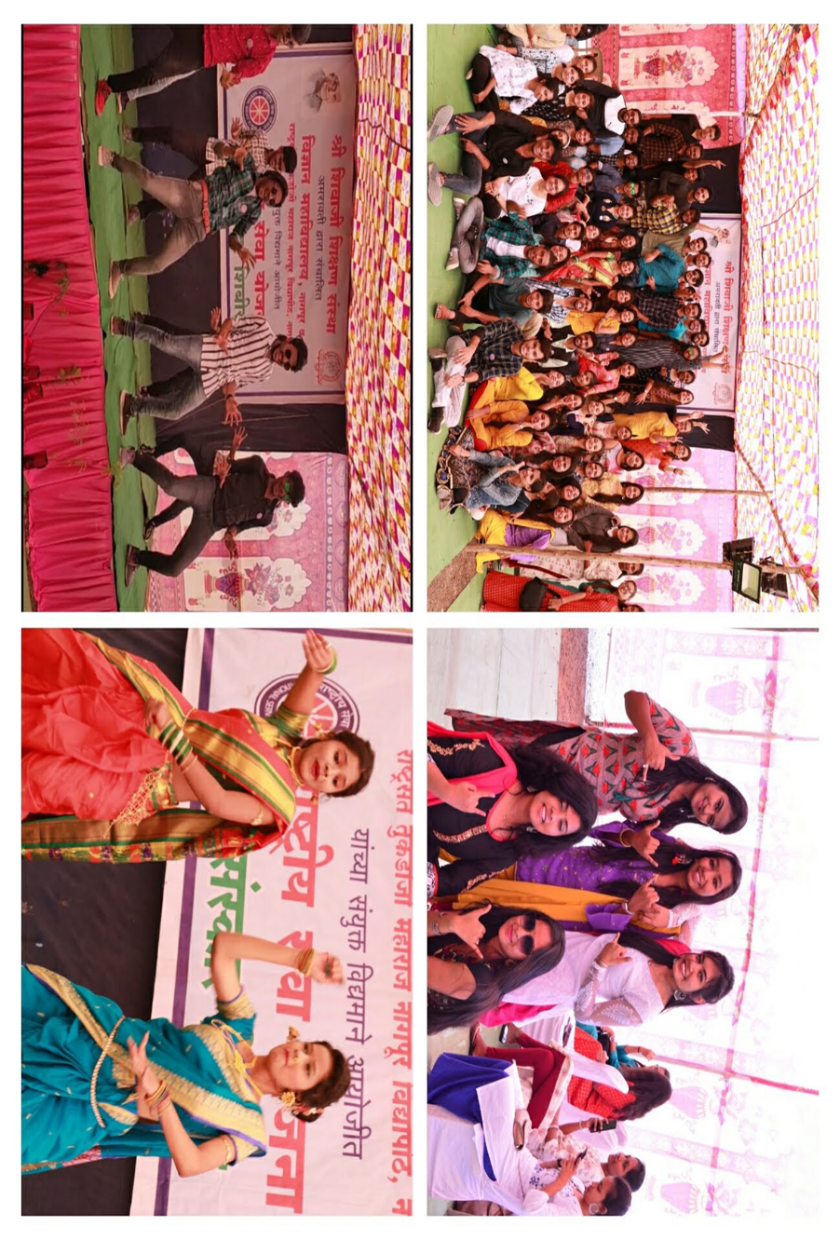
NSS volunteers performing in the cultural event
7th day: Monday, 11 Jan 2020

The day started with yoga at early morning, after yoga all volunteers had refreshment then they freshed. This was last day of our camp. The conclusion day “Samarop” program started at 11.30 am. . The program was wind up with speeches of president, guest, principal and NSS coordinator. The president was Shri Haemant Kalmegh, guest was Dr. M.P. Dhore principal of Shri Shivaji Science College Nagpur, Dr. G.R. Avchar vice principal of Shri Shivaji Science College Nagpur, Mrs. Dhanashree M. Dhomane Sarpanch Grampanchayat Fetri. Then principal and guests with program coordinator concluded the NSS camp and appreciating the hard work done by all volunteers and leaders of camp.

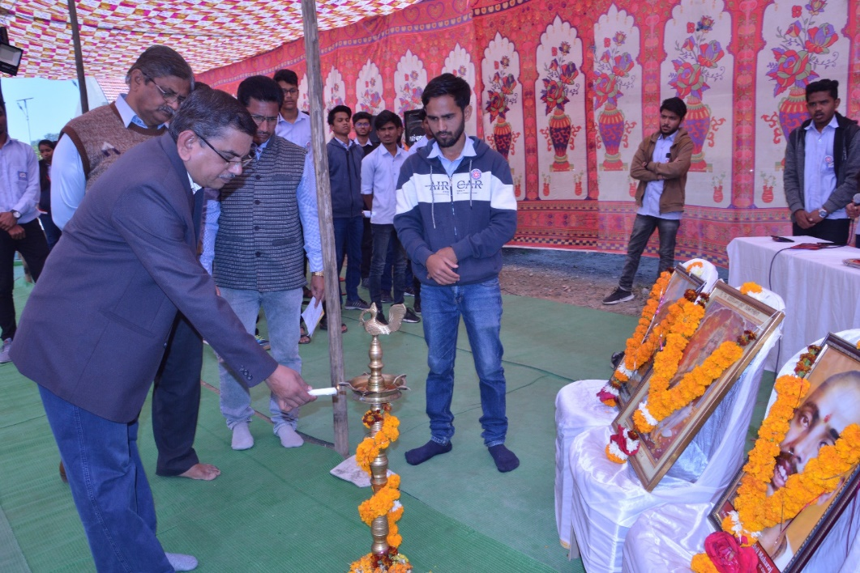
Prof. M. P. Dhore inaugurating the “Samarop” program
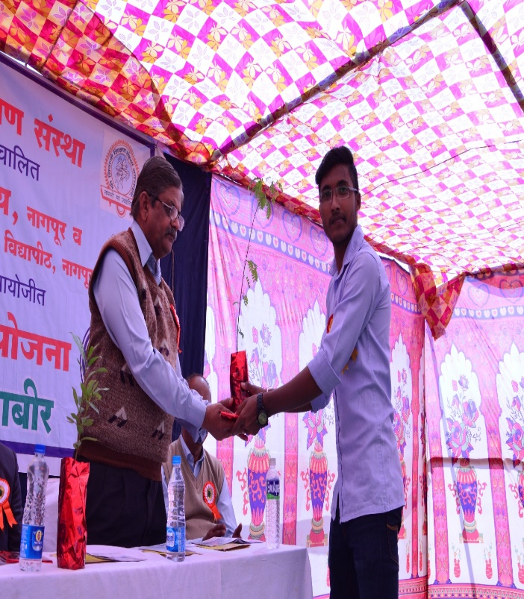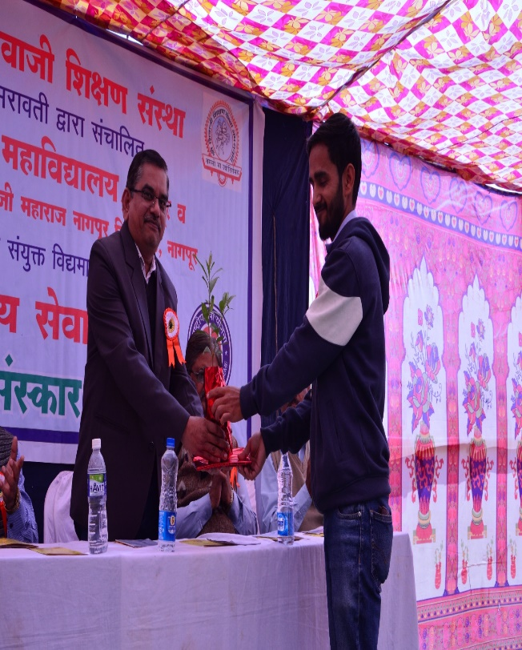
Welcoming of Prof M. P. Dhore and Prof. G. R. Avchar by the NSS volunteer by presenting a sapling
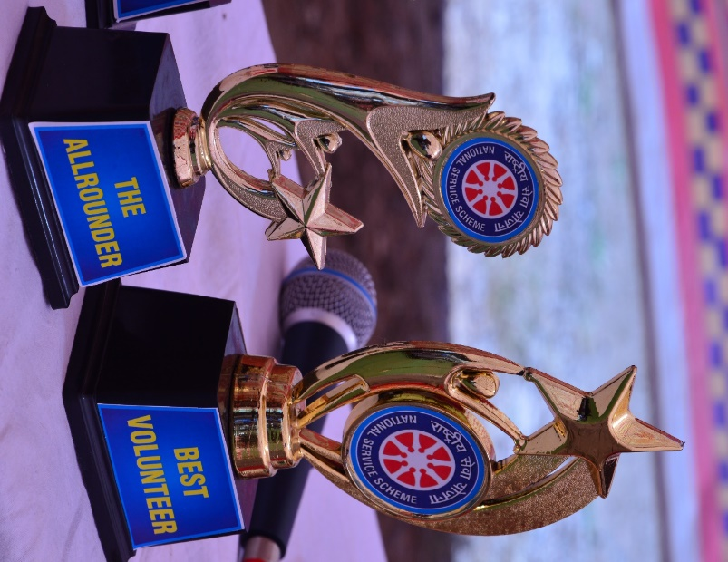
Trophies of Best Allrounder and Best Volunteer during the NSS Camp

