N.S.S Unit Celebrated Birth Anniversary of Mahatma Gandhi And Lal Bahadur Shastri and Organize Campus Cleaning Under Swachha Bharat Abhiyaan
Date : 2 October 2019

N.S.S unit of Shri Shivaji Educaton Society Amravati’s Science College Congress Nagar, Nagpur, Maharashtra organized and celebrated birth anniversary of Mahatma Gandhi and Lal Bahadur Shastri with great fervor and enthusiasm. The chief speaker for the program was Dr.C.J Chandekar, Chief Guest was Dr. M.P. Dhore and Guest was Dr.G.R. Avchar and program officer was Dr. P.S Utale
The celebrations for Gandhi Jayanti started welcoming all the teachers and students explained the significance of the day. After the lamp-lighting a highlighted presentation on Gandhiji’s childhood and his childhood stories was made by students. A unique poem was performed by volunteers it was really unbelievable to listen to a poem on Bapuji and it was presented in a very beautiful and dignified manner. Some volunteers narrated a beautiful conversation of Gandhi & Lal Bhadur Shastri.
Chief speaker Dr. Chandekar gave their gracious speech. Lastly program was concluded with chief guest Dr. M.P Dhore. At the end of the program N.S.S volunteers and N.S.S programe officer organized campus cleaning work under the Swachha Bharat Abhiyaan.
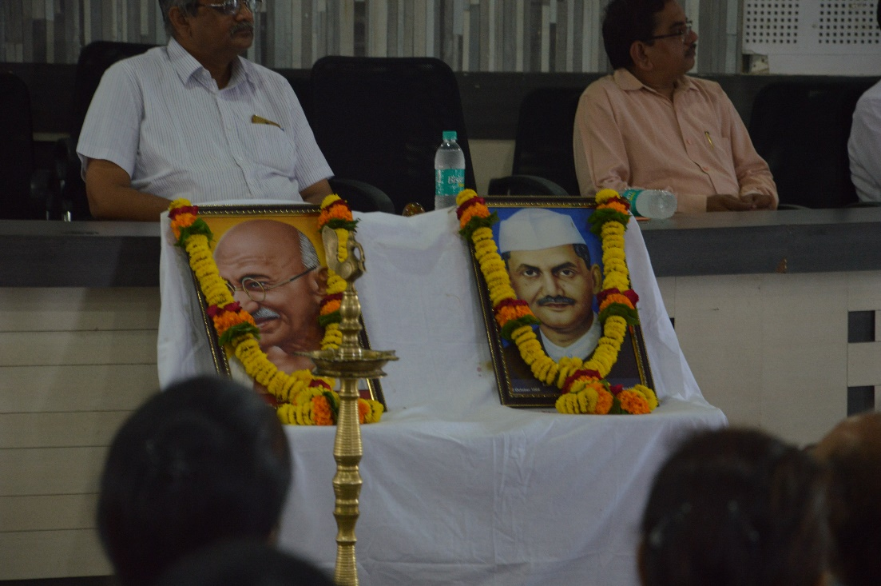
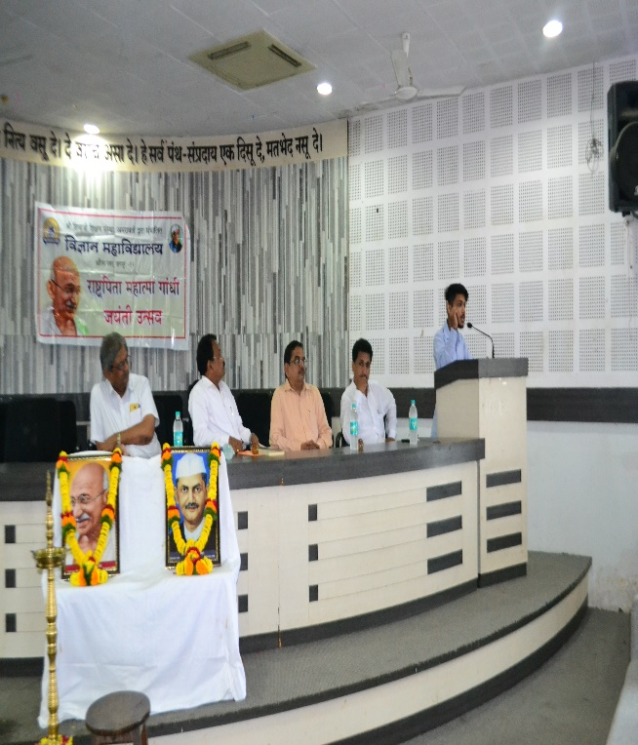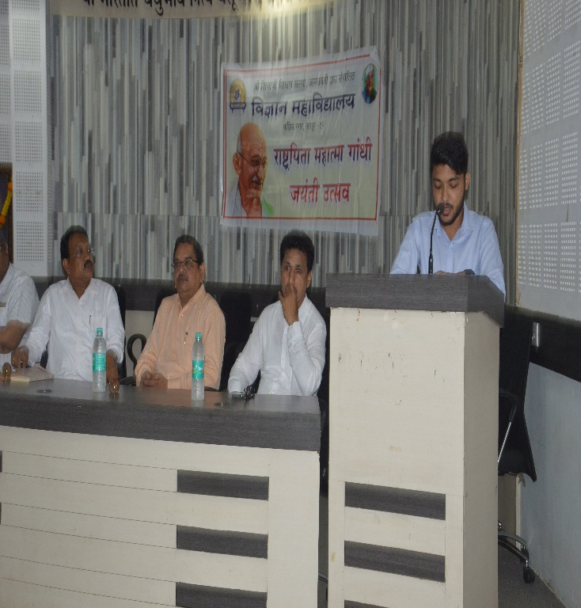
Students narrating beautiful conversation of Gandhi & Lal Bhadur Shastri

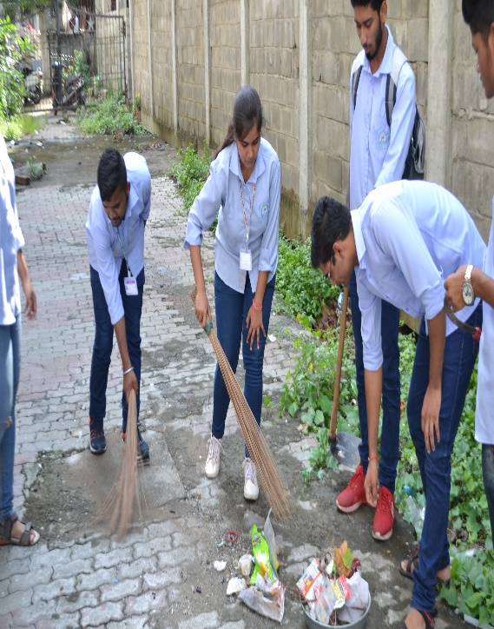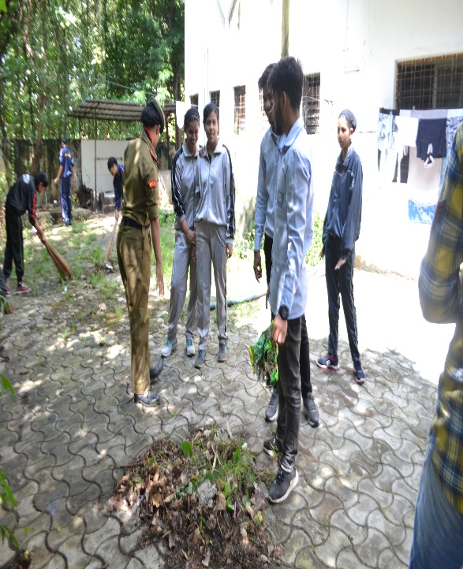
Students participating in the cleanliness drive

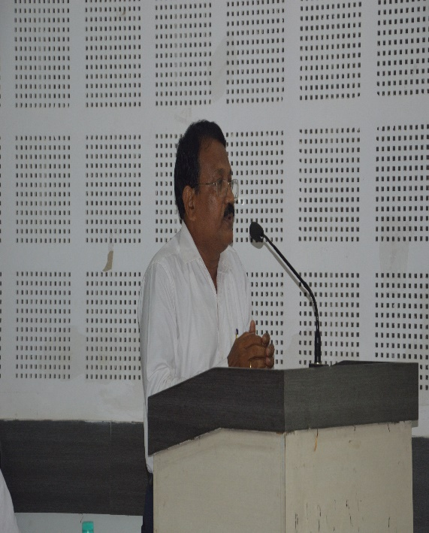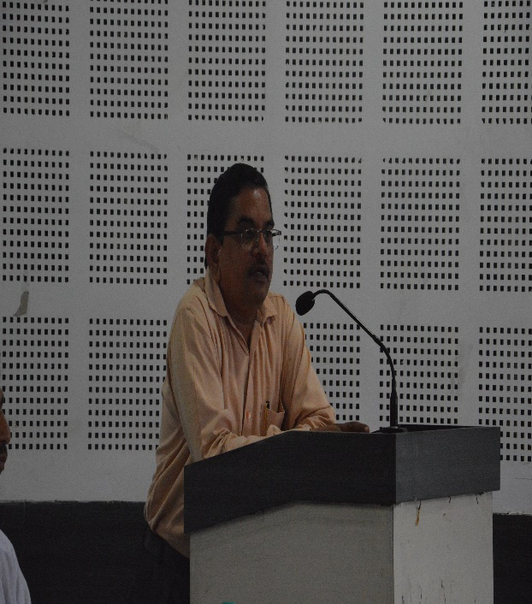
Chief speaker Dr. Chandekar and Chief Guest Dr. M.P. Dhore addressing the students
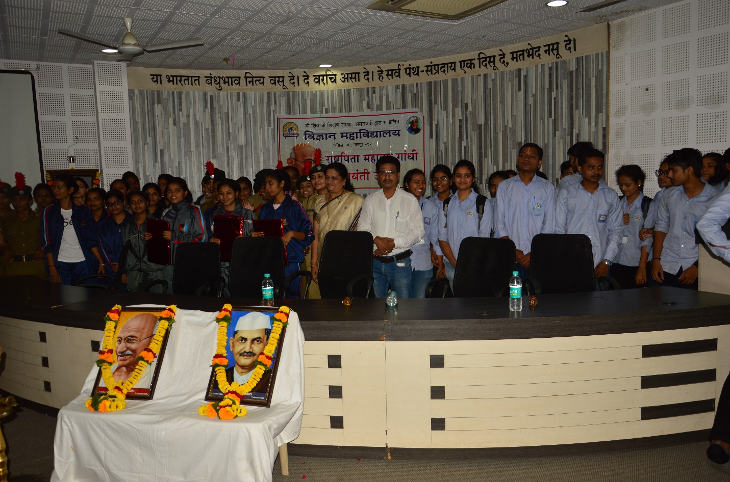
All the students with NCC Incharge and NSS Program Officer
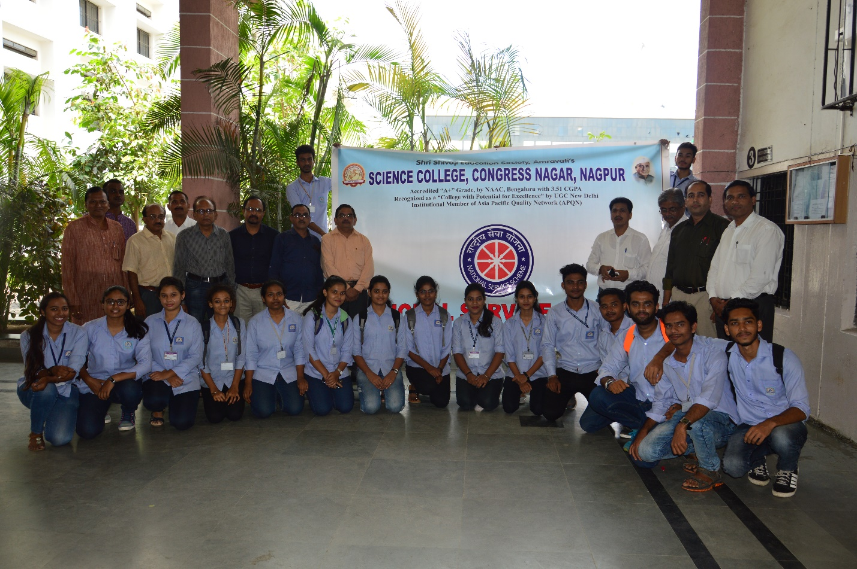
NSS volunteers with Faculty Members

