DEPARTMENT OF STATISTICS
2017-2018
National Statistics day:
National Statistics day is celebrated in department of Statistics on the occasion of birth anniversary of Indian scientist and statistician Prasanta Chandra Mahalanobis. Students actively participated in the various activities (Presentation, one minute activity etc.) held during the celebration.
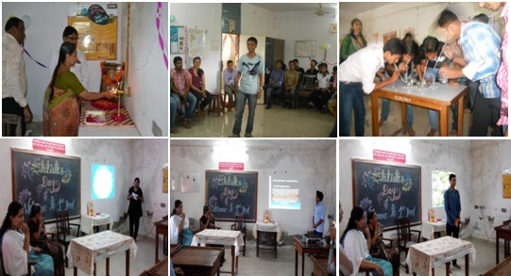

2. POSTER COMPETITION: Poster competition held in department of Statistics. Students actively participated .
