DEPARTMENT OF STATISTICS
ACTIVITIES-2018-2019

1. Guest lecture
Guest lecture on B.SC. STATISTICS IN IT SECTOR by Mr. Nikhil Bhokardankar on occasion of National Statistics day.
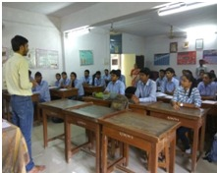

2. Teachers day celebration:
Teacher’s day is celebrated in department of Statistics. Students actively participated.
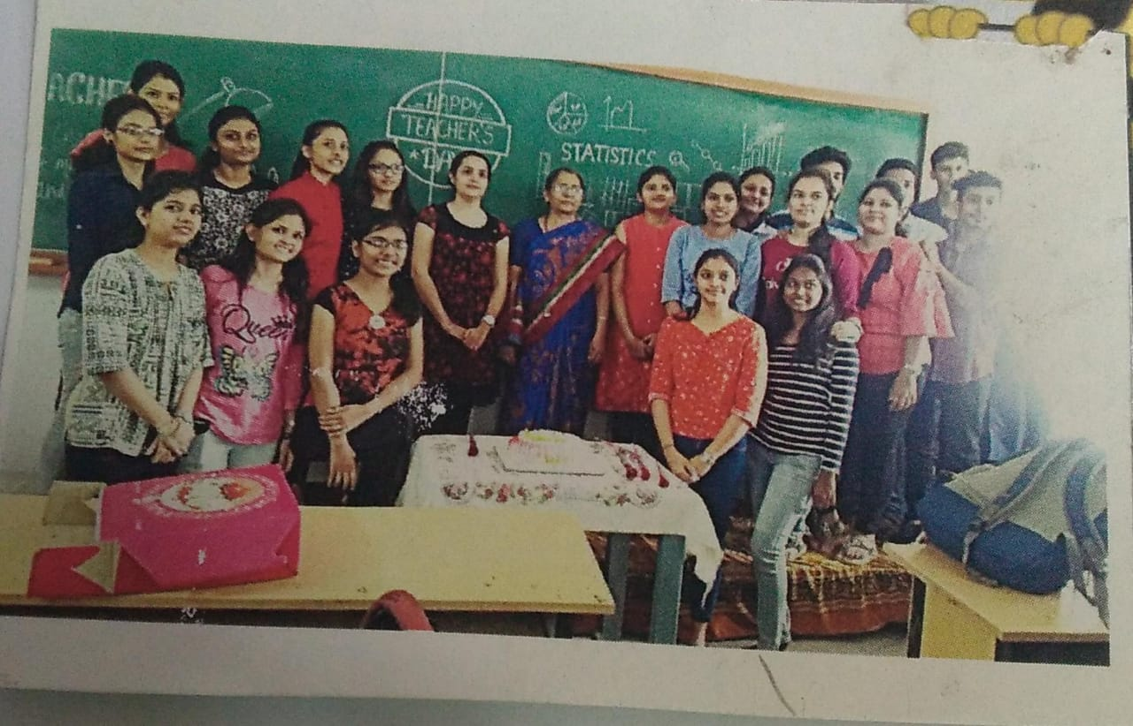
TORA WORKSHOP: Workshop taken by Prof.Gayatri Behere Institute of science Nagpur.
