Shri Shivaji Education Society Amt's, Science College, Nagpur.
Three Days Intercollegiate Workshop
organized by Department of Zoology
“Hands on Training of Micro-techniques and Biostatistics”
Venue – Conference hall / Zoology Laboratory

Shri Shivaji Education Society’s, Science College, Congress nagar, Nagpur, on the occasion of 125th Birth Anniversary of our founder President, a great Educationalist Shree Punjabrao alias Bhousaheb Deshmukh and Centenary Year of Rashtrasant Tukdoji Maharaj Nagpur University, Nagpur under the Aegis of IQAC, the Department of Zoology organizes different Cocurricular activities to enhance the knowledge, information, skill development, and acquaintance of students with new technological methods. Every Year Department of Zoology Conducted different intercollegiate workshops related to syllabi with updated new conceptual development among the students. This year also Department of Zoology Conducted three days Intercollegiate workshops from 15 to 17th March on Microtechniques and Biostatistics for students and researchers. The workshop was inaugurated at the hand of Hon’ble Principal, Prof. M.P. Dhore, in the presence of distinguished guests Dr. Vijay Bhagat sir, Head of department, Prof. A. D. Bobdey sir, Dr. Seema Kadu, Dr. Rupali Bhagat, Convener, Prof. Sharayu Ghonmode, Dr. Shilpa Katre, Dr. Pranita Gulhane and Ms. Shivani Patil.
In this context Dept. of Zoology organized a memorable intercollegiate 3 days’ workshop from 15 to 17th March 2023 based on Hands-on training on Techniques of Mictotechniques and Biostatistical analysis. The workshop focuses on development of creative thinking skills that framework our students in the 21st Century and thus Empowerment of creative thinking skills must be a concern for all educators.
The important objective of our department is to organize such Intercollegiate workshops for students, and researchers to motivate the ability to think creatively and generate a research attitude to use appropriate methods. Furthermore, studies that involved the students in laboratory activities such as formulating titles, problems, objectives, hypotheses, and determining tools for work procedures are needed. In conclusion, we hope the students will able to build strong connections between science studies with their life as a major component of education reform also to understand the nature and importance of scientific inquiry as a human endeavour.
The workshop implementation will be conducted in several phases, at very first day 1 we are organized, Lecture of Prof. Bhagat based on explanation of Animal Tissue Microtechniques followed by Hands-on training session in the laboratory. On 2nd day of workshop students will be acquainted by the Molecular biology techniques with the implementation of laboratory techniques. On 3rd day of the workshop organized an informative lecture series on techniques in Microbiology in first session and techniques in Biostatistics during second session with presentations and group discussions.
Day-1: Morning session Inauguration and Gust Lecture by Distinguished Guest, Dr. V.J. Bhagat sir on Microtechniques and Animal Tissue Culture. Afternoon Session Hand-on Training on Animal tissue processing, Mictrotechnique processes, and Double staining methods.
Day-2: Hands-on training on Gel Electrophoresis. Demonstration, Processing, and loading of Samples of Plasma DNA and Ribosomal DNA using a Hi-media Kit, by Dr. Pranita Gulhane and staff members of the Biotechnology Department.
Day-3: In the Morning session Organized a Guest Lecture on Molecular Biology and Genomic Sequencing techniques by Dr. Pranita Gulhane from Biotechnology Department. Afternoon Session Guest Lecture on Biostatistic techniques by Ms. Shivani Patil from Biostatistics Department. Certificate Distribution for the all participants carried at the hand of Delegates to motivate all the students to participate such informative workshops in future.

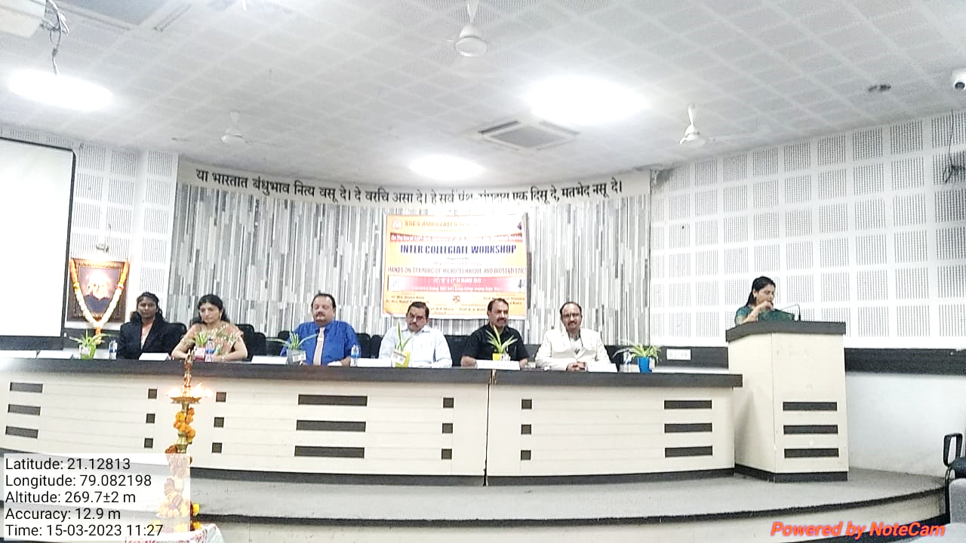
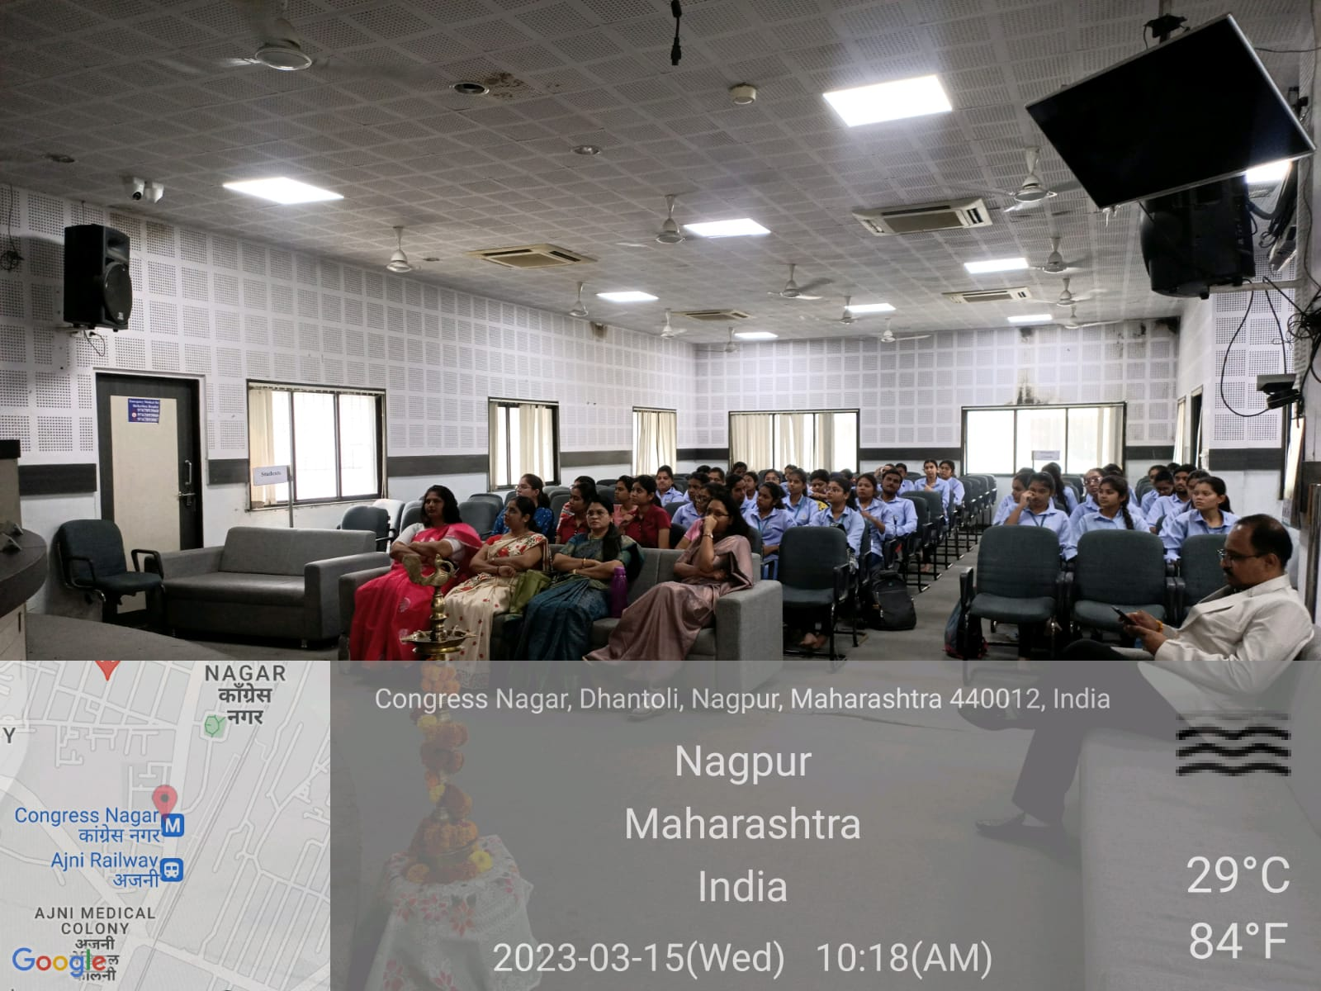
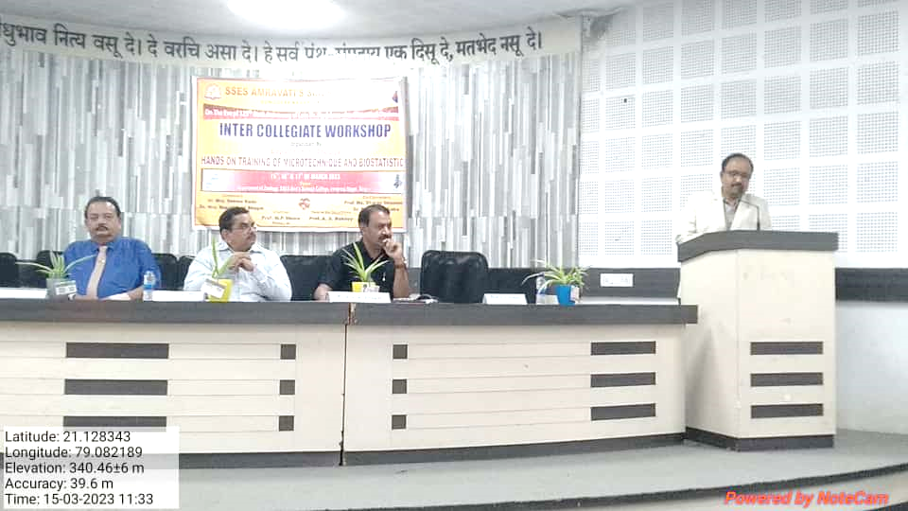
Inaugural ceremony
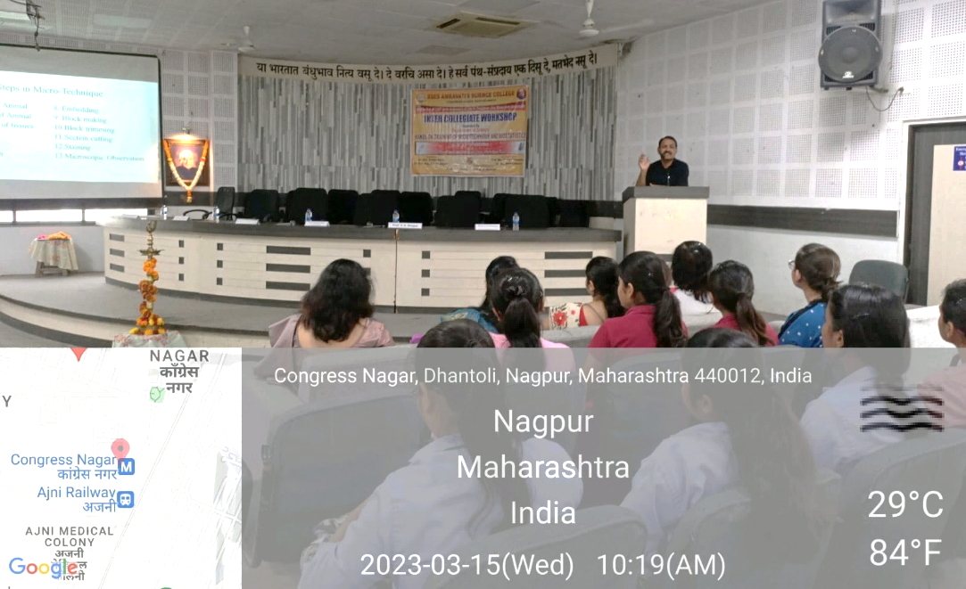

1st Session – Lecture of Prof. Vijay Bhagat

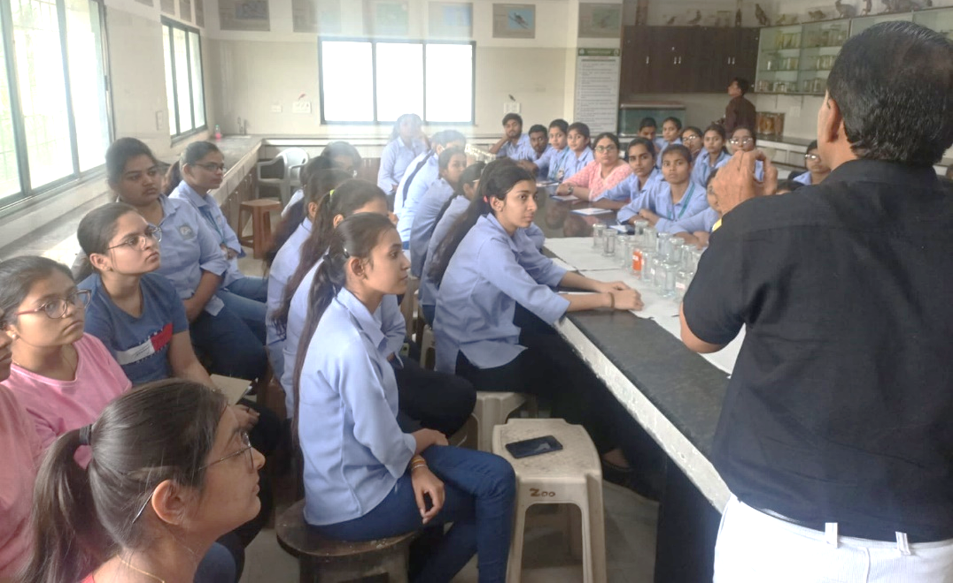

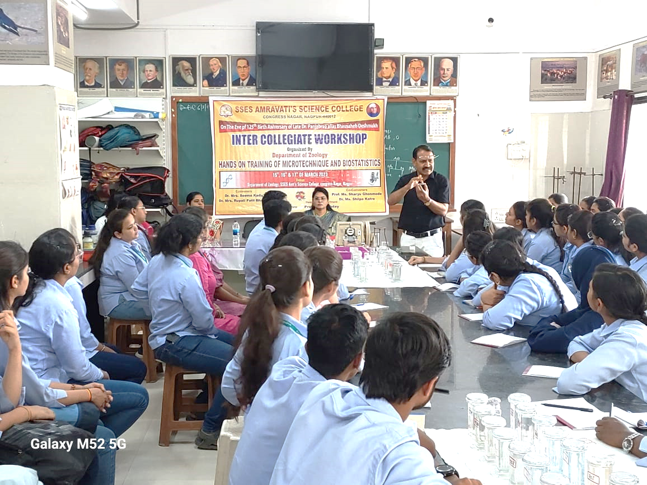

2nd Session – Hands on training of microtechnique by Prof. Bhagat
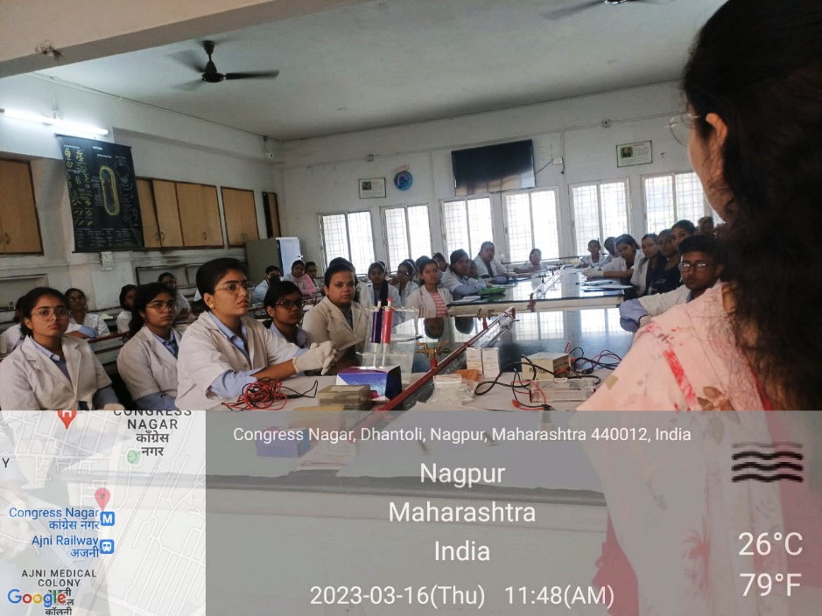

2nd day 1st Session- Demonstration of Biotechniques by Dr. Pranita Gulhane

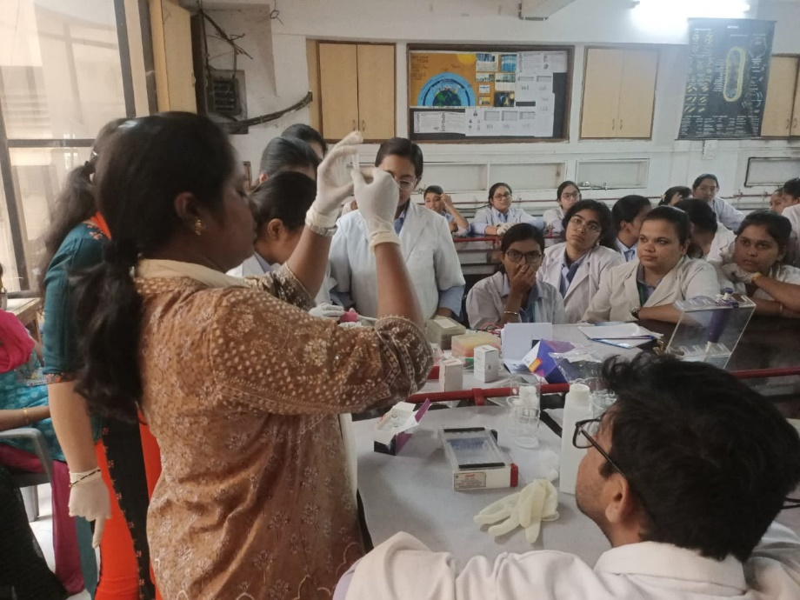

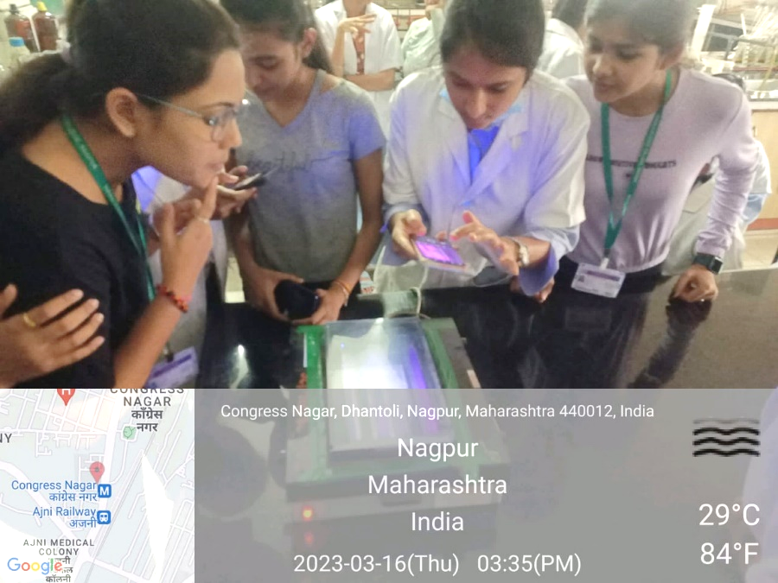

2nd day 2nd Session – Hands on training of Biotechniques by Dr. Pranita Gulhane.
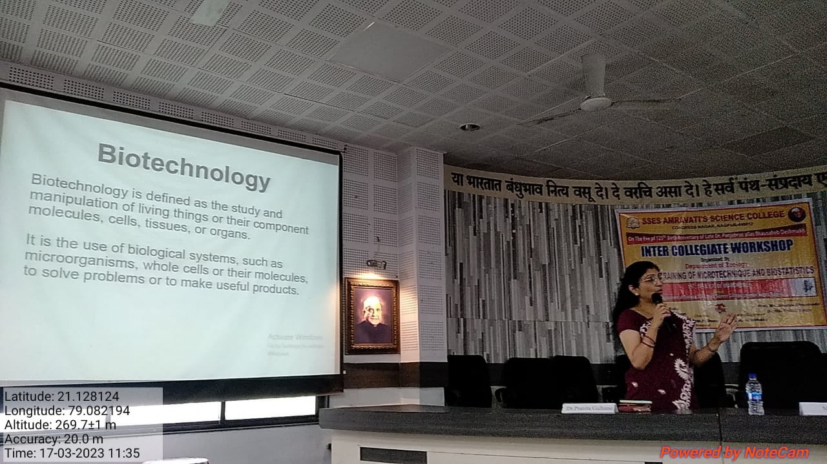

3rd day 1st Session – Lecture on techniques in Molecular Biology by Dr. Pranita Gulhane

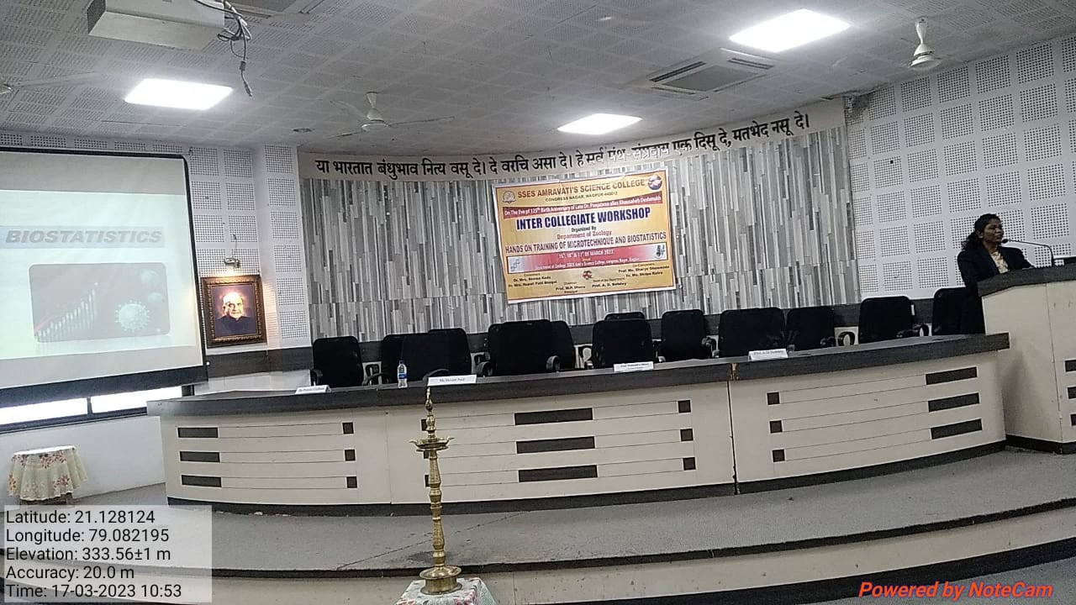
3rd day 1st Session – Lecture on techniques in Biostatistics by Ms. Shalini Patil
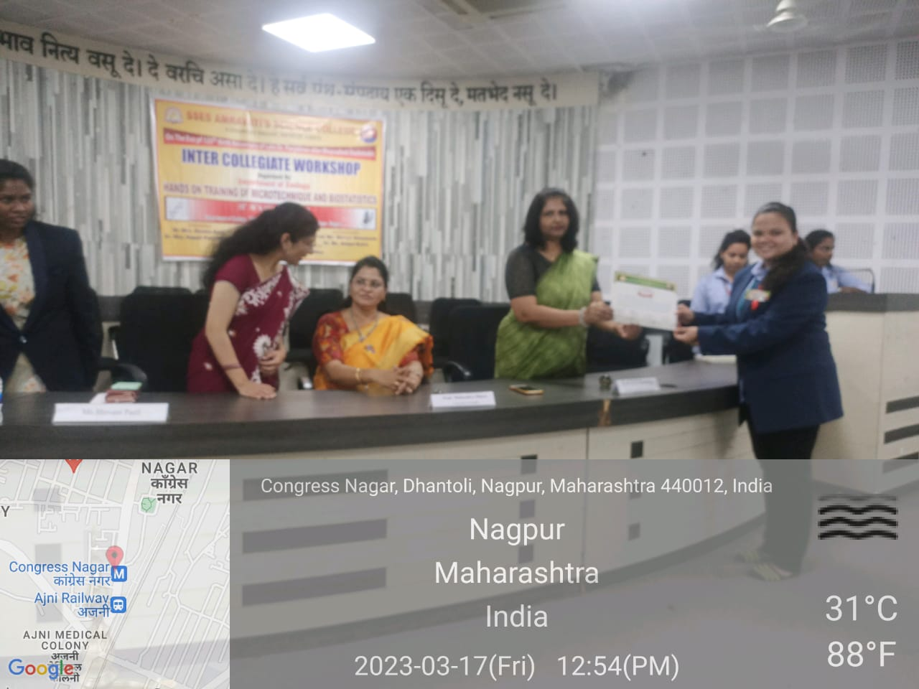

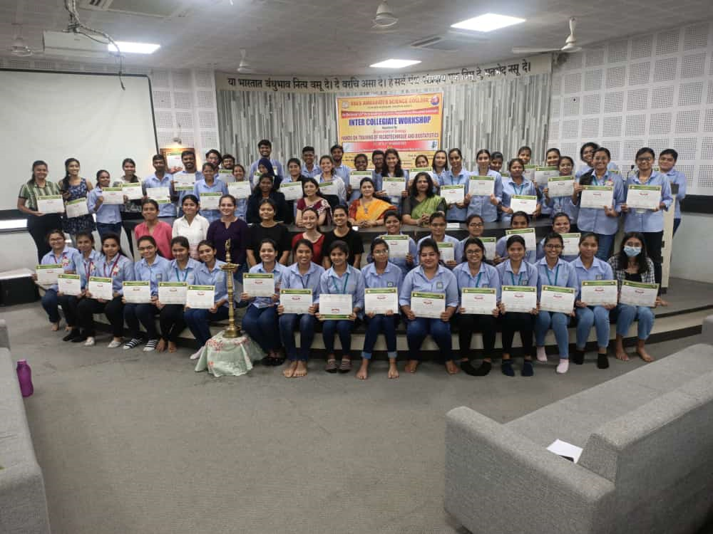
3rd day 2nd session Valedictory and counselling of student
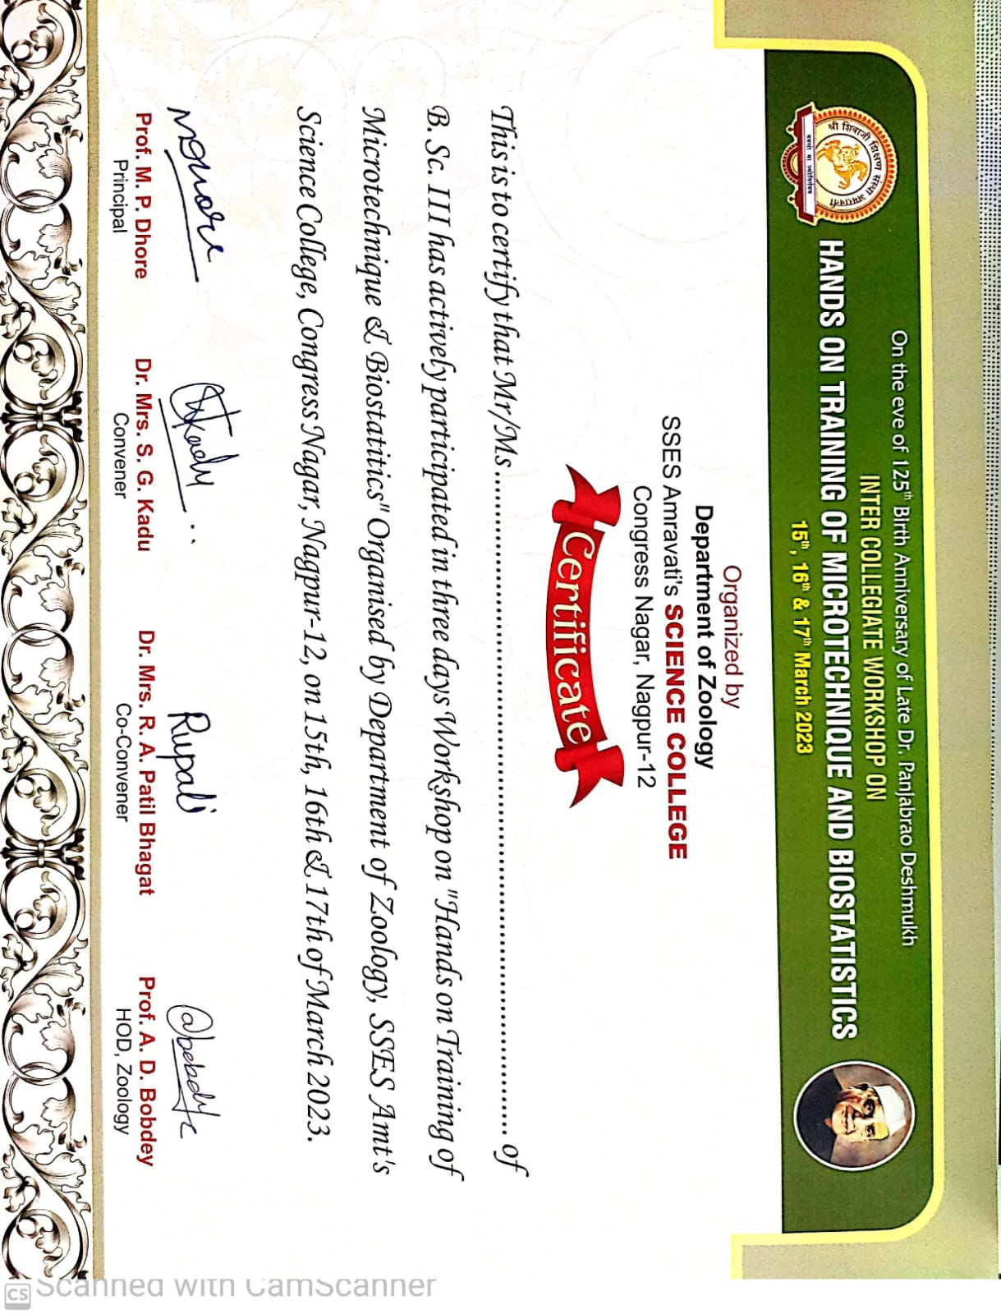

SSES AMRAVATIS SCIENCE COLLEGE CONGRESS NAGAR, NAGPUR-12
(On the eve of 125th Birth Anneversary of Late Panjabrao alias Bhausaheb Deshmukh)
WORKSHOP ON HANDS ON TRAINING OF MICROTECHNIQUE AND BIOSTATISTICS
INAUGURAL PROGRAMME – 15/03/2023
1. LIGHTING OF LAMPS BY DIGNITORIES
2. WELCOME OF GUESTS BY SAPLINGS
- Chairman (Hon’ble Principal) – by Prof. A.D.Bobdey, Head Dept. of zoology
- Prof. V.B. Bhagat ( Guest of honour) – by Hon’ble Principal
- Dr. Sanjeev kumar Singh (Technician) by Prof. A.D. Bobdey
- Dr. Mrs. Pranita Gulhane (resource person) by – Dr. Mrs. Rupali PatilBhagat
- Ms Shivani Patil (resource person ) by – Dr. Ms. Sharyu Ghonmode
3. INTRODUCTION OF GUESTS - STUDENT
4. INTRODUCTORY SPEECH – DR. MRS. SEEMA KADU
5. FEW WORDS – HEAD OF THE DEPARTMENT
6. ADDRESS BY CHAIRMAN (Hon’ble Principal)
7. VOTE OF THANKS – DR. MRS. RUPALI PATILBHAGAT

SSES AMRAVATIS SCIENCE COLLEGE CONGRESS NAGAR, NAGPUR-12
(On the eve of 125th Birth Anniversary of Late Panjabrao alias Bhausaheb Deshmukh)
WORKSHOP ON HANDS ON TRAINING OF MICROTECHNIQUE AND BIOSTATISTICS
PROGRAMME SCHEDULE
15,16 & 17TH OF MARCH 2023

15/03/2023- 1st Session-
9.30 AM TO 11.30 AM - Lecture by Prof. Vijay Bhagat “ SKILLS ON MICROTECHNIQUES”
11.30 TO 12.00 - Inauguration Programme
12.00 TO 1.00 - Lunch Time
2nd Session-
1.00 TO 5.00 - HANDS ON TRAINING OF MICROTECHNIQUE
- 16/03/2023- 1st Session-
11.30 TO 12.30 - Demonstration of Bio-techniques
12.30 TO 1.30 - Lunch Time
2nd Session-
01.30 TO 5.00 - Hands on training of Bio-techniques
- 17/03/2023- 1st Session-
11.00 TO 01.00 - Lecture by Dr. Pranita Gulhane “Special Techniques in
Molecular Biology”
1.00 TO 2.00 - Lunch time
2nd Session-
2.00 – 4.00 Valedictory function Feedback and Certificate distribution

List of Participants:
