S.S.E.S.A’s Science College, Congress Nagar, Nagpur

DEPARTMENT OF BIOTECHNOLOGY ACTIVITIES REPORT 2019-20
…………………………………………………………………………………………………
RANGOLI COMPETITION ON “IMMUNOLOGY” 27th AUGUST 2019

A Rangoli competition on theme of “Immunology” was organized by Department of Biotechnology, S.S.E.S.A’s Science College, Nagpur in collaboration with Microbiologist Society, India on 27th August 2019. Dr. S.D. Patankar, former Principal, S.S. Jaiswal College, Arjuni Morgaon was invited to judge the competition. A total of 33 Microbiology students from B.Sc. and M.Sc. Microbiology of the college have participated the same. Prizes to the winners and certificates of participation to all the participants were distributed at the hands of Chief Guest, Dr. S.D. Patankar and Principal Dr. M.P.Dhore sir. Presidential address was given by Dr.
M.P. Dhore, Principal, S.S.E.S.A’s Science College, Nagpur. The programme was anchored by Dr. Manpreet Kour and ‘Vote of Thanks’ was given by Dr. Pranita Gulhane.
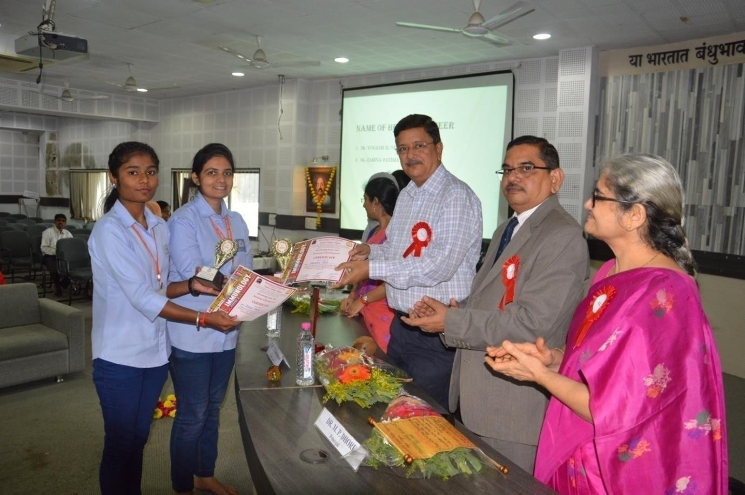

Winners of Rangoli Competition 27/08/19

