SHRI SHIVAJI EDUCATION SOCIETY AMRAVATI'S
SCIENCE COLLEGE, CONGRESS NAGAR, NAGPUR.
Department of Biotechnology
B. Sc. III Semester-VI (2018-19)
BIOTECHNOLOGY Paper-I

Result of Unit Test held on 05/03/2018 on Unit II
Name of the teacher: Mrs. Manjushrre Shani

Batch B5 CMBT |  |  |  |  | Paper-I
Sr.  No. | Name |  | Students Name | Students Father Name | Marks out of 20
- 1 |  | P. Mahalakshmi | V | P | 15
- 2 |  | Alsi | A | A | 14
- 3 |  | Badal | S | S | 14
- 4 |  | Bagade | V | Y | 13
- 5 |  | Balapure | S | M | AA
- 6 |  | Barbate | P | G | 13
- 7 |  | Bhawalkar | P | R | 15
- 8 |  | Bomle | D | V | 14
- 9 |  | Bondade | A | P | AA
- 10 |  | Chaudhari | R | D | 12
- 11 |  | Chilbule | R | U | 18
- 12 |  | Chitaley | S | C | 17
- 13 |  | Choudhari | M | S | 18
- 14 |  | Dawale | A | S | 20
- 5 |  | Deotale | P | S | 16

- 16 |  | Deshbhratar | V | N | 17
- 17 |  | Deshmukh | D | Y | 14
- 18 |  | Deshmukh | Y | C | 17
- 19 |  | Dhodare | N | P | 15
- 20 |  | Dhoke | B | S | 17
- 21 |  | Dhopte | P | R | 16
- 22 |  | Gahukar | M | N | 16
- 23 | Ku | Gajbhiye | A | A | 16
 |  | Gajbhiye | K | B | 15
- 6 | Ku | Gawande | A | S | 18
- 7 |  | Ghude | R | M | 19
- 8 |  | Gotmare | A | T | AA
- 9 | Ku | Gurao | K | N | 17
- 10 |  | Hatwar | S | R | 15
- 11 | Ku | Ingole | S | D | 14
- 12 | Ku | Kale | M | A | 15
- 14 | Ku | Kamble | P | D | 15
- 15 | Ku | Kanere | N | P | 17
- 16 | Ku | Katole | D | V | 16
- 18 | Ku | Khante | P | R | 15

36. | Kodwani | P | H | 15
37. | Kumbhare | A | S | AA
38. | Marotkar | S | D | 18
39. | Daphale | D | J | 17

Batch B6 CMBT |  |  |  |  | Paper-I
Sr.  No. | Name |  | Students Name | Students Father Name | Marks out of 20
 |  | Wankhede | A | V | 18
 |  | Mehta | V | B | 19
 |  | Mengal | R | R | 15
 |  | Meshram | B | P | 16
 |  | Motilinge | A | Y | 15
 |  | Mungale | S | N | 16
 |  | Nande | P | P | 16
 |  | Nasare | D | V | 16
 |  | Nimje | D | K | 16
 |  | Pajai | S | E | 16
 |  | Parate | K | R | 14
 |  | Patle | S | R | 15
 |  | Patne | S | S | 16
 |  | Pawar | N | S | 17
 |  | Phadnavis | P | P | 16
- 1 |  | Rajkarne | P | S | 15
- 2 |  | Ramteke | K | B | 15
- 3 |  | Sahare | A | T | 16
- 4 |  | Sahare | S | K | AA
- 5 |  | Shandilya | S | D | 15
- 6 |  | Sharma | S | V | 18
- 7 |  | Shende | D | B | 18
- 8 |  | Shingnapure | P | A | 18
- 9 |  | Shrirame | S | R | 16
- 10 |  | Singh | N | S | 17
- 11 |  | Sonkusare | M | M | 17
- 12 |  | Thakre | M | S | 19
- 13 |  | Thakur | P | N | 17
- 14 |  | Thote | H | B | 16
- 15 |  | Thutheja | T | N | 18
 |  | Tote | A | S | 15
 |  | Tupe | M | A | 15
 |  | Verma | P | K | 16
 |  | Wanjale | T | S | 15
 |  | Wankhede | P | V | 15
 |  | Yadav | L | T | 16
 |  | Zade | A | A | 15
 |  | Zode | G | G | 16
Head of the Department
Dr.C.J.Chandekar


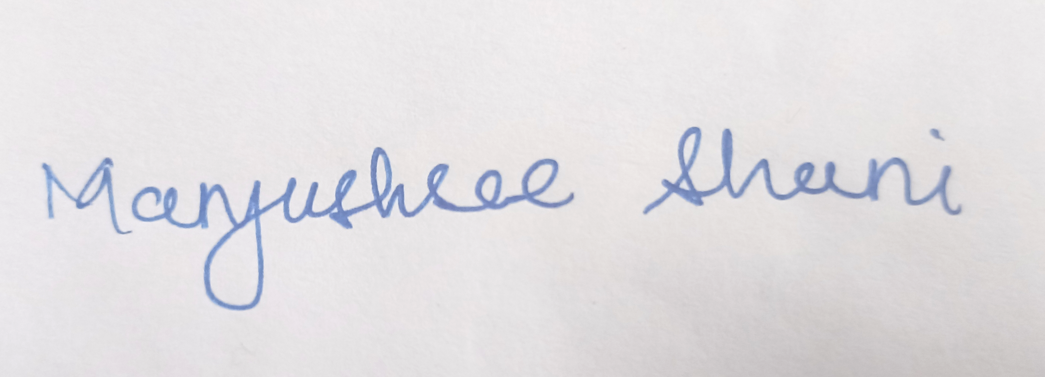
Signature of the Teacher
Mrs. Manjushrre Shani


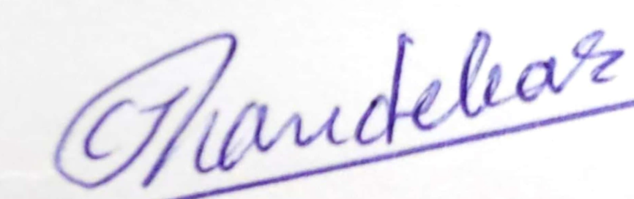

Shri Shivaji Education Society Amravati’s
Science College, Congress Nagar, Nagpur Academic Session 2018-2019
Bachelor of Science (B. Sc.) (Semester-VI) BIOTECHNOLOGY Paper-I
(APPLICATIONS OF BIOTECHNOLOGY)
UNIT TEST on Unit II
Time: 45 min. [Maximum Marks: 20]
N.B. :- (1) Solve all the questions.

UNIT-I

Q.1 | Explain Significance and principal of IMViC. | 05
Q.2 | Write a note on Bioaccumulation and biomagnification. | 05
Q.3 | Give concept of COD,DO and BOD. | 05
Q.4 | Write a note on Indicators of faecal pollution and MPN and MF technique for coliforms. | 05

Head of the Department
Dr.C.J.Chandekar
Signature of the Teacher
Mrs. Manjushrre Shani

