**SHRI SHIVAJI EDUCATION SOCIETY AMRAVATI'S**

**SCIENCE COLLEGE, CONGRESS NAGAR, NAGPUR.**

**Department of Biotechnology**

**B. Sc. III Semester-VI (2018-19)**

**BIOTECHNOLOGY Paper-II**

**Result of Unit Test held on 03/02/2018 on Unit III**

**Name of the teacher: Ms.Priyanka Jadhav**

|  |  |  |  |  |  |
| --- | --- | --- | --- | --- | --- |
| **Batch B5 CMBT** | | | | | **Paper-II** |
| **Sr.**  **No.** | **Name** | | **Students Name** | **Students Father Name** | **Marks out of 20** |
| 1. **1** |  | **P. Mahalakshmi** | **V** | **P** | **15** |
| 1. **2** |  | **Alsi** | **A** | **A** | **14** |
| 1. **3** |  | **Badal** | **S** | **S** | **14** |
| 1. **4** |  | **Bagade** | **V** | **Y** | **13** |
| 1. **5** |  | **Balapure** | **S** | **M** | **AA** |
| 1. **6** |  | **Barbate** | **P** | **G** | **13** |
| 1. **7** |  | **Bhawalkar** | **P** | **R** | **15** |
| 1. **8** |  | **Bomle** | **D** | **V** | **14** |
| 1. **9** |  | **Bondade** | **A** | **P** | **AA** |
| 1. **10** |  | **Chaudhari** | **R** | **D** | **12** |
| 1. **11** |  | **Chilbule** | **R** | **U** | **18** |
| 1. **12** |  | **Chitaley** | **S** | **C** | **17** |
| 1. **13** |  | **Choudhari** | **M** | **S** | **14** |
| 1. **14** |  | **Dawale** | **A** | **S** | **20** |
| 1. **5** |  | **Deotale** | **P** | **S** | **15** |

|  |  |  |  |  |  |
| --- | --- | --- | --- | --- | --- |
| 1. **16** |  | **Deshbhratar** | **V** | **N** | **17** |
| 1. **17** |  | **Deshmukh** | **D** | **Y** | **AA** |
| 1. **18** |  | **Deshmukh** | **Y** | **C** | **17** |
| 1. **19** |  | **Dhodare** | **N** | **P** | **18** |
| 1. **20** |  | **Dhoke** | **B** | **S** | **17** |
| 1. **21** |  | **Dhopte** | **P** | **R** | **15** |
| 1. **22** |  | **Gahukar** | **M** | **N** | **13** |
| 1. **23** | **Ku** | **Gajbhiye** | **A** | **A** | **16** |
|  |  | **Gajbhiye** | **K** | **B** | **17** |
| 1. **6** | **Ku** | **Gawande** | **A** | **S** | **17** |
| 1. **7** |  | **Ghude** | **R** | **M** | **19** |
| 1. **8** |  | **Gotmare** | **A** | **T** | **20** |
| 1. **9** | **Ku** | **Gurao** | **K** | **N** | **17** |
| 1. **10** |  | **Hatwar** | **S** | **R** | **15** |
| 1. **11** | **Ku** | **Ingole** | **S** | **D** | **14** |
| 1. **12** | **Ku** | **Kale** | **M** | **A** | **15** |
| 1. **14** | **Ku** | **Kamble** | **P** | **D** | **15** |
| 1. **15** | **Ku** | **Kanere** | **N** | **P** | **17** |
| 1. **16** | **Ku** | **Katole** | **D** | **V** | **16** |
| 1. **18** | **Ku** | **Khante** | **P** | **R** | **15** |

|  |  |  |  |  |
| --- | --- | --- | --- | --- |
| **36.** | **Kodwani** | **P** | **H** | **15** |
| **37.** | **Kumbhare** | **A** | **S** | **17** |
| **38.** | **Marotkar** | **S** | **D** | **AA** |
| **39.** | **Daphale** | **D** | **J** | **17** |

|  |  |  |  |  |  |
| --- | --- | --- | --- | --- | --- |
| **Batch B6 CMBT** | | | | | **Paper-I** |
| **Sr.**  **No.** | **Name** | | **Students Name** | **Students Father Name** | **Marks out of 20** |
|  |  | **Wankhede** | **A** | **V** | **18** |
|  |  | **Mehta** | **V** | **B** | **16** |
|  |  | **Mengal** | **R** | **R** | **15** |
|  |  | **Meshram** | **B** | **P** | **16** |
|  |  | **Motilinge** | **A** | **Y** | **17** |
|  |  | **Mungale** | **S** | **N** | **16** |
|  |  | **Nande** | **P** | **P** | **14** |
|  |  | **Nasare** | **D** | **V** | **16** |
|  |  | **Nimje** | **D** | **K** | **17** |
|  |  | **Pajai** | **S** | **E** | **16** |
|  |  | **Parate** | **K** | **R** | **AA** |
|  |  | **Patle** | **S** | **R** | **15** |
|  |  | **Patne** | **S** | **S** | **18** |
|  |  | **Pawar** | **N** | **S** | **17** |
|  |  | **Phadnavis** | **P** | **P** | **16** |
| 1. **1** |  | **Rajkarne** | **P** | **S** | **15** |
| 1. **2** |  | **Ramteke** | **K** | **B** | **15** |
| 1. **3** |  | **Sahare** | **A** | **T** | **16** |
| 1. **4** |  | **Sahare** | **S** | **K** | **17** |
| 1. **5** |  | **Shandilya** | **S** | **D** | **15** |
| 1. **6** |  | **Sharma** | **S** | **V** | **18** |
| 1. **7** |  | **Shende** | **D** | **B** | **18** |
| 1. **8** |  | **Shingnapure** | **P** | **A** | **AA** |
| 1. **9** |  | **Shrirame** | **S** | **R** | **16** |
| 1. **10** |  | **Singh** | **N** | **S** | **17** |
| 1. **11** |  | **Sonkusare** | **M** | **M** | **17** |
| 1. **12** |  | **Thakre** | **M** | **S** | **19** |
| 1. **13** |  | **Thakur** | **P** | **N** | **17** |
| 1. **14** |  | **Thote** | **H** | **B** | **16** |
| 1. **15** |  | **Thutheja** | **T** | **N** | **18** |
|  |  | **Tote** | **A** | **S** | **15** |
|  |  | **Tupe** | **M** | **A** | **15** |
|  |  | **Verma** | **P** | **K** | **16** |
|  |  | **Wanjale** | **T** | **S** | **15** |
|  |  | **Wankhede** | **P** | **V** | **15** |
|  |  | **Yadav** | **L** | **T** | **16** |
|  |  | **Zade** | **A** | **A** | **15** |
|  |  | **Zode** | **G** | **G** | **16** |

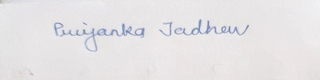

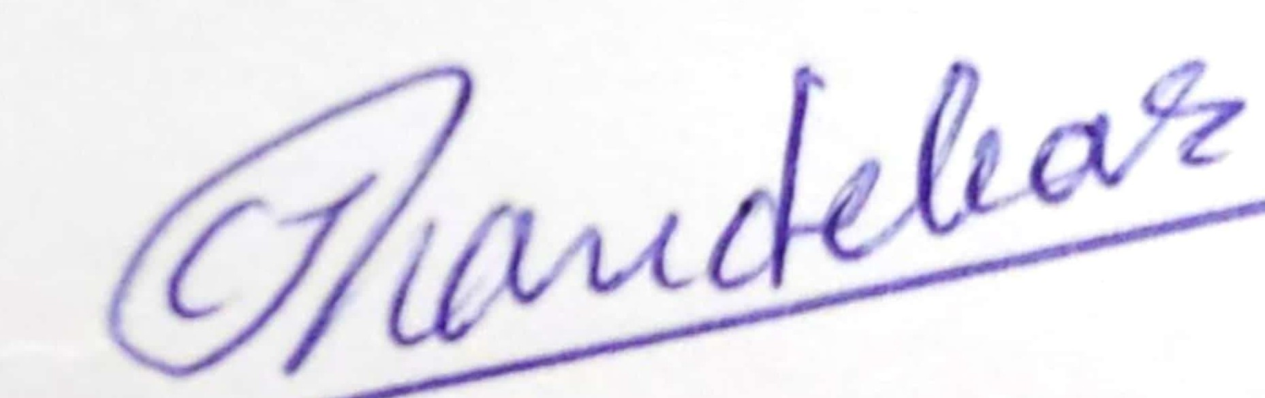

Head of the Department

Dr.C.J.Chandekar



Signature of the Teacher

Ms.Priyanka Jadhav

**Shri Shivaji Education Society Amravati’s**

**Science College, Congress Nagar, Nagpur Academic Session 2017-2018**

**Bachelor of Science (B. Sc.) (Semester-VI) BIOTECHNOLOGY Paper II**

**(PLANT & ANIMAL BIOTECHNOLOGY)**

**UNIT TEST on Unit III**

**Time: 45 min. [Maximum Marks: 20]**

**N.B. :- (1) Solve all the questions.**

**UNIT-III**

|  |  |  |
| --- | --- | --- |
| **Q.1** | **Explain immortal cells & cell lines** | **05** |
| **Q.2** | **Write a note on anchorage dependence.** | **05** |
| **Q.3** | **Give Various techniques of animal cell and tissue culture** | **05** |
| **Q.4** | **Write a note on cell and tissue response to trophic factors** | **05** |





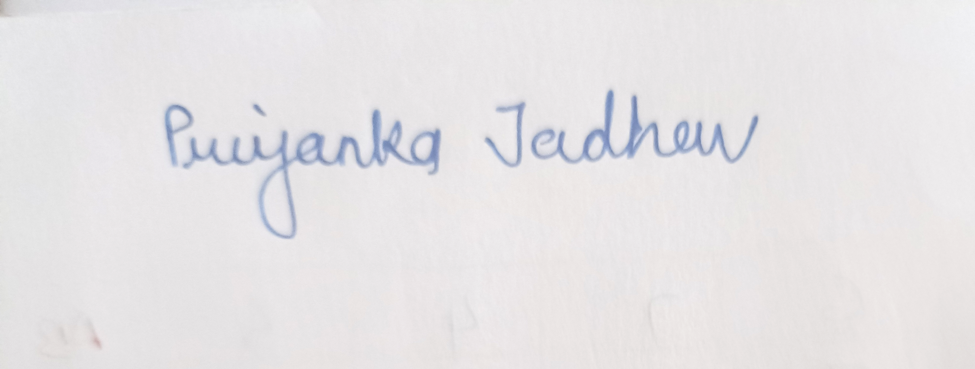

Head of the Department

Dr.C.J.Chandekar



Signature of the Teacher

Ms.Priyanka Jadhav