SHRI SHIVAJI EDUCATION SOCIETY AMRAVATI'S
SCIENCE COLLEGE, CONGRESS NAGAR, NAGPUR.
Department of Biotechnology
B. Sc. I Semester-V (2019-20)
BIOTECHNOLOGY Paper-I

Result of Unit Test held on 15/12/2019 on Unit IV
Name of the teacher: Mrs.Raksha Pandit

Batch B5 CMBT |  |  |  |  | Paper-I
Sr.  No. | Name |  | Students Name | Students Father Name | Marks out of 20
- 1 | Ku | Lakshmi Kumari | Ravindra | R | 15
- 2 | Ku | Aswale | Neha | D | 16
- 3 | Ku | Badwe | Ritika | S | 14
- 4 | Ku | Bagwe | Anjali | B | 13
- 5 | Ku | Bawane | Aishwarya | P | AA
- 6 |  | Bhagwatkar | Kunal | P | 12
- 7 | Ku | Bhalwatkar | Pranoti | R | 15
- 8 | Ku | Bire | Shraddha | G | 16
- 9 | Ku | Burghate | Mansi | J | 15
- 10 | Ku | Chahande | Saloni | S | 12
- 11 |  | Chauhan | Vishwanath | P | 15
- 12 |  | Chidam | Akash | R | AA
- 13 | Ku | Choudhary | Sauravi | G | 18
- 14 | Ku | Dadmal | Amruta | A | 20
- 15 | Ku | Deshpande | Aboli | S | 16

- 16 |  | Hedaoo | Parth | G | 17
- 17 |  | Jamunkar | Lokesh | S | 16
- 18 | Ku | Junchare | Aachal | G | 17
- 19 |  | Kalbut | Siddhesh | Y | 15
- 20 |  | Kargaonkar | Bhushan | S | AA
- 21 | Ku | Khandre | Ishika | P | 16
- 22 | Ku | Khursange | Yash | G | 16
- 23 |  | Kirnapure | Priyanshu | B | 15
 | Ku | Koche | Vrukshali | B | 15
- 6 |  | Mahale | Shubham | S | 18
- 7 |  | Mahale | Trupti | Mahale | 19
- 8 |  | Meharkule | Prachi | Meharkule | 15
- 9 | Ku | Mirashe | Tanmay | Mirashe | 17
- 10 |  | Mohammed | Zayan | Mohammed | 15
- 11 | Ku | Nagrare | Aaishwarya | Nagrare | 14
- 12 | Ku | Nirgulkar | Rudali | Nirgulkar | 15
- 14 | Ku | Nirwan | Ritika | Nirwan | 15
- 15 | Ku | Pakhmode | Shweta | Pakhmode | AA
- 16 | Ku | Parihar | Himasnshu | Parihar | 16
- 18 | Ku | Parshuramkar | Prajwal | Parshuramkar | 15

36. | Lawat |  |  | Divya |  | U |  |  | 15
37. | More |  |  | Paris |  | S |  |  | 18
38. | Deshmukh |  |  | Shivani |  | P |  |  | 18
39. | Shirsath |  |  | Mrunali |  | P |  |  | 17
40. | Bokade |  |  | Apeksha |  | A |  |  | 15
41. | Mishra |  |  | Wasudew |  | G |  |  | 16
Batch B6 CMBT |  |  |  |  |  |  |  | Paper-I
Sr.  No. |  | Name |  |  | Students Name |  | Students Father Name | Marks out of 20
 |  | Ku | Lodhey |  | Shreayashree |  | P | 18
 |  | Ku | Mallurwar |  | Vaishnavi |  | G | 19
 |  | Ku | Mankar |  | Lakshika |  | V | 15
 |  |  | Meshram |  | Adil |  | N | 16
 |  | Ku | Meshram |  | Ragini |  | S | 15
 |  | Ku | Muley |  | Avanti |  | M | 16
 |  | Ku | Musale |  | Ashwini |  | P | 16
 |  |  | Nalage |  | Suraj |  | P | 16
 |  | Ku | Nare |  | Prachi |  | B | 16
 |  | Ku | Pande |  | Indrayani |  | R | 16
 |  | Ku | Pande |  | Tanushree |  | M | 14
 |  |  | Parate |  | Kamlesh |  | S | 15
 |  | Ku | Patankar |  | Shivani |  | D | 16
 |  | Ku | Patankar |  | Shriya |  | S | 17
 |  | Ku | Pathan |  | Alisha |  | R | 16
- 1 |  | Ku | Patil |  | Ankita |  | Ku | 15
- 2 |  | Ku | Patle |  | Apeksha |  | Ku | 15
- 3 |  | Ku | Prasad |  | Neha |  | Ku | 16
- 4 |  | Ku | Rahangdale |  | Sakshi |  | Ku | AA
- 5 |  | Ku | Randale |  | Apurva |  | Ku | 15
- 6 |  |  | Raut |  | Kunal |  | K | 18
- 7 |  | Ku | Salunke |  | Jyotsna |  | S | 18
- 8 |  | Ku | Salve |  | Gouri |  | M | 18
- 9 |  | Ku | Samarth |  | Piyusha |  | P | 16
- 10 |  | Ku | Saraf |  | Simran |  | V | 17
- 11 |  | Ku | Sarode |  | Pratiksha |  | L | 17
- 12 |  | Ku | Shambahrkar |  | Neha |  | D | 19
- 13 |  | Ku | Sheikh |  | Aaliya |  | G | 17
- 14 |  | Ku | Shrawane |  | Srushti |  | R | 16
- 15 |  | Ku | Solanki |  | Vaishnavi |  | D | 18
 |  |  | Soyam |  | Ankit |  | R | 15
 |  | Ku | Tekade |  | Suwarna |  | D | 15
 |  | Ku | Telang |  | Amruta |  | N | 16
 |  | Ku | Thakare |  | Dhanashree |  | Y | 15
 |  | Ku | Thakur |  | Roshni |  | S | 15
 |  | Ku | Tharani |  | Misbah |  | T | 16

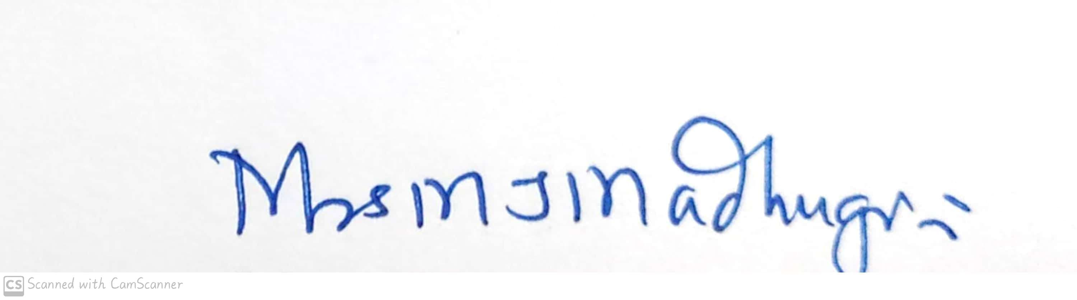
Head of the Department
Mrs.M.J.Madhugiri


Signature of the Teacher
Mrs.Raksha Pandit

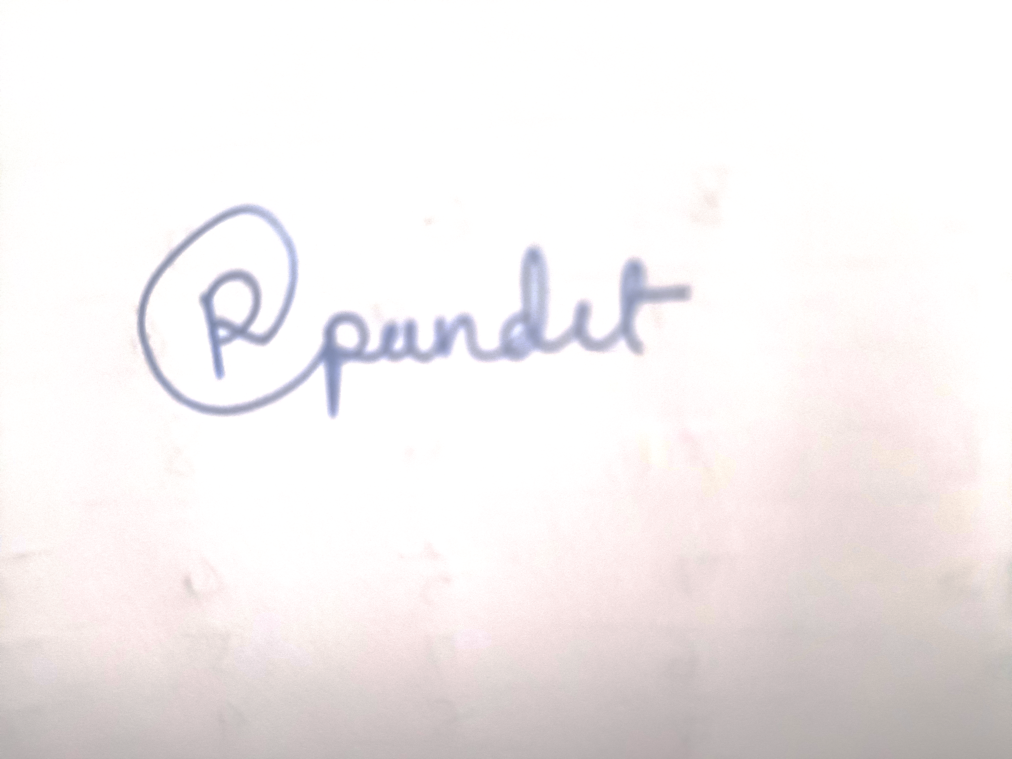

Shri Shivaji Education Society Amravati’s
Science College, Congress Nagar, Nagpur Academic Session 2019-2020
Department of Biotechnology
Bachelor of Science (B. Sc.) (Semester-V) BIOTECHNOLOGY Paper-I

(MOLECULAR BIOLOGY)
UNIT TEST on Unit IV
Time: 45 min. [Maximum Marks: 20]
N.B. :- (1) Solve all the questions.

UNIT-IV

Q.1 | Give proof for Basic idea of lac- and trp-operons. | 05
Q.2 | Write a note on termination (intrinsic and rho factor mediated termination). | 05
Q.3 | Give use of DNA replication mutants in the study of replication. | 05
Q.4 | Write a note on reverse transcription. | 05


Head of the Department
Mrs.M.J.Madhugiri

Signature of the Teacher
Mrs.Raksha Pandit

