**SHRI SHIVAJI EDUCATION SOCIETY AMRAVATI'S**

**SCIENCE COLLEGE, CONGRESS NAGAR, NAGPUR.**

**Department of Biotechnology**

**B. Sc. III Semester-V (2020-21)**

**BIOTECHNOLOGY Paper-I**

**Result of Unit Test held on 05/10/2020 on Unit I**

**Name of the teacher: Ms.Nikita Pawar**

|  |  |  |
| --- | --- | --- |
| **Sr.**  **No.** | **Batch B5**  **Students Name** | **Paper I**  **Marks out of 20** |
| 1. 1 | BARAPATRE SHREYA NITIN | 15 |
| 1. 2 | BASOLE SONAL CHANDRAKANT | 16 |
| 1. 3 | BEHUNE ANSHUL SUKHRAM | 14 |
| 1. 4 | BELEKAR KHUSHI MANOJ | 13 |
| 1. 5 | BHAGAT TRIVENI POLIRAM | AA |
| 1. 6 | BHONGADE BHAVANA NARAYAN | 12 |
| 1. 7 | BISEN BHUMESH MANOHAR | 15 |
| 1. 8 | BORIKAR RIYA SUNIL | 16 |
| 1. 9 | BUTE NIHARIKA PRADEEP | 15 |
| 1. 10 | CHAMBHARE RUCHIKA LAXMIKANT | 12 |
| 1. 11 | CHANDE DEVARSHI VIJAY | 15 |
| 1. 12 | CHANDURKAR AASTHA RAJKUMAR | AA |
| 1. 13 | CHARDE ADITI DILIP | 18 |
| 1. 14 | CHAUDHARI VEENA VASANTRAO | 20 |
| 1. 15 | CHOPKAR RASHMI NARESHCHANDRA | 16 |

|  |  |  |
| --- | --- | --- |
| 1. 16 | CHOURASIA SAKSHI RAJESH | 17 |
| 1. 17 | DAHAKE NAMRATA MAROTI | 16 |
| 1. 18 | DAHALE RUTUJA NAVAL | 17 |
| 1. 19 | DEOTALE DUSHANT PRAKASH | 15 |
| 1. 20 | DESHMUKH RITUJA MAHENDRA | AA |
| 1. 21 | DHANORKAR TANVI BALRAM | 16 |
| 1. 22 | DHOTE MIHIR PRASHANT | 16 |
| 1. 23 | DIWALE PRANJALEE MILIND | 15 |
|  | DUBEY RASHMI VIJAY | 15 |
| 1. 6 | DUDANI AMISHA SUNIL | 18 |
| 1. 7 | FUTANE MEGHNA VILASRAO | 19 |
| 1. 8 | GADGIL PRIYANKA ANANDRAO | 15 |
| 1. 9 | GAIKWAD SANKET ASHOK | 17 |
| 1. 10 | GEDAM DIKSHA DILICHAND | 15 |
| 1. 11 | GHUGAL VAISHNAVI RAJENDRA | 14 |
| 1. 12 | GODBOLE AKANKSHA DASHRATH | 15 |
| 1. 14 | GUGHANE REVATI CHAITANYARAO | 15 |
| 1. 15 | GUPTA SWATI ANIL | AA |
| 1. 16 | HEDAOO CHARUDATTA PRAKAS | 16 |
| 1. 18 | JOSHI PRANJALI ATUL | 15 |
|  | KADPATI SUVARNA JAYANT | 16 |
|  | KALE PRITI RAMESH | 16 |
|  | KAMALE SANJEEVANI SANJAY | AA |
|  | KAMBLE SHIWALEE KISHOR | 16 |
|  | GHUGAL VAISHNAVI RAJENDRA | 11 |
|  | KOKATE RADHIKA PRAVINRAO | 18 |
|  | KHADATKAR DIKSHA VILAS | AA |
|  | KHARCHWAL VISHAL RAJKUMAR | 16 |
|  | KHIANI OSHEEN MANGHANLAL | 17 |
|  | KOTHEWALE ARUNDHATI KISHO | 18 |
|  | KSHIRSAGAR PRIYANKA NARESH | 16 |
|  | KUMBHARE YASH KHUSHAL | 17 |

|  |  |  |
| --- | --- | --- |
| **Sr.**  **No.** | **Batch B6**  **Students Name** | **Paper I**  **Marks out of 20** |
|  | MESHRAM PRAJAKTA SANJAY | 18 |
|  | MOHADIKAR MINAL SAMPAT | 19 |
|  | MOTWANI NIKITA NARESH | 15 |
|  | MUNESHWAR PRANALI PRAMOD | 16 |
|  | NAGDEVE SIMRAN MANOJ | 15 |
|  | NAGPURE SHRUTIKA SHRIHARI | 16 |
|  | NAIK SAKSHI SANJAY | 16 |
|  | NANWANI KUNJAN VINOD | 16 |
|  | PSNCHBHAI TAPASHU SHYAM | 16 |
|  | PANDE APEKSHA PANDHARI | 16 |
|  | PARKHI POOJA ARUN | 14 |
|  | PATKI SWARALI RAJESH | 15 |
|  | PILLEWAN SHASHWATI RAJESH | 16 |
|  | POTE PALLAVI ANIL | 17 |
|  | RAHANGDALE SUCHI BHUPENDRA | 16 |
| 1. 1 | RAJORA KARISHMA AJAYPAL | 15 |
| 1. 2 | RAMTEKE ASHUTOSH ANIRUDDHA | 15 |
| 1. 3 | RATHOD PALLAVI VASANTRAO | 16 |
| 1. 4 | RAUT ANCHAL RAMESH | AA |
| 1. 5 | RAUT PRATIKSHA DEWANAND | 15 |
| 1. 6 | RAUT VASTAV PRAKASH | 18 |
| 1. 7 | SAHU AMISHA BIJAYKUMAR | 18 |
| 1. 8 | SALODKAR ANTARA VIJAY | 18 |
| 1. 9 | SAMARTH SURABHI RAVINDRA | 16 |
| 1. 10 | SATPUTE SAMIKSHA KAILAS | 17 |
| 1. 11 | SHARMA JYOTI BRIJENDRA | 17 |
| 1. 12 | SHENDE MRUNALI VINOD | 19 |
| 1. 13 | SHINGNE VISHVAJA CHHAGAN | 17 |
| 1. 14 | SINGH MEGHNA H | 16 |
| 1. 15 | SINGH JANHAVI BRIRAJ | 18 |
|  | SINGH MAYURI BRIBHUSHAN | 15 |
|  | SINGH SIDDHI AMOD | 15 |
|  | TANDULKAR PRANJAL;I KESHAV | 16 |
|  | TELANG SHREYASH SHASHANK | 15 |
|  | THOOL SAJESH SUDHIR | 15 |
|  | TIWARI APURVA RAJESH | 16 |
|  | TIWARI KHUSHI KAMLESH | AA |
|  | TIWARI SUJITKUMAR SURENDRA | 14 |
|  | TUMSARE HRSHALI RAJESH | 17 |
|  | UKE ADITYA TEJRAM | 15 |
|  | UPASHYAM NEHA AJAYRAO | AA |
|  | WADHAI NATASHA PRAKASH | 16 |
|  | WAKALKAR VAISHNAVI SUNIL | 17 |
|  | WAIRAGADE VAISHNAVI ISHWAR | 15 |
|  | WANJARI DARSHAN DNYANESHWAR | 16 |
|  | WANKHEDE SAMIKSHA VIJAY | 14 |
|  | WATULKAR URMILA SUNIL | 17 |
|  | ZADE NIKHIL KUNDAN | 16 |

Head of the Department

Dr,Pranita B. Gulhane

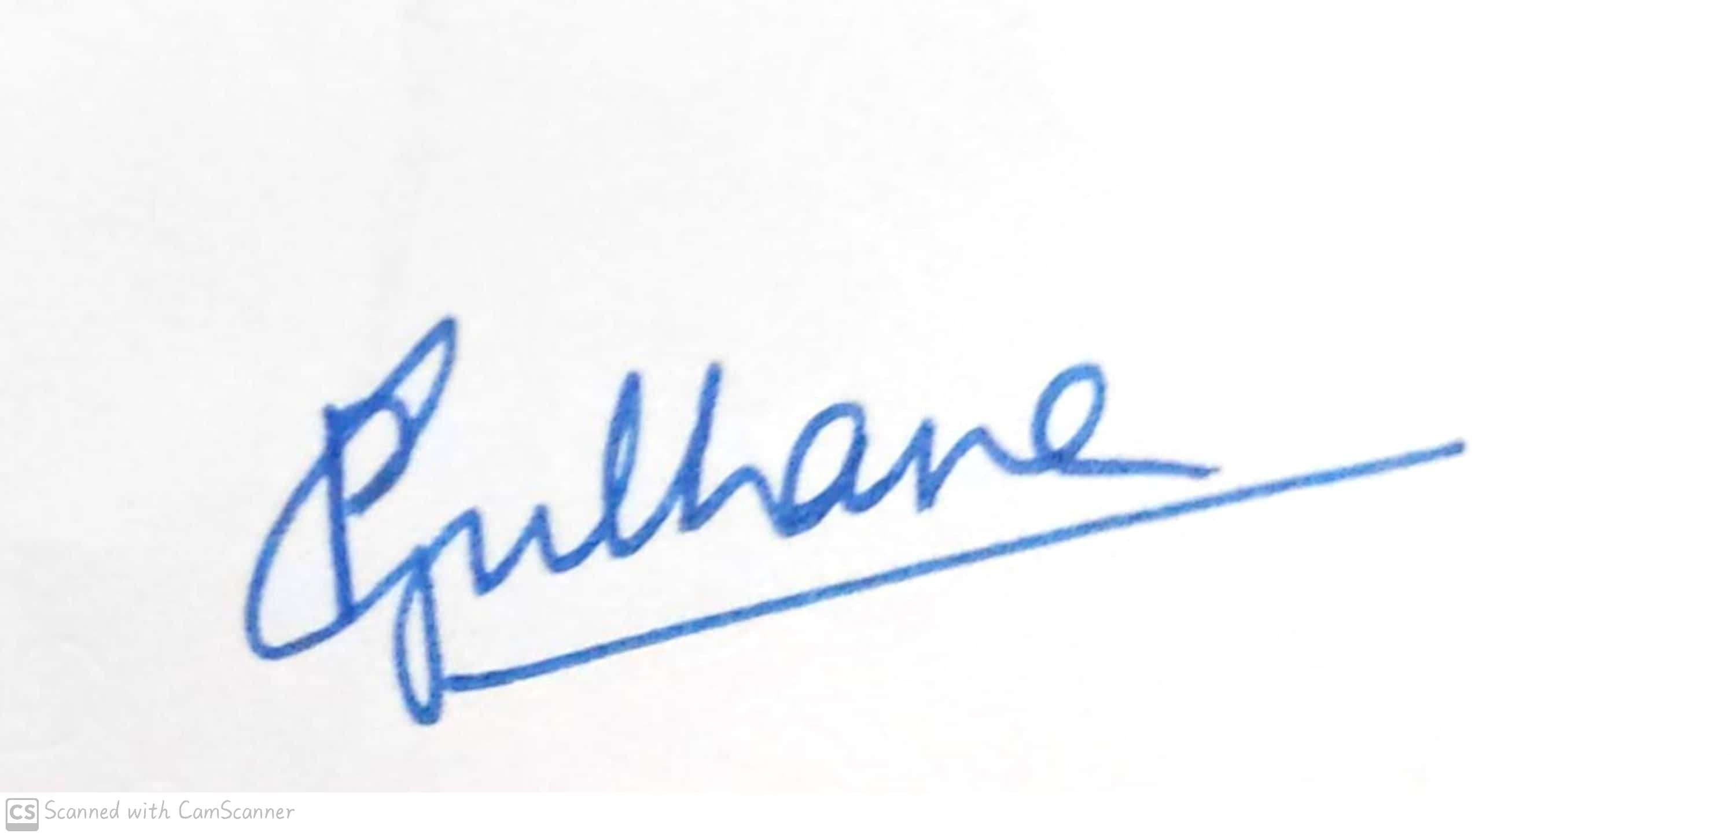

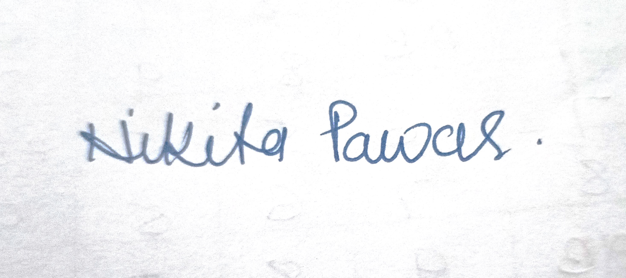

Signature of the Teacher

Ms.Nikita Pawar



**Shri Shivaji Education Society Amravati’s**

**Science College, Congress Nagar, Nagpur Academic Session 2020-2021**

**Department of Biotechnology**

**Bachelor of Science (B. Sc.) (Semester-V) BIOTECHNOLOGY Paper-I**

## (MOLECULAR BIOLOGY)

**UNIT TEST on Unit II**

Time: 45 min. [Maximum Marks: 20]

**N.B. :- (1) Solve all the questions.**

UNIT-II

|  |  |  |
| --- | --- | --- |
| **Q.1** | Give Physical and chemical mutagens. | **05** |
| **Q.2** | Write a note on frameshift mutations. | **05** |
| **Q.3** | Give Missense mutation. | **05** |
| **Q.4** | Write a note on SOS repair. | **05** |







Head of the Department

Dr,Pranita B. Gulhane

Signature of the Teacher

Ms.Nikita Pawar