**SHRI SHIVAJI EDUCATION SOCIETY AMRAVATI'S**

**SCIENCE COLLEGE, CONGRESS NAGAR, NAGPUR.**

**Department of Biotechnology**

**B. Sc. III Semester-V (2020-21)**

**BIOTECHNOLOGY Paper-II**

**Result of Unit Test held on 06/10/2020 on Unit I**

**Name of the teacher: Ms.Nikita Pawar**

|  |  |  |
| --- | --- | --- |
| **Sr.**  **No.** | **Batch B5**  **Students Name** | **Paper I**  **Marks out of 20** |
| 1. 1 | BARAPATRE SHREYA NITIN | 15 |
| 1. 2 | BASOLE SONAL CHANDRAKANT | 16 |
| 1. 3 | BEHUNE ANSHUL SUKHRAM | 14 |
| 1. 4 | BELEKAR KHUSHI MANOJ | 13 |
| 1. 5 | BHAGAT TRIVENI POLIRAM | AA |
| 1. 6 | BHONGADE BHAVANA NARAYAN | 12 |
| 1. 7 | BISEN BHUMESH MANOHAR | 15 |
| 1. 8 | BORIKAR RIYA SUNIL | 16 |
| 1. 9 | BUTE NIHARIKA PRADEEP | 15 |
| 1. 10 | CHAMBHARE RUCHIKA LAXMIKANT | 12 |
| 1. 11 | CHANDE DEVARSHI VIJAY | 15 |
| 1. 12 | CHANDURKAR AASTHA RAJKUMAR | AA |
| 1. 13 | CHARDE ADITI DILIP | 18 |
| 1. 14 | CHAUDHARI VEENA VASANTRAO | 20 |
| 1. 15 | CHOPKAR RASHMI NARESHCHANDRA | 16 |

|  |  |  |
| --- | --- | --- |
| 1. 16 | CHANNE SIDDHI PRADIP | 17 |
| 1. 17 | CHAVHAN PRITAM UKANDRAO | 16 |
| 1. 18 | CHIKHALE SAKSHI SANJAY | 17 |
| 1. 19 | DESHMUKHA ADITI PRAVIN | 15 |
| 1. 20 | DEULKAR TANAYA DEVANAND | AA |
| 1. 21 | DHABALE KAUSHALYA | 16 |
| 1. 22 | DHARAMSHAHARE SAYOG VIKAS | 16 |
| 1. 23 | DHOLE SALONI SATISH | 15 |
|  | DHOTE BHAVESH PURUSHOTTAM | 15 |
| 1. 6 | FARKADE VAISHNAVI MADHUKAR | 18 |
| 1. 7 | GAIKWAD EKTA KRISHNAKANT | 19 |
| 1. 8 | GANDHI SAKSHI GHANSHYAM | 15 |
| 1. 9 | GOUR ISHIKA HARISH | 17 |
| 1. 10 | GUJAR SHREEYA VIPINSINGH | 15 |
| 1. 11 | JADHAV PRANOTI HEMANT | 14 |
| 1. 12 | JAGTAP JANVI SUNIL | 15 |
| 1. 14 | JAIN AVANTIKA SATISH | 15 |
| 1. 15 | JAISWAL MITALI RAJESH | AA |
| 1. 16 | KADASNE VEDANT DILIP | 16 |
| 1. 18 | KADU UNNATI RAJU | 15 |
|  | KAHATE SIDDHI SURESH | 16 |
|  | KALLATTU ADITHYA ANIL | 16 |
|  | KAMBLE KSHITIJ KISHOR | AA |
|  | KHAWASE GAURAVI CHANDRASHEKHAR | 16 |
|  | KHOJARE SUPRIYA SUJEET | 11 |
|  | KOKATE RADHIKA PRAVINRAO | 18 |

|  |  |  |
| --- | --- | --- |
| **Sr.**  **No.** | **Batch B6**  **Students Name** | **Paper I**  **Marks out of 20** |
|  | KUMBHARE SHUBHAM SURESH | 18 |
|  | KUMARI RUCHI HARSHMOHAN | 19 |
|  | LAKKEWAR ISHITA SHARAD | 15 |
|  | MADAVI ANJALI RAJESH | 16 |
|  | MANE APOORVA PRAVINRAO | 15 |
|  | MARODKAR NANDINI BABARAO | 16 |
|  | MASKE MOHINI RUPESH | 16 |
|  | MEKRATWAR SEJAL SANJAY | 16 |
|  | MESHRAM SHRUTI DEODAS | 16 |
|  | MIRASHI BHOOMIKA SHIRISH | 16 |
|  | MUDNAIK VAIBHAVI PRASHANT | 14 |
|  | NASHINE NATASHA NAVIN | 15 |
|  | NAVALEKAR SAKSHI PRAMOD | 16 |
|  | NINAVE NISHITA ARUN | 17 |
|  | NIPANE VANSHIKA ANIL | 16 |
| 1. 1 | PADWE PRACHI RAVINDRA | 15 |
| 1. 2 | PARDHI NAYANSHRI NARESH | 15 |
| 1. 3 | PARIHAR ANKITA MADHUKAR | 16 |
| 1. 4 | PATIL ANJALI SHAILENDRA | AA |
| 1. 5 | RAJKAROSIA RAJ RAKESH | 15 |
| 1. 6 | RAMTEKE SANJANA SANJAY | 18 |
| 1. 7 | ROHRA HARSHITA ANIL | 18 |
| 1. 8 | SAOJI SHREENIVAS ASHISH | 18 |
| 1. 9 | SELOKAR GAURAV DILIP | 16 |
| 1. 10 | SHAHU ANJAL RAJENDRA | 17 |
| 1. 11 | SHIMPI VAISHNAVI PANKAJ | 17 |
| 1. 12 | SHINDE RUHI DEEPAK | 19 |
| 1. 13 | SHRIPAL TEJAS CHANDRASHEKHAR | 17 |
| 1. 14 | SINGH POONAM ASHOK | 16 |
| 1. 15 | SORTE DIVYA BHUPENDRA | 18 |
|  | TABHANE PRAGATI ANIL | 15 |
|  | TEKADE VEDANTI HEMANT | 15 |
|  | THAKRE NIKITA RAJESH | 16 |
|  | THAKRE VAISHNAVI VILAS | 15 |
|  | TIDKE SHASHANK PARASNATH | 15 |
|  | TITARMARE SAHIL PRASHANT | 16 |
|  | WANKHEDE JANAVI UMESH | AA |
|  | WANVE KAUSTUBH SURESH | 14 |
|  | WARATKAR RAKHI RUPESH | 17 |
|  | YAWALKAR VRUSHALI JAYANTKUMAR | 15 |

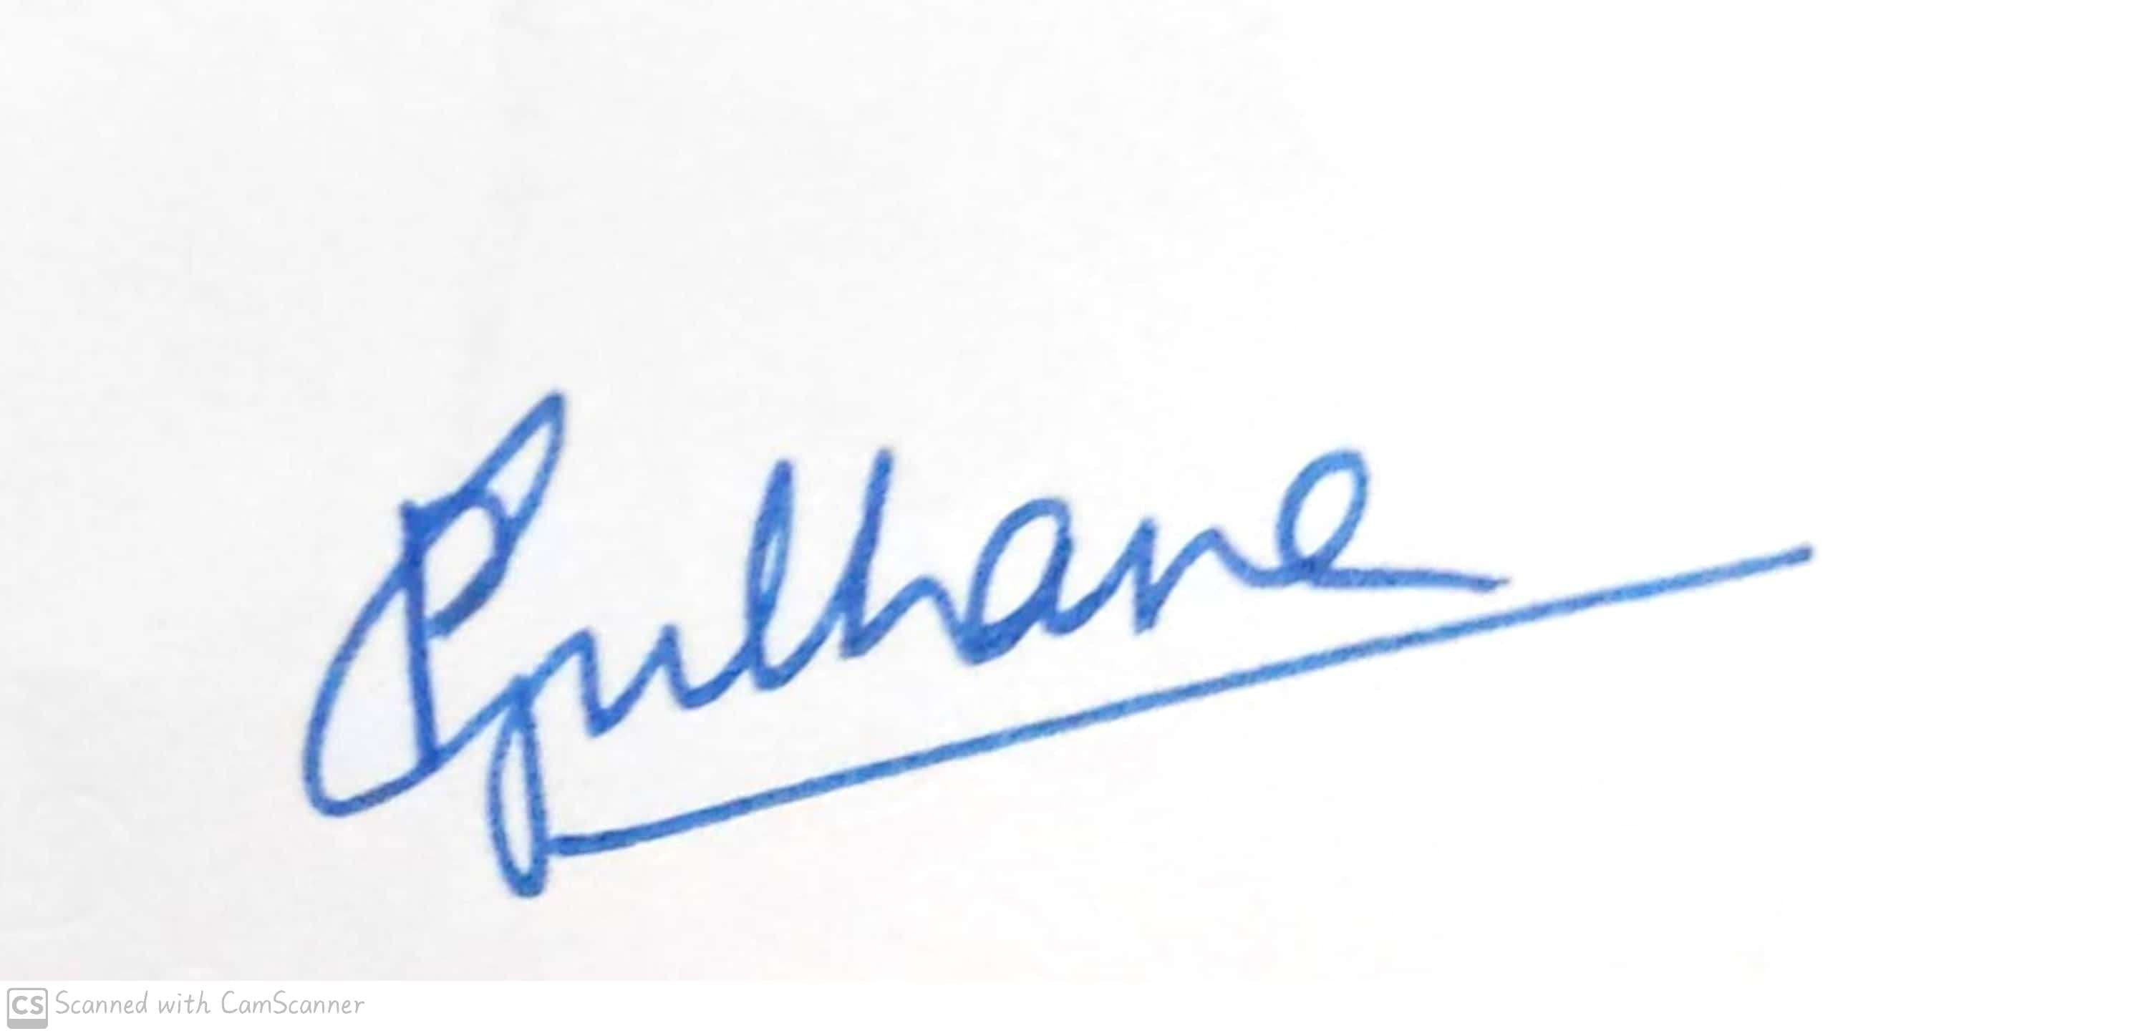

Head of the Department

Dr,Pranita B. Gulhane

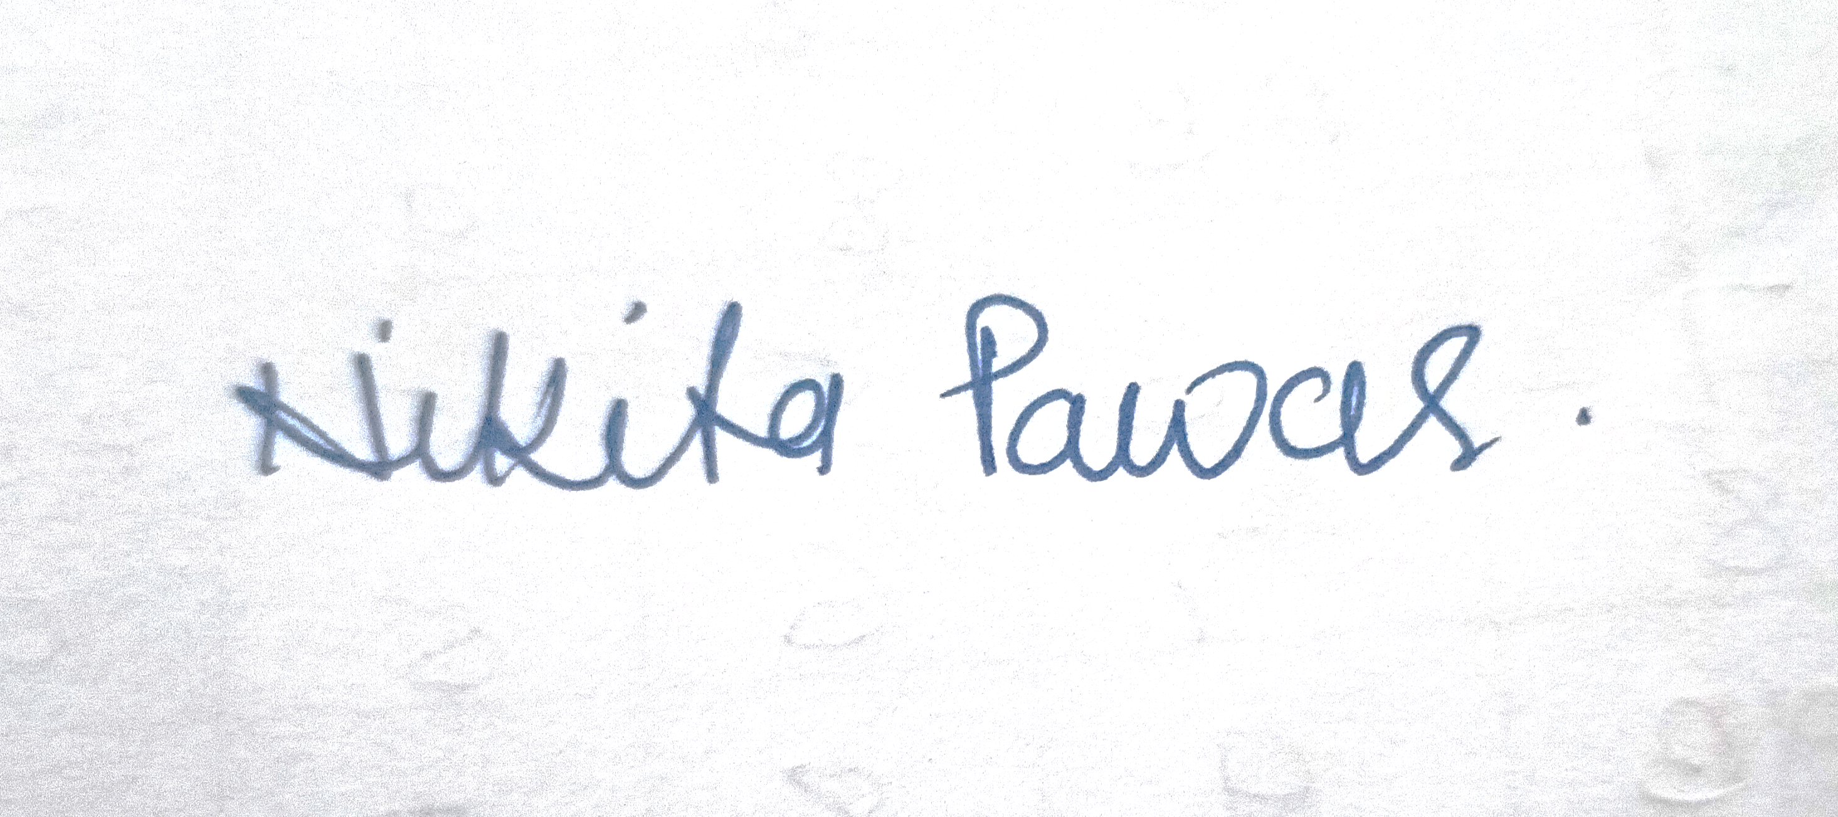

Signature of the Teacher

Ms.Nikita Pawar



**Shri Shivaji Education Society Amravati’s**

**Science College, Congress Nagar, Nagpur Academic Session 2021-2022**

**Department of Biotechnology**

**Bachelor of Science (B. Sc.) (Semester-V) BIOTECHNOLOGY Paper-II**

## (MOLECULAR BIOLOGY & rDNA TECHNOLOGY)

**UNIT TEST on Unit III**

Time: 45 min. [Maximum Marks: 20]

**N.B. :- (1) Solve all the questions.**

UNIT-III

|  |  |  |
| --- | --- | --- |
| **Q.1** | Write a note on Phage vector. | **05** |
| **Q.2** | Write a note on Cutting and joining DNA. | **05** |
| **Q.3** | Give enzymes of DNA manipulation | **05** |
| **Q.4** | Write a note on Transfection and transformation | **05** |







Head of the Department

Dr,Pranita B. Gulhane

Signature of the Teacher

Ms.Nikita Pawar