SHRI SHIVAJI EDUCATION SOCIETY AMRAVATI'S
SCIENCE COLLEGE, CONGRESS NAGAR, NAGPUR.
Department of Biotechnology
B. Sc. I Semester-V (2019-20)
BIOTECHNOLOGY Paper-II

Result of Unit Test held on 12/09/2022 on Unit I
Name of the teacher:

Batch B5 CMBT |  |  |  |  | Paper-I
Sr.  No. | Name |  | Students Name | Students Father Name | Marks out of 20
- 1 | Ku | Lakshmi Kumari | Ravindra | R | 14
- 2 | Ku | Aswale | Neha | D | 16
- 3 | Ku | Badwe | Ritika | S | 14
- 4 | Ku | Bagwe | Anjali | B | 13
- 5 | Ku | Bawane | Aishwarya | P | AA
- 6 |  | Bhagwatkar | Kunal | P | 11
- 7 | Ku | Bhalwatkar | Pranoti | R | 15
- 8 | Ku | Bire | Shraddha | G | 16
- 9 | Ku | Burghate | Mansi | J | 15
- 10 | Ku | Chahande | Saloni | S | 12
- 11 |  | Chauhan | Vishwanath | P | AA
- 12 |  | Chidam | Akash | R | 17
- 13 | Ku | Choudhary | Sauravi | G | 18
- 14 | Ku | Dadmal | Amruta | A | 20
- 15 | Ku | Deshpande | Aboli | S | 16

- 16 |  | Hedaoo | Parth | G | 17
- 17 |  | Jamunkar | Lokesh | S | 15
- 18 | Ku | Junchare | Aachal | G | 16
- 19 |  | Kalbut | Siddhesh | Y | 15
- 20 |  | Kargaonkar | Bhushan | S | 18
- 21 | Ku | Khandre | Ishika | P | 16
- 22 | Ku | Khursange | Yash | G | 16
- 23 |  | Kirnapure | Priyanshu | B | 15
 | Ku | Koche | Vrukshali | B | AA
- 6 |  | Mahale | Shubham | S | 18
- 7 |  | Mahale | Trupti | Mahale | 17
- 8 |  | Meharkule | Prachi | Meharkule | 15
- 9 | Ku | Mirashe | Tanmay | Mirashe | 17
- 10 |  | Mohammed | Zayan | Mohammed | 15
- 11 | Ku | Nagrare | Aaishwarya | Nagrare | 14
- 12 | Ku | Nirgulkar | Rudali | Nirgulkar | 15
- 14 | Ku | Nirwan | Ritika | Nirwan | 15
- 15 | Ku | Pakhmode | Shweta | Pakhmode | 15
- 16 | Ku | Parihar | Himasnshu | Parihar | AA
- 18 | Ku | Parshuramkar | Prajwal | Parshuramkar | 15

36. | Lawat | Divya | U | 15
37. | More | Paris | S | 15
38. | Deshmukh | Shivani | P | 18
39. | Shirsath | Mrunali | P | 17
40. | Bokade | Apeksha | A | AA
41. | Mishra | Wasudew | G | 16

Batch B6 CMBT |  |  |  |  | Paper-I
Sr.  No. | Name |  | Students Name | Students Father Name | Marks out of 20
 | Ku | Lodhey | Shreayashree | P | 18
 | Ku | Mallurwar | Vaishnavi | G | AA
 | Ku | Mankar | Lakshika | V | 18
 |  | Meshram | Adil | N | 16
 | Ku | Meshram | Ragini | S | 19
 | Ku | Muley | Avanti | M | 16
 | Ku | Musale | Ashwini | P | 16
 |  | Nalage | Suraj | P | 16
 | Ku | Nare | Prachi | B | 16
 | Ku | Pande | Indrayani | R | 16
 | Ku | Pande | Tanushree | M | 14
 |  | Parate | Kamlesh | S | 15
 | Ku | Patankar | Shivani | D | 16
 | Ku | Patankar | Shriya | S | 17
 | Ku | Pathan | Alisha | R | AA
- 1 | Ku | Patil | Ankita | Ku | 15
- 2 | Ku | Patle | Apeksha | Ku | 15
- 3 | Ku | Prasad | Neha | Ku | 16
- 4 | Ku | Rahangdale | Sakshi | Ku | 16
- 5 | Ku | Randale | Apurva | Ku | 15
- 6 |  | Raut | Kunal | K | 18
- 7 | Ku | Salunke | Jyotsna | S | 18
- 8 | Ku | Salve | Gouri | M | 16
- 9 | Ku | Samarth | Piyusha | P | 16
- 10 | Ku | Saraf | Simran | V | 19
- 11 | Ku | Sarode | Pratiksha | L | 17
- 12 | Ku | Shambahrkar | Neha | D | 20
- 13 | Ku | Sheikh | Aaliya | G | 17
- 14 | Ku | Shrawane | Srushti | R | 16
- 15 | Ku | Solanki | Vaishnavi | D | AA
 |  | Soyam | Ankit | R | 15
 | Ku | Tekade | Suwarna | D | 15
 | Ku | Telang | Amruta | N | 18
 | Ku | Thakare | Dhanashree | Y | 15
 | Ku | Thakur | Roshni | S | 16
 | Ku | Tharani | Misbah | T | 16


Head of the Department
Mrs.M.J.Madhugiri
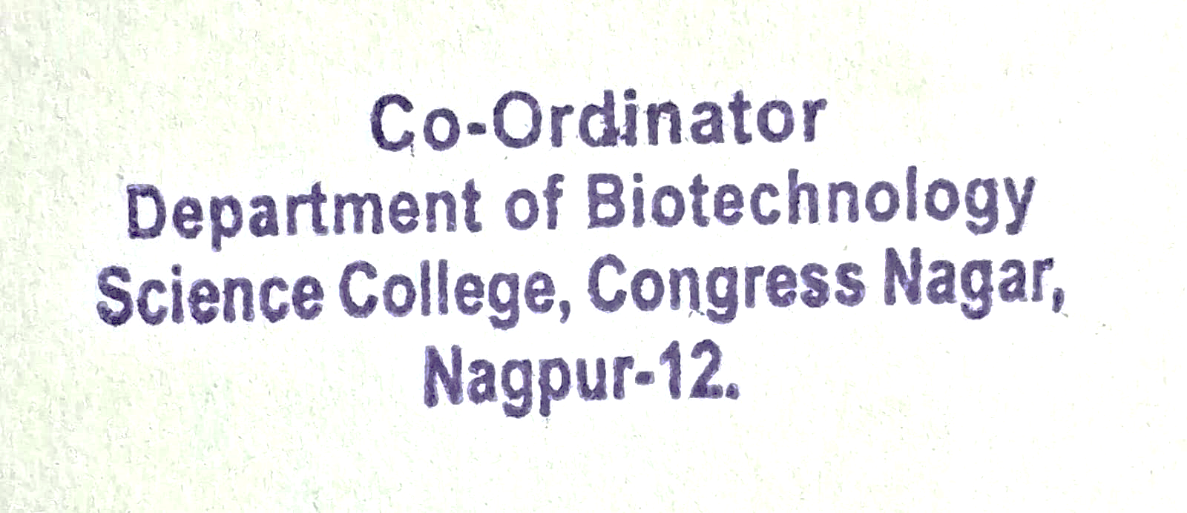

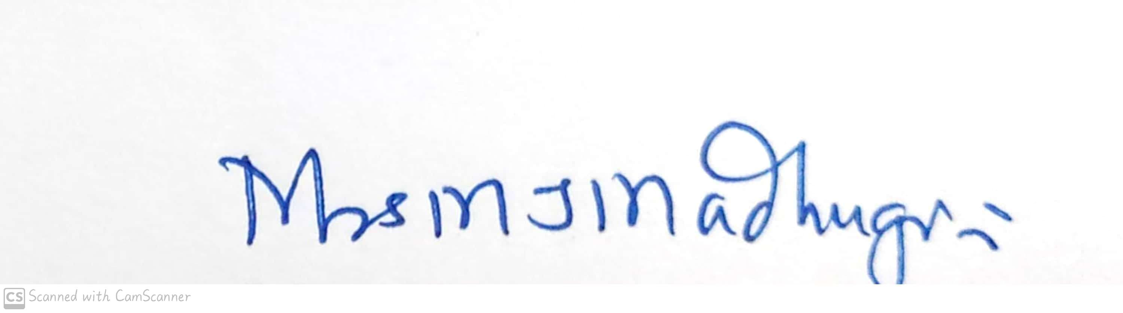
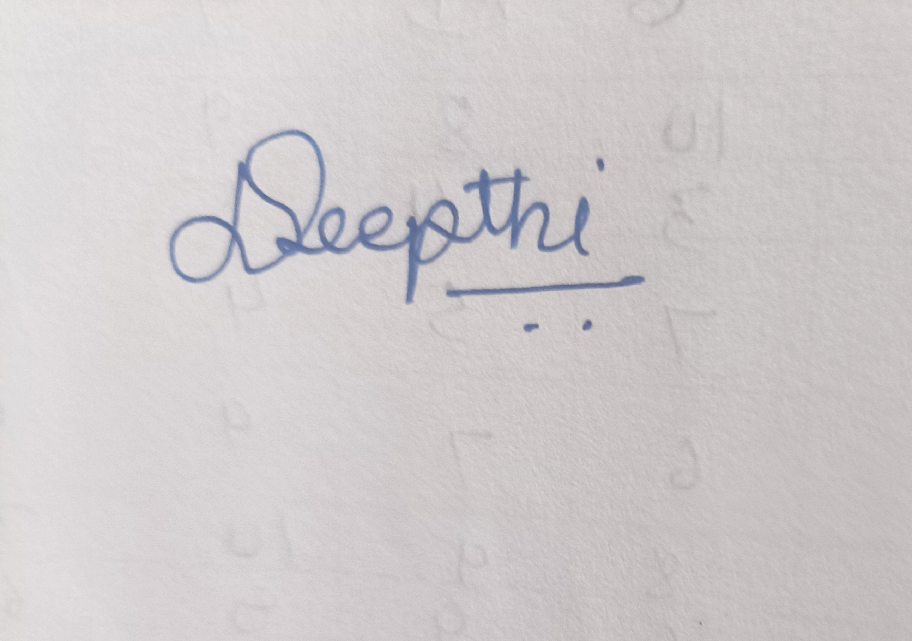
Signature of the Teacher
D.Deepthi Hynal

Shri Shivaji Education Society Amravati’s
Science College, Congress Nagar, Nagpur Academic Session 2019-2020
Department of Biotechnology
Bachelor of Science (B. Sc.) (Semester-V) BIOTECHNOLOGY Paper-II

(MOLECULAR BIOLOGY & rDNA TECHNOLOGY)
UNIT TEST on Unit I
Time: 45 min. [Maximum Marks: 20]
N.B. :- (1) Solve all the questions.

UNIT-I

Q.1 | Give experimental elucidation of codons | 05 | 05
Q.2 | Write a note on Codon-anticodon interaction - the wobble hypothesis. | 05 | 05
Q.3 | Explain : degeneracy and commaless nature of codons. | 05 | 05
Q.4 | Write a note on Shine and Dalgarno sequence and the 16S rRNA. | 05 | 05

Head of the Department
Mrs.M.J.Madhugiri
Signature of the Teacher
D.Deepthi Hynal

