**SHRI SHIVAJI EDUCATION SOCIETY AMRAVATI'S**

**SCIENCE COLLEGE, CONGRESS NAGAR, NAGPUR.**

**Department of Biotechnology**

**B. Sc. I Semester-V (2017-18)**

**BIOTECHNOLOGY Paper-II**

**Result of Unit Test held on 28/10/2017on Unit II**

**Name of the teacher: Ms.Priyanka Jadhav**

|  |  |  |  |  |  |  |  |  |  |  |
| --- | --- | --- | --- | --- | --- | --- | --- | --- | --- | --- |
| **Batch B5 CMBT** | | | | | | | | | | **Paper-II** |
| **Sr.**  **No.** | **Name** | | | **Student Name** | | | | | **Father Name** | **Marks out of 20** |
| 1. 1 |  | Agarkar | | | P | | | | G | 15 |
| 1. 2 |  | Asare | | | M | | | | S | 12 |
| 1. 3 |  | Aundhekar | | | S | | | | A | 14 |
| 1. 4 |  | Badwekar | | | K | | | | K | 15 |
| 1. 5 |  | Bansinge | | | A | | | | R | 12 |
| 1. 6 |  | Belsare | | | P | | | | T | 16 |
| 1. 7 |  | Chandane | | | H | | | | M | AA |
| 1. 8 |  | Chouhan | | | P | | | | P | 16 |
| 1. 9 |  | Datke | | | P | | | | S | 12 |
| 1. 10 |  | Deolasi | | | P | | | | A | 14 |
| 1. 11 |  | Deshmukh | | | M | | | | V | 13 |
| 1. 12 |  | Deshmukh | | | P | | | | R | 15 |
| 1. 13 |  | Deulkar | | | Akanksha | | | N | | 12 |
| 1. 14 |  | Dhabekar | | | A | | | N | | 12 |
| 1. 15 |  | Ghate | | | M | | | S | | 04 |
| 1. 16 |  | Giri | | | S | | | D | | AA |
| 1. 17 |  | Ilame | | | S | | | P | | 14 |
| 1. 18 |  | Kadge | | | D | | | T | | 15 |
| 1. 19 |  | Kathale | | | R | | | R | | AA |
| 1. 20 |  | Kawade | | | S | | | D | | 15 |
| 1. 21 |  | Kewlani | | | M | | | K | | 12 |
| 1. 22 |  | Khandalkar | | | R | | | Y | | 01 |
| 1. 23 | Ku | Kirnapure | | | P | | | M | | 11 |
|  |  | Kukade | | | R | | | D | |  |
| 1. 6 | Ku | Londhekar | | | K | | | D | | 15 |
| 1. 7 |  | Malghade | | | D | | | S | | 12 |
| 1. 8 |  | Malke | | | H | | | C | | AA |
| 1. 9 | Ku | Mankar | | | P | | | S | | 12 |
| **Batch B-6 CMBT** | | | | | | | | | | |
| Sr.  No. |  | | Name | | | |  | | | **Paper-II** |
| 1. 10 |  | Bawane | A | | | K | | | | 14 |
| 1. 11 | Ku | Mankar | S | | | T | | | | 12 |
| 1. 12 | Ku | Nachankar | L | | | U | | | | 15 |
| 1. 14 | Ku | Nagbhidkar | K | | | G | | | | 15 |
| 1. 15 | Ku | Ninave | S | | | R | | | | 00 |
| 1. 16 | Ku | Pachabhai | W | | | A | | | | 16 |
| 1. 1 |  | Patankar | Y | | | N | | | | AA |
| 1. 2 |  | Paunikar | A | | | A | | | | 19 |
| 1. 3 | Ku | Pawar | A | | | S | | | | 15 |
| 1. 4 |  | Pund | A | | | K | | | | 18 |
| 1. 5 | Ku | Ramtekkar | P | | | C | | | | 15 |
| 1. 6 | Ku | Saiman | R | | | R | | | | 12 |
| 1. 7 | Ku | Selokar | H | | | V | | | | 14 |
| 1. 8 | Ku | Singh | C | | | V | | | | 15 |
| 1. 9 |  | Sisodia | G | | | V | | | | AA |
| 1. 10 | Ku | Talewar | V | | | N | | | | 15 |
| 1. 11 | Ku | Thakur | A | | | N | | | | 15 |
| 1. 12 | Ku | Thawari | S | | | S | | | | AA |
| 1. 13 | Ku | Tikkas | K | | | A | | | | 12 |
| 1. 14 |  | Tonpe | A | | | P | | | | 15 |
| 1. 15 | Ku | Umare | S | | | S | | | | 10 |
| 1. 16 | Ku | Vedi | P | | | C | | | | 20 |
| 1. 17 | Ku | Wadhai | R | | | R | | | | 15 |
| 1. 18 | Ku | Wagh | H | | | V | | | | 14 |
| 1. 19 | Ku | Warghade | C | | | V | | | | 15 |
| 1. 20 | Ku | Yawale | G | | | V | | | | AA |





Signature of the Teacher

Ms.Priyanka Jadhav



Head of the Department

Dr.C.J.Chandekar



**Shri Shivaji Education Society Amravati’s**

**Science College, Congress Nagar, Nagpur Academic Session 2017-2018**

**Bachelor of Science (B. Sc.) (Semester-V) BIOTECHNOLOGY Paper-II**

## (MOLECULAR BIOLOGY & rDNA TECHNOLOGY)

## UNIT TEST on Unit II

Time: 45 min.] [Maximum Marks: 20]

**N.B. :- (1) Solve all the questions.**

UNIT-II

|  |  |  |
| --- | --- | --- |
| **Q.1** | Give Autogenous control of r-proteins. | **05** |
| **Q.2** | Write a note on Initiation, elongation, and termination in Protein synthesis | **05** |
| **Q.3** | Explain : phage T4 protein p32 translational regulation. | **05** |
| **Q.4** | Write a note on Antibiotics affecting translation. | **05** |



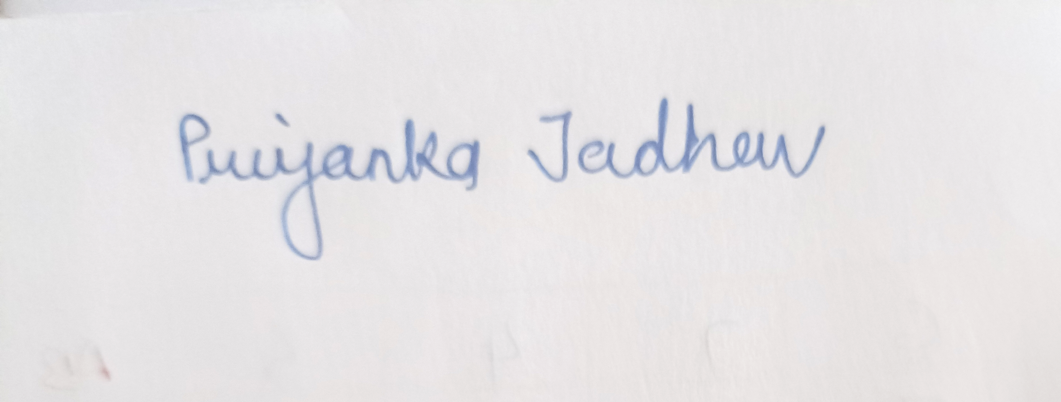

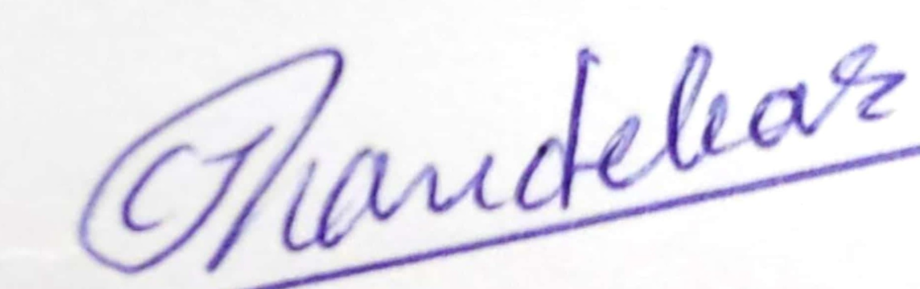

Head of the Department

Dr.C.J.Chandekar



Signature of the Teacher

Ms.Priyanka Jadhav