SHRI SHIVAJI EDUCATION SOCIETY AMRAVATI'S
SCIENCE COLLEGE, CONGRESS NAGAR, NAGPUR.
Department of Biotechnology
B. Sc. III Semester-VI (2021-22)
BIOTECHNOLOGY Paper-II

Result of Unit Test held on 13/02/2022 on Unit III
Name of the teacher: D.Deepthi Hynal

Sr.  No. | Batch B5 CMBT  Students Name | Paper I  Marks out of 20
- 1 | ADASE ANIKET SANJAY | 17
- 2 | AGASHE RASHMI KISHOR | 18
- 3 | ARGHODE ISHA VILIN | 14
- 4 | BAGDE SARVESH CHANDRASHEKHAR | 13
- 5 | BHANDARGE HIMANSHU VIJAY | 17
- 6 | BOBDE SAKSHI VIJAY | 12
- 7 | BURCHUNDE MAHEK RAJENDRA | AA
- 8 | CHAURE MUSKARN RAMESH | 16
- 9 | CHAVHAN SAKSHI SUDHIR | 15
- 10 | CHAVHAN SNEHA NARENDRA | 12
- 11 | CHOPKAR SHRUTI CHANDRASHEKHAR | 15
- 12 | DESHPANDE SHIVANI SHRIRANG | 20
- 13 | DHOBLE VAISHNAVI PRAMOD | 18
- 14 | DHOKE PRIYAL AJAY | 20
- 15 | DHOTE JANHVI SANJAY | AA

- 16 | CHIKHALE SAKSHI SANJAY | 16
- 17 | DESHMUKHA ADITI PRAVIN | 16
- 18 | DEULKAR TANAYA DEVANAND | 17
- 19 | DHABALE KAUSHALYA | 15
- 20 | DHARAMSHAHARE SAYOG VIKAS | 17
- 21 | DHOLE SALONI SATISH | 16
- 22 | DHOTE BHAVESH PURUSHOTTAM | AA
- 23 | FARKADE VAISHNAVI MADHUKAR | 15
 | GAIKWAD EKTA KRISHNAKANT | 15
- 6 | GANDHI SAKSHI GHANSHYAM | 18
- 7 | GOUR ISHIKA HARISH | 19
- 8 | GUJAR SHREEYA VIPINSINGH | 15
- 9 | JADHAV PRANOTI HEMANT | 17
- 10 | JAGTAP JANVI SUNIL | 15
- 11 | JAIN AVANTIKA SATISH | 14
- 12 | JAISWAL MITALI RAJESH | 15
- 14 | KADASNE VEDANT DILIP | 15
- 15 | KADU UNNATI RAJU | AA
- 16 | KAHATE SIDDHI SURESH | 16
- 18 | KALLATTU ADITHYA ANIL | 15
 | KAMBLE KSHITIJ KISHOR | 14
 | KHAWASE GAURAVI CHANDRASHEKHAR | 15
 | KHOJARE SUPRIYA SUJEET | 14
 | KOKATE RADHIKA PRAVINRAO | 14
 | KUMBHARE SHUBHAM SURESH | 16

Sr.  No. | Batch B6  Students Name | Paper II  Marks out of 20
 | MOHOD RENUKA RAMU | 18
 | MOON SAMYAK RAJKUMAR | 19
 | MULEY ANUSHREE CHANDRAKANT | 15
 | NAVGHARE PRACHI BALAJI | 16
 | NIMBALKAR ARATI CHANDRASHEKHAR | 15
 | NIRWAN SONAL VASANT | 16
 | OHRI DAKSHA DEVENDRA | 16
 | PAJAI ANKIT MADHUIKAR | 16
 | PALANDURKAR PRATIKSHA MANISH | 16
 | PANDEY SUPRIYA DEVIPRASAD | 16
 | PARALKAR ANURADHA SHRIRAM | 14
 | PATHAK SAMRUDDHI SANJAY | 15
 | PATRO KALPANA SAMAR | 16
 | PODDAR BHAVANA OMPRAKASH | 17
 | RANGARI SHRUTI RAJENDRA | 16
- 1 | RANGU DIPTI MADHUKAR | 15
- 2 | RATHOD ATHARVA LAXMAN | 15
- 3 | RENGE SHRUTI PRASAHNT | 16
- 4 | ROY SAPTARNA SHEHANSU | AA
- 5 | SARDA SAKSHI RAMPRAKASH | 15
- 6 | SAWANE SHARAYU MANGESH | 18
- 7 | SHARMA SHUBHANGI RAMBHAU | 18
- 8 | SHARMA SWATI RAMESH | 18
- 9 | SHEIKH SUMEIYA IQBAL | 16
- 10 | SHENDRE NISHITA BHAGWAN | 17
- 11 | SINGH PRANJALI RAMVIR | 17
- 12 | TAKSANDE VIBHA JAIKUMAR | 19
- 13 | TIRPUDE RAHUL GAJANAN | 17
- 14 | TIWARI SAMIP SUSHEEL | 16
- 15 | UKEY RUTUGANDHA DEVANAND | 18
 | UMATE JANHAVI HARIHAR | 15
 | UMREKAAR AAYUSHI RAKESH | 15
 | VARMA MUSKAN VIJAYKUMAR | 16
 | WADE YASHODA RAVINDRA | AA
 | WADIWA BHAVESH NILKANTH | 13
 | WAGHMARE KOMAL RAVINDRA | 16
 | WAGHMARE PRIYA SHARAD | 14
 | WAGHMARE SIDDHI SUDHIR | 13
 | WARKADE HARSH VIJAY | AA
 | WASAKE MANISHA DASHRATH | 16
 | ZADE SAKSHI SURENDRA | 13
 | ZILPE SHREYA SURESH | 15

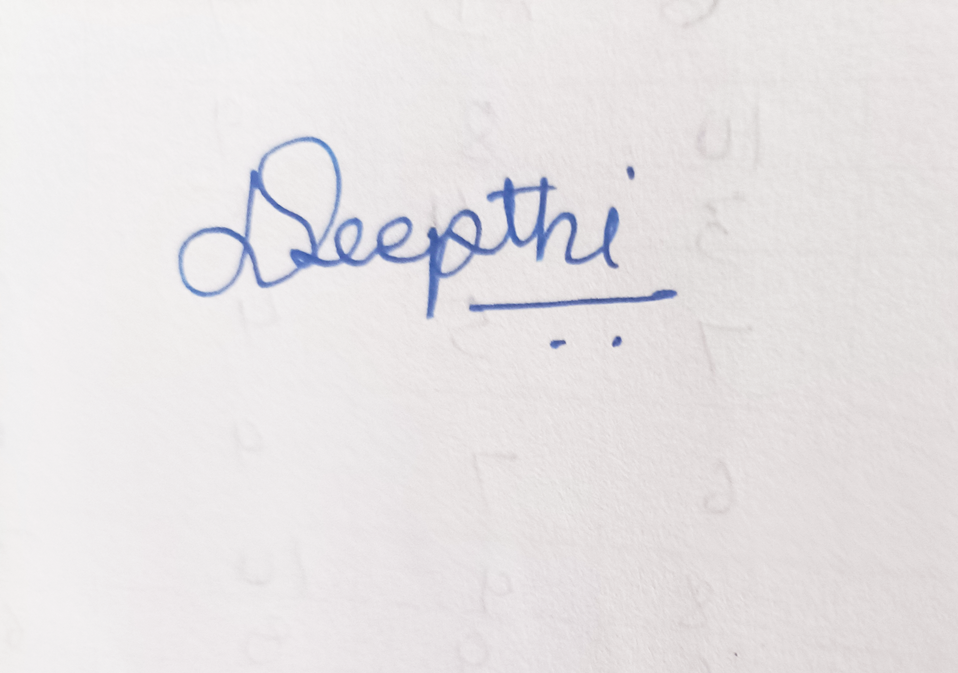

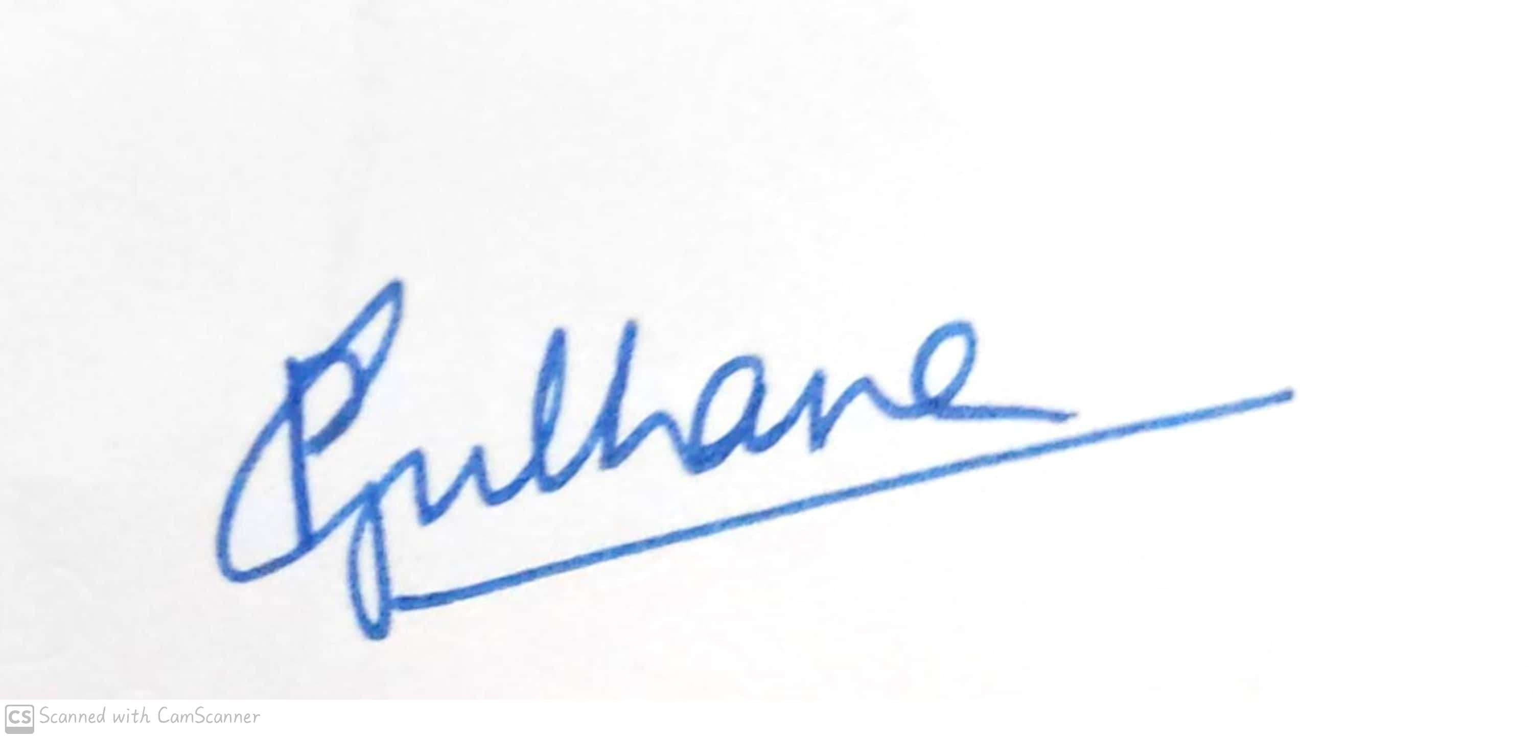
Signature of the Teacher
D.Deepthi Hynal

Head of the Department
Dr. Pranita B. Gulhane

Shri Shivaji Education Society Amravati’s
Science College, Congress Nagar, Nagpur Academic Session 2022-2023
Deapartment of Biotechnology
Bachelor of Science (B. Sc.) (Semester-VI) BIOTECHNOLOGY Paper-II
(PLANT & ANIMAL BIOTECHNOLOGY)
UNIT TEST on Unit II
Time: 45 min.] [Maximum Marks: 20]
N.B. :- (1) Solve all the questions.

UNIT-II

Q.1 | Give Introduction to cell and Tissue culture | 05
Q.2 | Write a note on Callus and suspension cultures | 05
Q.3 | Give Autogenous on single-cell clones. | 05
Q.4 | Write a note on Tissue culture media (composition and preparation) | 05

Head of the Department
Dr. Pranita B. Gulhane

Signature of the Teacher
D.Deepthi Hynal

