**SHRI SHIVAJI EDUCATION SOCIETY AMRAVATI'S**

**SCIENCE COLLEGE, CONGRESS NAGAR, NAGPUR.**

**Department of Biotechnology**

**B. Sc. III Semester-V (2021-22)**

**BIOTECHNOLOGY Paper-II**

**Result of Unit Test held on 13/12/2022 on Unit III**

**Name of the teacher: D.Deepthi Hynal**

|  |  |  |
| --- | --- | --- |
| **Sr.**  **No.** | **Batch B5 CMBT**  **Students Name** | **Paper II**  **Marks out of 20** |
| 1. 1 | ADASE ANIKET SANJAY | 17 |
| 1. 2 | AGASHE RASHMI KISHOR | 18 |
| 1. 3 | ARGHODE ISHA VILIN | 14 |
| 1. 4 | BAGDE SARVESH CHANDRASHEKHAR | 13 |
| 1. 5 | BHANDARGE HIMANSHU VIJAY | 17 |
| 1. 6 | BOBDE SAKSHI VIJAY | 12 |
| 1. 7 | BURCHUNDE MAHEK RAJENDRA | AA |
| 1. 8 | CHAURE MUSKARN RAMESH | 16 |
| 1. 9 | CHAVHAN SAKSHI SUDHIR | 15 |
| 1. 10 | CHAVHAN SNEHA NARENDRA | 12 |
| 1. 11 | CHOPKAR SHRUTI CHANDRASHEKHAR | 15 |
| 1. 12 | DESHPANDE SHIVANI SHRIRANG | 20 |
| 1. 13 | DHOBLE VAISHNAVI PRAMOD | 18 |
| 1. 14 | DHOKE PRIYAL AJAY | 20 |
| 1. 15 | DHOTE JANHVI SANJAY | AA |

|  |  |  |
| --- | --- | --- |
| 1. 16 | CHIKHALE SAKSHI SANJAY | 16 |
| 1. 17 | DESHMUKHA ADITI PRAVIN | 16 |
| 1. 18 | DEULKAR TANAYA DEVANAND | 17 |
| 1. 19 | DHABALE KAUSHALYA | 15 |
| 1. 20 | DHARAMSHAHARE SAYOG VIKAS | 17 |
| 1. 21 | DHOLE SALONI SATISH | 16 |
| 1. 22 | DHOTE BHAVESH PURUSHOTTAM | AA |
| 1. 23 | FARKADE VAISHNAVI MADHUKAR | 15 |
|  | GAIKWAD EKTA KRISHNAKANT | 15 |
| 1. 6 | GANDHI SAKSHI GHANSHYAM | 18 |
| 1. 7 | GOUR ISHIKA HARISH | 19 |
| 1. 8 | GUJAR SHREEYA VIPINSINGH | 15 |
| 1. 9 | JADHAV PRANOTI HEMANT | 17 |
| 1. 10 | JAGTAP JANVI SUNIL | 15 |
| 1. 11 | JAIN AVANTIKA SATISH | 14 |
| 1. 12 | JAISWAL MITALI RAJESH | 15 |
| 1. 14 | KADASNE VEDANT DILIP | 15 |
| 1. 15 | KADU UNNATI RAJU | AA |
| 1. 16 | KAHATE SIDDHI SURESH | 16 |
| 1. 18 | KALLATTU ADITHYA ANIL | 15 |
|  | KAMBLE KSHITIJ KISHOR | 14 |
|  | KHAWASE GAURAVI CHANDRASHEKHAR | 15 |
|  | KHOJARE SUPRIYA SUJEET | 14 |
|  | KOKATE RADHIKA PRAVINRAO | 14 |
|  | KUMBHARE SHUBHAM SURESH | 16 |

|  |  |  |
| --- | --- | --- |
| **Sr.**  **No.** | **Batch B6**  **Students Name** | **Paper II**  **Marks out of 20** |
|  | MOHOD RENUKA RAMU | 18 |
|  | MOON SAMYAK RAJKUMAR | 19 |
|  | MULEY ANUSHREE CHANDRAKANT | 15 |
|  | NAVGHARE PRACHI BALAJI | 16 |
|  | NIMBALKAR ARATI CHANDRASHEKHAR | 15 |
|  | NIRWAN SONAL VASANT | 16 |
|  | OHRI DAKSHA DEVENDRA | 16 |
|  | PAJAI ANKIT MADHUIKAR | 16 |
|  | PALANDURKAR PRATIKSHA MANISH | 16 |
|  | PANDEY SUPRIYA DEVIPRASAD | 16 |
|  | PARALKAR ANURADHA SHRIRAM | 14 |
|  | PATHAK SAMRUDDHI SANJAY | 15 |
|  | PATRO KALPANA SAMAR | 16 |
|  | PODDAR BHAVANA OMPRAKASH | 17 |
|  | RANGARI SHRUTI RAJENDRA | 16 |
| 1. 1 | RANGU DIPTI MADHUKAR | 15 |
| 1. 2 | RATHOD ATHARVA LAXMAN | 15 |
| 1. 3 | RENGE SHRUTI PRASAHNT | 16 |
| 1. 4 | ROY SAPTARNA SHEHANSU | AA |
| 1. 5 | SARDA SAKSHI RAMPRAKASH | 15 |
| 1. 6 | SAWANE SHARAYU MANGESH | 18 |
| 1. 7 | SHARMA SHUBHANGI RAMBHAU | 18 |
| 1. 8 | SHARMA SWATI RAMESH | 18 |
| 1. 9 | SHEIKH SUMEIYA IQBAL | 16 |
| 1. 10 | SHENDRE NISHITA BHAGWAN | 17 |
| 1. 11 | SINGH PRANJALI RAMVIR | 17 |
| 1. 12 | TAKSANDE VIBHA JAIKUMAR | 19 |
| 1. 13 | TIRPUDE RAHUL GAJANAN | 17 |
| 1. 14 | TIWARI SAMIP SUSHEEL | 16 |
| 1. 15 | UKEY RUTUGANDHA DEVANAND | 18 |
|  | UMATE JANHAVI HARIHAR | 15 |
|  | UMREKAAR AAYUSHI RAKESH | 15 |
|  | VARMA MUSKAN VIJAYKUMAR | 16 |
|  | WADE YASHODA RAVINDRA | AA |
|  | WADIWA BHAVESH NILKANTH | 13 |
|  | WAGHMARE KOMAL RAVINDRA | 16 |
|  | WAGHMARE PRIYA SHARAD | 14 |
|  | WAGHMARE SIDDHI SUDHIR | 13 |
|  | WARKADE HARSH VIJAY | 15 |
|  | WASAKE MANISHA DASHRATH | 16 |
|  | ZADE SAKSHI SURENDRA | 18 |
|  | ZILPE SHREYA SURESH | 17 |



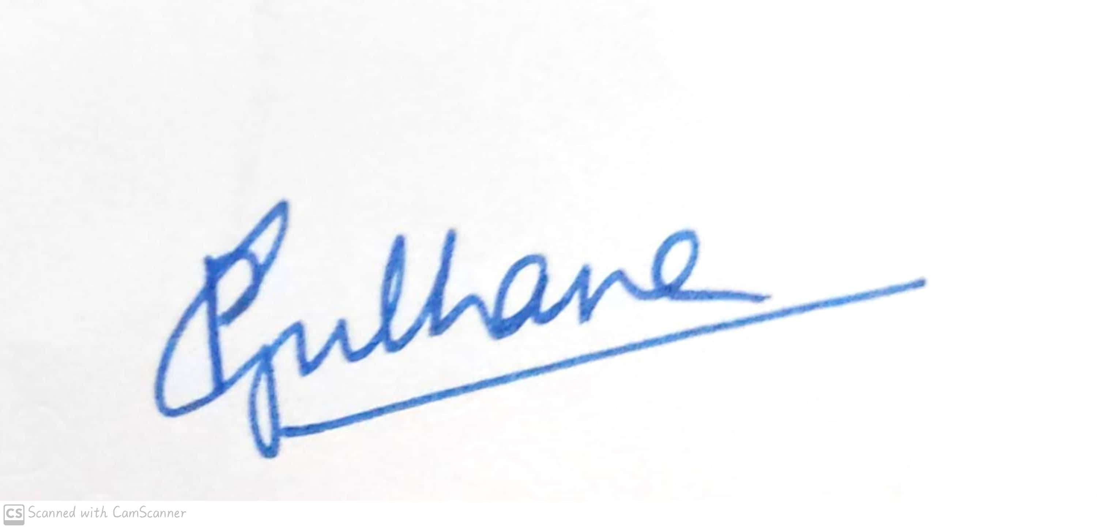

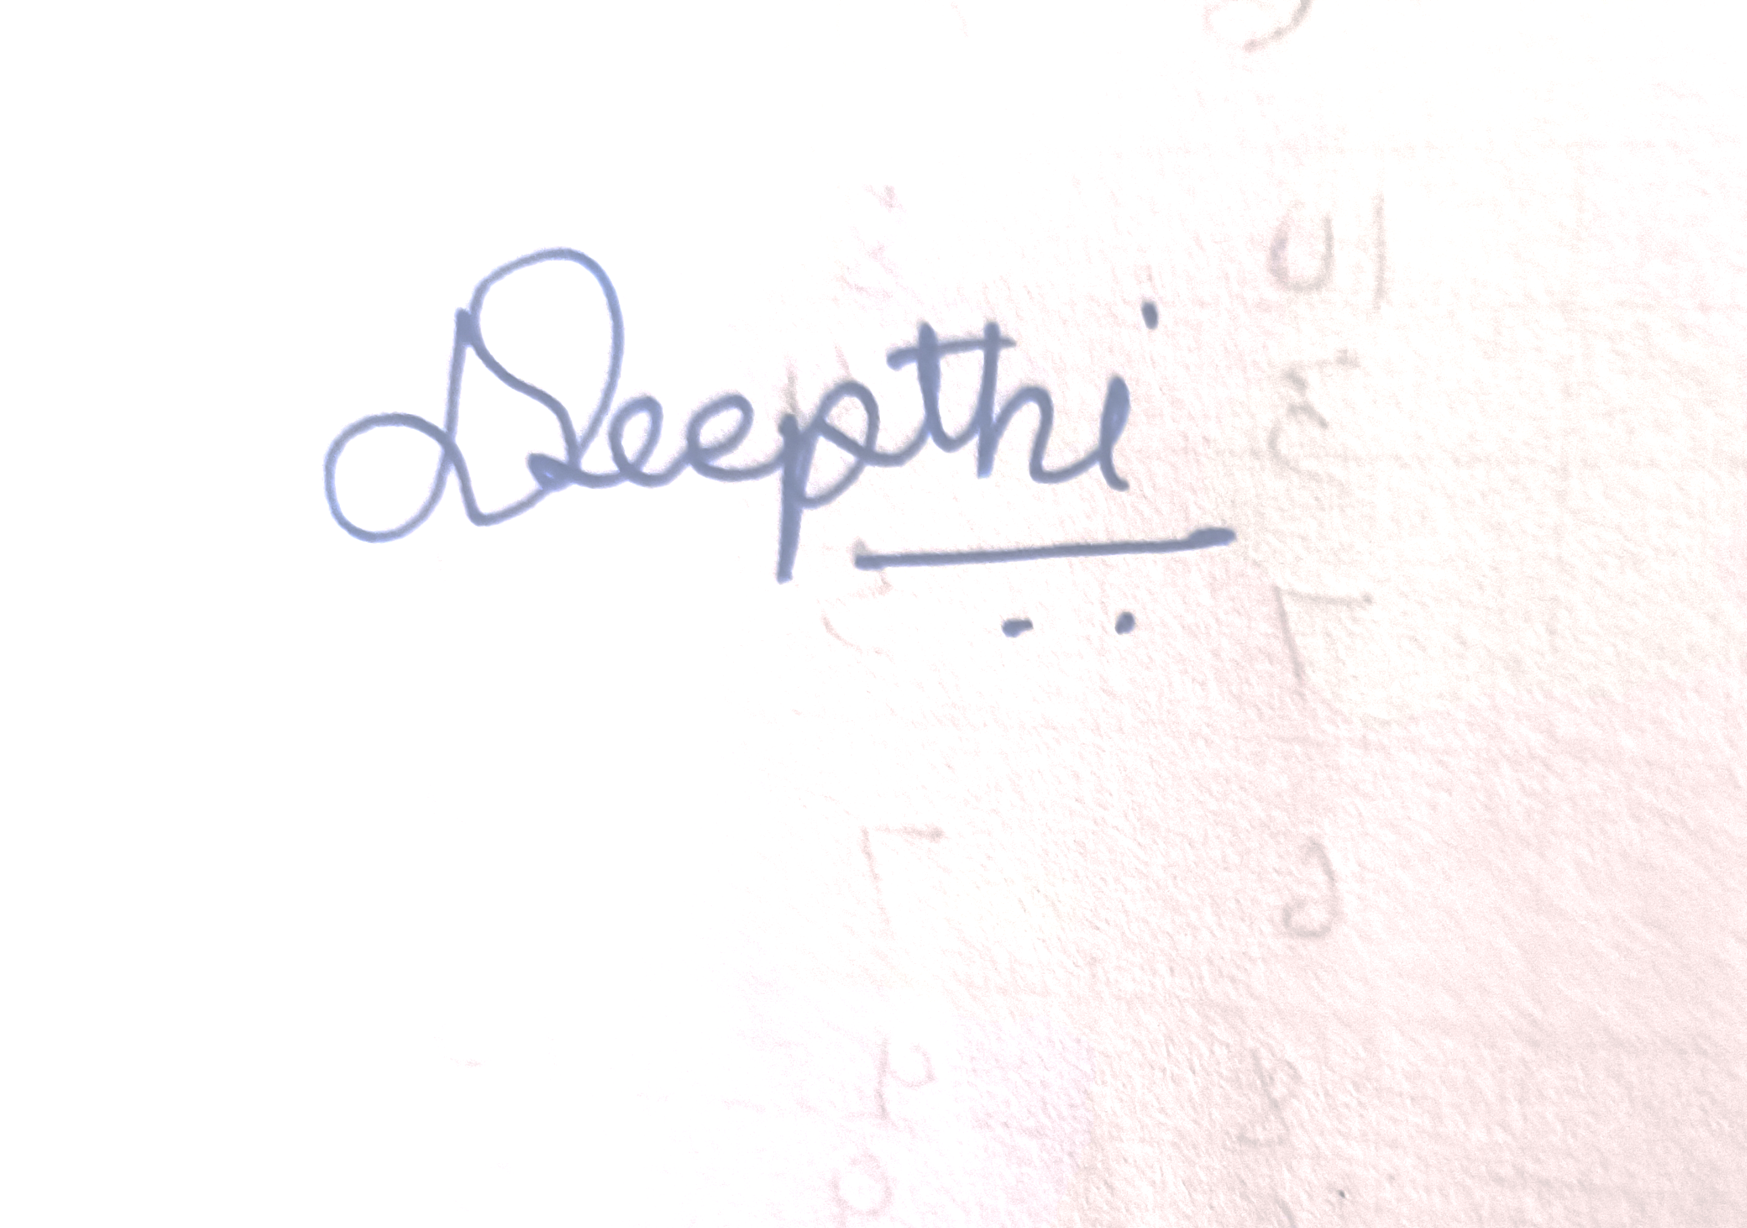

Signature of the Teacher

D.Deepthi Hynal

Head of the Department

Dr. Pranita B. Gulhane

**Shri Shivaji Education Society Amravati’s**

**Science College, Congress Nagar, Nagpur Academic Session 2021-2022**

**Department of Biotechnology**

**Bachelor of Science (B. Sc.) (Semester-VI) BIOTECHNOLOGY Paper-II**

**(PLANT & ANIMAL BIOTECHNOLOGY)**

**UNIT TEST on Unit III**

Time: 45 min.] [Maximum Marks: 20]

**N.B. :- (1) Solve all the questions.**

UNIT-III

|  |  |  |
| --- | --- | --- |
| **Q.1** | Write a note on immortal cells, | **05** |
| **Q.2** | Write a note on Contact inhibition, | **05** |
| **Q.3** | What is Cell senescence? | **05** |
| **Q.4** | Give Various techniques of animal cell and tissue culture. | **05** |





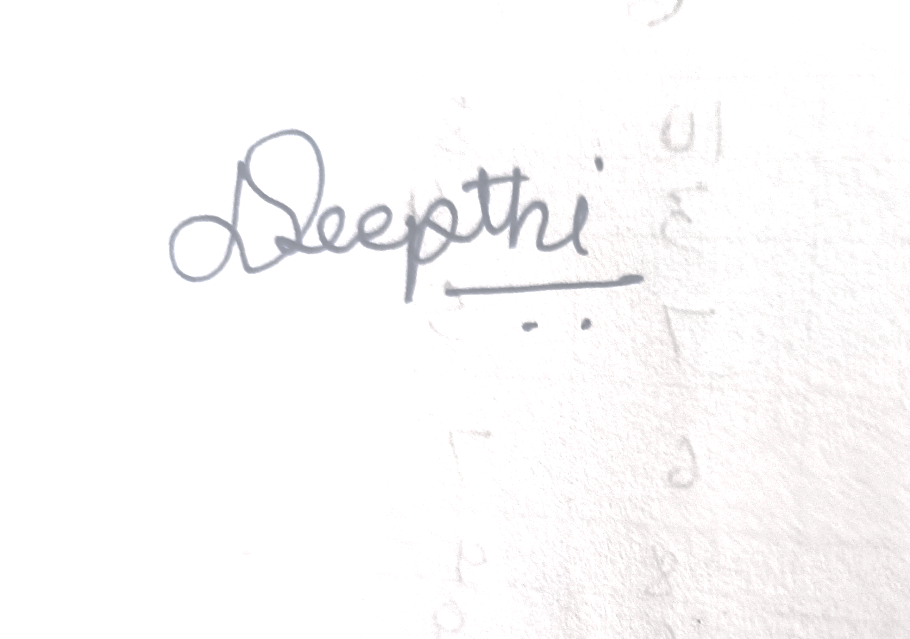

Head of the Department

Dr. Pranita B. Gulhane

Signature of the Teacher

D.Deepthi Hynal