Shri Shivaji Education Society Amravati’s
SCIENCE COLLEGE, CONGRESS NAGAR, NAGPUR
Session 2019 – 2020
National Cadet Corp
3 MAH GIRLS BATTALION NCC NAGPUR
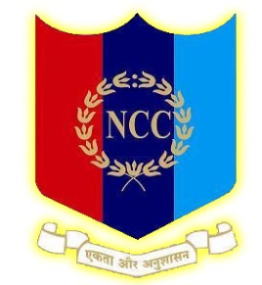
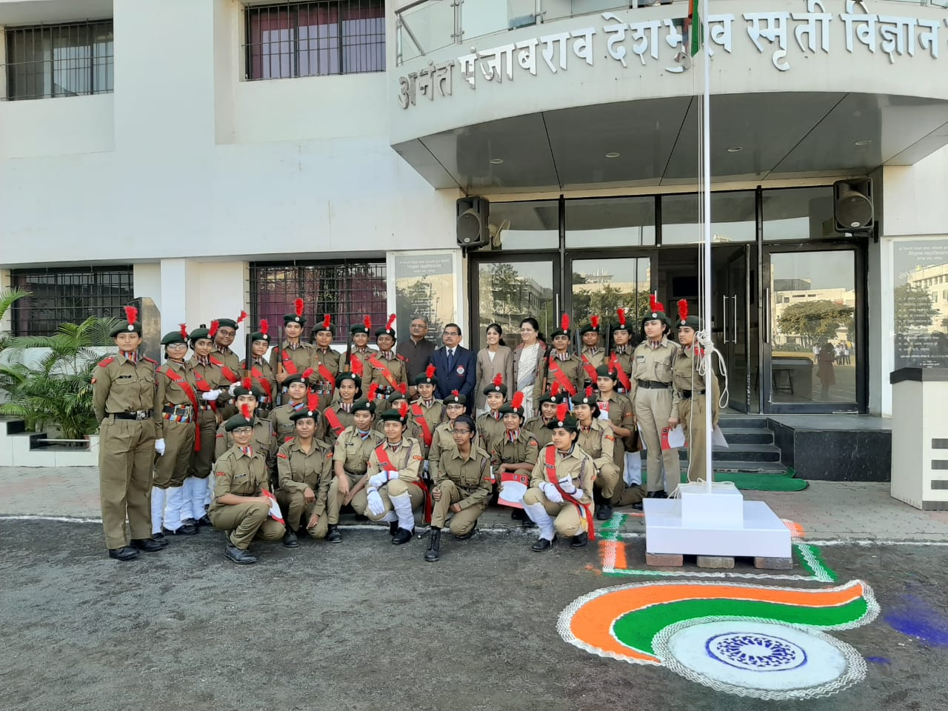
Ceremonial parades were organized in the college, on the occasion of Republic Day celebrations in presence of Hon’ble Principal Sir.

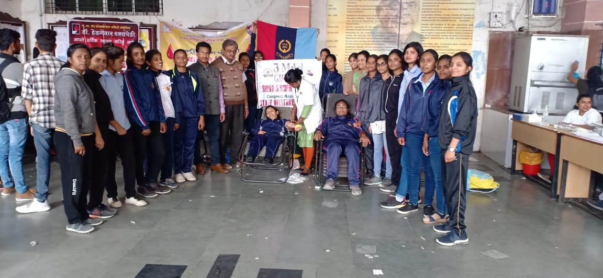
Blood Donation Camp on the occasion of the Birth anniversary of Panjabrao alias Bhausaheb Deshmukh
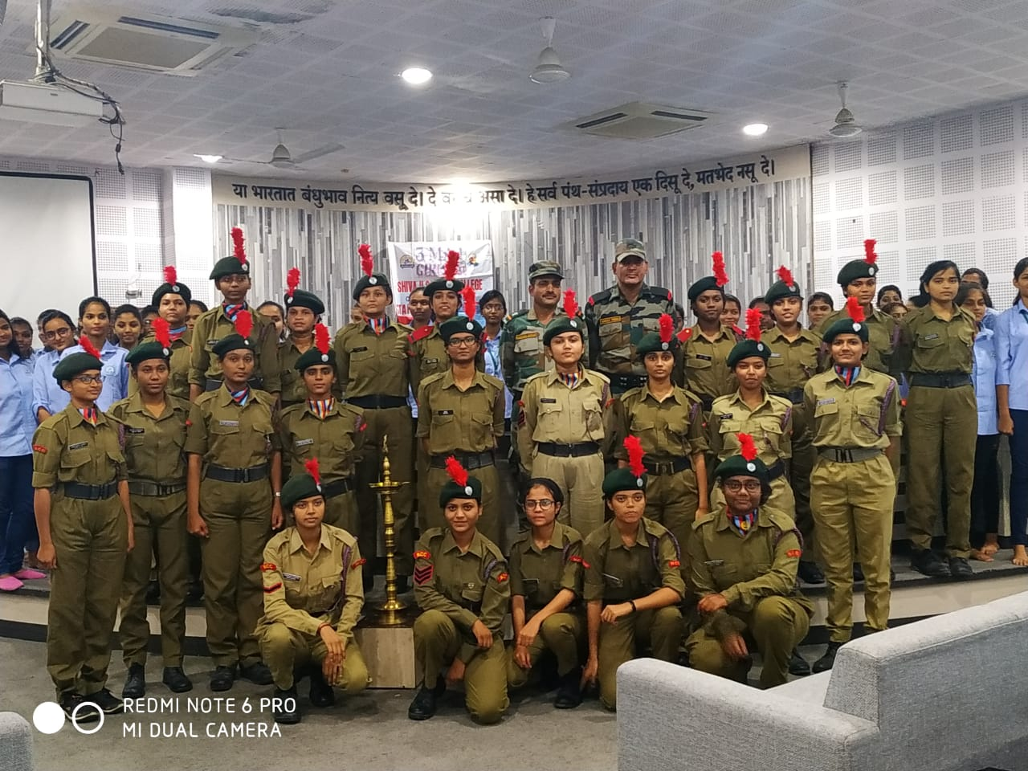
NCC awareness program 2020 organized in the college premises.
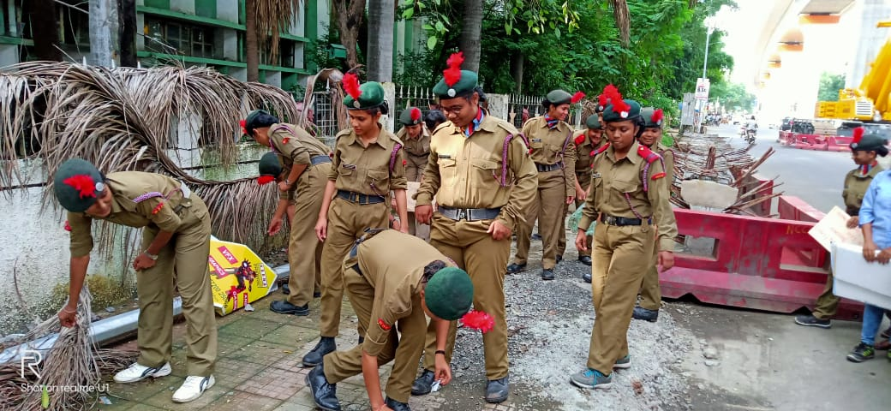Swachh Bharat Abhiyan Program organized in the college by NCC cadets.

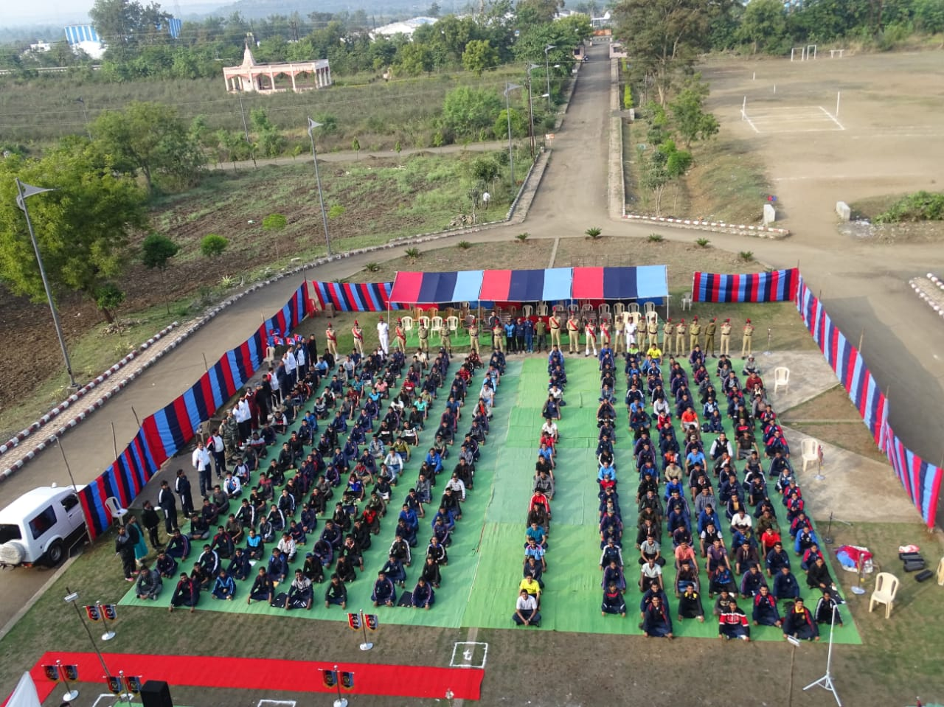
NCC camp organized by 3 MAH Girls BN, NCC, Nagpur.

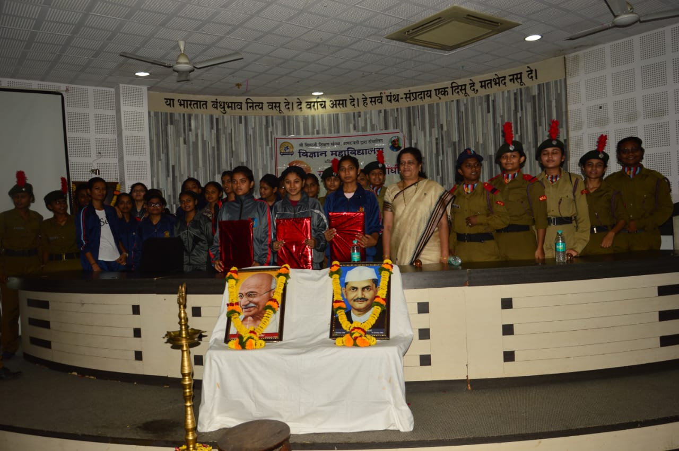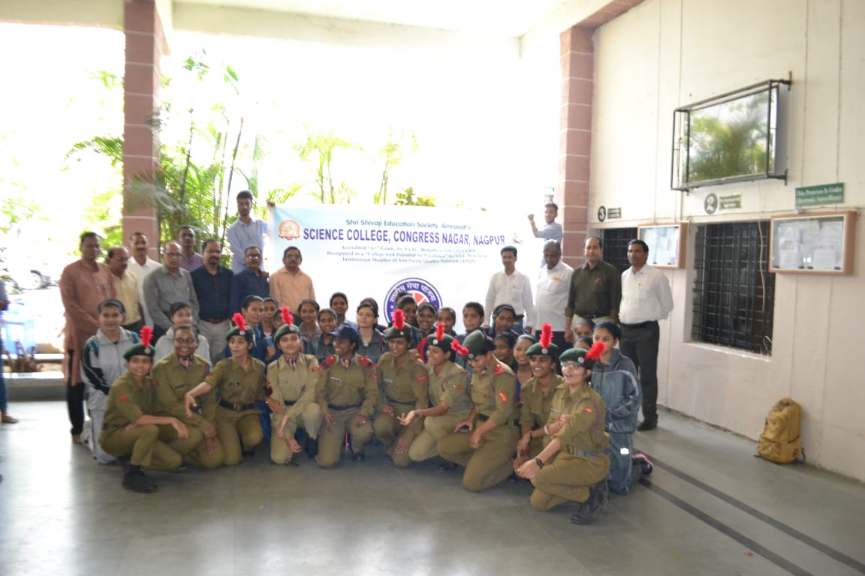
Painting Competition and Tree Plantation Program in the college premises
organized by NCC Cadets

Shri Shivaji Education Society Amravati’s
SCIENCE COLLEGE, CONGRESS NAGAR, NAGPUR
Session 2020 – 2021
National Cadet Corp
3 MAH GIRLS BATTALION NCC NAGPUR

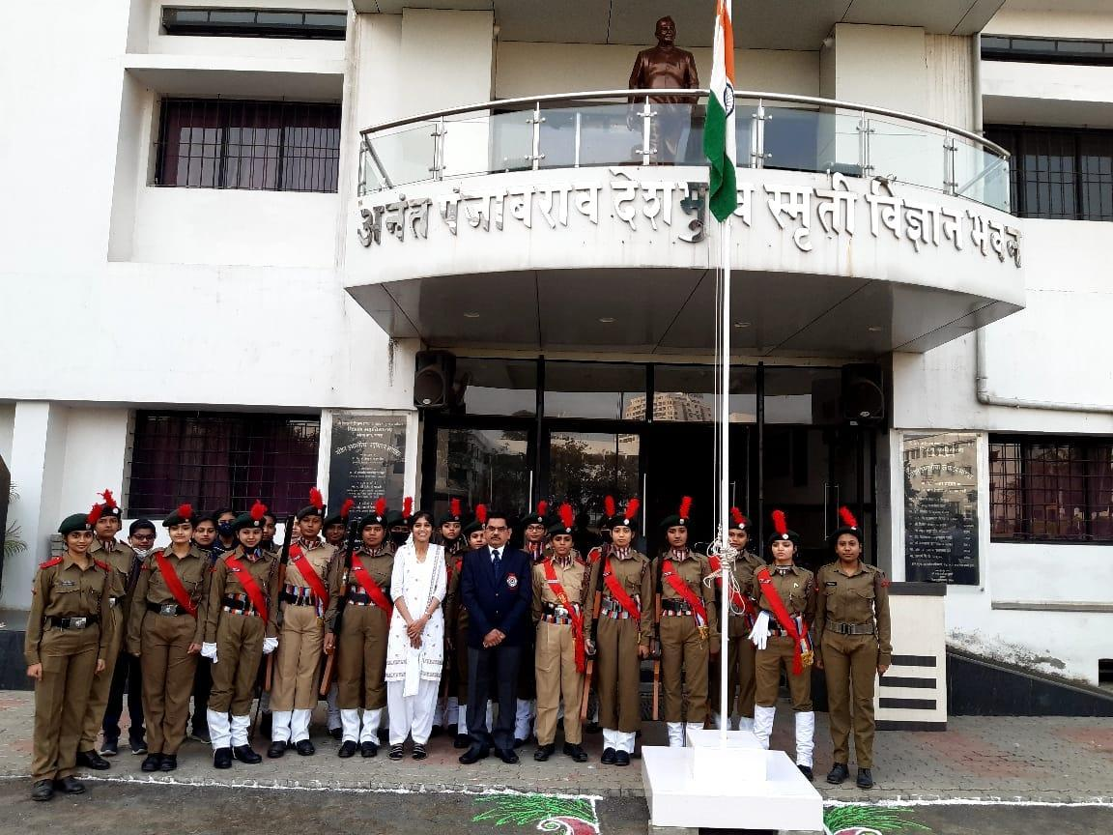
Ceremonial parades were organized in the college, on the occasion of Republic Day celebrations.

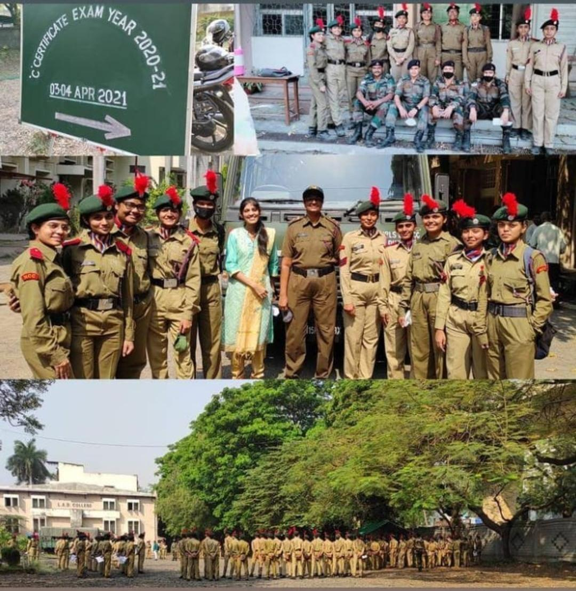
C' Certificate examination on dated 03/04/2021 and 04/04/2021
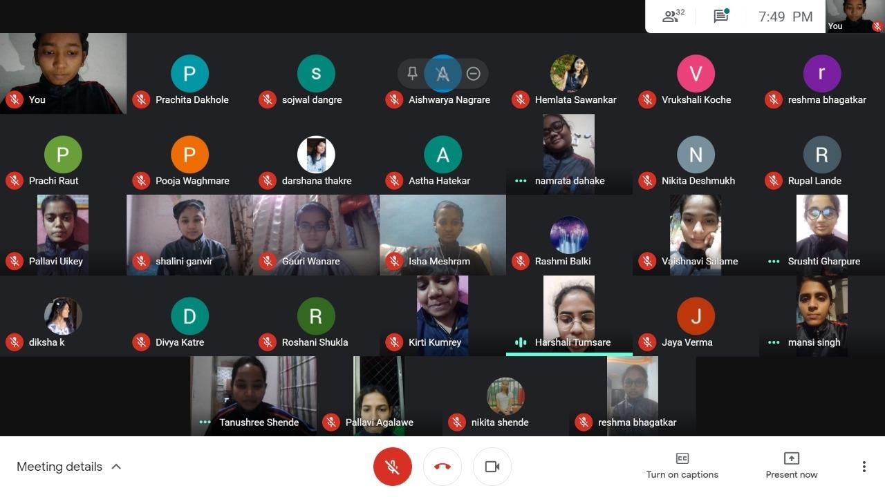
Online cadres were arranged for C' cert appearing cadets.

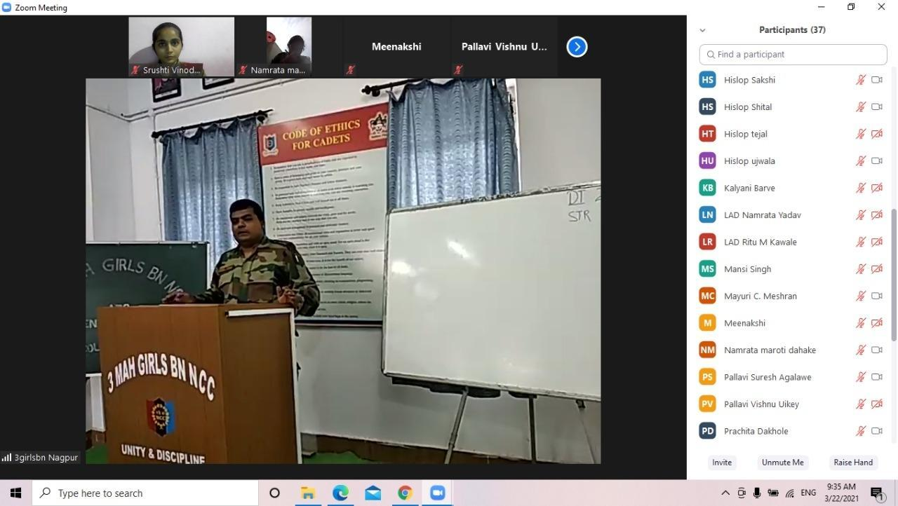
3 Mah Girls BN, NCC unit conducted online Classes for C' Cert appearing cadets.

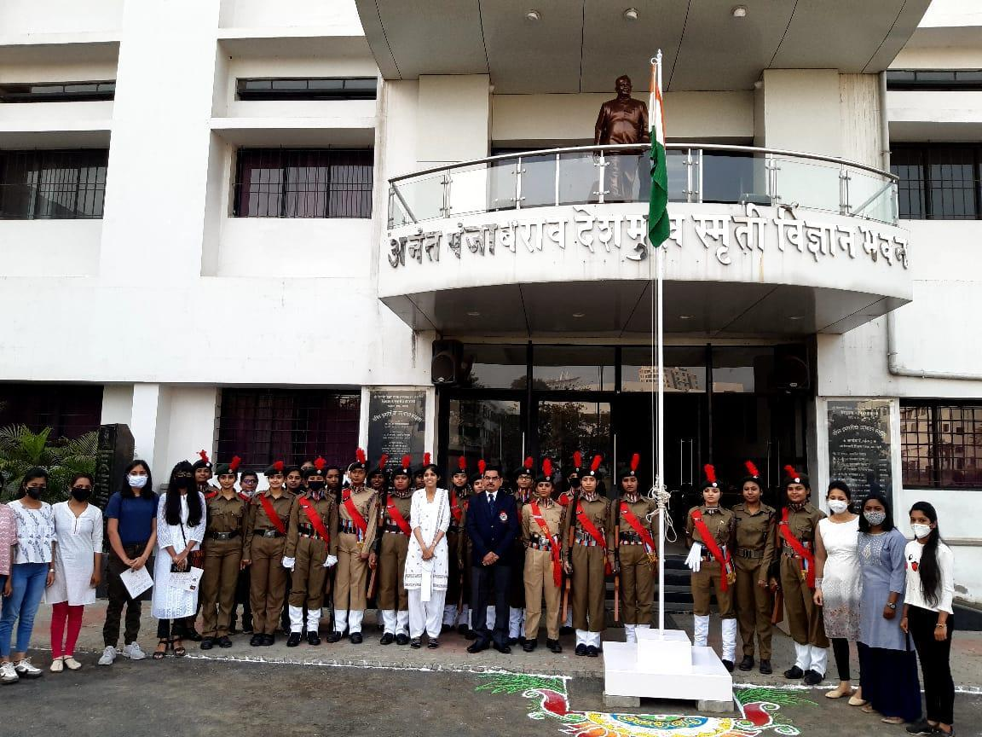
B' Certificate and C' Certificate distribution ceremony program was held on 26/01/2021 in presence of Hon’ble Principal Prof. M. P. Dhore Sir.

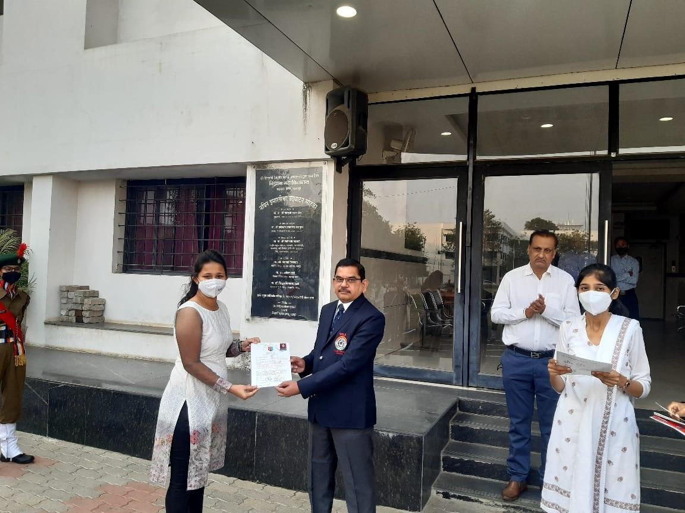
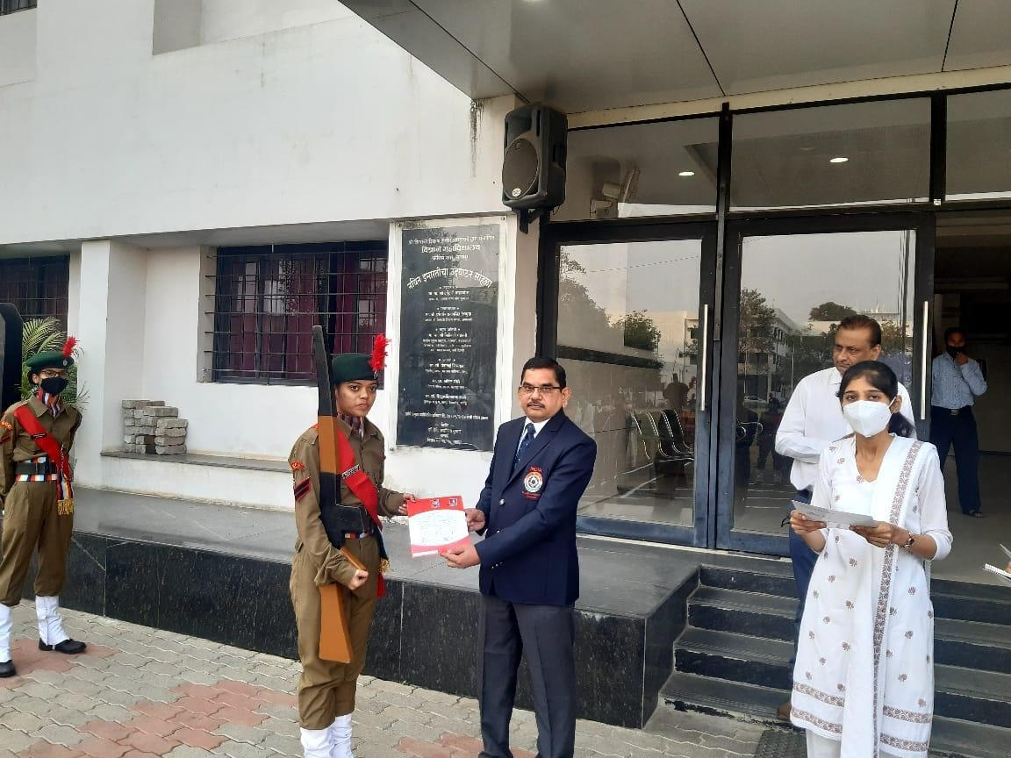
Certificate distribution ceremony program was held on 26/01/2021.

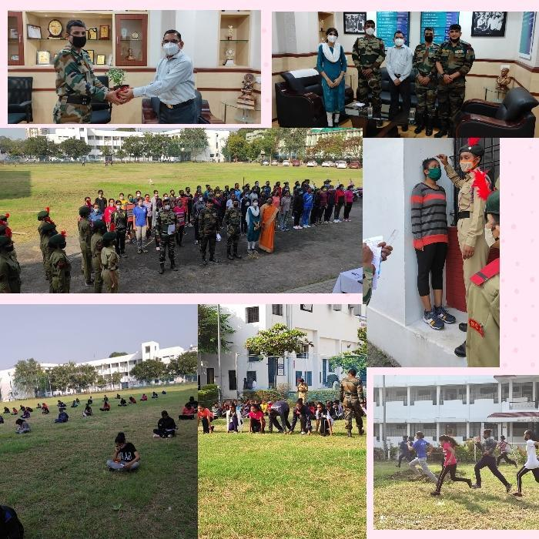
First Year Enrollment Process (Year 2020-2021)

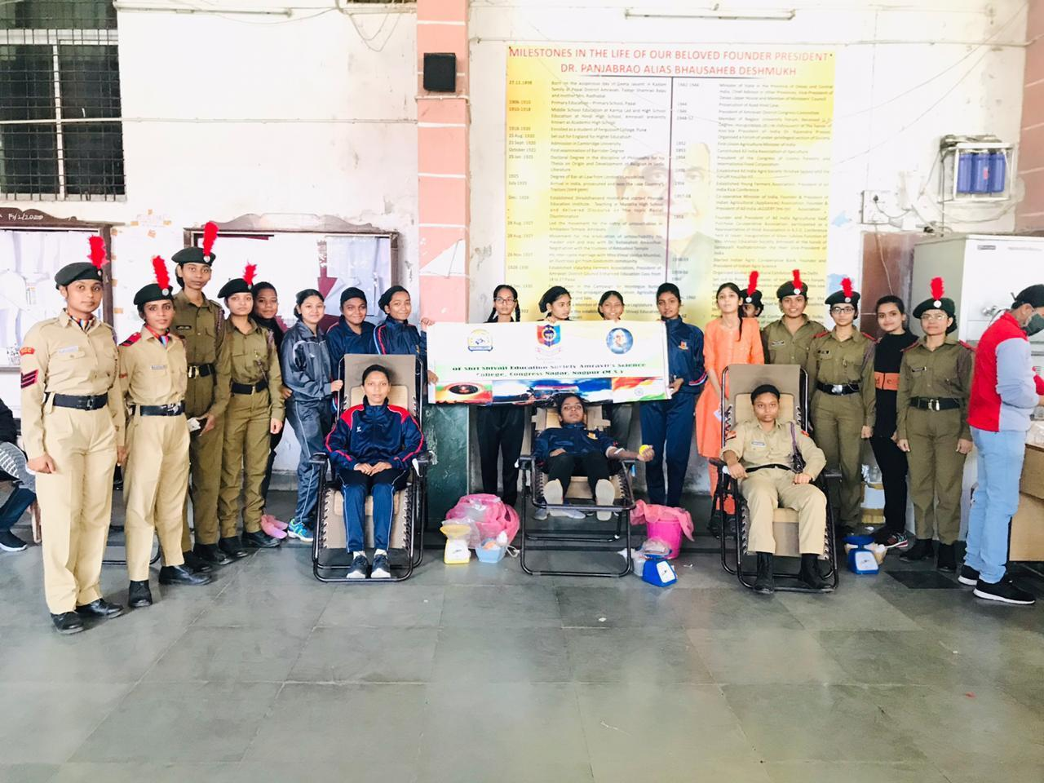
Blood Donation Camp was organized by the College.

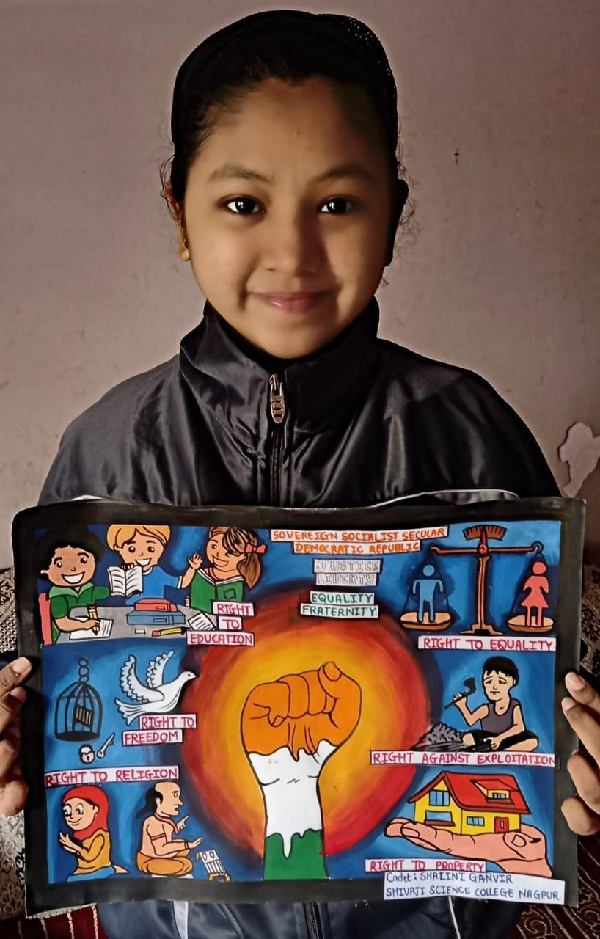
Constitution Day Youth Club Activities Campaign - Poster making by Cdt. Shalini Ganvir

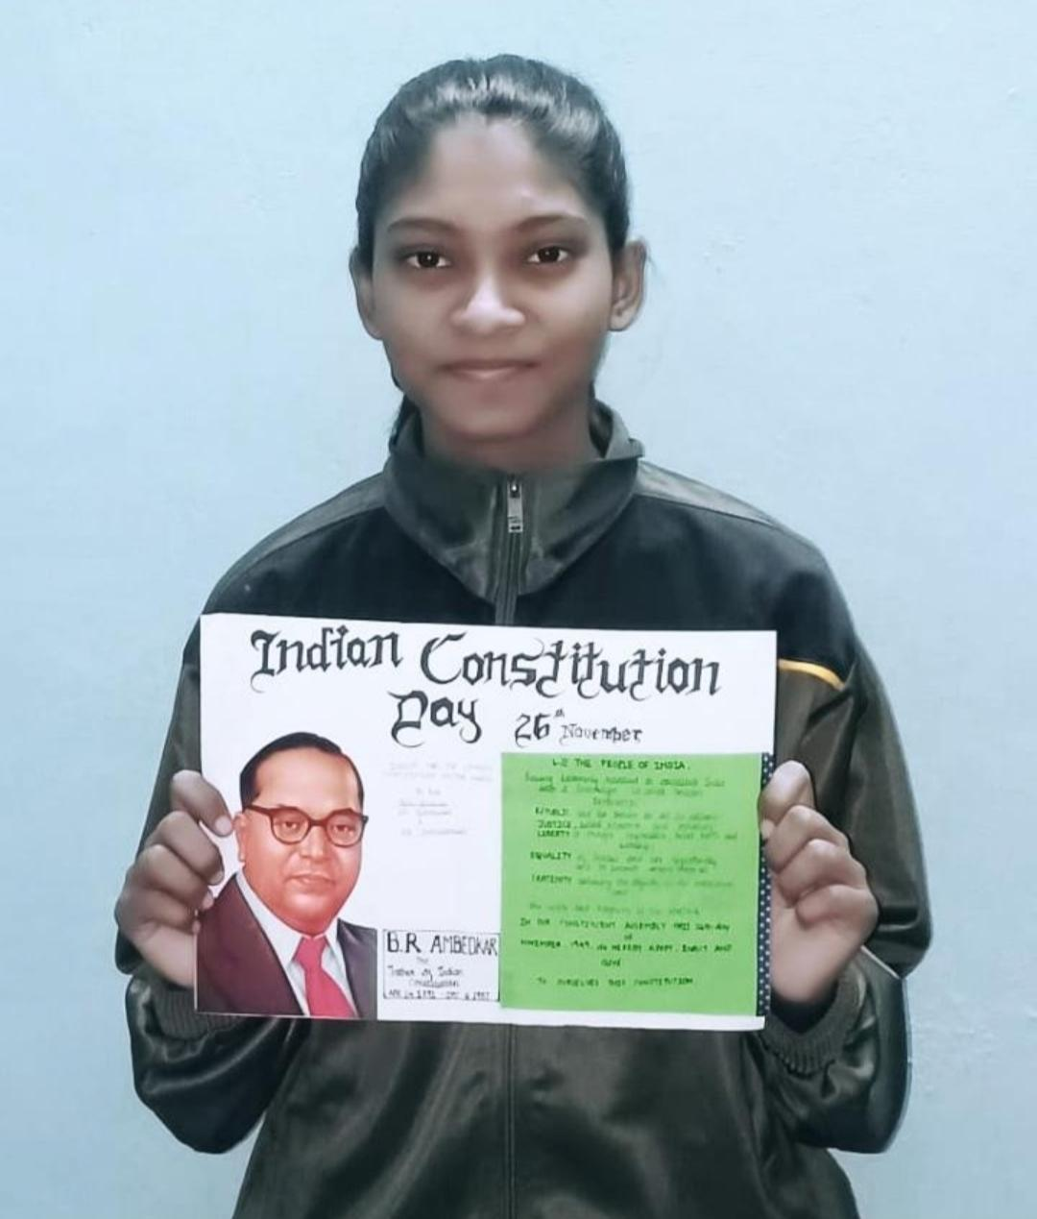
Constitution Day Youth Club Activities Campaign - Poster making by Cdt. Deepali Choudhari

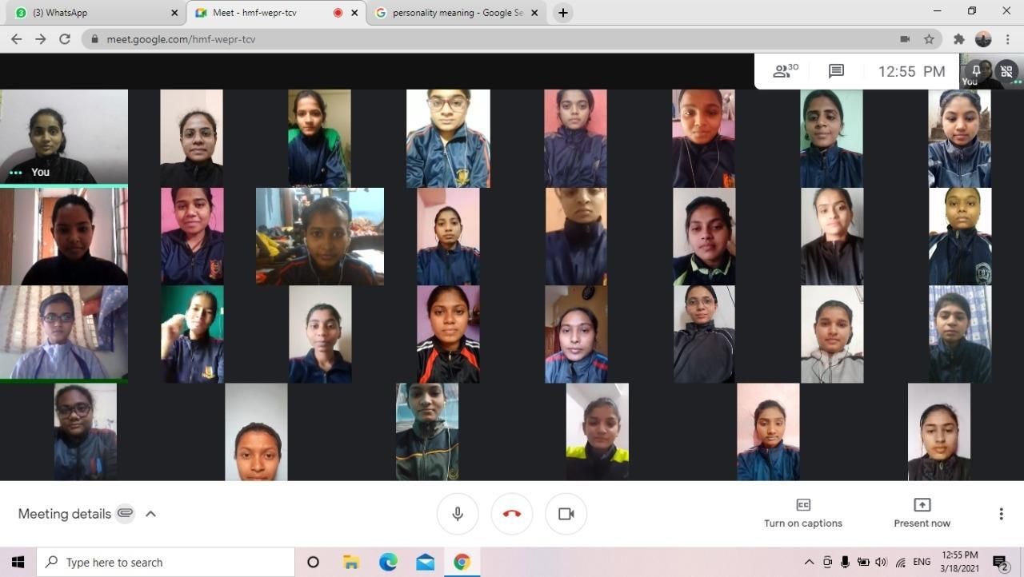
Online seminar conducted for B' and C' Cert appearing cadets

Shri Shivaji Education Society Amravati’s
SCIENCE COLLEGE, CONGRESS NAGAR, NAGPUR
Session 2021 – 2022
National Cadet Corp
3 MAH GIRLS BATTALION NCC NAGPUR
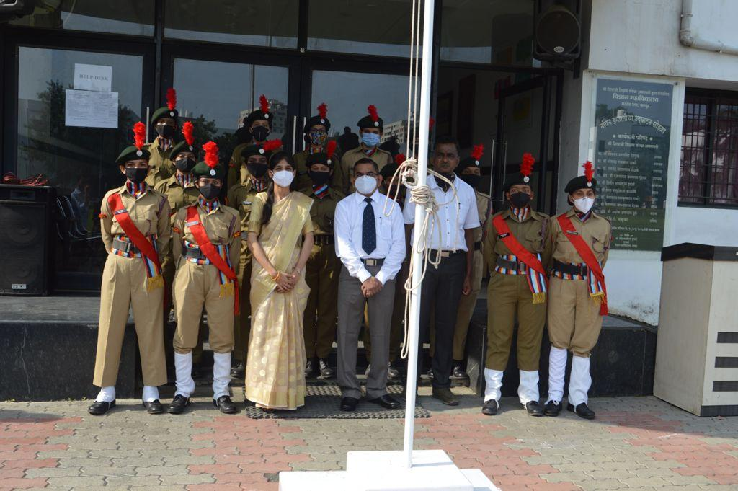
Independence day celebration in presence of Hon’ble Principal Prof. M. P. Dhore Sir on 15 August 2021

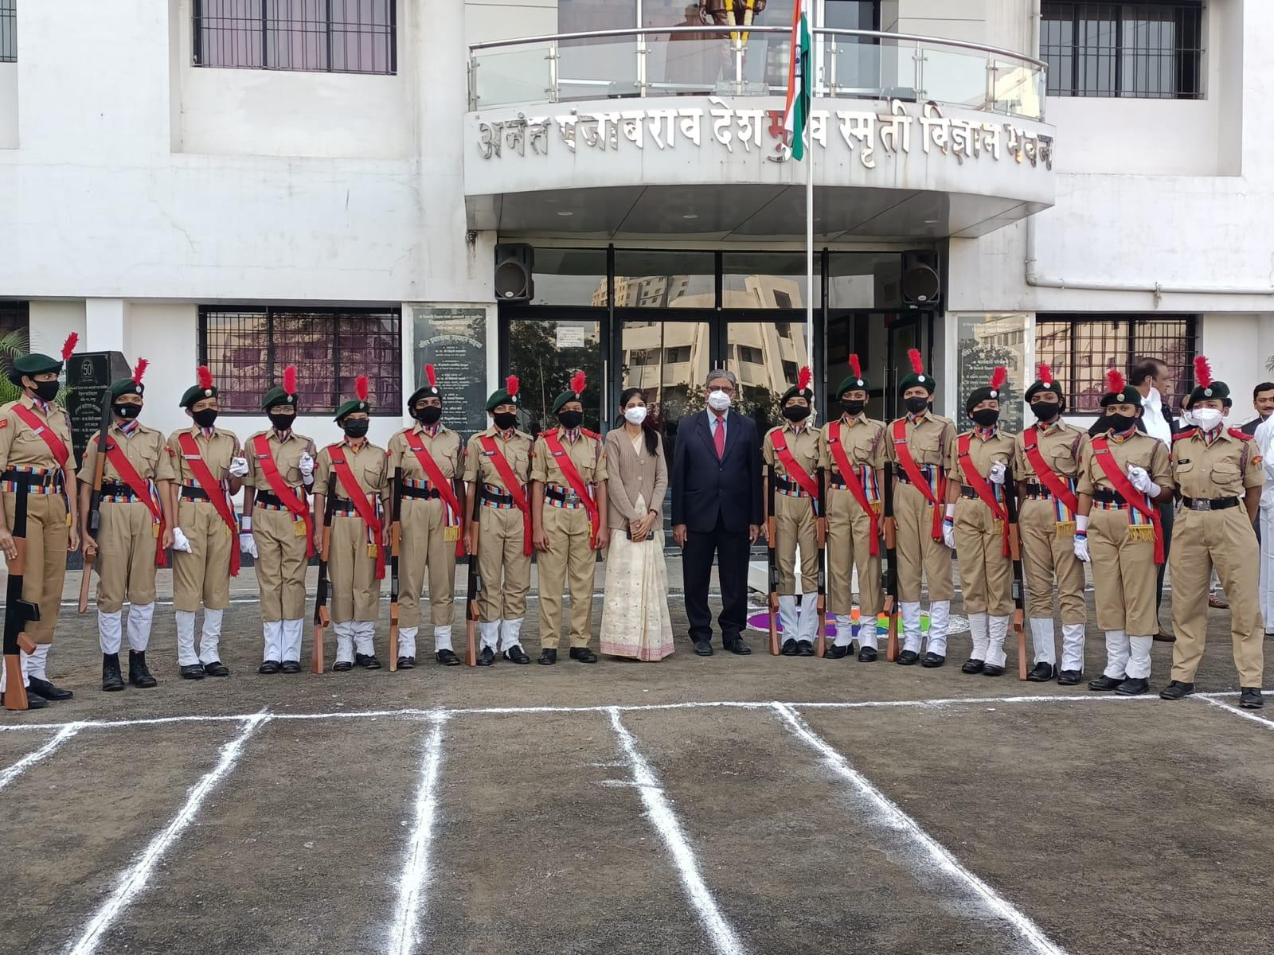
Ceremonial parades were organized in the college, on the occasion of Republic Day celebrations in presence of Hon’ble Vice Principal Sir.
.
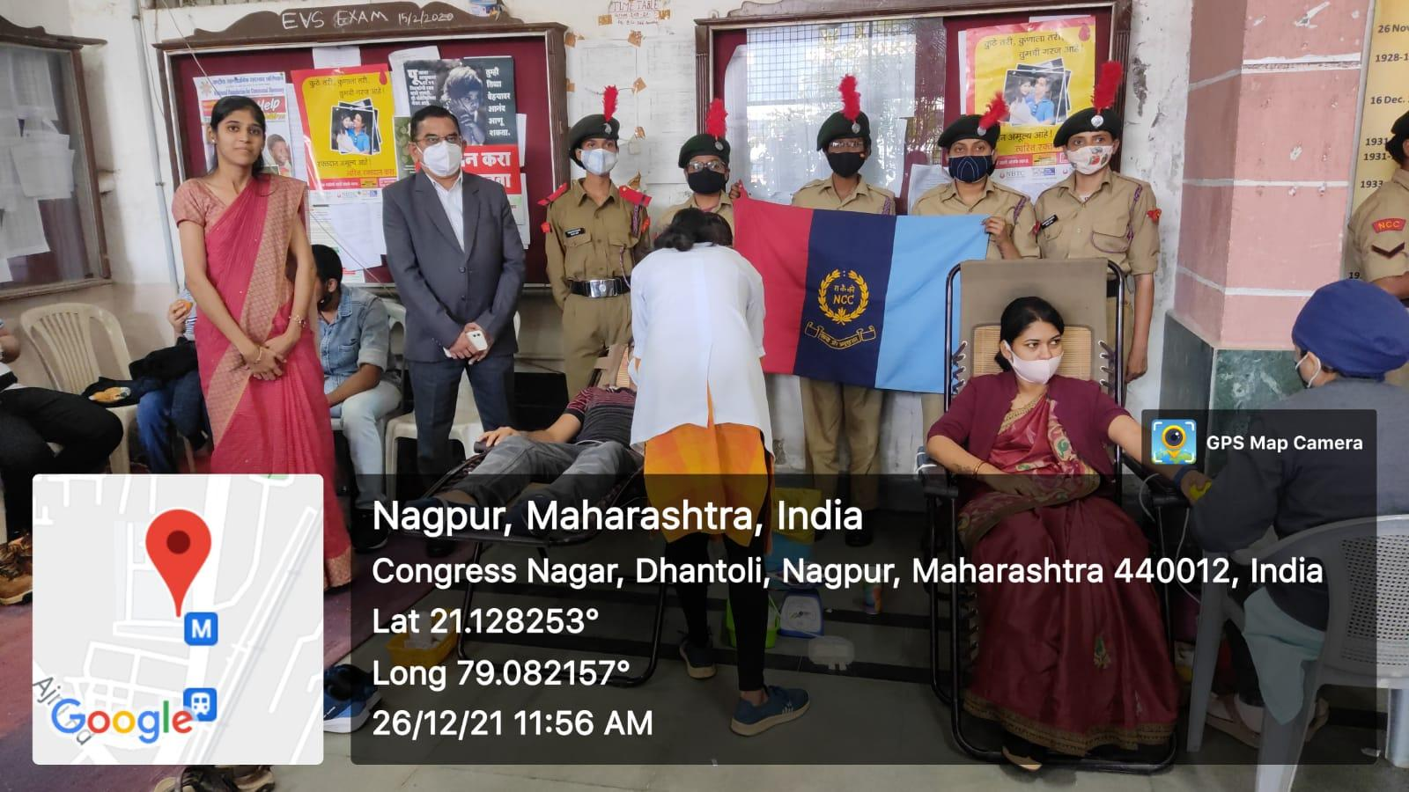
Blood Donation Camp on the occasion of the Birth anniversary of Panjabrao alias Bhausaheb Deshmukh on 27th December 2021.
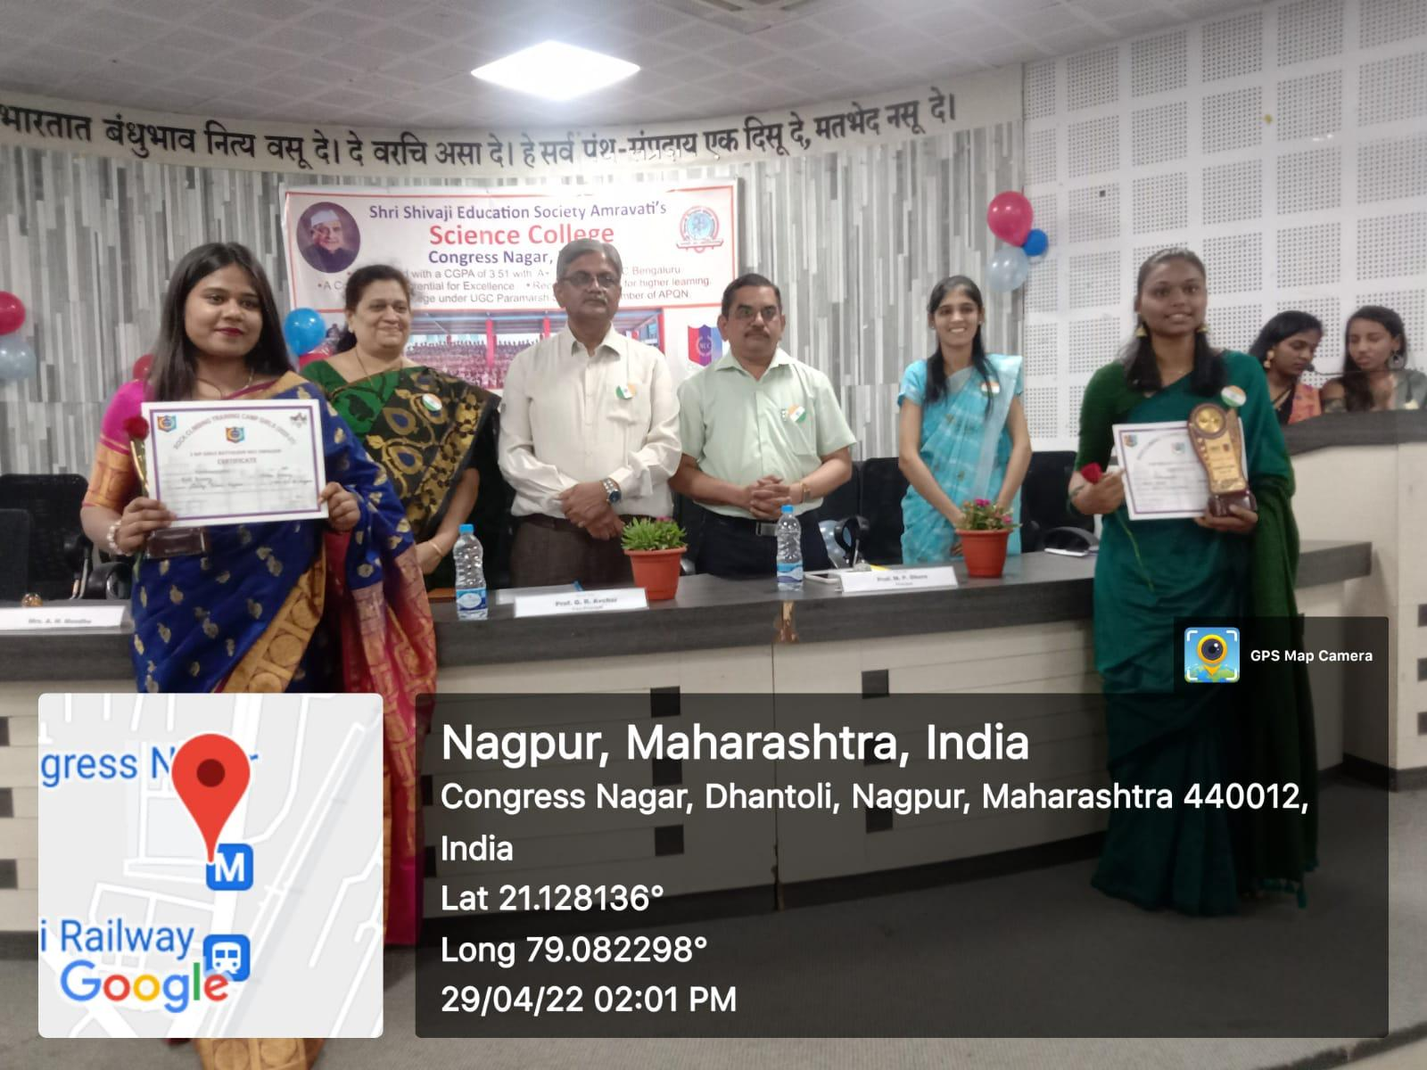
NCC certificate distribution ceremony program was held on 29 April 2022

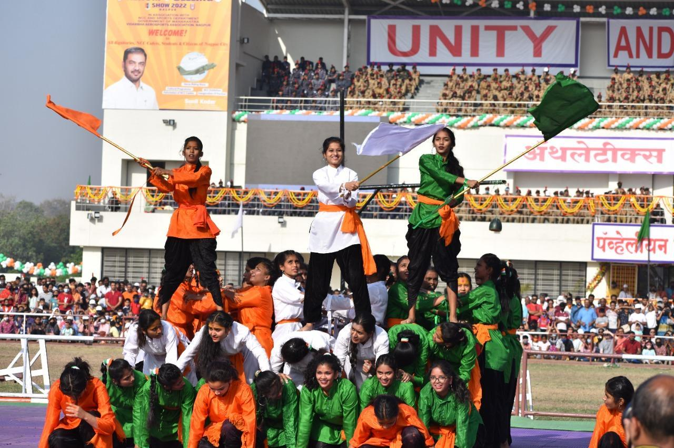

Cultural Programme on 29 March 2022 based on the 75th Anniversary of Independence for Nagpur citizens at Mankapur Stadium, Nagpur.
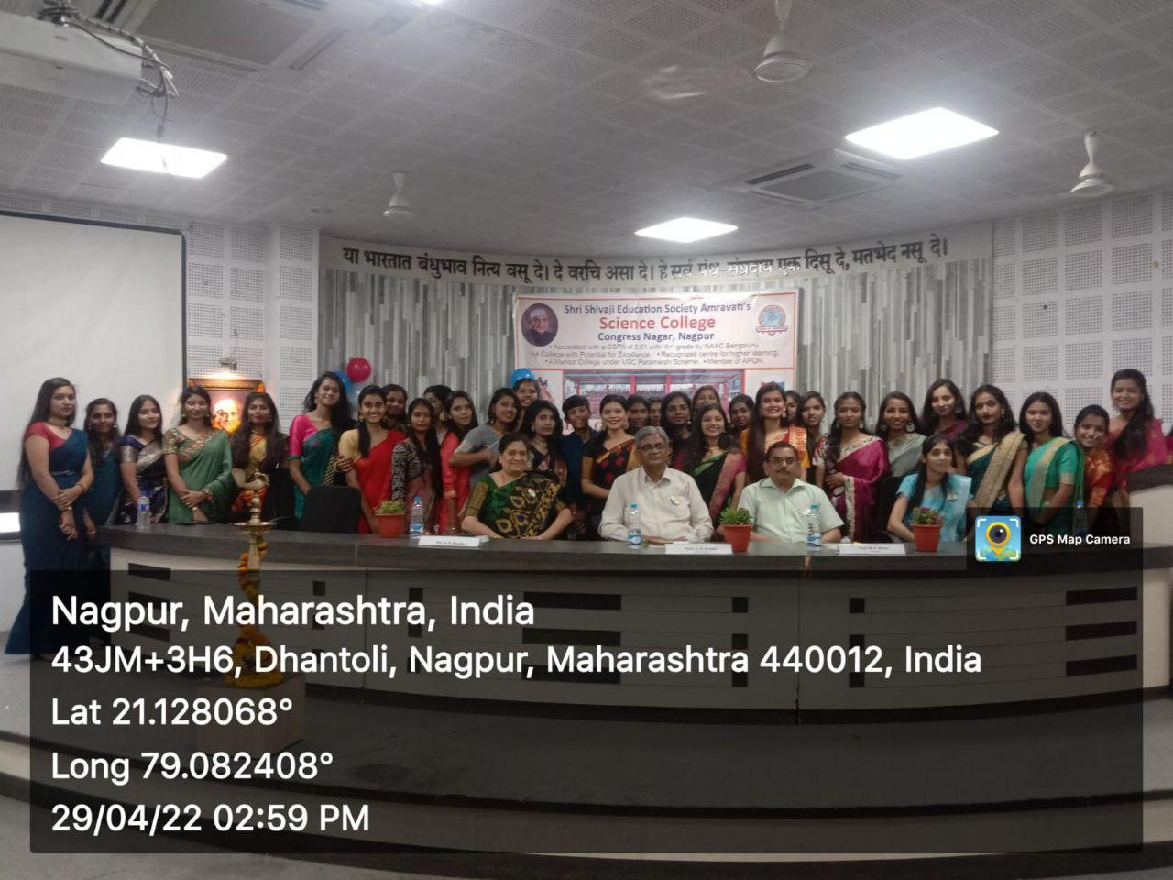
NCC Farewell Program in presence Hon’ble Principal Prof. M. P. Dhore Sir was held on
29 April 2022.

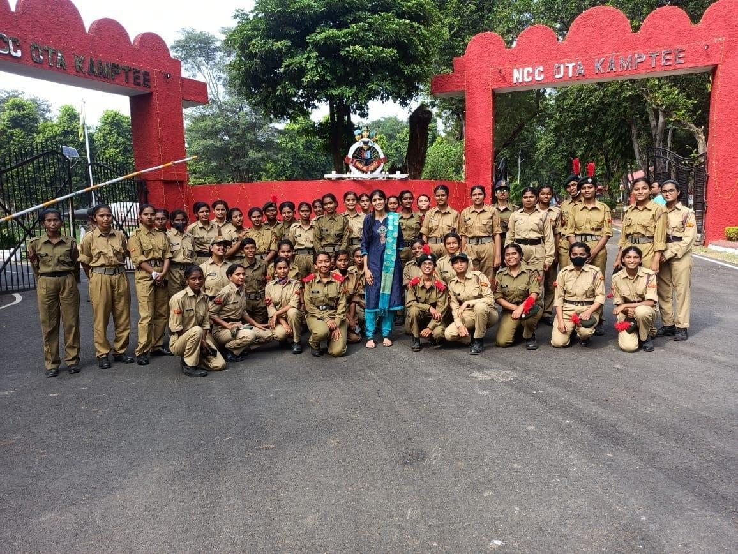
40 NCC cadets actively participated in the Firing Practice at OTA Kamptee on 12 Nov. 2021.

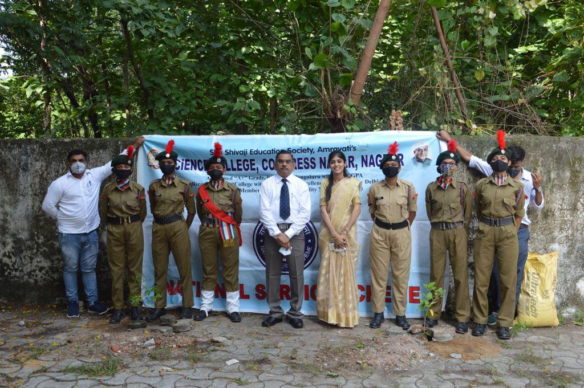
Plantation day celebrated in presence Hon’ble Principal Prof. M. P. Dhore Sir.

]

Shri Shivaji Education Society Amravati’s
SCIENCE COLLEGE, CONGRESS NAGAR, NAGPUR
Session 2022 – 2023
National Cadet Corp
3 MAH GIRLS BATTALION NCC NAGPUR
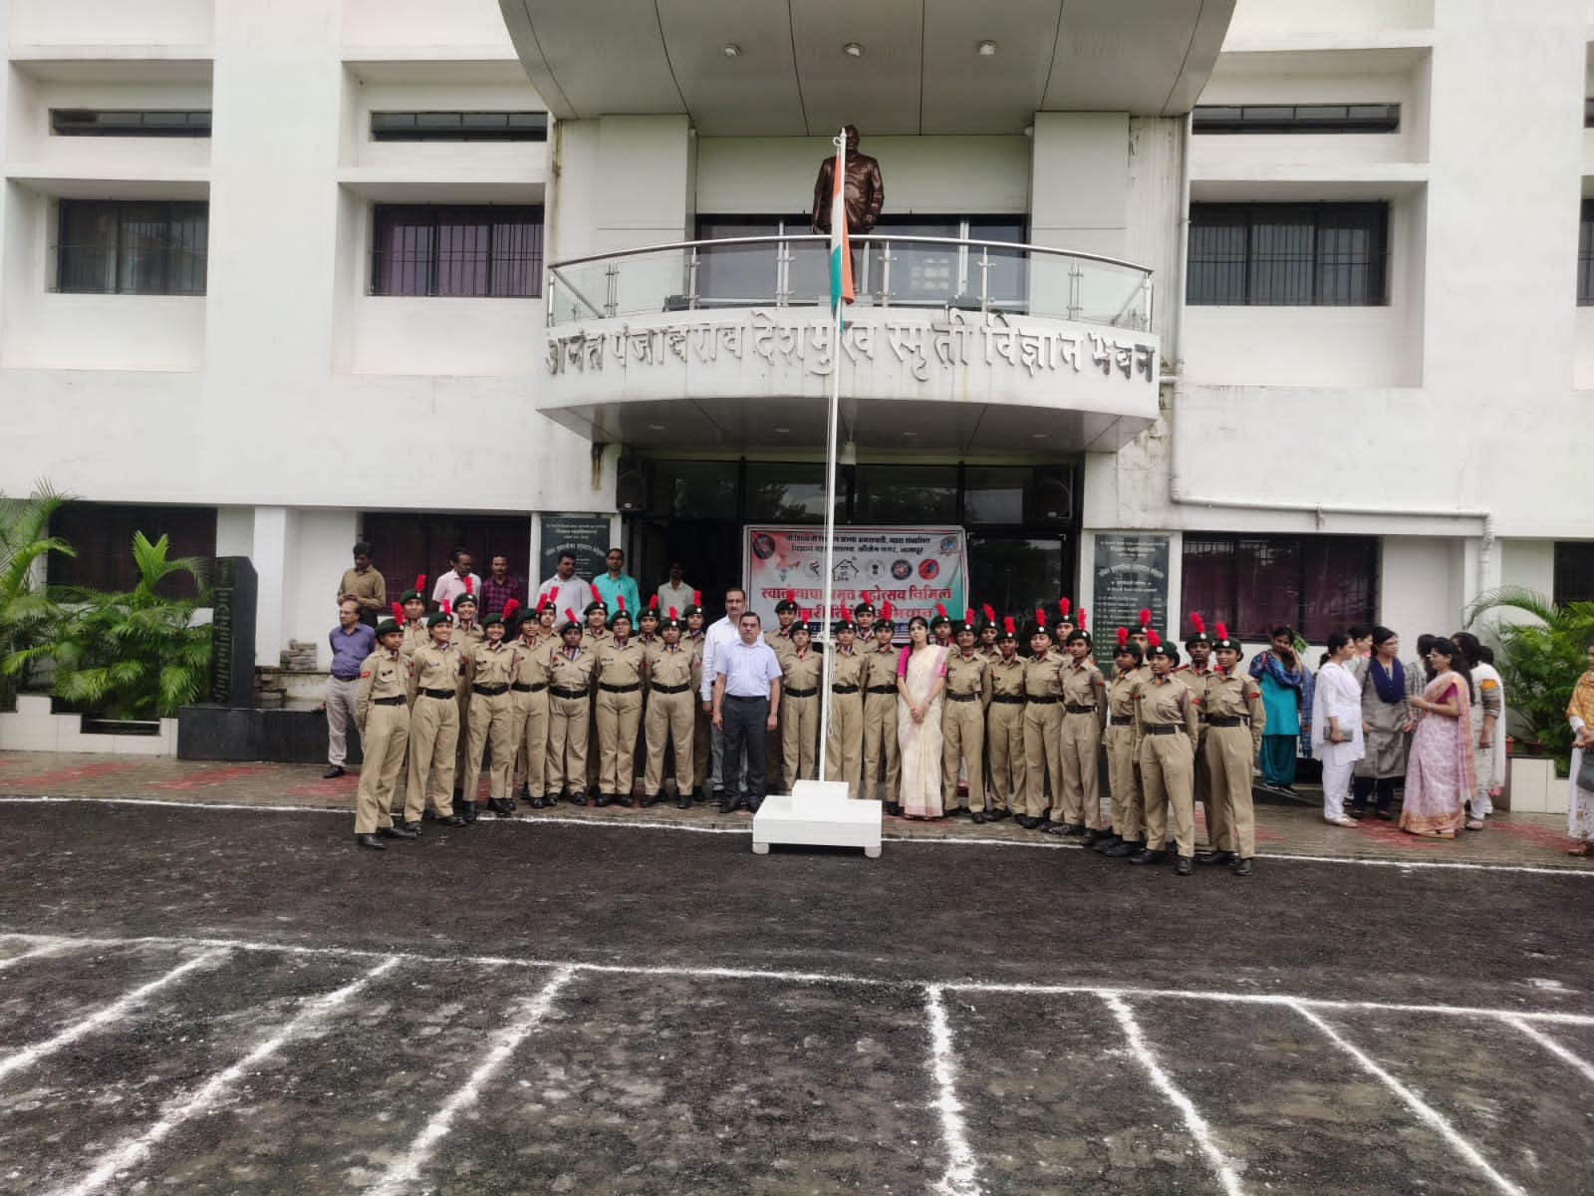 | 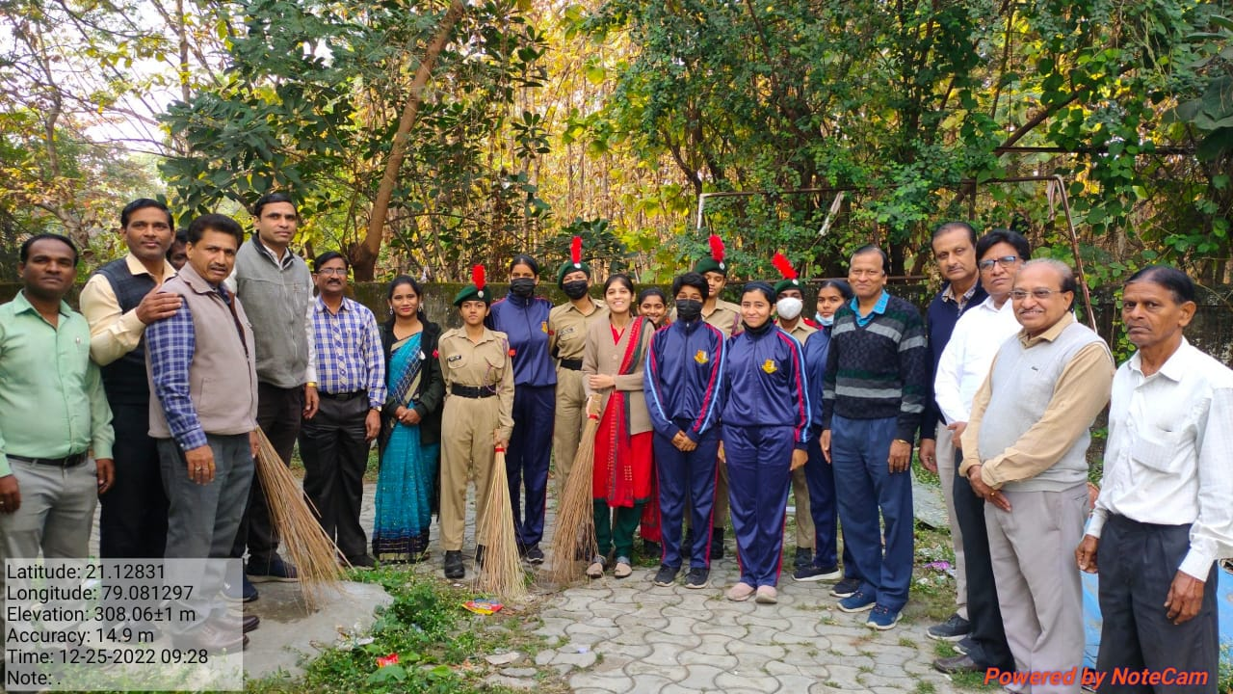  Swachata Abhiyaan
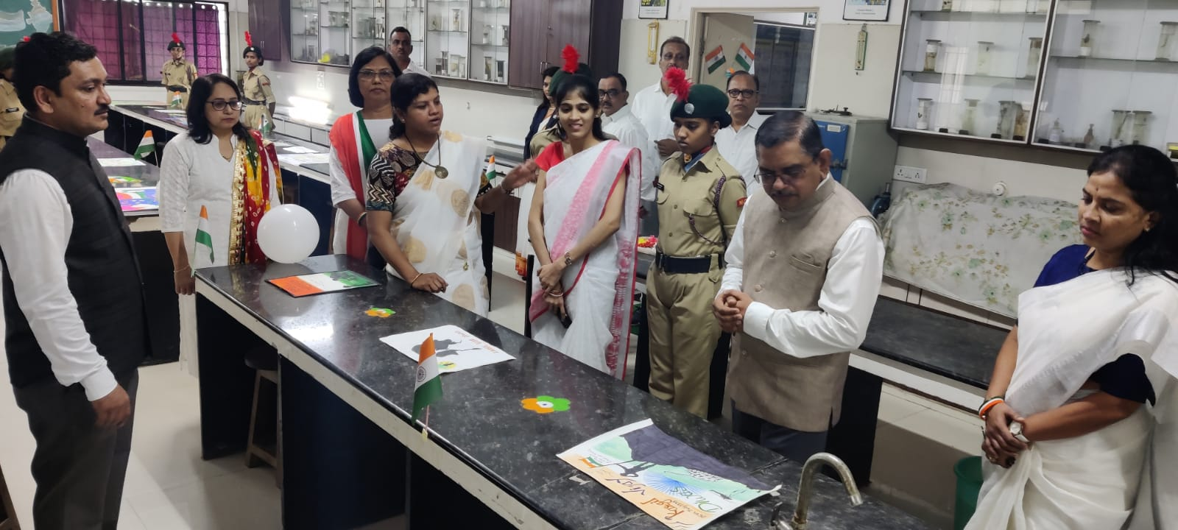  Poster Exhibition | 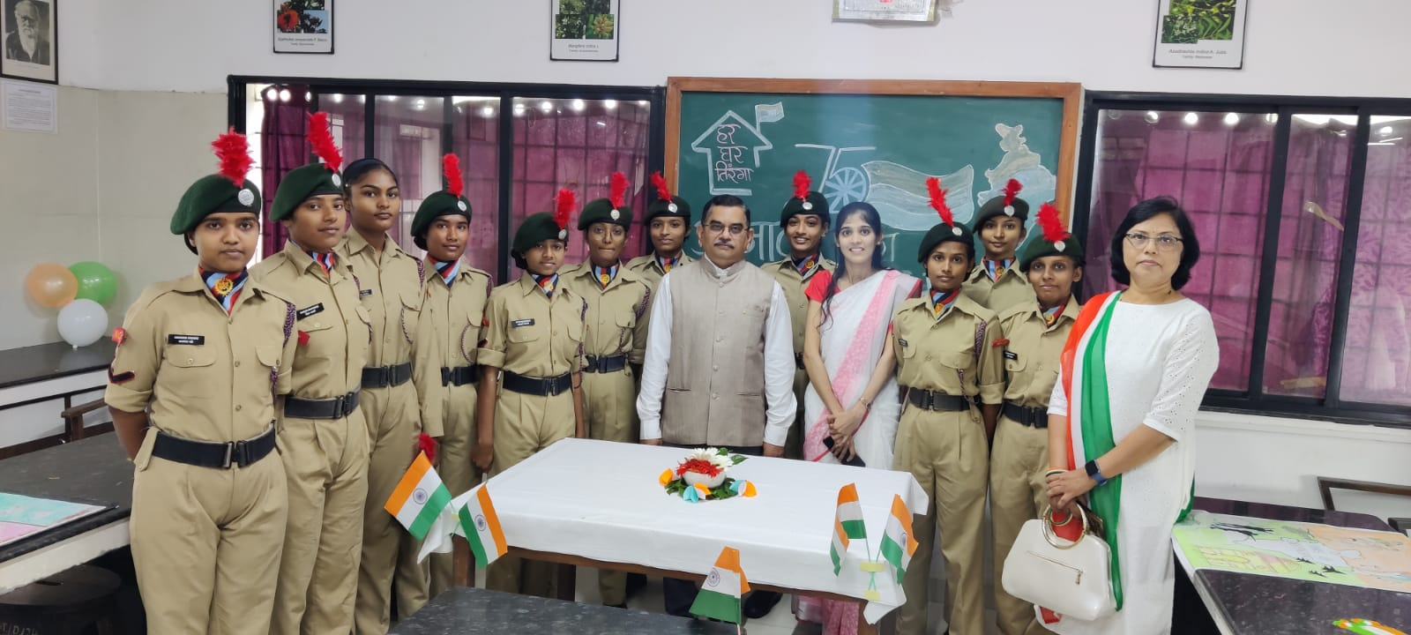
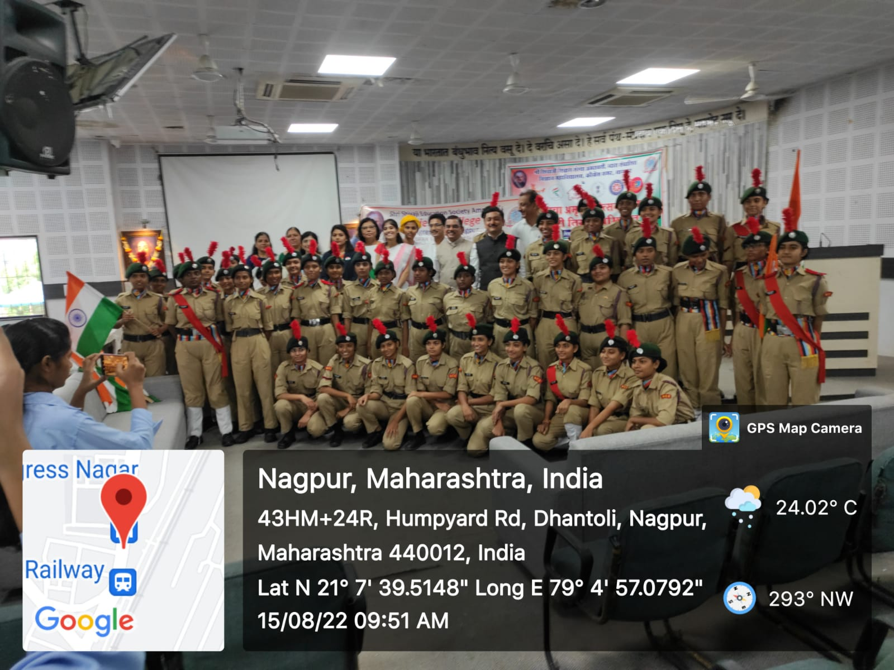 | 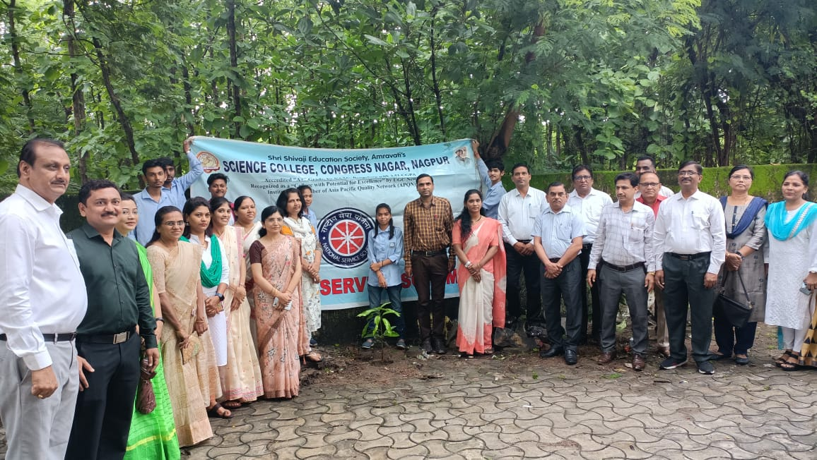  Plantation drive celebrated in College Premises
Har ghar tiranga celebration on the occasion of Azadi ka Amrut mahotsav in presence Hon’ble Principal Prof. M. P. Dhore Sir dated 13 August 2022 to 15 August 2022.
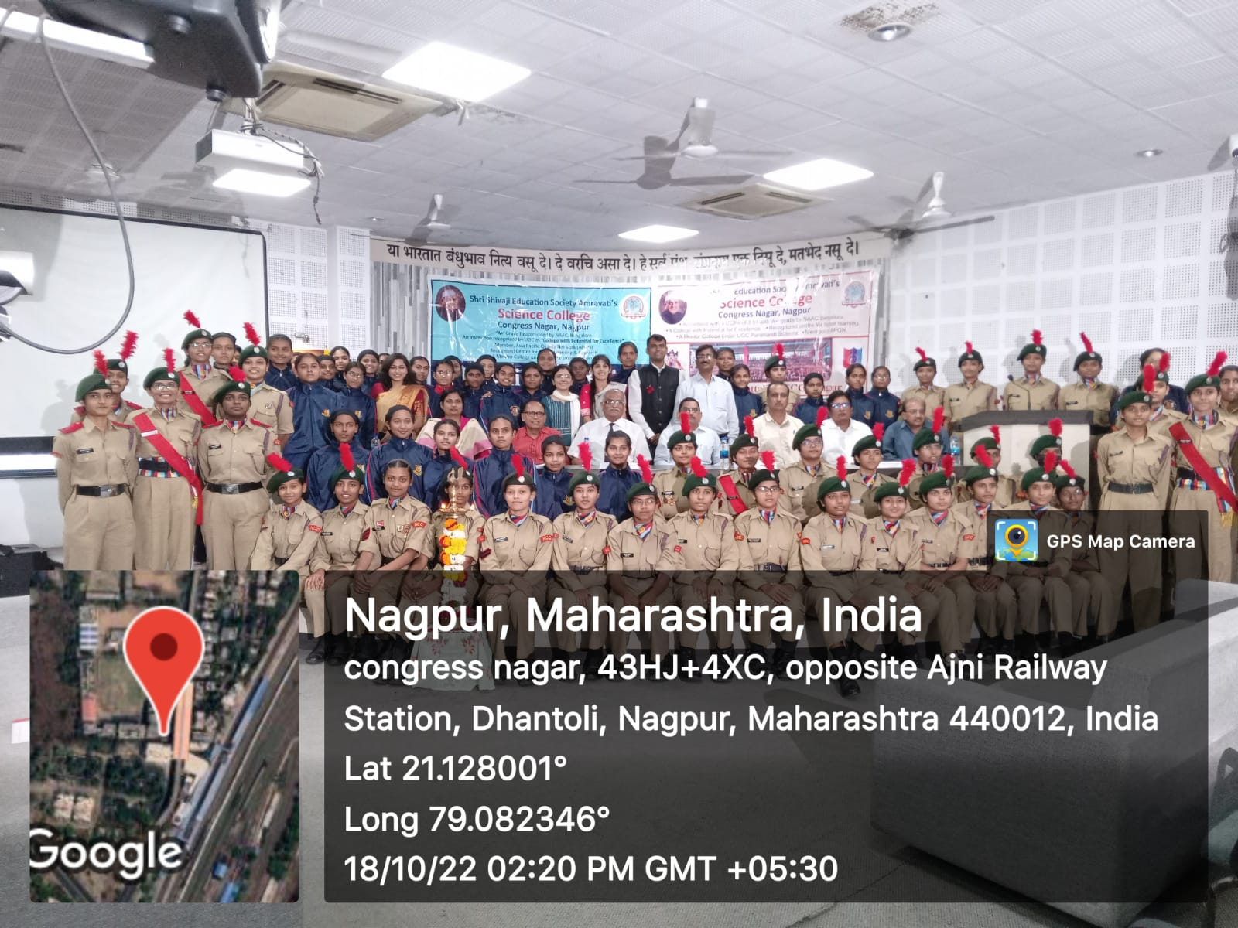 | 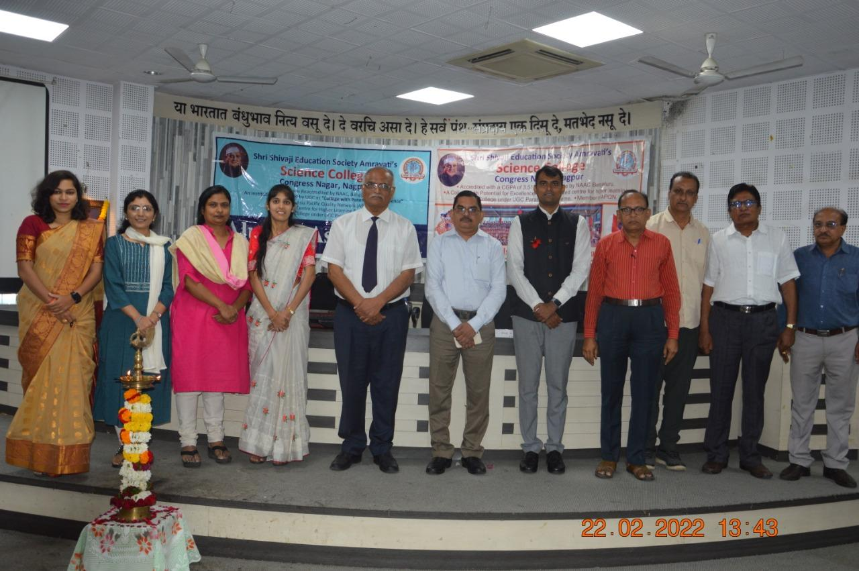
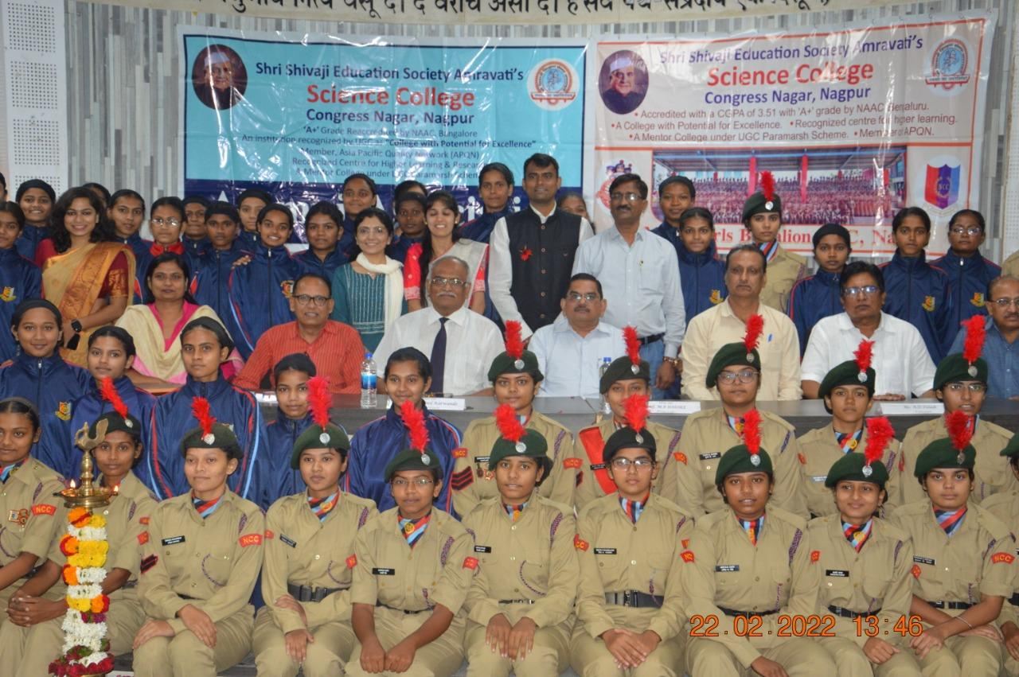 | 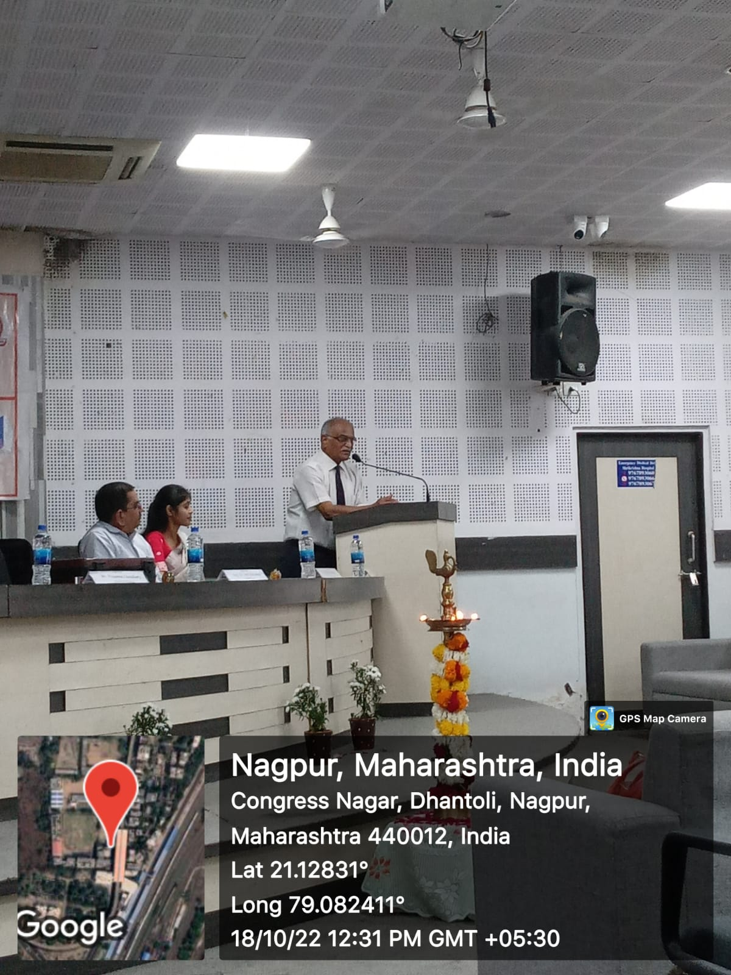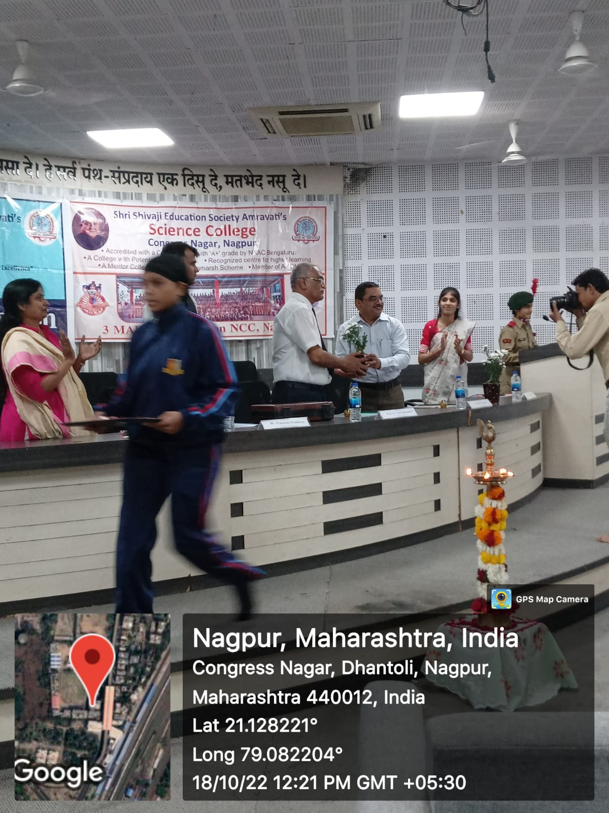
Guest lectures on the topic ‘‘Why should you take armed forces as a career option?” by Dr. Anil Karwande sir and Guest lectures on the topic “Career opportunities in armed forces and ways to join it?” by Prassana Chowdhari Sir on 18 Oct. 2022.
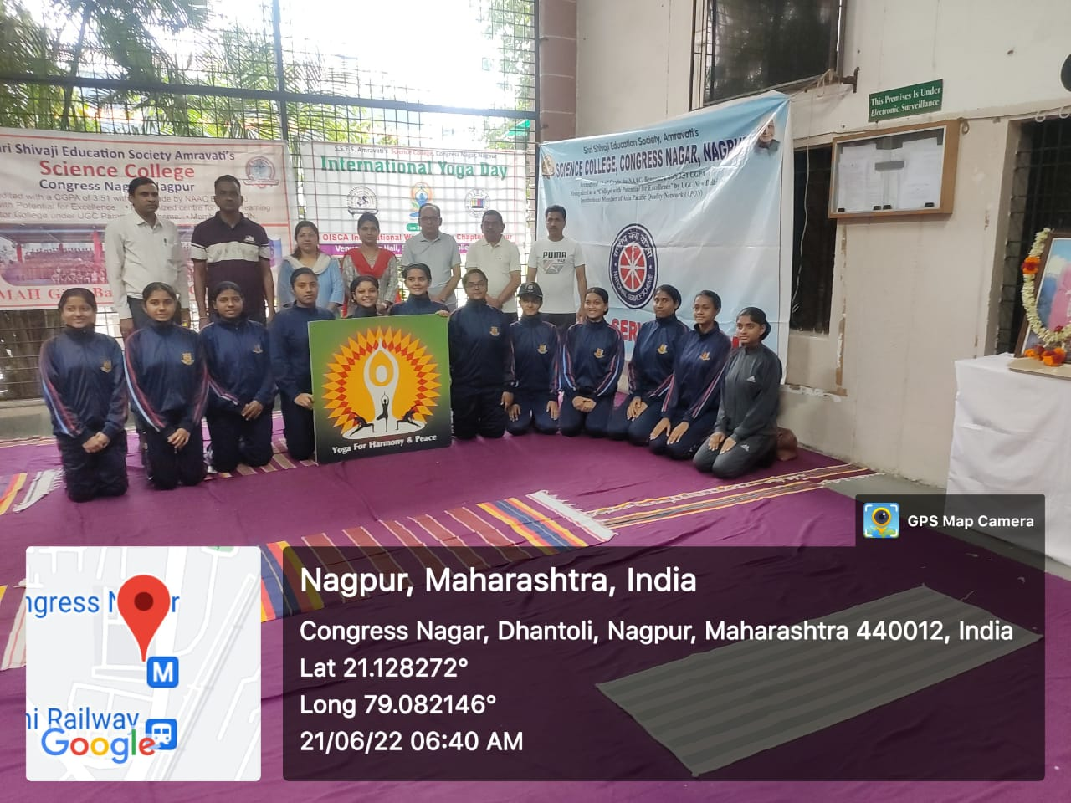 | 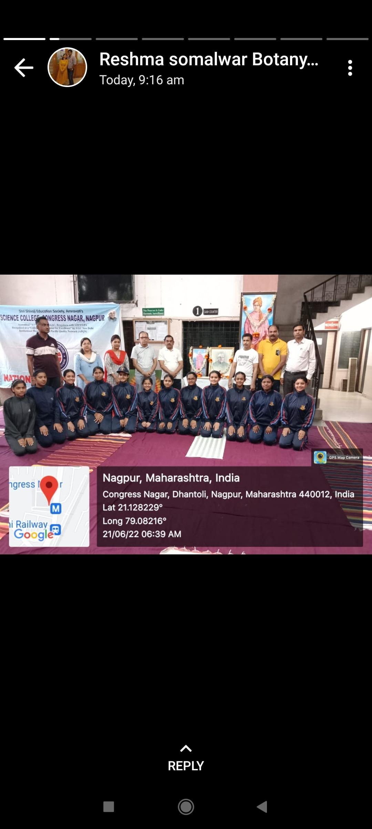
International Yoga Day Celebration on dated 21 June 2022 in presence of Hon’ble Principal Prof. M. P. Dhore Sir along with teaching faculty members and NCC cadets has actively participated.

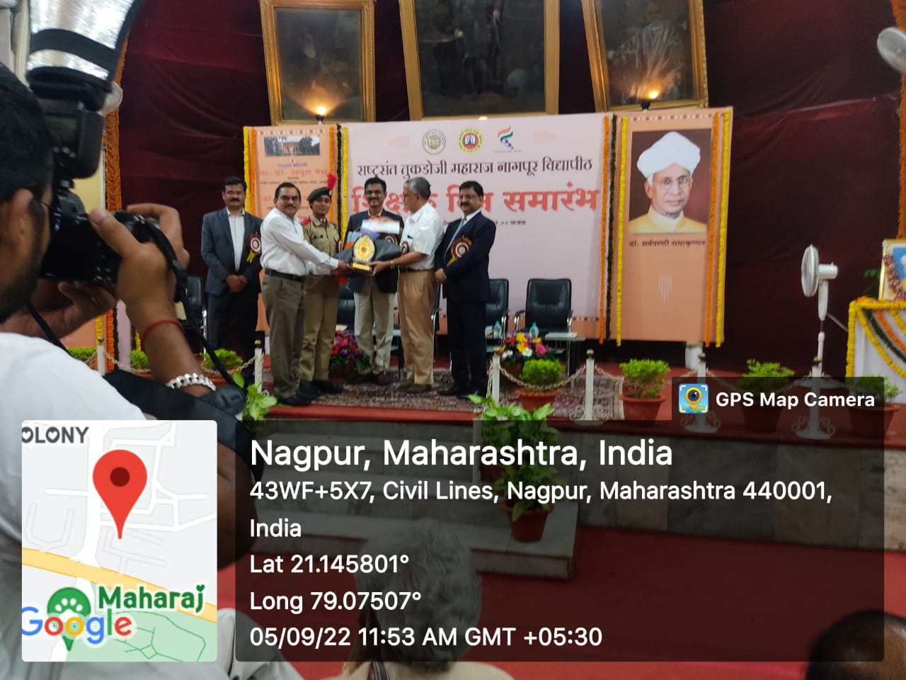
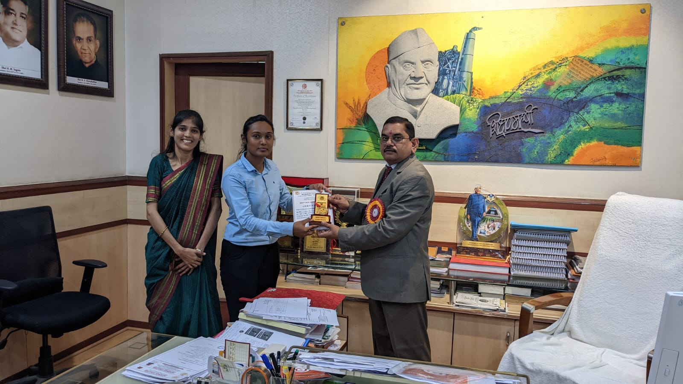
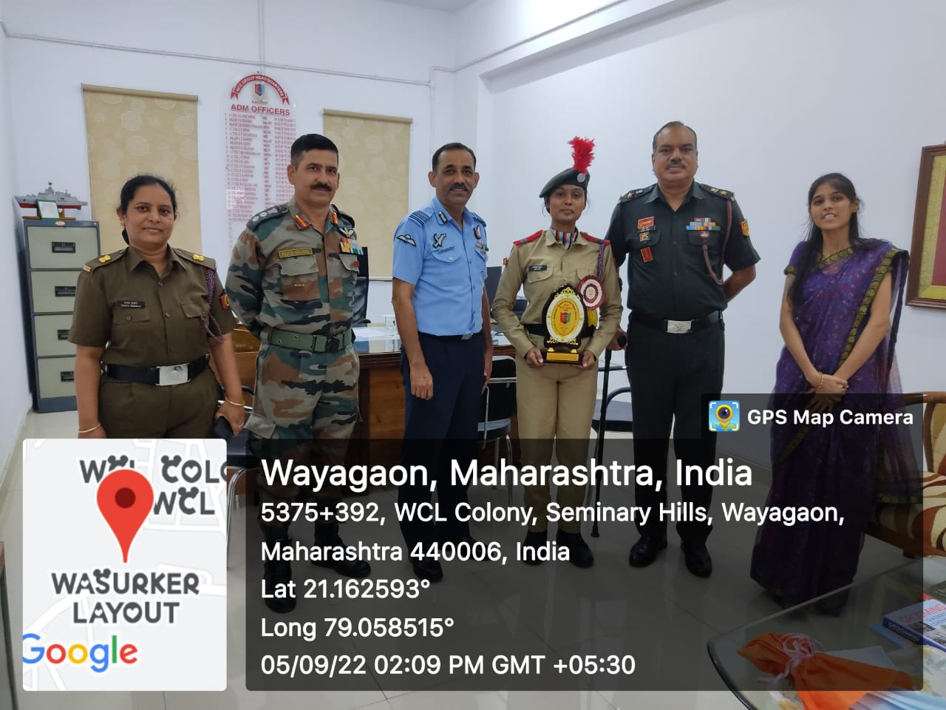

NCC Best Cadet Award (Senior Wing) given by R,T.M. Nagpur University, Nagpur to CWO Rashmi P. Balki for the training year 2020-21 on 5th September 2022.

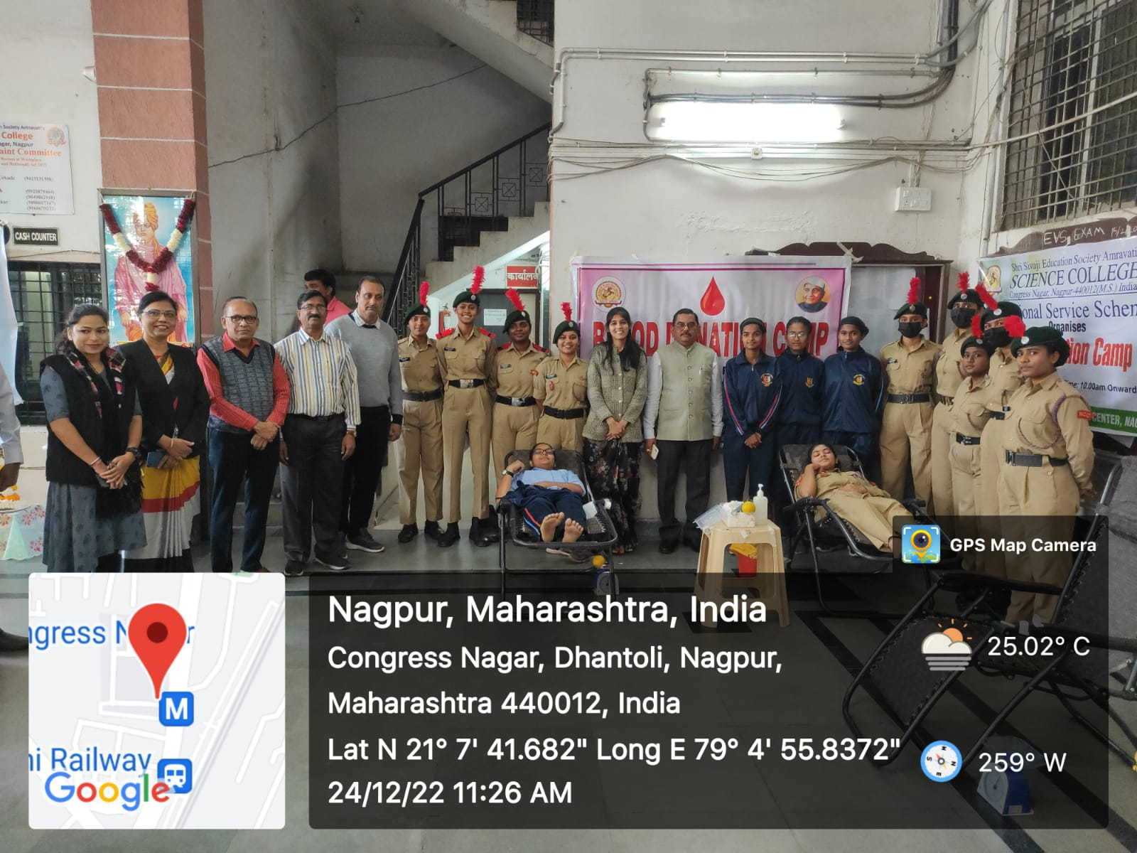
Blood Donation Camp was organized by the NCC unit on the occasion of the 124 th Birth anniversary of Dr. Panjabrao Deshmukh.

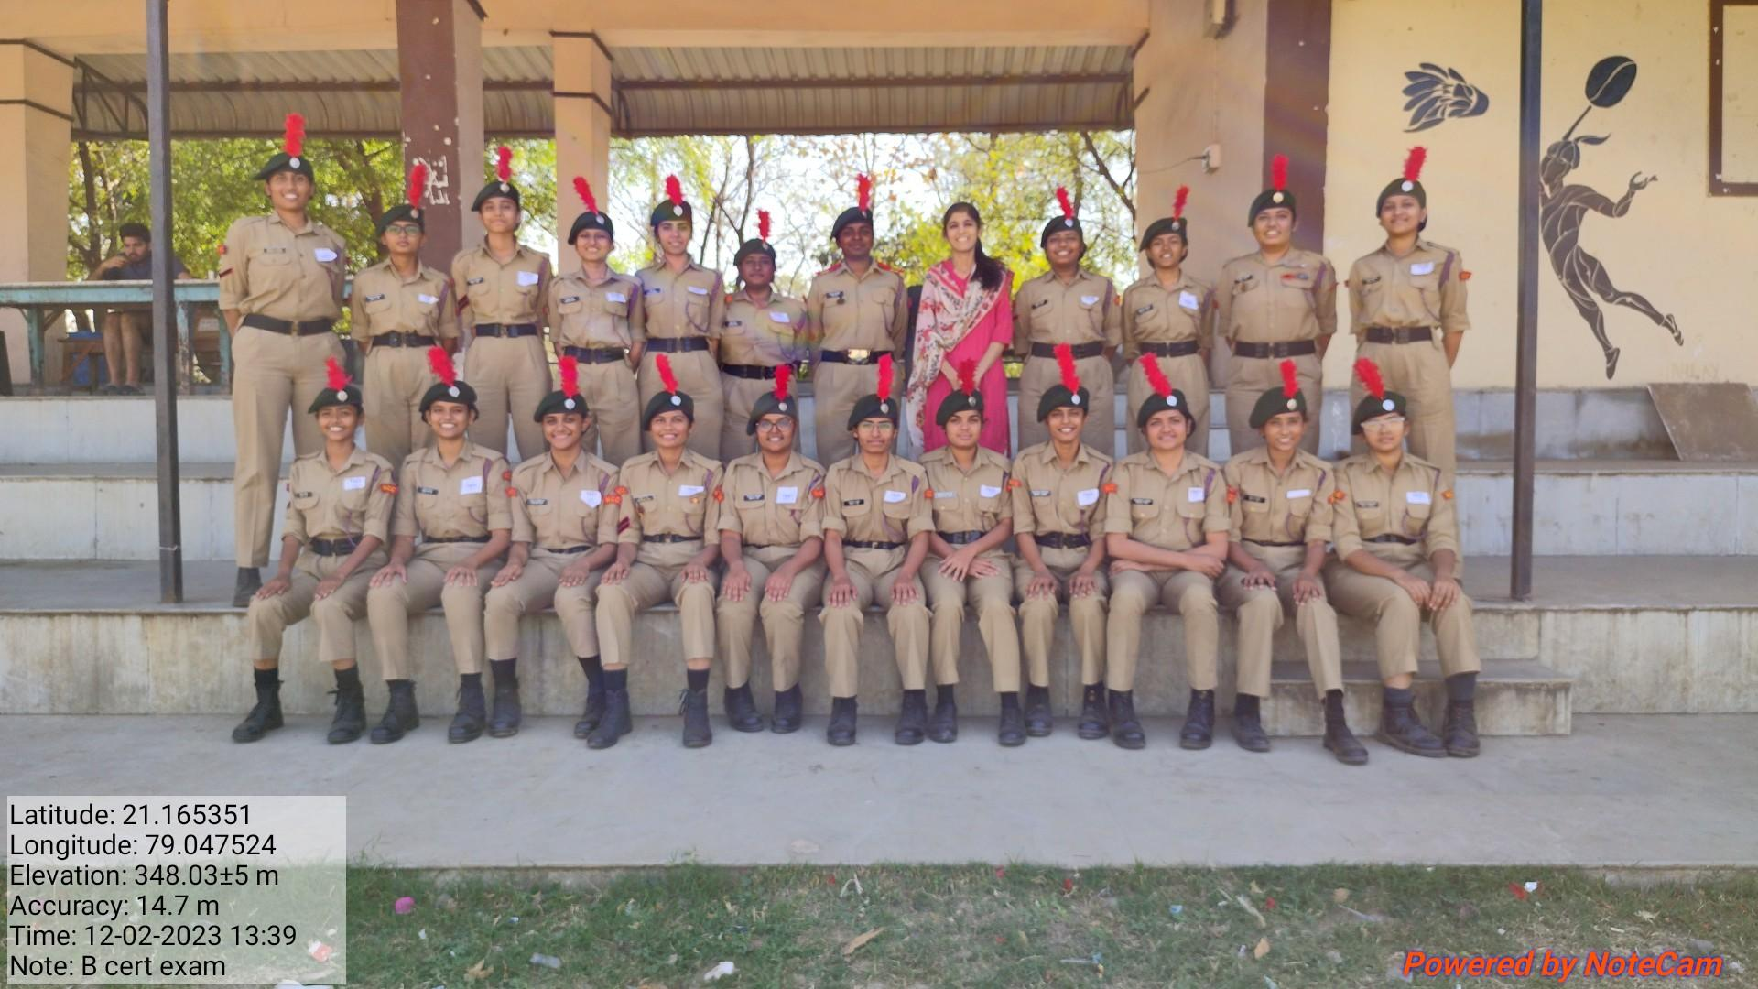 | 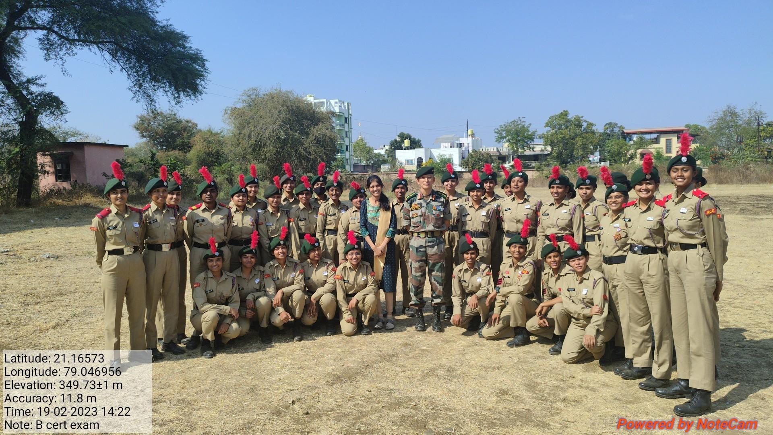

B’ cert exam. held on 11-12 Feb. 2023 and C’ cert exam. held on 18-19 Feb. 2023.
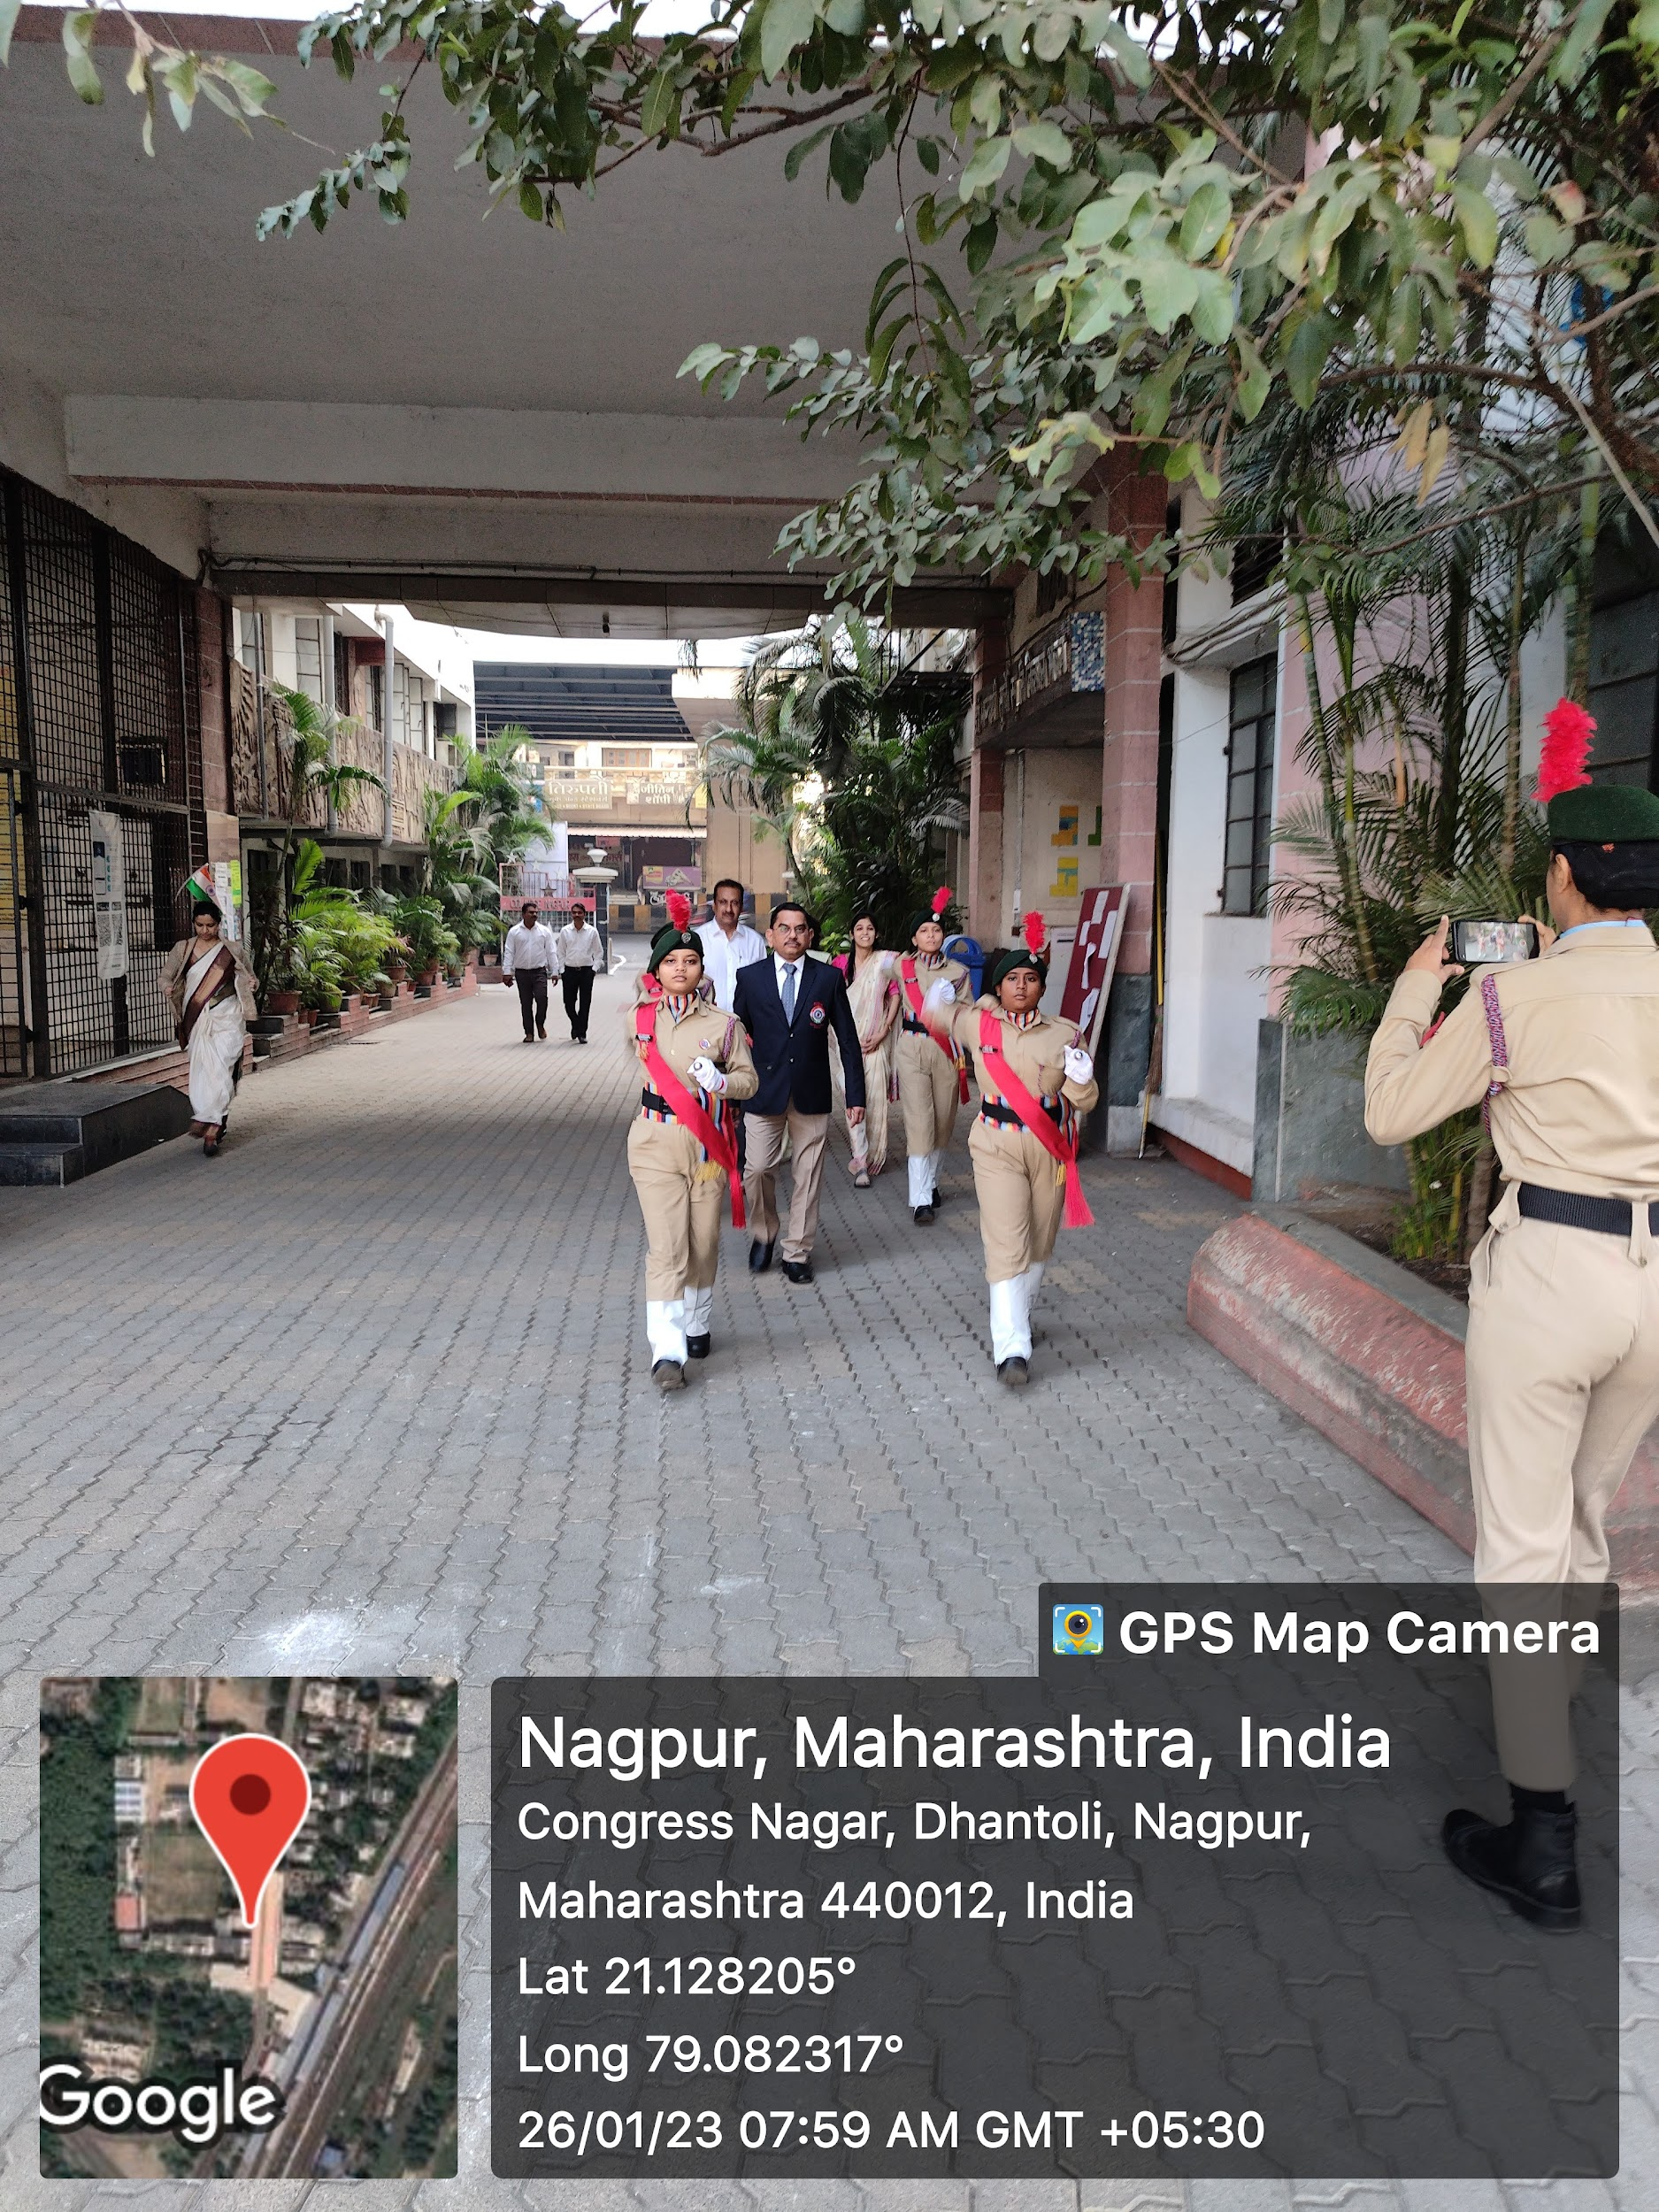 | 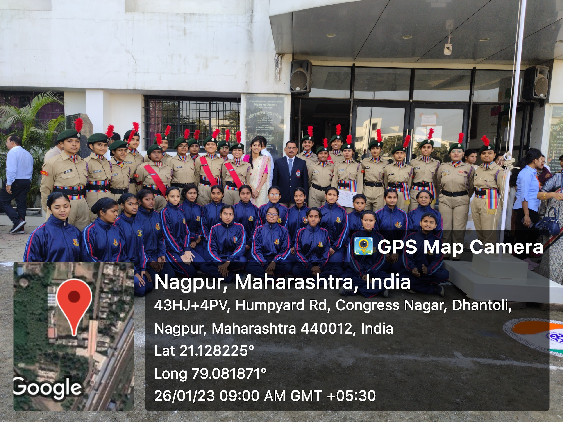
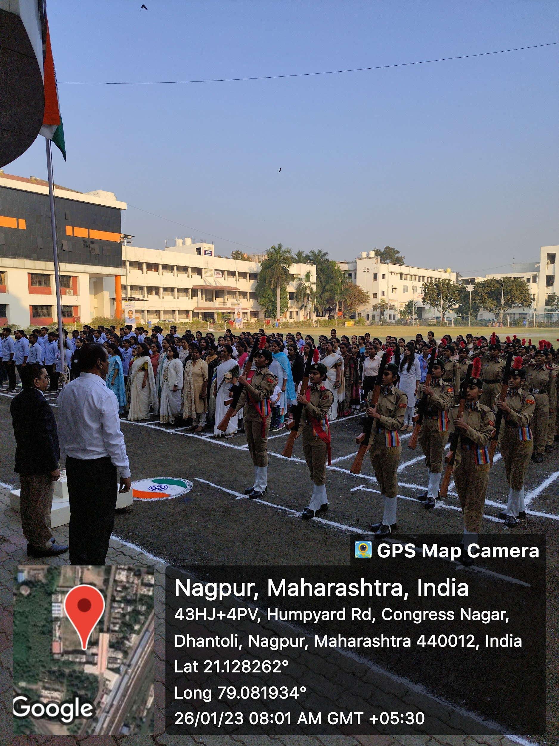 | 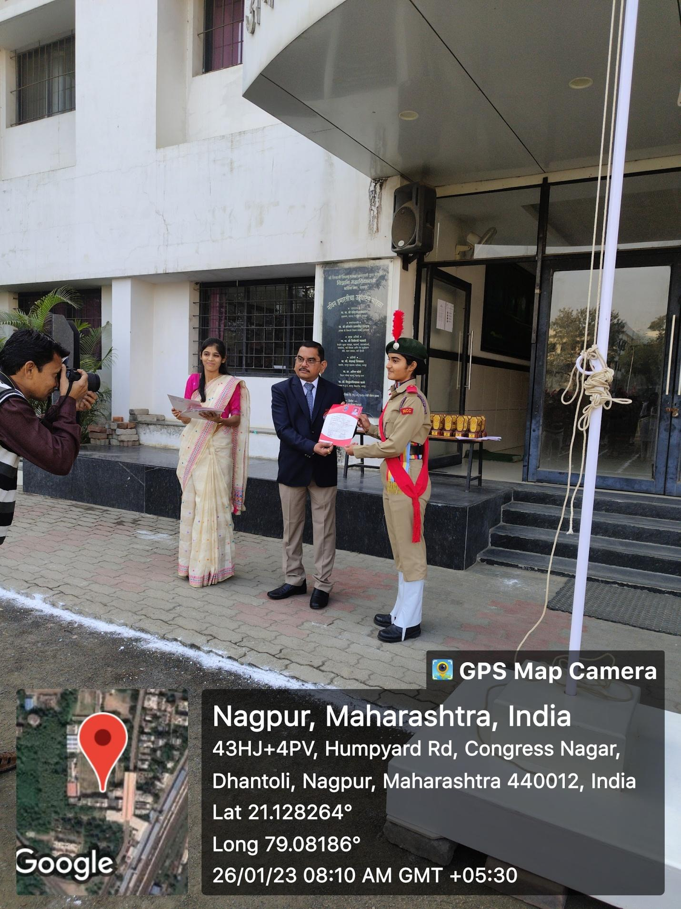

Ceremonial parades and B and C Certificate Distribution ceremony program were organized by the NCC unit on the Republic Day in presence of Hon’ble Principal Prof. M. P. Dhore Sir.

National Cadet Corp Ms. Apurva D. Fuladi
3 MAH GIRLS BATTALION NCC NAGPUR Program Officer

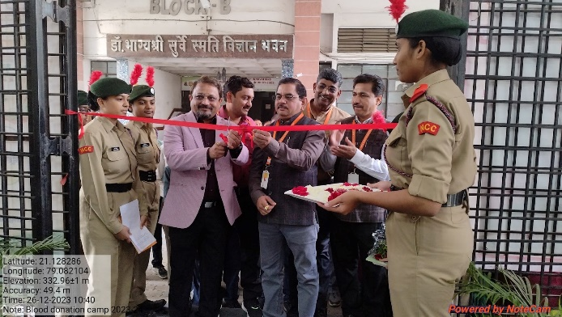 | 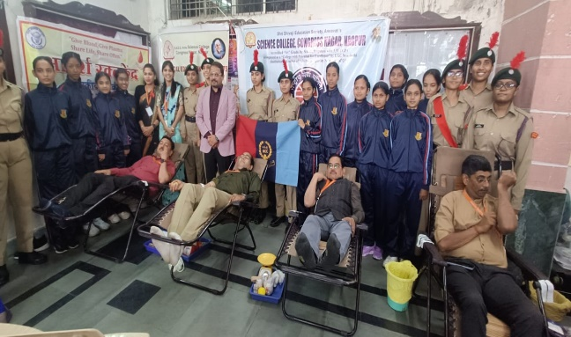
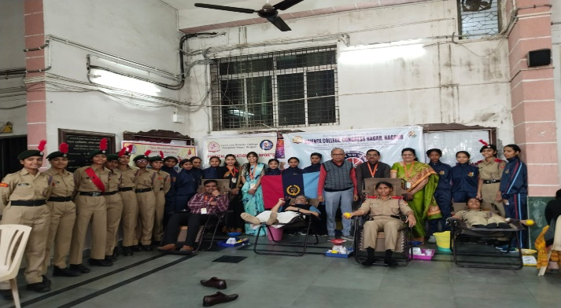 | 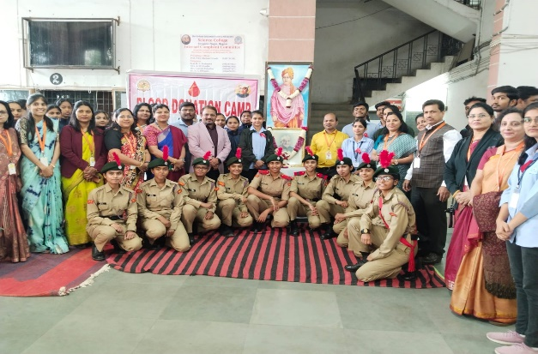
Blood Donation Camp was organized by the NCC and NSS unit in presence of Hon’ble Principal Prof. M. P. Dhore Sir and Hon'ble Dr. Avinash Gawande sir on the occasion of the 125 th Birth anniversary of Dr. Panjabrao Deshmukh.
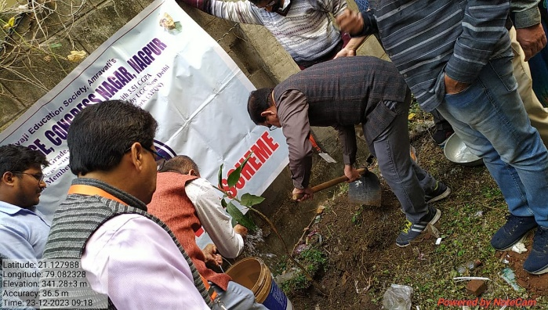 | 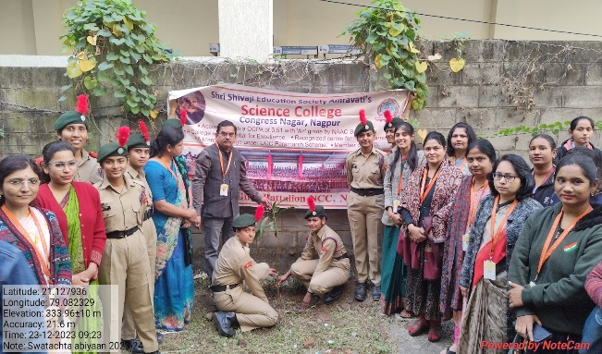
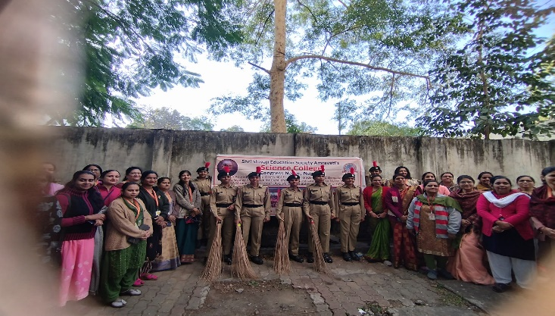 | 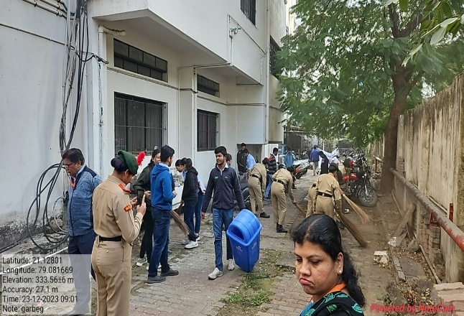
Plantation drive and Swachatta Abhiyaan were organized in the college premises in presence of Hon’ble Principal Prof. M. P. Dhore Sir, faculty members and Cadets on the occasion of the 125 th Birth anniversary of Dr. Panjabrao Deshmukh

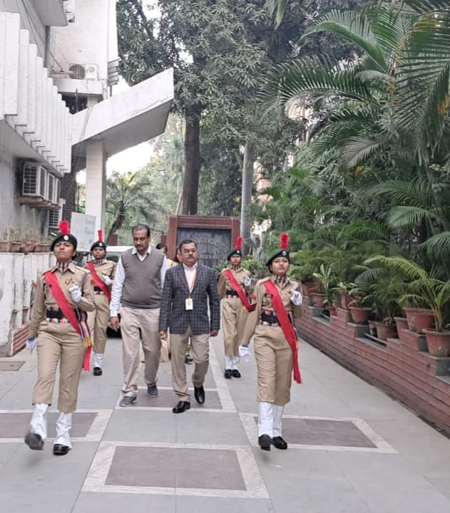 | 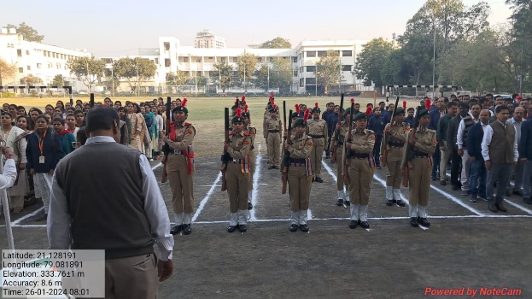
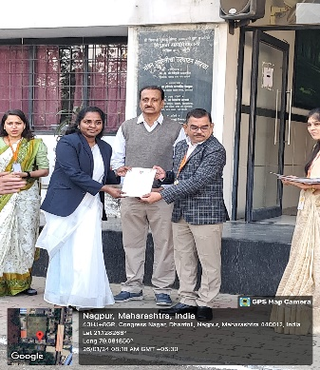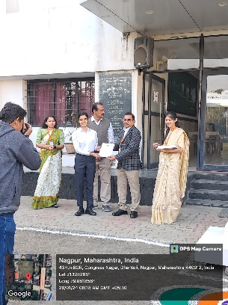 | 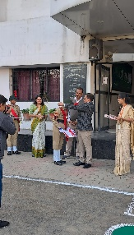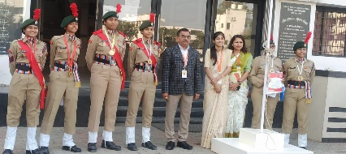
Ceremonial parades were organized in the college, on the occasion of Republic Day celebrations in presence of Hon’ble Principal Prof. M. P. Dhore Sir.
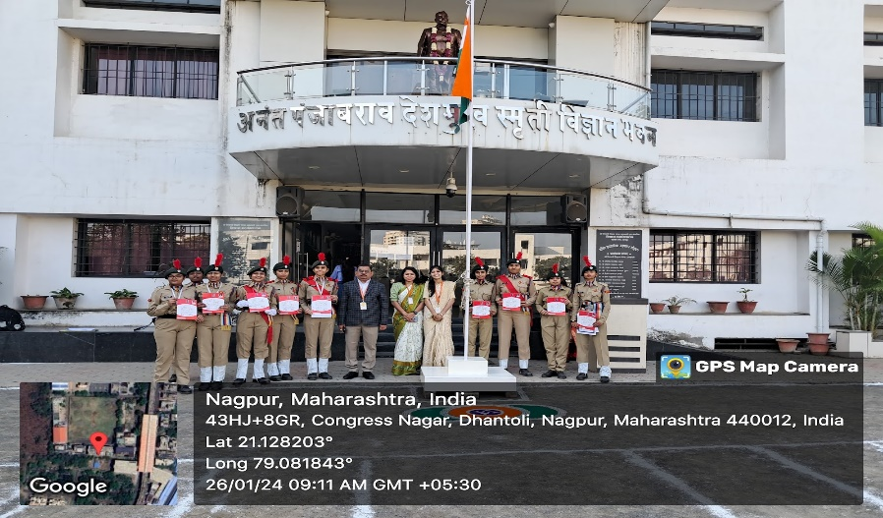 | 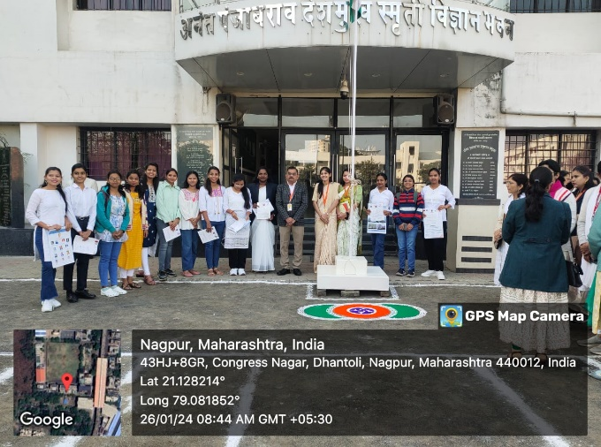
B and C Certificate Distribution ceremony program was held on 26 Jan. 2024

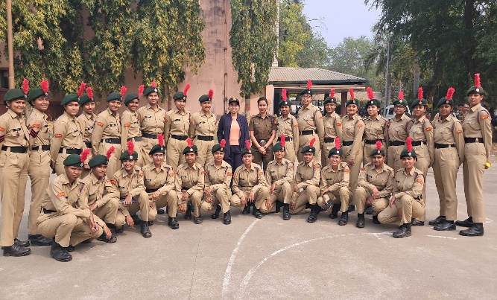 | 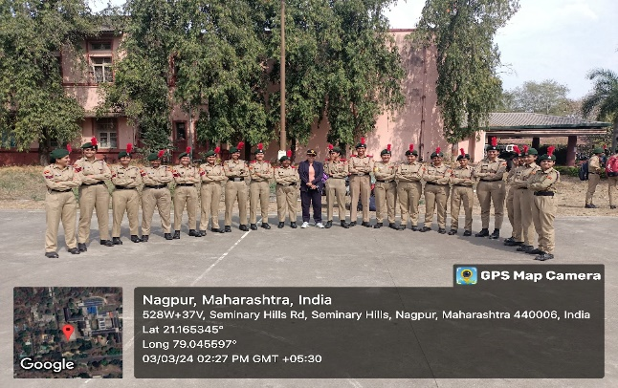
B cert exam was held on 10-11 Feb. 2024 and 12 Feb. 2024 and
C cert exam. was held on 26 Feb. 2024 and 03 March 2024.

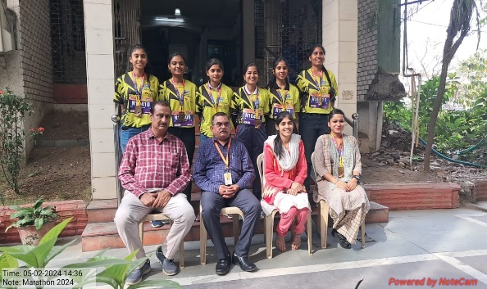 | 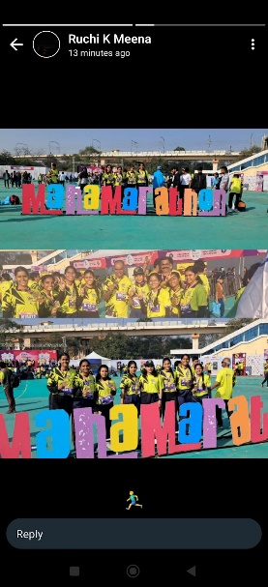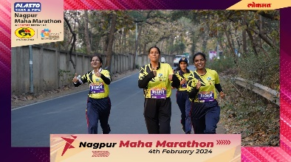
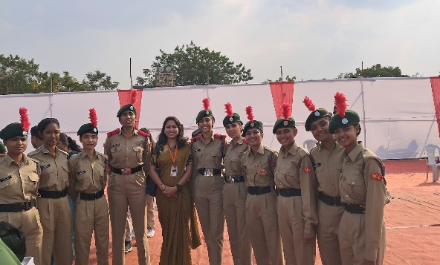 | 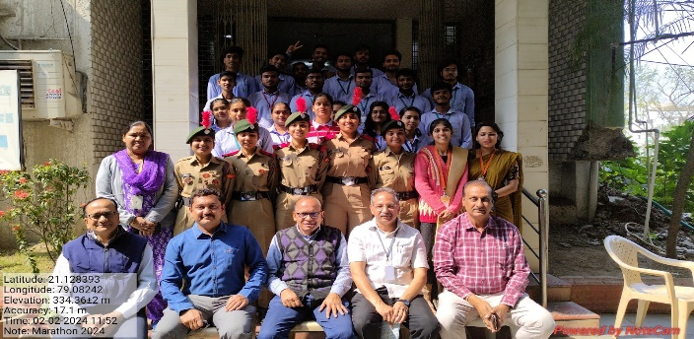
Maha-Marathon 2024

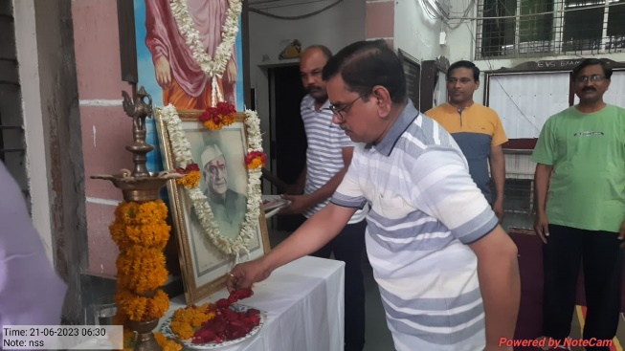 | 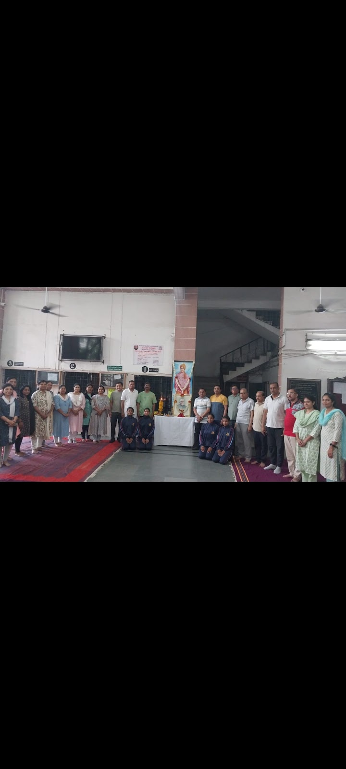
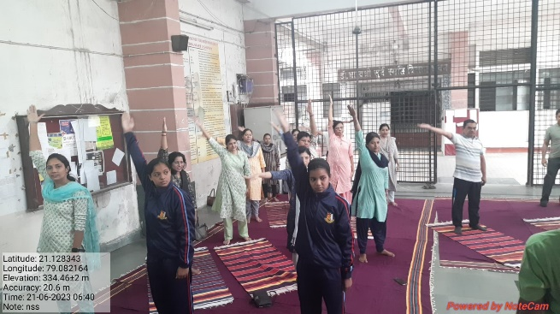 | 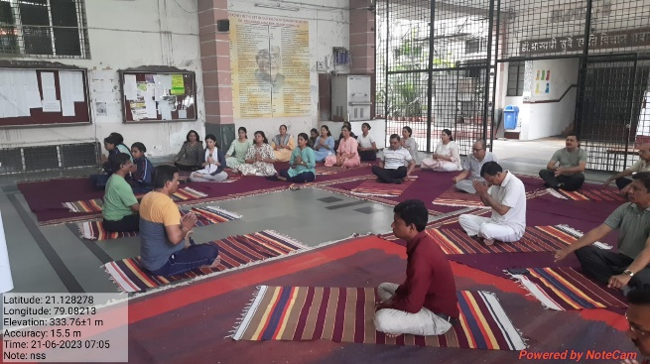
On the occasion of 7th International Yoga Day 2022, Yoga Asana events were organized in the college premises in presence of Hon’ble Principal Prof. M. P. Dhore Sir

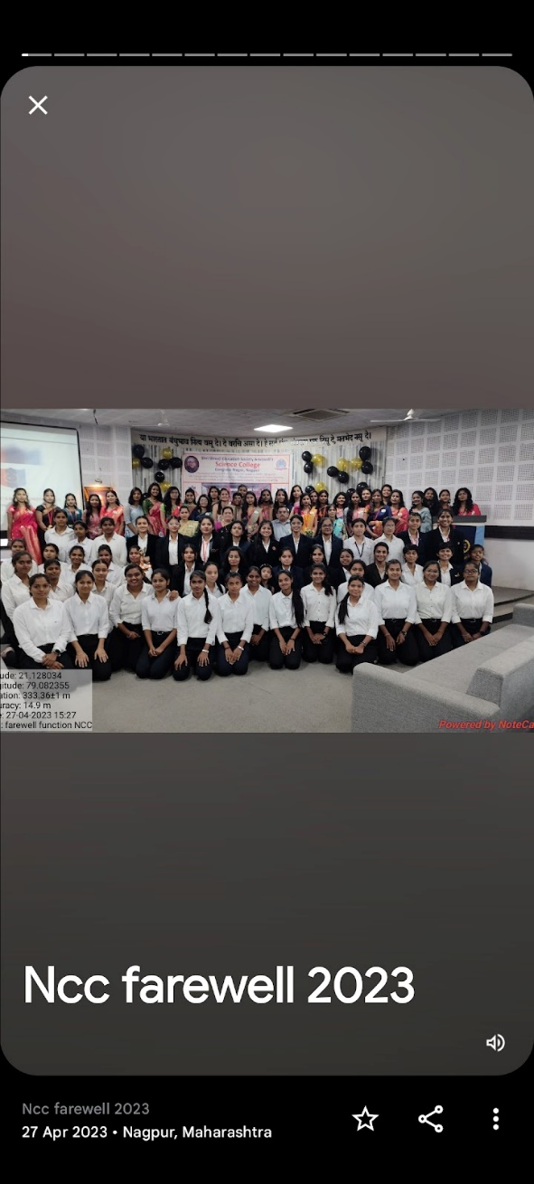 | 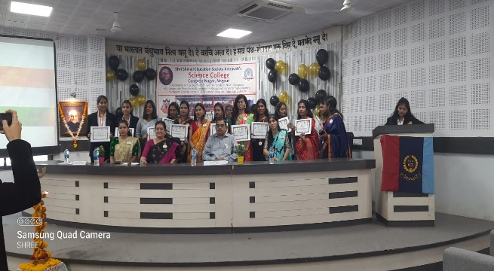
Final year NCC Farewell program 2023 in presence of Hon’ble Principal Prof. M. P. Dhore Sir

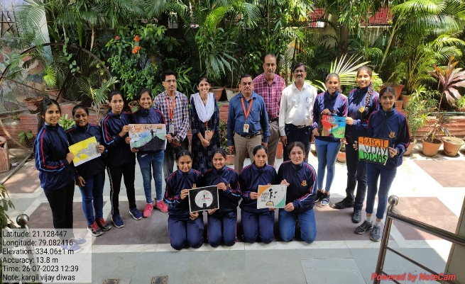 | 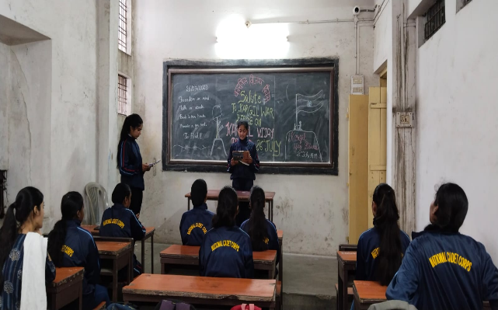
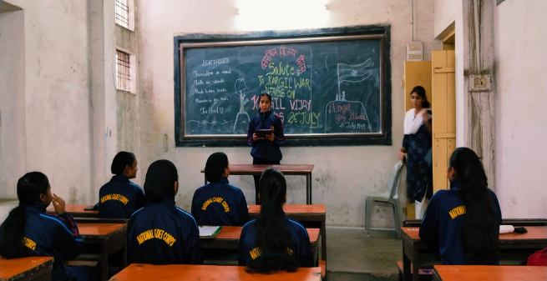 | 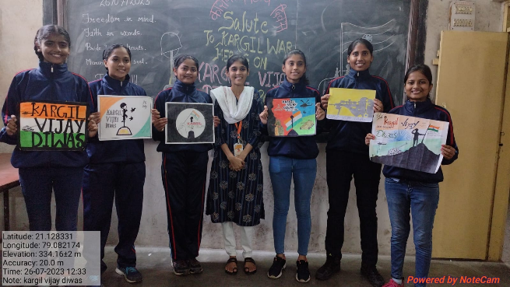
Kargil Vijay Diwas 2023

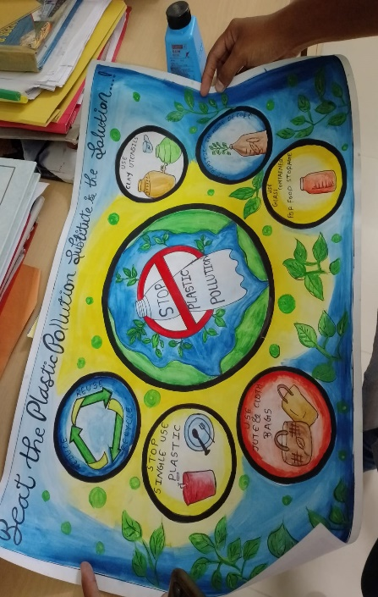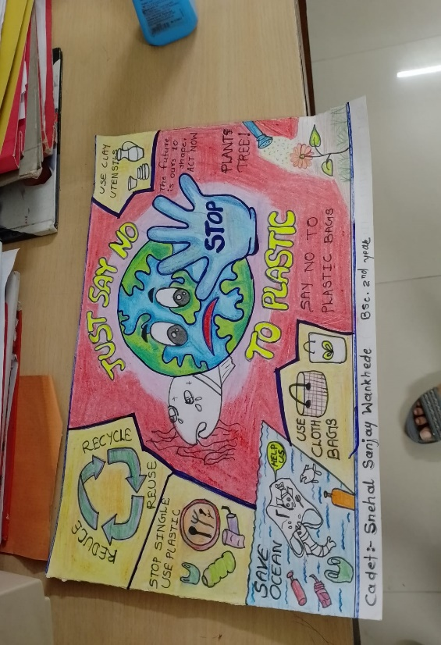 | 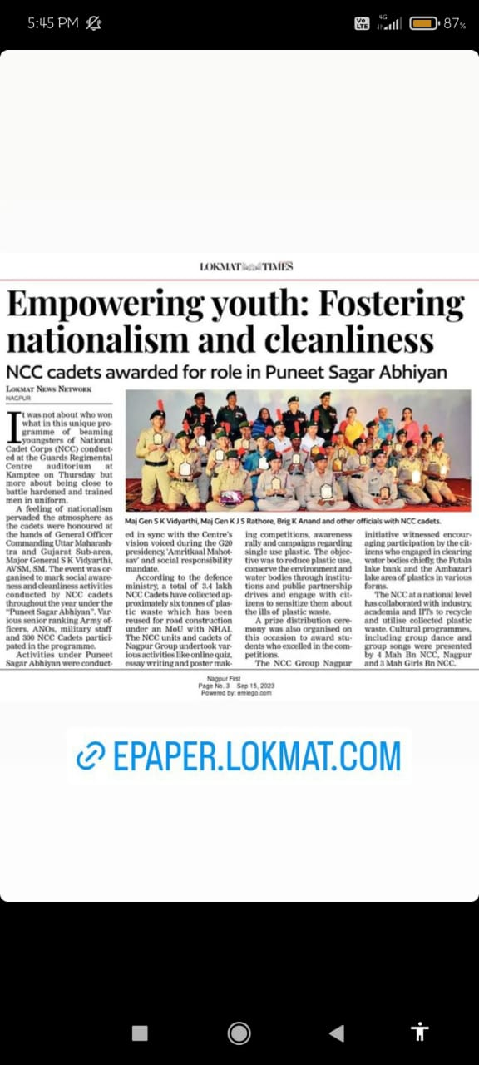
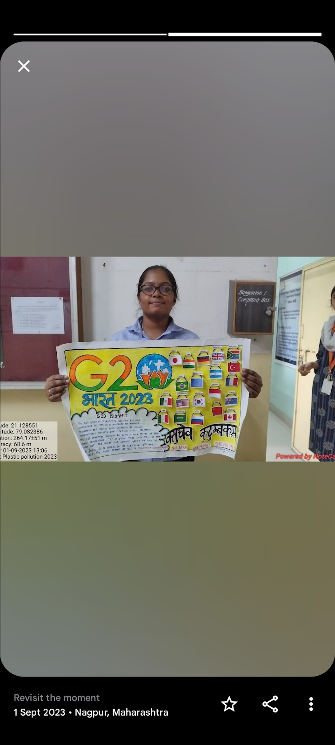 | 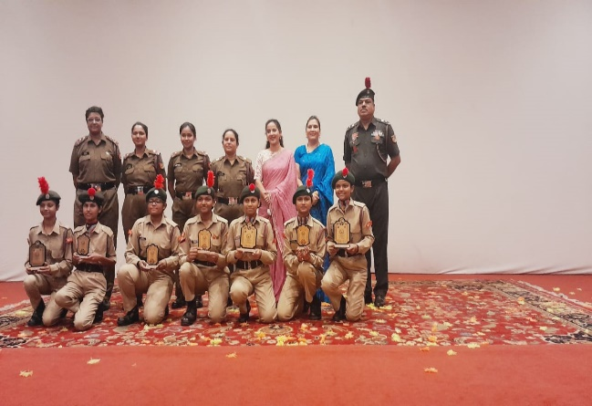
Puneet Sagar Abhiyaan 2023-24 with special reference G20 presidency NCC army wing organized a series of events from 6 to 8 sep 2023. In which Our cadets, Shreya Parihar won 2nd prize in a poster making competition.

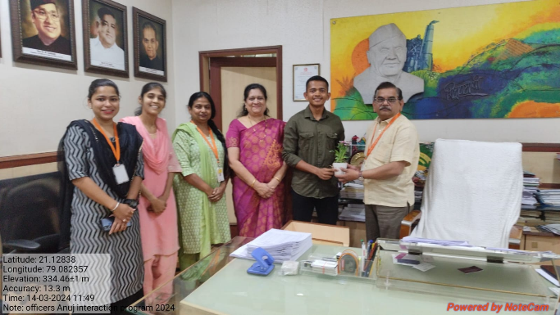 | 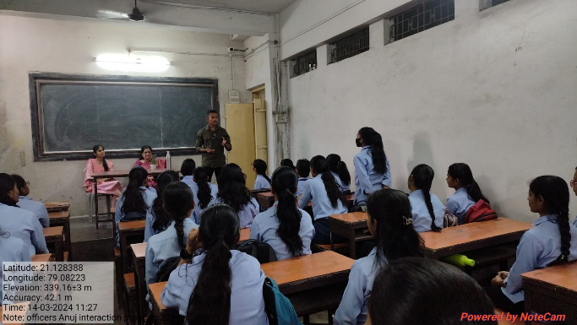
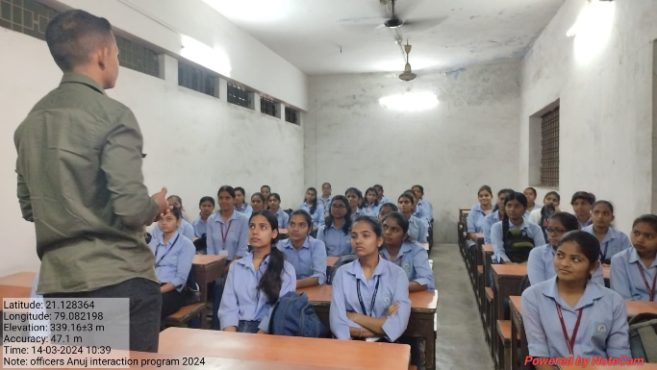 | 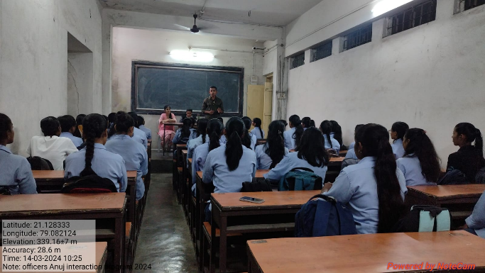
Interaction program organized by Lieutenant Anuj Ghatate was held on 14 March 2024

Shri Shivaji Education Society Amravati’s
SCIENCE COLLEGE, CONGRESS NAGAR, NAGPUR
Session 2024 – 2025
National Cadet Corp
3 MAH GIRLS BATTALION NCC NAGPUR

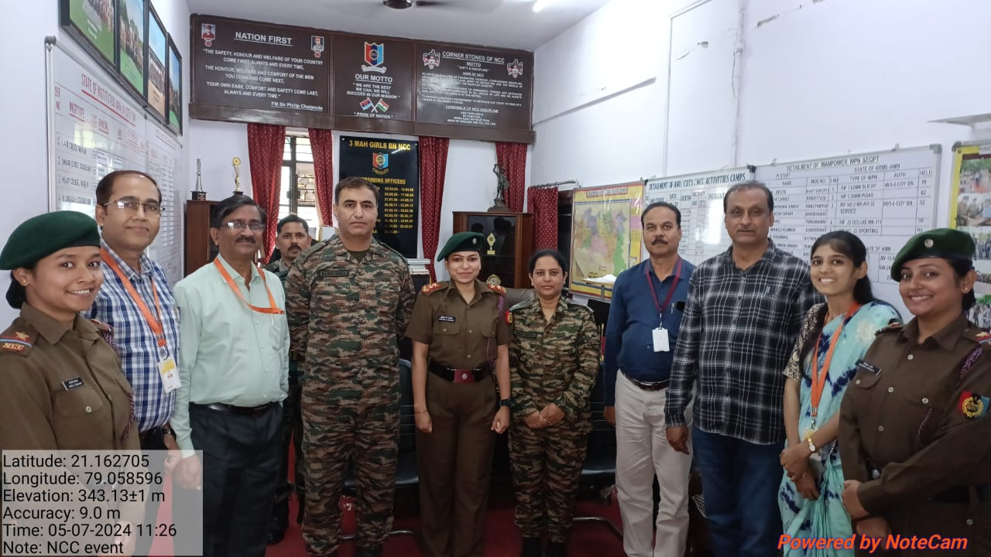

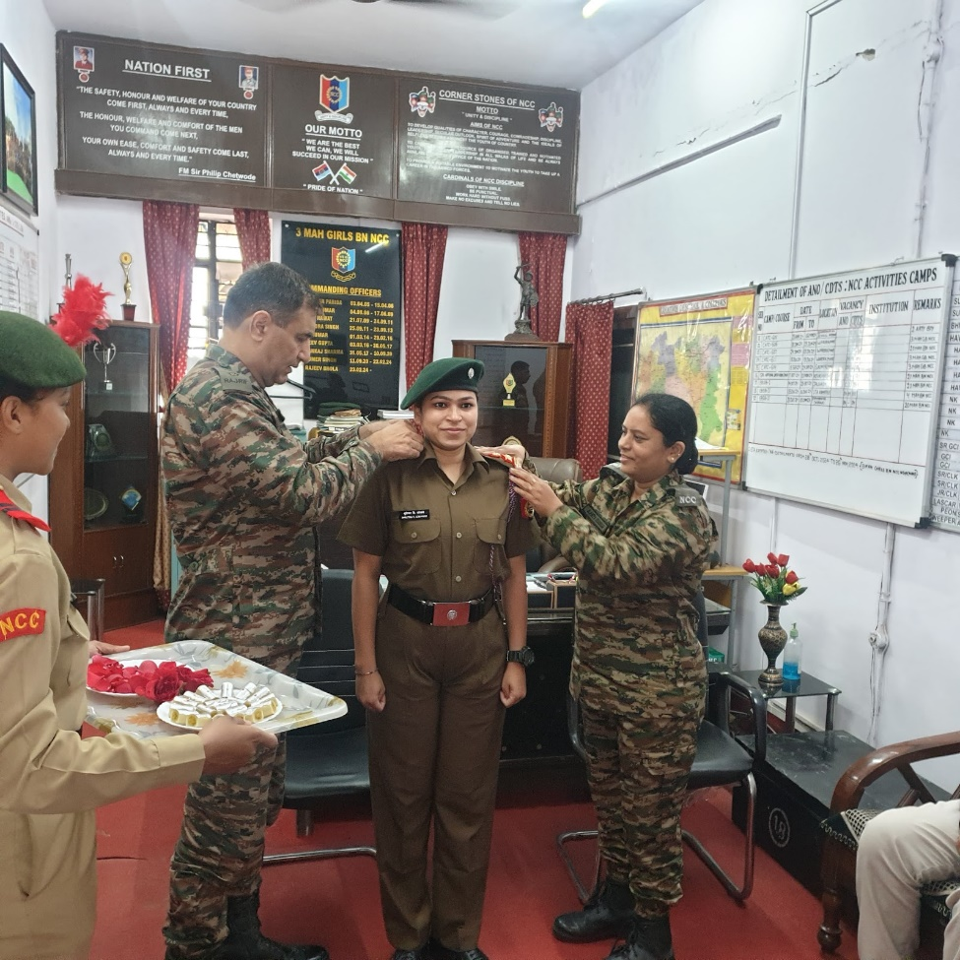
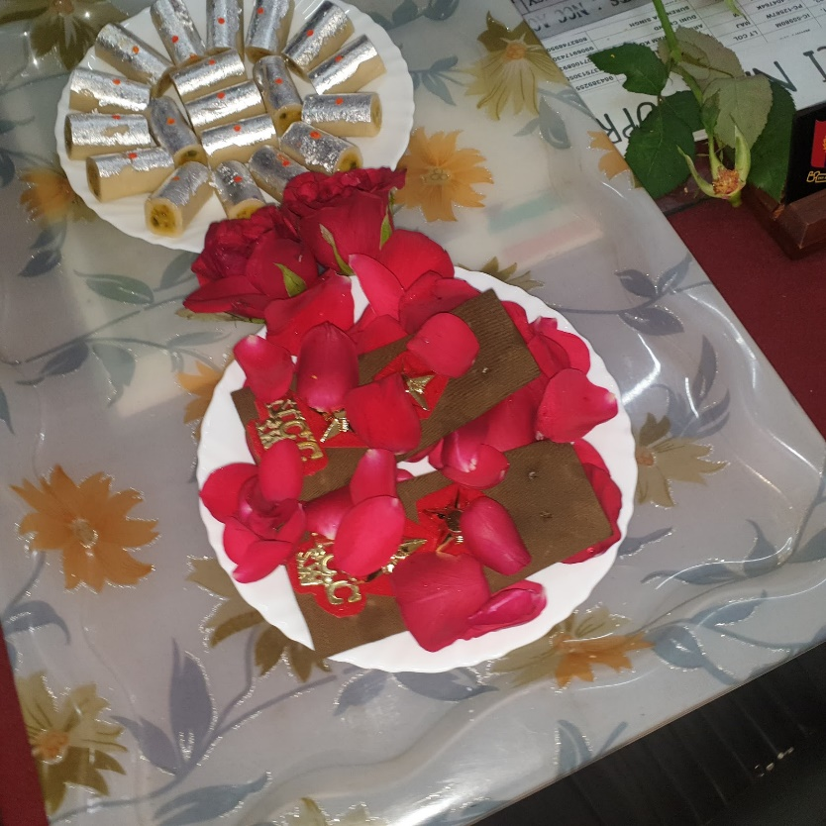

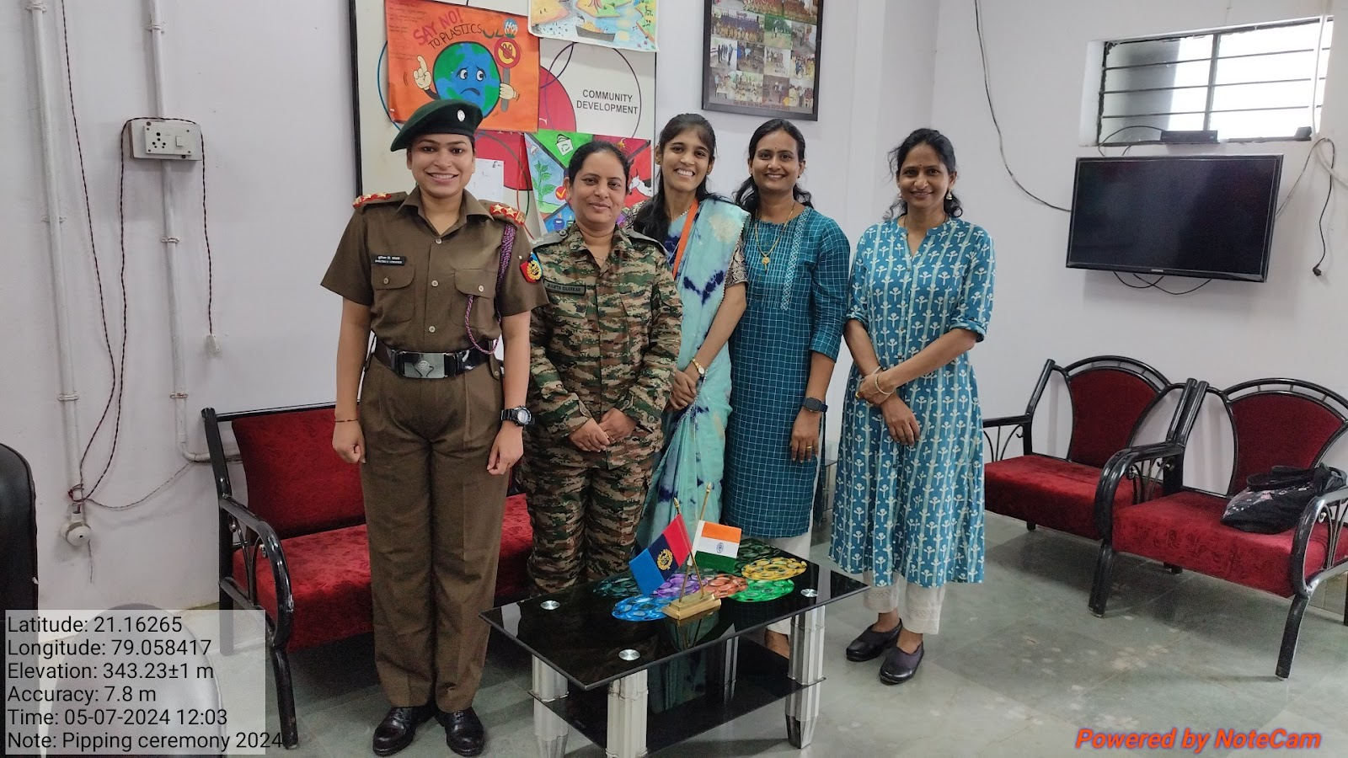

Pipping Ceremony - Lt. Shrutika V. Lokhande 2024

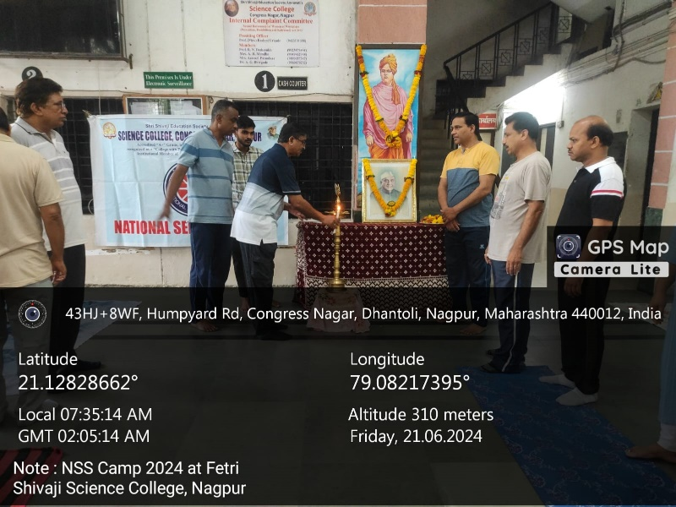

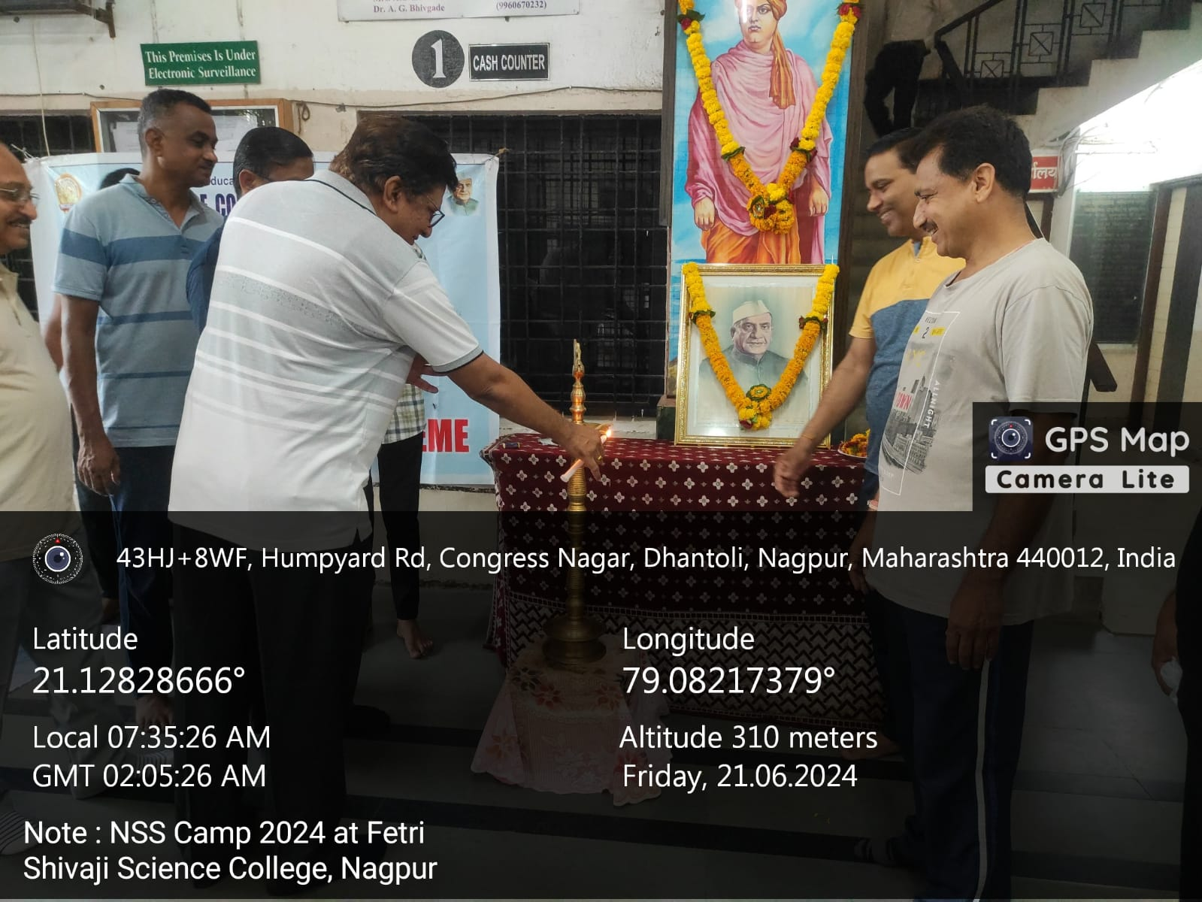

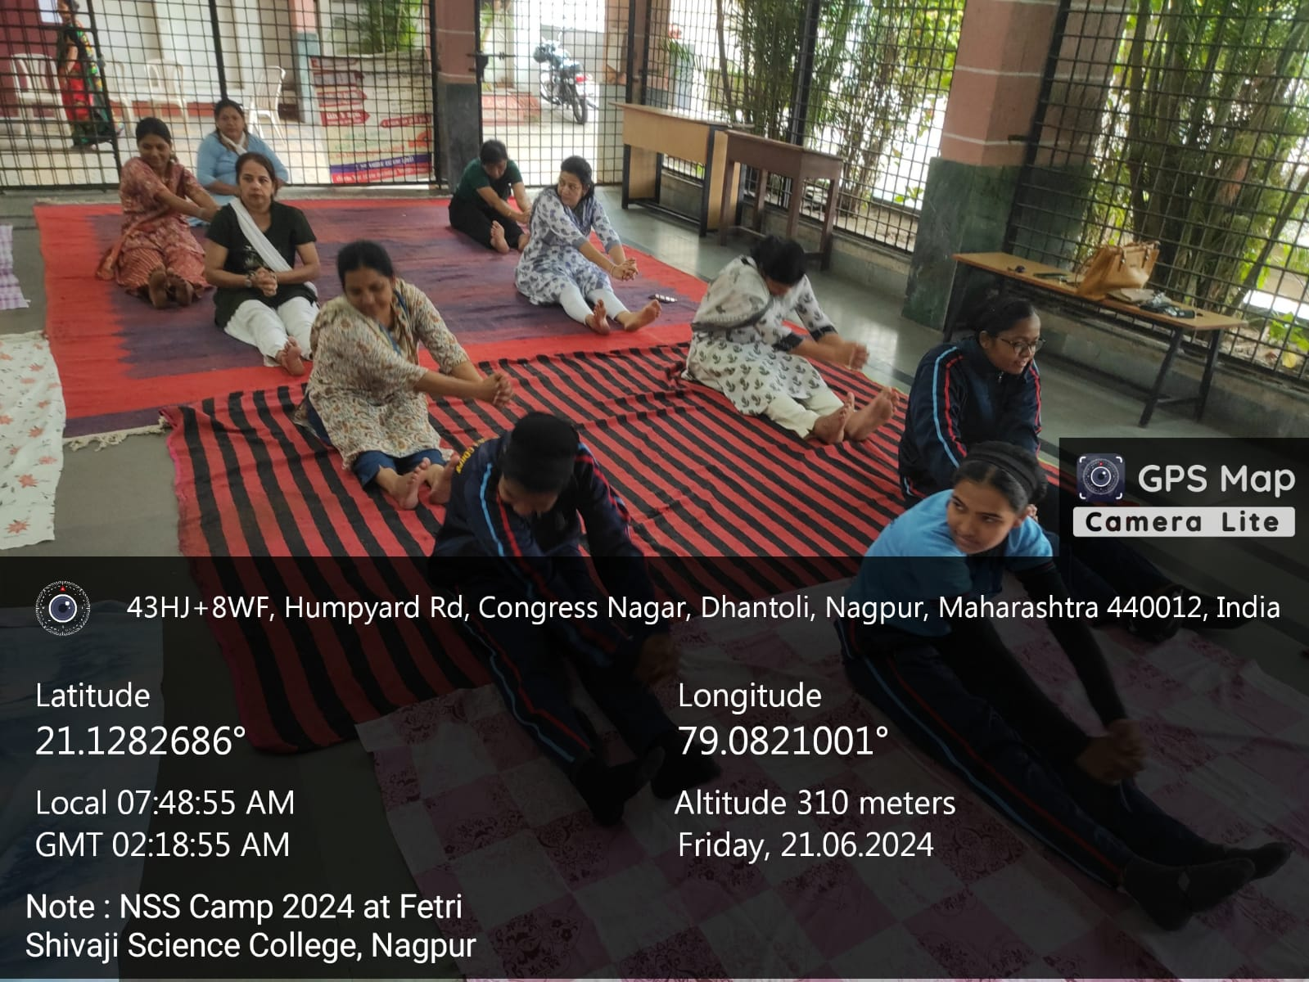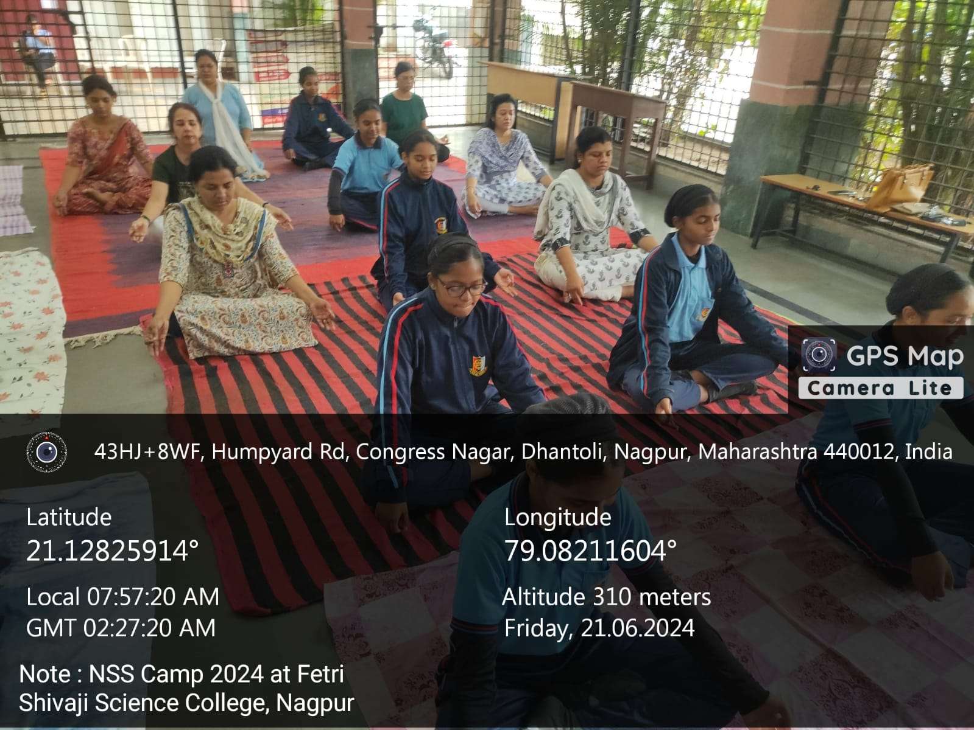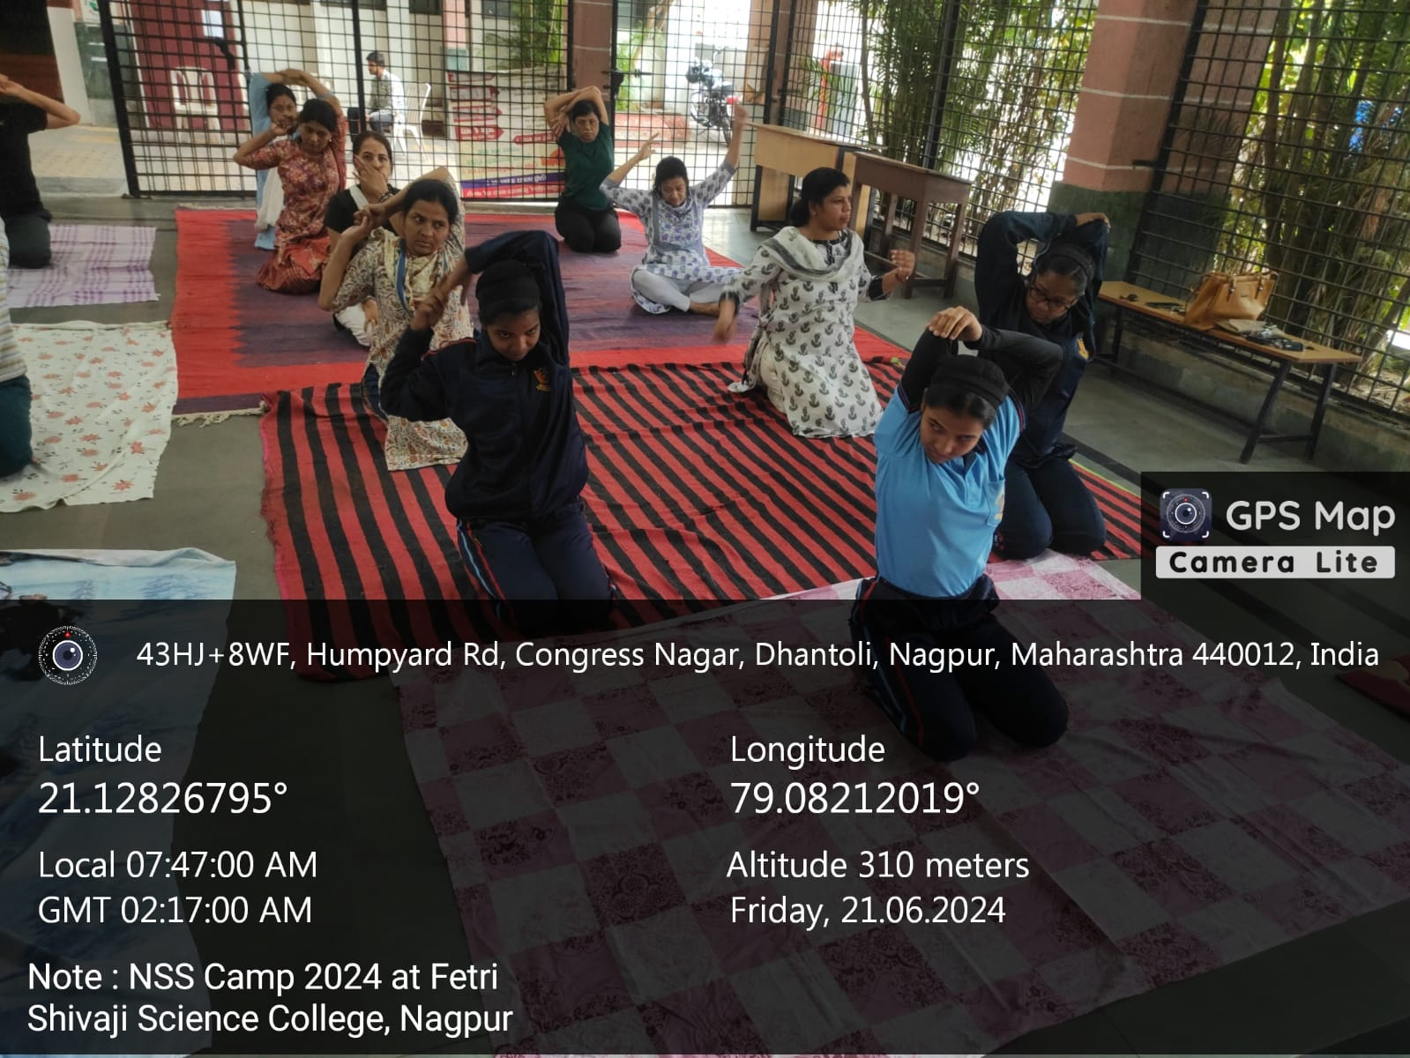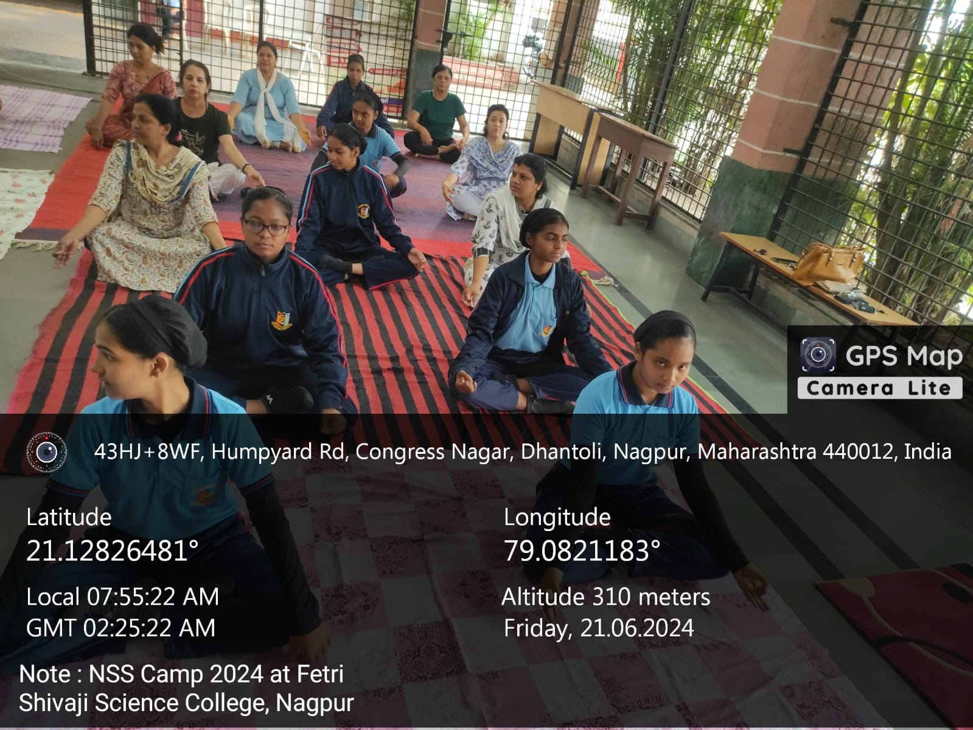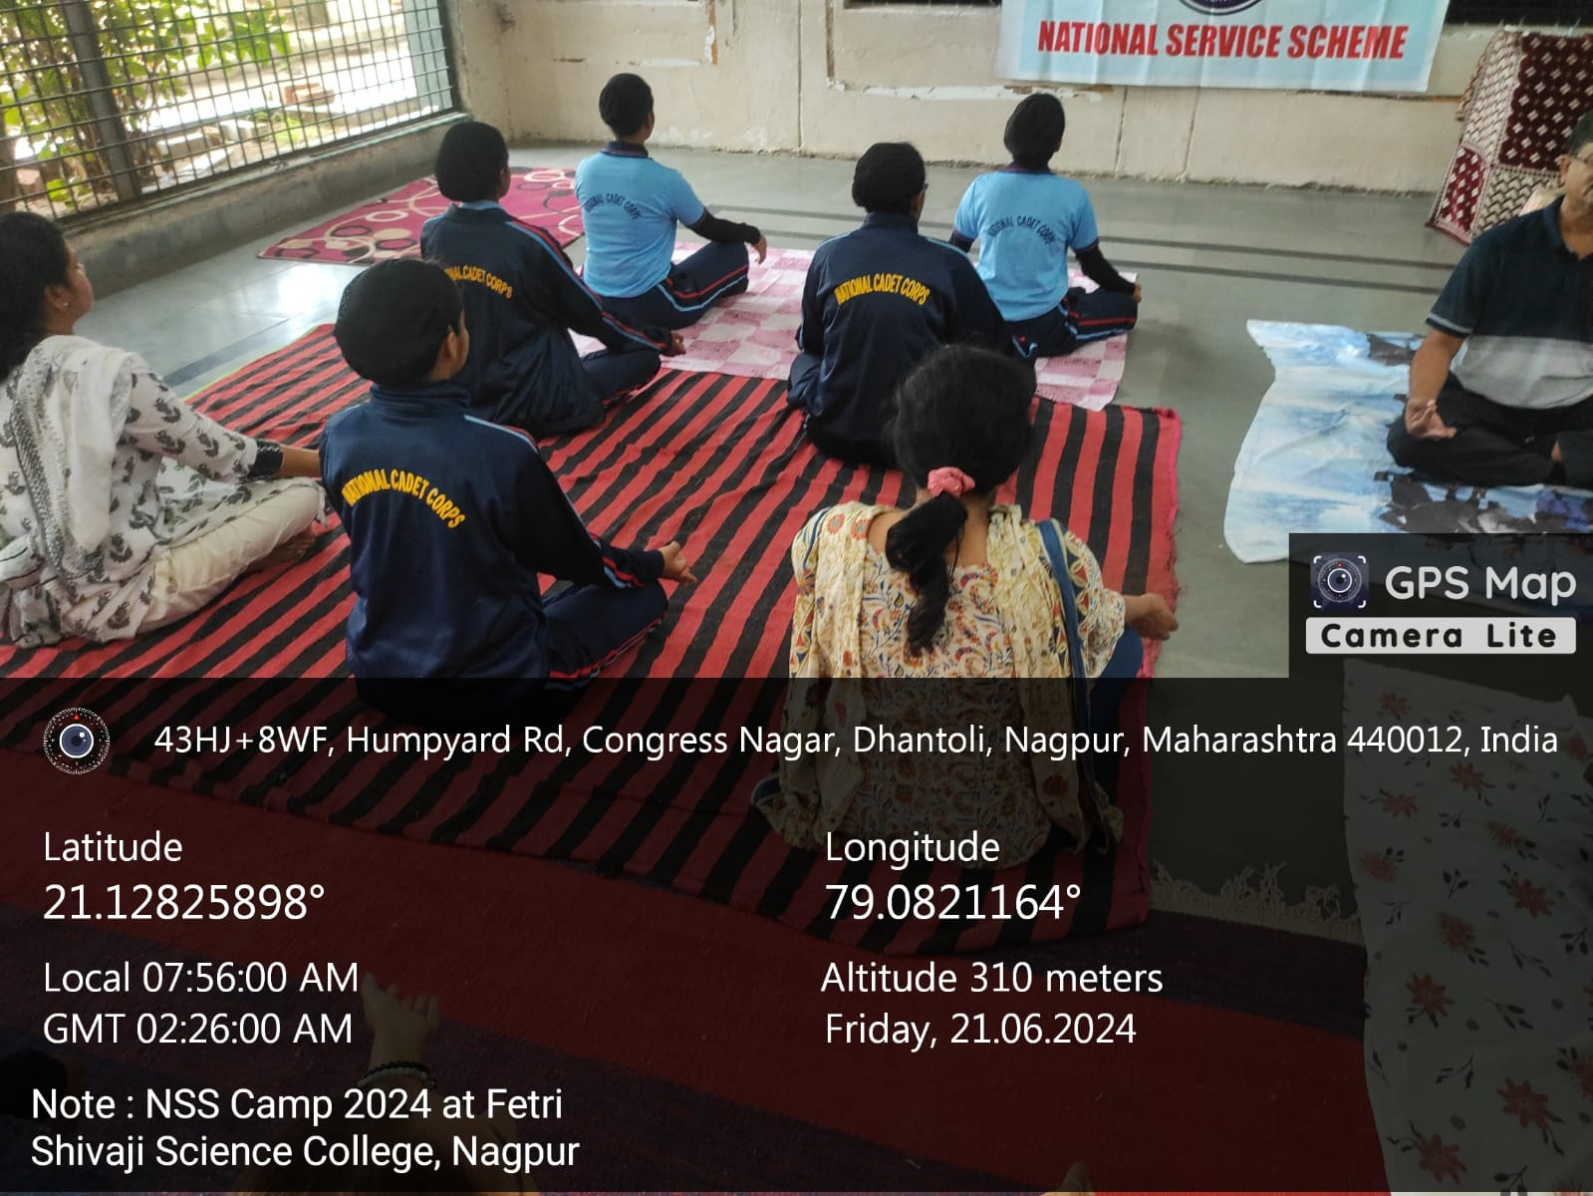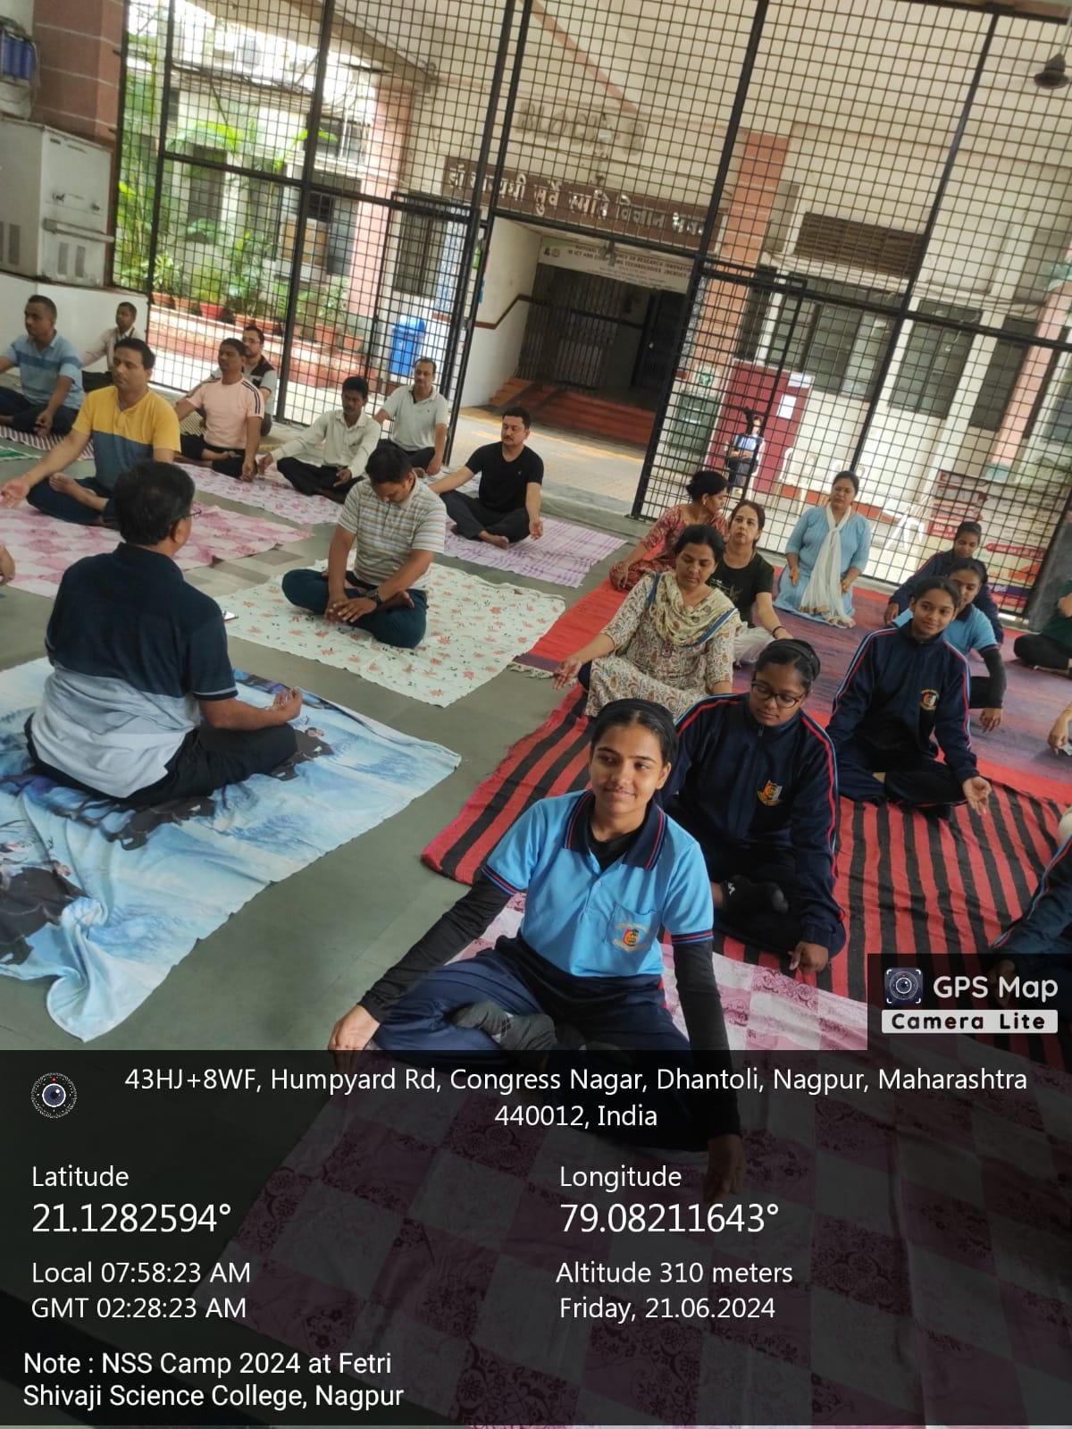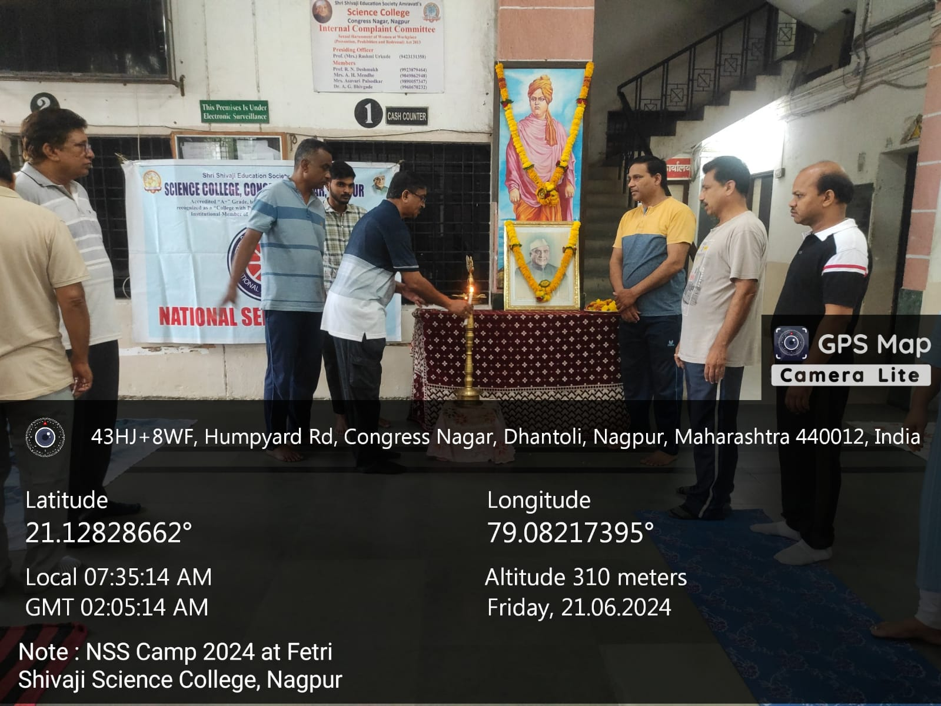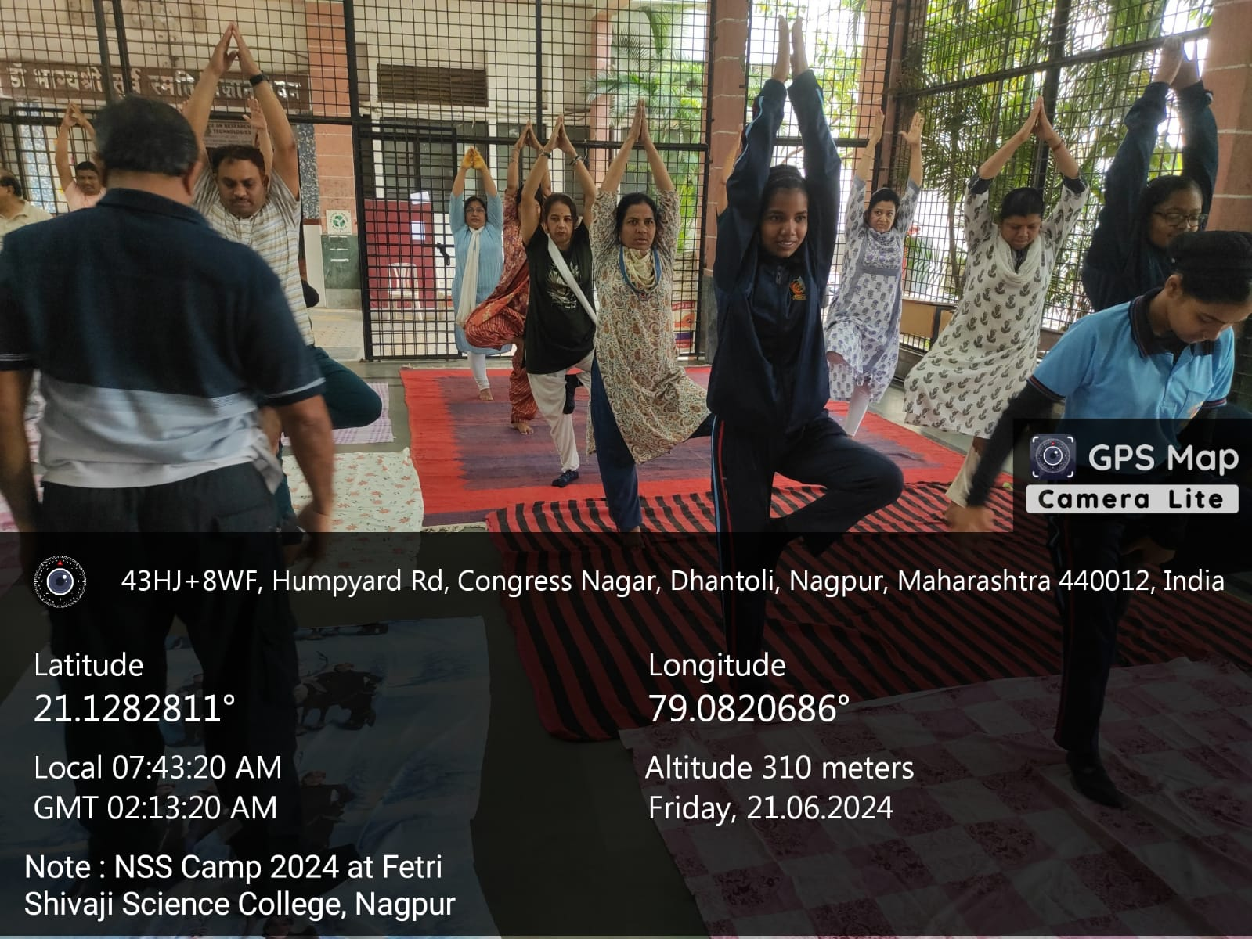

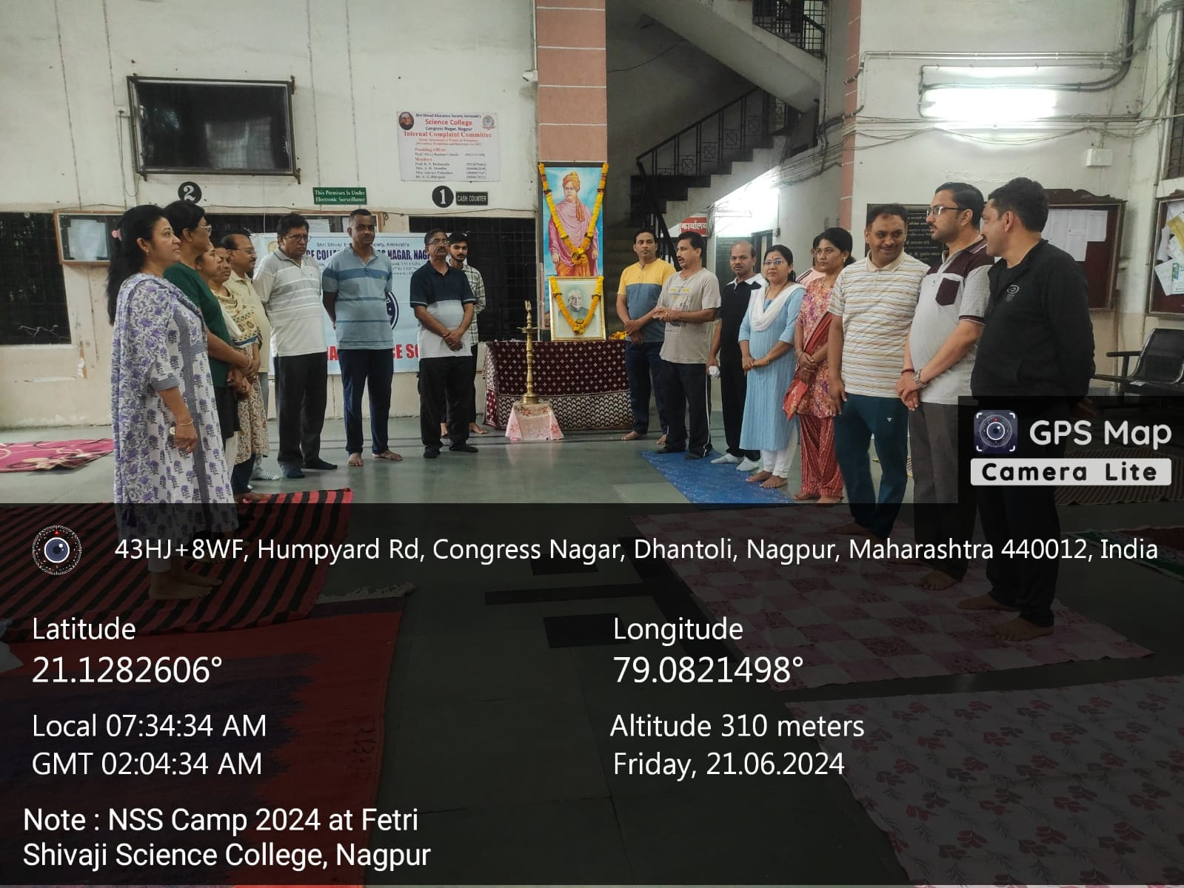

On the occasion of International Yoga Day 2022, Yoga Asana events were organised in the college premises in presence of Hon’ble Officiating Principal Prof. S. R. Pande Sir

