Shri Shivaji Education Society Amravati’s
SCIENCE COLLEGE, CONGRESS NAGAR, NAGPUR
Department of Chemistry
Organized activity “Yoga and Meditation for Non-teaching”
Session 2022-2023
Report
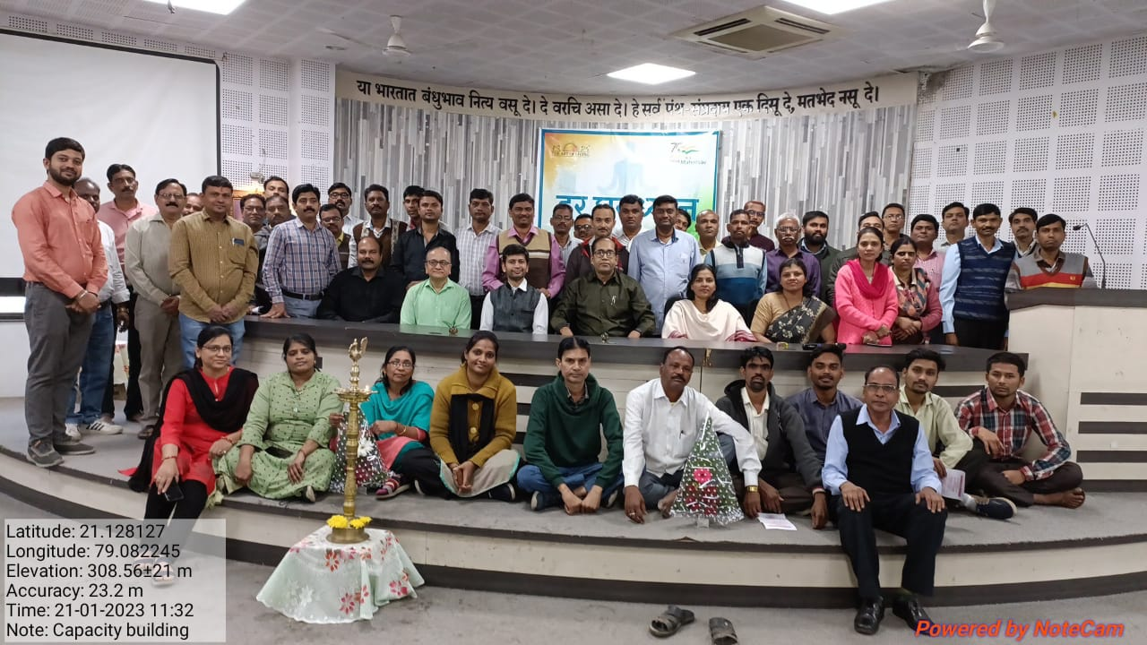
A few minutes of Yoga and Meditation during the day can be a great way to get rid of stress that accumulates daily, in both, the body and the mind. Yoga and meditation are effective techniques to release stress. Meditation is relaxation and rejuvenates the body and mind. With this aim in mind, a special session on Yoga and Meditation was organized by IQAC of the College on 21 Jan. 2023 for the non-teaching staff. A total of 50 non-teaching staff members participated with full interest, enthusiasm, and eagerness with the protocols. Yoga instructor Dr. Amrita Sethi took yoga sessions with great dedication. The session began by seeking the blessings of the Almighty by chanting the Gayatri Mantra. Asanas starting with warming up and stretching were followed by a Padmasanas, Sukhasan, Tadasana, and Meditation. Exercises for relieving stress, reducing joint pain, and enhancing the flexibility of the back were also done for the benefit of the Staff. Dr. Sethi motivated the Non-teaching staff and conveyed the importance of making yoga an integral part of our daily life by extending the practice of yoga beyond the mat. The session concluded with an interactive session between the instructor and the non-teaching staff in which their queries were addressed satisfactorily. The program ended with a vote of thanks which was proposed by Shri Zodpe, superintendent of the college.

Convener
Prof. Mrs. Reshal Deshmukh

